Ministry of Education, Culture and Research of the Republic of Moldova

Technical University of Moldova

Department of Software and Automation Engineering

**REPORT**

Laboratory work No. 4

Discipline: AMS

Topic: Analysis of modeling results from use case diagrams and development into collaboration diagrams.

Analysis and modeling of an online store (e-commerce)

Done by: Lupascu Felicia

st.gr. FAF212

Verified by: univ.lect.  
 Sava Nina  
Melnic Radu

Chișinău 2022

**Objective**: studying the notion of object, collaboration links between these entities.

**Task:** to create 4 collaboration diagrams (1 example level diagram and 3 specification level diagrams) for the chosen information system.

**Theoretical considerations:**

Collaboration diagrams show the interaction between objects in a concrete situation. Unlike sequence diagrams that emphasize the interaction expressed over time, collaboration diagrams show the logical links between objects. Objects are the basic elements or graphical primitives that make up the collaboration diagram.

Collaboration is the interaction of a totality of elements that produce a corporate effect. The link between objects is the exemplar or example of arbitrary association. A link as an element of the UML language can be between two or more objects.

**Types of stereotyps:**

* "association" – association (it is assumed by default; therefore, this type may not be indicated).
* "parameter" – the parameter of the method. The respective object can only be a parameter of a method.
* "local" – the local variable of the method. Its field of visibility is limited by the neighboring object.
* "global" – the global variable. Its field of visibility is the entire collaboration diagram.
* "self" – reflexive link meaning message to self.

The chosen topic is **Analysis and modeling of an online store (e-commerce**). In recent times, the advancement of wireless technology and the growth of market potentials have led to an increase in the number of mobile device users. The emergence of this technology gave rise to the rapid development of mobile e-commerce technologies. It brings on-the-go Internet access to the general online market, without geographical and time constraints.

**Implementation, practical results:**

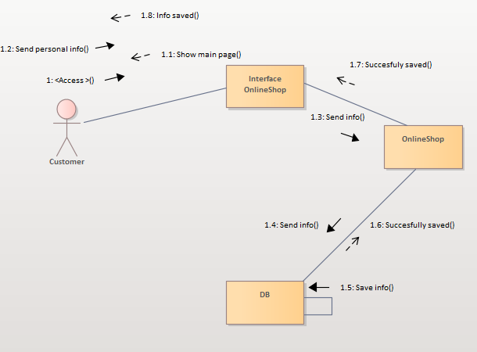

***Figure 1.*** *Personal Info Diagram*

Collaboration diagram ( example level) number 1 shows the process of sending personal info to the data bases, and receving as a response : Info saved succesfully.  
At the first step user acces the website, then send his personal info, after that the data is sent to the server (data base) where data is verified and saved. In our case data is saved succesfully. The functionality represented is : Saving personal data.

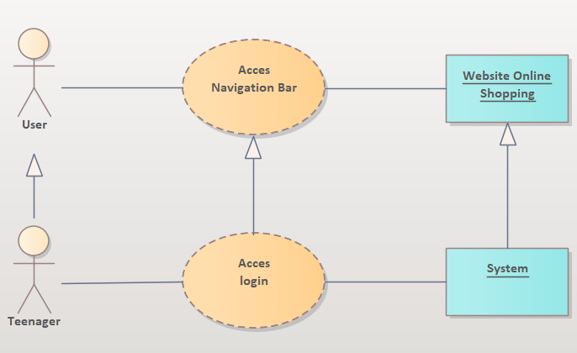

***Figure 2..*** *Navigation Bar Diagram*

Figure 2 shows the collaboration diagram at the specification level for accessing the navigation bar, with which users can search for specific products in the online store. For the given case, the actor named User is specified as Teenager. The "Access navigation bar" collaboration is specified by "Access Logging" in the bar, and the Website object is specified as System level, because to access logging, the system processes the signal.

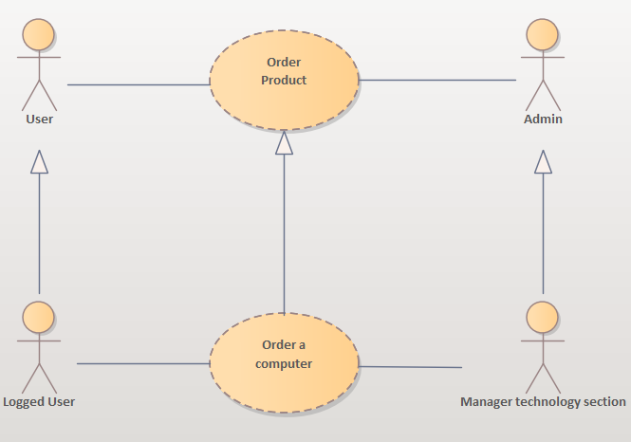

***Figure 3..*** *Order Product Diagram*

Collboration diagram number 3 (specification level) shows a summary of making an order. In the image you can see the interaction between the Teenager user and the Computer Section Manager. After the teenager completes the order, the manager contacts the user to specify details such as the delivery date or delivery address.

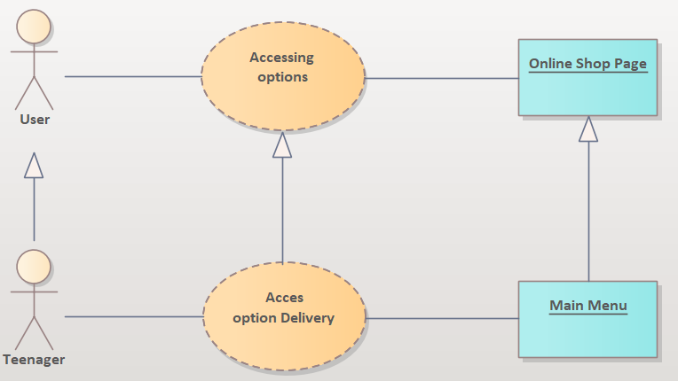

***Figure 4.*** *Accesing Options Diagram*

Figure 4 shows the collaboration diagram at the specification level for accessing the options. In this case, our actor named User is specified as a Teenager via the generalization relationship.

**Conclusions:** The purpose of this lab work is to understand and familiarize ourselves with Collaboration diagrams, the connections between them and the actors. In this lab work I created some collaboration (communication) diagrams. These diagrams allow us to demonstrate how the inner workings of our system work. The relationships between a user, the request processed by him and the actions of the system are exemplified. Having completed this work, the idea was reached that collaboration diagrams do not only represent the consecutiveness of interactions, but also structural relationships between objects. Unlike the instance level where the objects and links within the collaboration are represented, the specification level represents the roles of entities and the role of associations within the collaboration between objects.

**Bibliography**

1. **Melnic R., Sava N.** Indrumar metodic “Analiza si modelarea sistemelor informationale”.
2. **Моделирование бизнес процессов|CASE средства|Rational Rose**, [Электронный ресурс].-Режим доступа: <http://www.kpms.ru/Automatization/Rational_Rose.htm>