Ministry of Education, Culture and Research of the Republic of Moldova

Technical University of Moldova

Department of Software and Automation Engineering

**REPORT**

Laboratory work No. 2

Discipline: AMS

Topic: System analysis based on APOO methodology and model development through use case diagrams.

Analysis and modeling of an online store (e-commerce)

Done by: Lupascu Felicia

st.gr. FAF212

Verified by: univ.lect.  
 Sava Nina  
Melnic Radu

Chișinău 2022

**Objective**: studying the notions of actor, use case, note, package and UML entity relationships

**Task:** to create 4 use-case diagrams for the chosen information system.

**Theoretical considerations:** Visual modeling in UML can be represented as a process of passing from the most general, abstract level to the logical and then physical model of the system. The use case diagram describes the functionality of the system.

The Use Case diagram shows a collection of use cases and actors that:

• Provides a general description of how the system will be used

• Provides an overview of the functionalities that the system wants to offer

• Show how the system interacts with one or more actors

• Ensures that the system will perform as intended.

The main elements of a Use Case diagram are:

• Use Case Entity

• The Actor entity.

• Generalization and Dependency relationships

The chosen topic is Analysis and modeling of an online store (e-commerce). In recent times, the advancement of wireless technology and the growth of market potentials have led to an increase in the number of mobile device users. The emergence of this technology gave rise to the rapid development of mobile e-commerce technologies. It brings on-the-go Internet access to the general online market, without geographical and time constraints.

**Implementation, practical results:**  
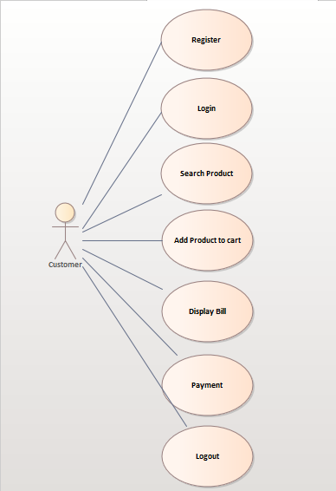

***Figure 1.*** *Customer Diagram*

Use case diagram is usually referred to as behavior diagram used to describe user actions. In this case, we have the Customer as an actor and the actions he takes or he may choose are represented, as an association relationship is present.

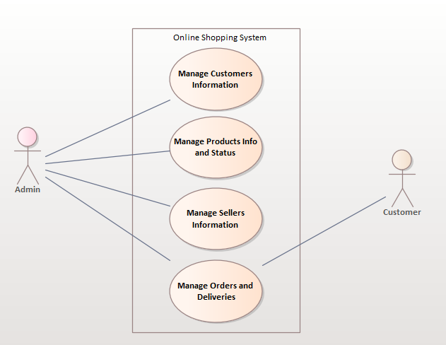

***Figure 2.*** *Online Shopping System*

Diagram no. 2 shows the general processes of online shopping. It is based on the activities performed by the shopping administrator and customers in the system. The diagram shows the main use cases in online shopping. Use cases are user information management, information management and updates, debtor management and transaction record management.

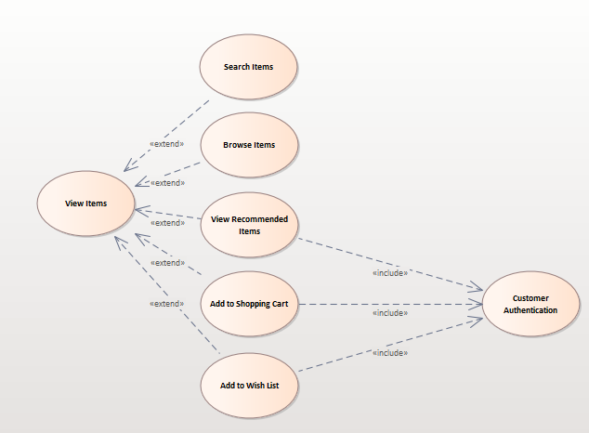

***Figure 3.*** *View Items Diagram*

The View Items use case is extended with several optional use cases - customers can search for items, browse the catalog, view items recommended for him/her, and add items to the shopping cart or wish list. All of these use cases are `Extend' use cases because they provide some optional features that allow customers to search for items.

The use case for customer authentication is included in View Featured Items, Add to Wish List, and Add to Cart because it requires customer authentication.

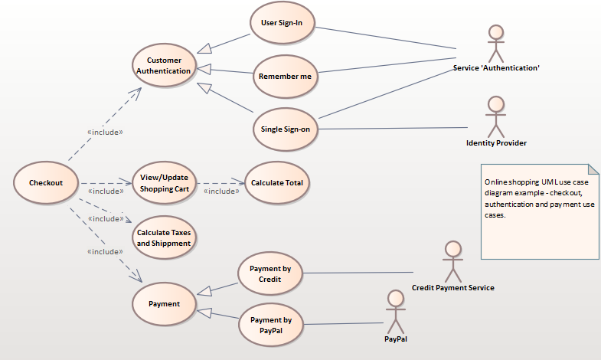

***Figure 4.*** *Checkout Use Case*

The Checkout use case includes several required use cases. Web clients should be authenticated. This can be done via a user login page, a user authentication cookie ("Remember Me") or Single Sign-On (SSO). So it means that there will be a generalization relationships, because it allows customers choosing from some options. The website authentication service is used in all of these use cases, while SSO also requires the participation of an external identity provider. The Checkout use case also includes the payment use case, which can be done either by using your credit card and third-party credit payment service or PayPal. I also added a note, in which I indicated the general name of this diagram.

**Conclusions:** The purpose of this lab work is to understand and familiarize ourselves with Use Case diagrams, the connections between them and the actors and fundamental entities. While working on this lab, I made web browser use case diagrams, as a result I understand what these diagrams are for, what they are made of, and when they should be used. I also discovered many other functions, such as editing diagrams, playing with colors and fonts. In conclusion, the Use-Case diagrams and the entire Enterprise Architect tool is very useful, especially for the Online Shopping theme, because it allows an easy and interactive representation of the process.

**Bibliography**

1. **Melnic R., Sava N.** Indrumar metodic “Analiza si modelarea sistemelor informationale”.
2. **Моделирование бизнес процессов|CASE средства|Rational Rose**, [Электронный ресурс].-Режим доступа: <http://www.kpms.ru/Automatization/Rational_Rose.htm>