Ministry of Education, Culture and Research of the Republic of Moldova

Technical University of Moldova

Department of Software and Automation Engineering

**REPORT**

Laboratory work No. 3

Discipline: AMS

Topic: Analysis of modeling results from use case diagrams and development into sequence diagrams.

Analysis and modeling of an online store (e-commerce)

Done by: Lupascu Felicia

st.gr. FAF212

Verified by: univ.lect.  
 Sava Nina  
Melnic Radu

Chișinău 2022

**Objective**: studying the notion of object, focus control, synchronous and asynchronous relationship, types of stereotypes

**Task:** to make 3-4 sequence diagrams for the chosen information system

**Theoretical considerations:** A Sequence diagram is a structured representation of behavior as a series of sequential steps over time. It is used to depict work flow, message passing and how elements in general cooperate over time to achieve a result.

* Each sequence element is arranged in a horizontal sequence, with messages passing back and forward between elements.
* An Actor element can be used to represent the user initiating the flow of events.
* Stereotyped elements, such as Boundary, Control and Entity, can be used to illustrate screens, controllers and database items, respectively.
* Each element has a dashed stem called a lifeline, where that element exists and potentially takes part in the interactions.

### A sequence diagram is a useful tool for documenting a system’s needs and fleshing out its architecture. Because it depicts the interaction logic between the items in the system in the time order in which they occur, the sequence diagram is quite valuable. The sequence diagram is used to model the system’s sequence of events. It describes the interaction between the users and the system.

### Purpose of Sequence Diagram

* Model high-level interaction between active objects in a system
* Model the interaction between object instances within a collaboration that realizes a use case
* Model the interaction between objects within a collaboration that realizes an operation
* Either model generic interactions (showing all possible paths through the interaction) or specific instances of a interaction (showing just one path through the interaction)

The chosen topic is Analysis and modeling of an online store (e-commerce). In recent times, the advancement of wireless technology and the growth of market potentials have led to an increase in the number of mobile device users. The emergence of this technology gave rise to the rapid development of mobile e-commerce technologies. It brings on-the-go Internet access to the general online market, without geographical and time constraints.

**Implementation, practical results:**  
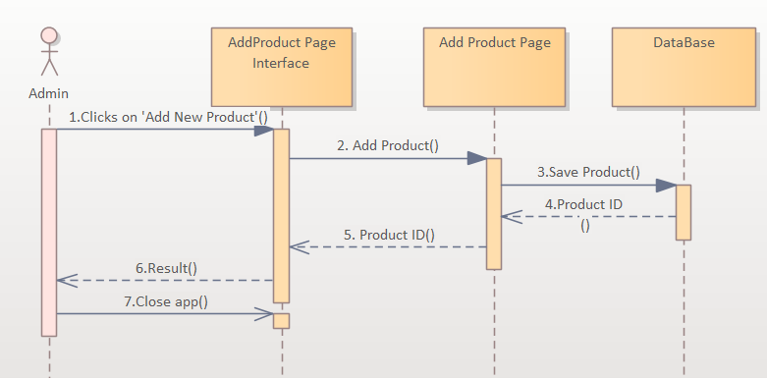

***Figure 1.*** *Admin Diagram*

Sequence diagram number 1 shows the process by which the online store administrator adds new products. It adds the product, saves its addition, and receives a Return with the name 'Product ID'. Here I used synchronous message shown as a solid line with a filled arrowhead, a return message shown as a dashed line with an open arrowhead and finally an asynchronous message shown as solid line with an open arrowhead

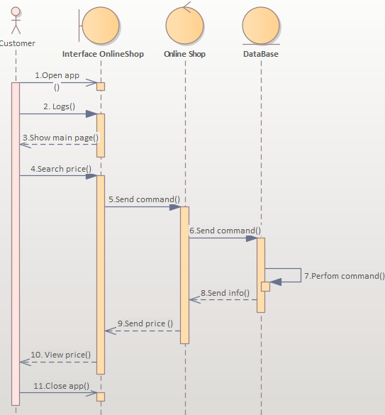

***Figure 2.*** *Search Price Diagram*

Sequence diagram number 2 shows a summary of several consecutive actions that the client could take. He opens the application, logs in, searches for products or prices. The Search Price command () is sent to the database, and later the response with the price offer is sent back. At the end, the client closes the application. Here I used synchronous message shown as a solid line with a filled arrowhead, a return message shown as a dashed line with an open arrowhead and finally an asynchronous message shown as solid line with an open arrowhead.

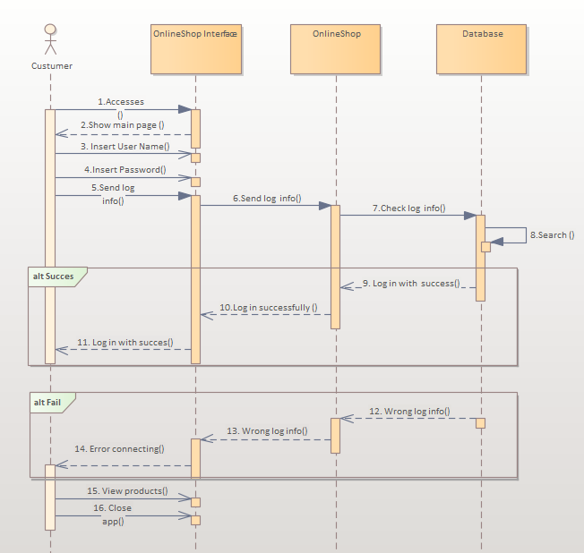

***Figure 3.*** *Log In Diagram*

In sequence diagram number 3, the entire process of logging in to the online store page is represented. The client/user accesses the page and later he enters his login and password, these actions are represented by asynchronous messages, then this information is sent to the database where it is verified whether the information was correct or not. As a result, we use alternative multiple fragments: only the one whose condition is true will execute.

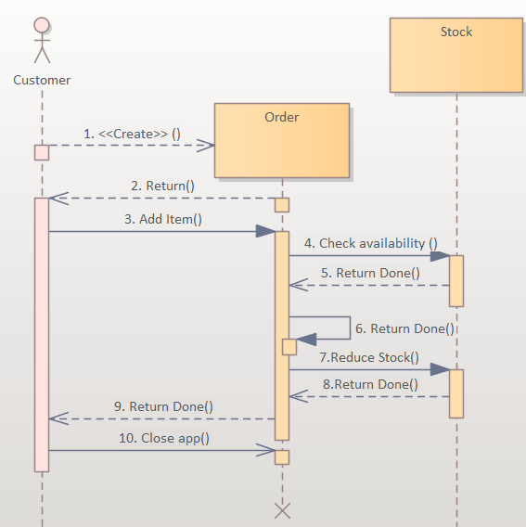

***Figure 4.*** *Create an order Diagram*

In sequence diagram number 4, the process of making an order is represented. The example shows a Sequence diagram with three participating objects: Customer, Order, and the Stock. .

* Step 1 and 2: Customer creates an order.
* Step 3: Customer adds items to the order.
* Step 4, 5: Each item is checked for availability in inventory.
* Step 6, 7, 8: If the product is available, it is added to the order.
* Step 9: Return
* Step 10: Close app

**Conclusions:** The purpose of this lab work is to understand and familiarize ourselves with Sequence diagrams, the connections between them and the actors. In this lab work I created some sequence diagrams. These diagrams allow us to demonstrate how the inner workings of our system work. The relationships between a user, the request processed by him and the actions of the system are exemplified.

**Bibliography**

1. **Melnic R., Sava N.** Indrumar metodic “Analiza si modelarea sistemelor informationale”.
2. **Моделирование бизнес процессов|CASE средства|Rational Rose**, [Электронный ресурс].-Режим доступа: <http://www.kpms.ru/Automatization/Rational_Rose.htm>