Ministry of Education, Culture and Research of the Republic of Moldova

Technical University of Moldova

Department of Software and Automation Engineering

**REPORT**

Laboratory work No. 7

Discipline: AMS

Topic: Development of elaborations by means of component and placement diagrams

Analysis and modeling of an online store (e-commerce)

Done by: Lupascu Felicia

st.gr. FAF212

Verified by: univ.lect.  
 Sava Nina  
Melnic Radu

Chișinău 2022

**Objective**: studying the notions of component, interface, node, dependency, connection between nodes

**Task:**  to make 3 component diagrams and 2 placement diagrams for the chosen information system

**Theoretical considerations:**

A **component** represents a modular part of a system that encapsulates its contents and whose manifestation is replaceable within its environment. In UML 2, a component is drawn as a rectangle with optional compartments stacked vertically. A high-level, abstracted view of a component in UML 2 can be modeled as:

* A rectangle with the component's name
* A rectangle with the component icon
* A rectangle with the stereotyped text and/or icon

The purpose of a **component diagram** is to show the relationship between different components in a system. For UML 2.0, the term "component" refers to a module of classes that represent independent systems or subsystems with the ability to interface with the rest of the system.

There is a whole development approach that revolves around components: component-based development (CBD). In this approach, component diagrams allow the planner to identify the different components so the whole system does what it's supposed to do.

**Benefits of component diagrams**

Although component diagrams may seem complex at first glance, they are invaluable when it comes to building your system. Component diagrams can help your team:

* Imagine the system's physical structure.
* Pay attention to the system's components and how they relate.
* Emphasize the service behaviour as it relates to the interface.

Deployment diagrams are used to visualize the processors/nodes/hardware devices of a system, the communication links between them, and the placement of software files on that hardware.

Deployment diagrams are typically used to visualize the physical hardware and software of a system. Using it you can understand how the system will be physically deployed on the hardware.

Deployment diagrams help model the hardware topology of a system compared to other UML diagram types which mostly outline the logical components of a system.

**How to Draw a Deployment Diagram**

Step 1: Identify the purpose of your deployment diagram. And to do so, you need to identify the nodes and devices within the system you'll be visualizing with the diagram.

Step 2: Figure out the relationships between the nodes and devices. Once you know how they are connected, proceed to add the communication associations to the diagram.

Step 3: Identify what other elements like components, active objects you need to add to complete the diagram.

Step 4: Add dependencies between components and objects as required.

The chosen topic is **Analysis and modeling of an online store (e-commerce**). In recent times, the advancement of wireless technology and the growth of market potentials have led to an increase in the number of mobile device users. The emergence of this technology gave rise to the rapid development of mobile e-commerce technologies. It brings on-the-go Internet access to the general online market, without geographical and time constraints.

**Implementation, practical results:**  
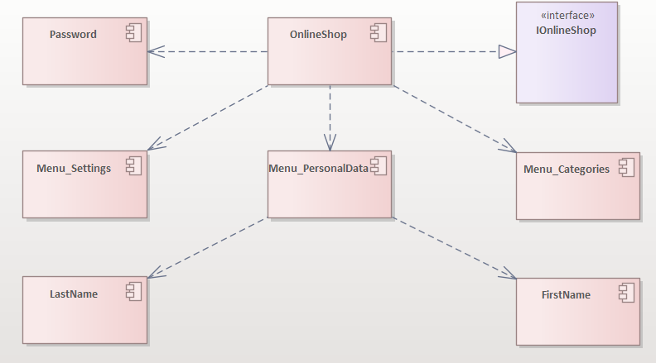

***Figure 1.*** *System Online Shop Diagram (component diagram)*

Component diagram no. 1 represents some main menus, personal data, settings and interface. The interface and the component are connected through the Realization relationship. And the rest of the components are connected through the Dependency relationship. Dependency - Shows that one part of your system depends on another. Dependencies are represented by dashed lines linking one component (or element) to another.

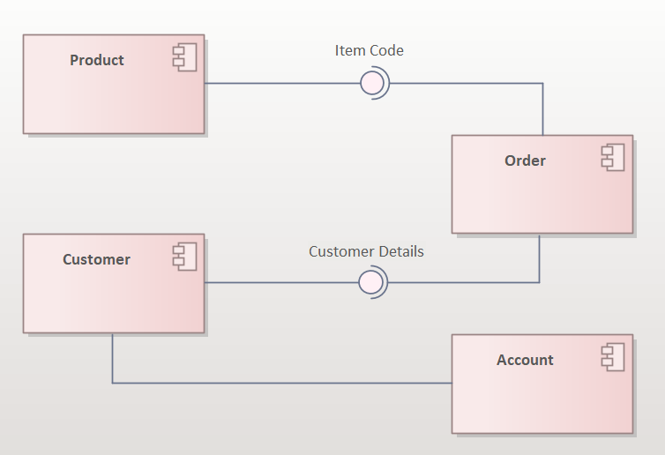

***Figure 2.*** *Order Diagram (component diagram)*

The component diagram no. 2 demonstrates a number of components and their inter-relationships.Assembly connectors connect the provided interfaces supplied by Product and Customer to the required interfaces specified by Order. Interfaces in component diagrams show how components are wired together and interact with each other. The assembly connector allows linking the component’s required interface (represented with a semi-circle and a solid line) with the provided interface (represented with a circle and solid line) of another component. This shows that one component is providing the service that the other is requiring.

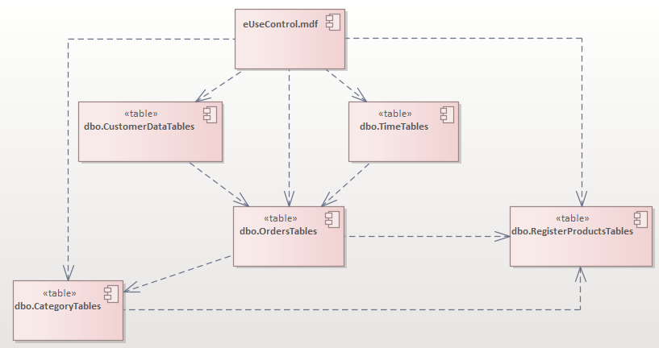

***Figure 3.***  *Tables Diagram (component diagram)*

Component diagram no. 3 represens some of the tables of a Online Shoppping System and the relationships between them. All tables are dependent of the table Use Control. Order Table is linked with Customert Details, Time of the order, Category of Product, and the Product itself. Register Product Category is in a relationships with Category and Order Tables.

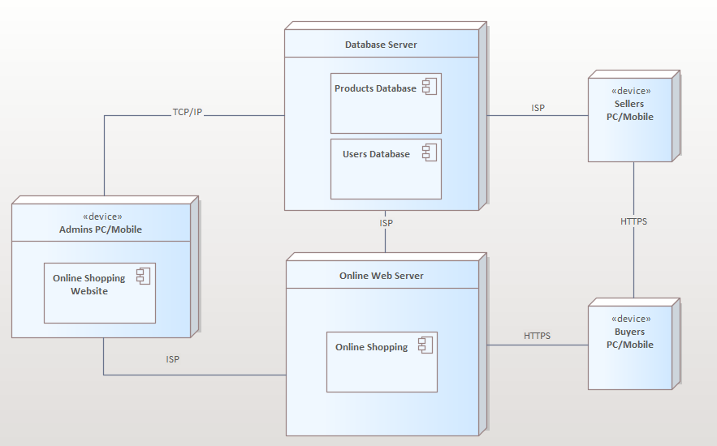

***Figure 4.*** *Online Shopping App/Website (deployment diagram)*

Figure 4 represents a deployment diagram. There we have 3 devices: Admin’s PC, Seller’s Mobile/PC, Buyers’ Mobile/PC. These sketch also includes the software and hardware components to clarify their part in the system’s operation. They were represented by nodes and the connections were represented by labeled arrows.

The admin’s PC has access to the system’s back end and can monitor the systems’ server. The deployment diagram shows the scenario when the system is deployed. It has 5 nodes represented with boxes and components within.

Additionally, the software is connected to ISP which enables it to pass data to the webserver. Then the webserver will be accessed by the buyers thru browsers with the help of URLs. The sellers and the buyers can communicate with the use of ISP.

TCP/IP - Transmission Control Protocol/Internet Protocol

ISP – Internet service provider

HTTP(S) - Hypertext Transfer Protocol Secure

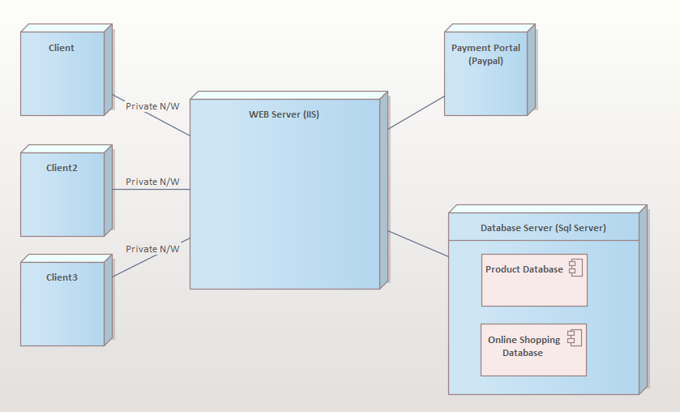

***Figure 5.*** *Clients Diagram (deployment)*

Deployment diagram no. 5 represents the deployment diagram for online shopping. There is a database server (SQL Server) and a Web server (II S) connected with each other. The diagram shows how multiple clients can be shopping at once.

**Conclusions:** The purpose of this laboratory work is to understand and familiarize ourselves with Component and Placement diagrams, and the connections between them. In this lab work, I created 5 diagrams. Component diagrams are used to get an idea of the implementation. This diagram is very important as without it the application cannot be implemented efficiently. The main purpose of the deployment diagram is to represent how software is installed on the hardware component. It depicts how software interacts with hardware to perform its execution. In conclusion, I can say that these 2 diagrams are very useful and necessary.

**Bibliography**

1. **Melnic R., Sava N.** Indrumar metodic “Analiza si modelarea sistemelor informationale”.
2. **Моделирование бизнес процессов|CASE средства|Rational Rose**, [Электронный ресурс].-Режим доступа: <http://www.kpms.ru/Automatization/Rational_Rose.htm>