For this lab, I implemented a customized version of the Conwoys Game of Life. First of all, I substituted traditional cells with red hearts. In general, I implemented the 4 original rules of the game. Then I added my "Exploding Cells" rule. I also added a rule that randomly adds cells in a specific zone. I also added an area where the original rules work differently "Deadly Zone". And for a more pleasant experience for the user, he can set the initial grid of the game, and more than that, he can select the number of generations for which to run the game.

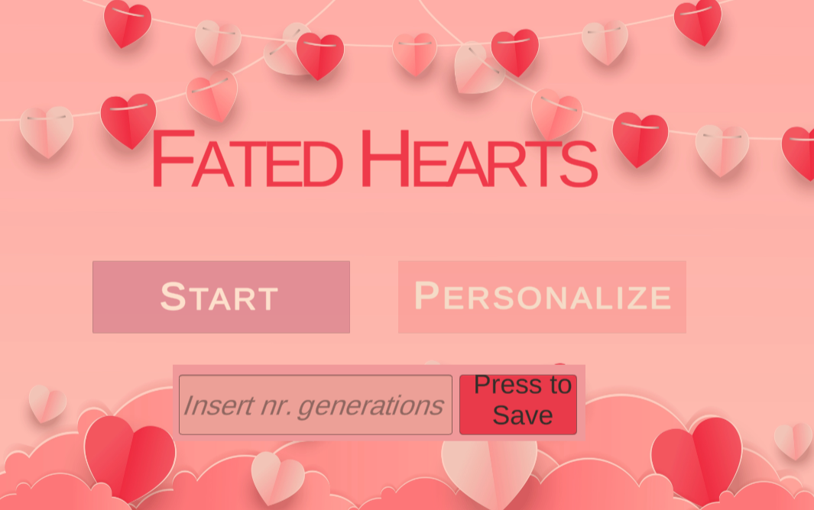

Figure i Main Menu

This is the main menu. First of all, we can directly press Start, and the game will generate a random grid. We can also select the Personalize mode and choose the initial grid with which the game will continue. And another option on the main menu is Input from the user. The user can enter a number, which will then serve as the number of generations, i.e. how many times the program runs.

This picture already shows what the program looks like when you press Start.

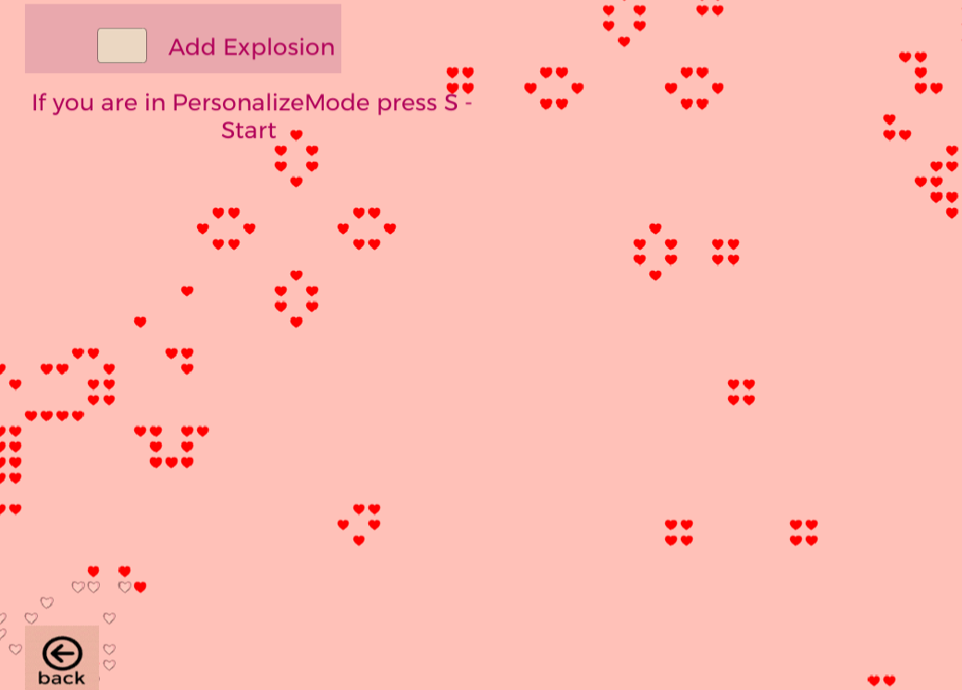

Figure ii Start

And this image shows how the "ExplosionRule" rule works. As seen in the image, during the game, the user can decide if he wants to use this rule or not, just by pressing the button next to the text with the name of the rule.

**How does exploding rule work?**

Living cells with three or more living neighbors explode into four new cells.

We can already see how the number of hearts is higher, thanks to the Exploding Rule. The game's dynamics were noticeably altered by this rule, as it triggered a series of reactions that quickly filled the game board with cells.

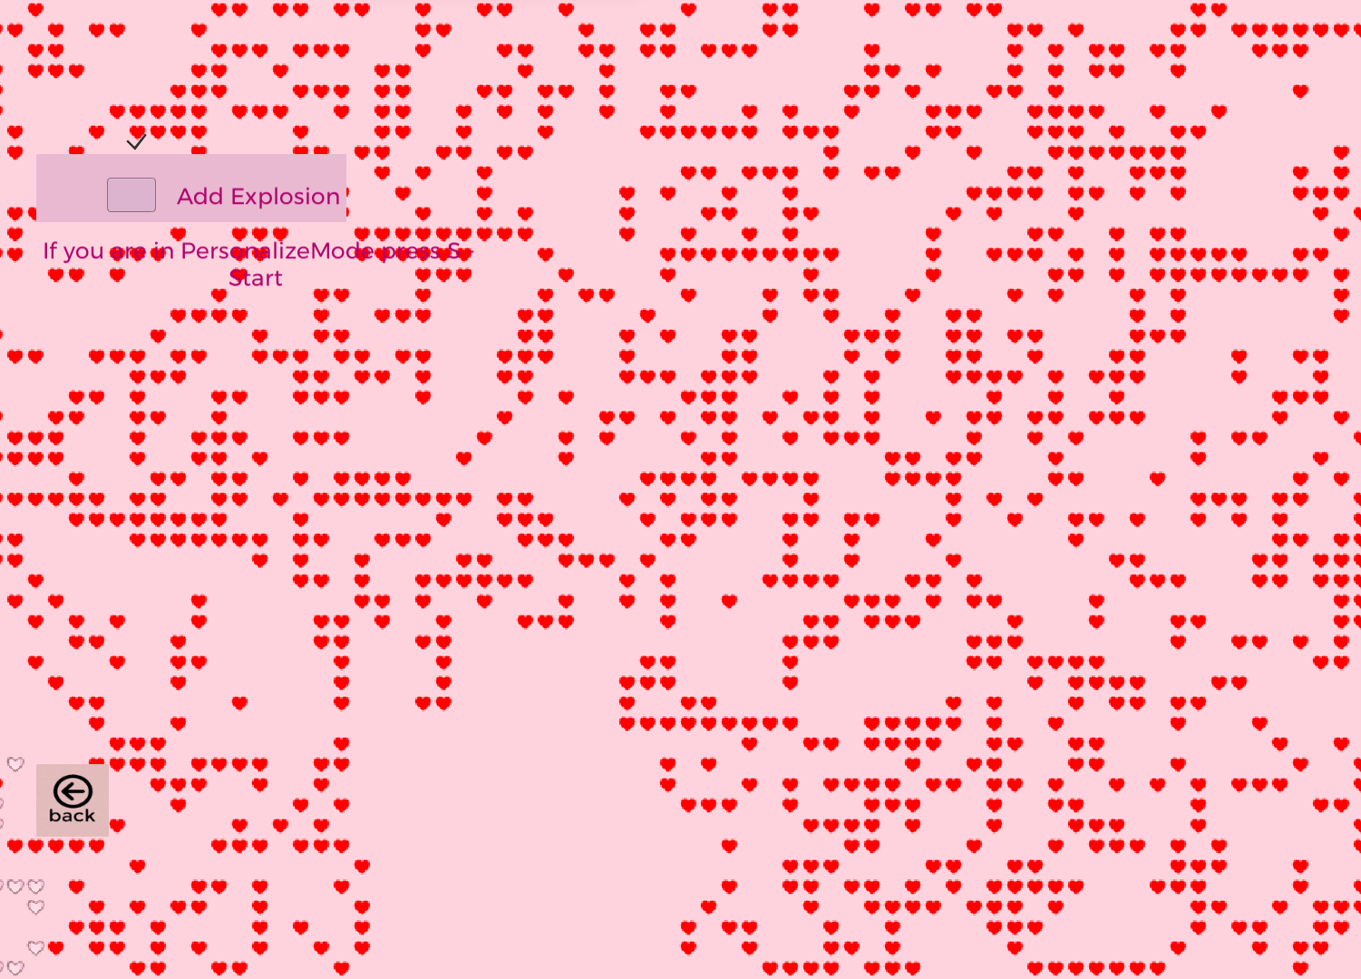

Figure iii Explosion Rule

DeadlyZone can also be seen in this picture. This area is represented in the form of a square at the bottom of the screen.

"Deadly Zone" rule has been introduced, which establishes a specific area on the game grid where living cells with three or more living neighbors are always eliminated due to overpopulation. This rule had a significant influence on the game's dynamics within and around the designated area. The cells within this zone struggled to thrive and propagate due to the constant threat of overpopulation, resulting in a decrease in the number of cells. Moreover, the presence of this barrier had a noticeable impact on the mobility of cells across the game board, as they were less likely to migrate in or out of the "Deadly Zone".

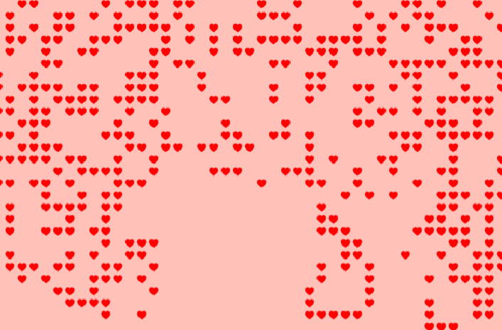

iv Deadly Zone

**Experiment**

In this experiment, I set the number of generations to 100. In the first case, I let the cells act according to the original rules, and in the second case, I added the Explosion Rule.

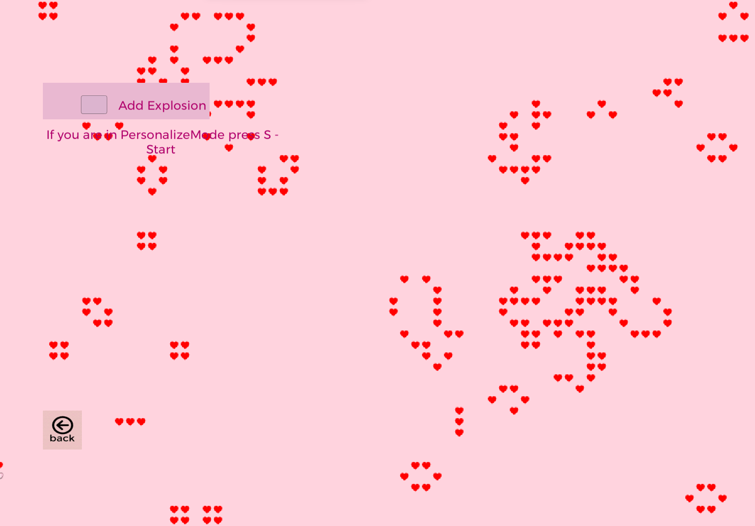

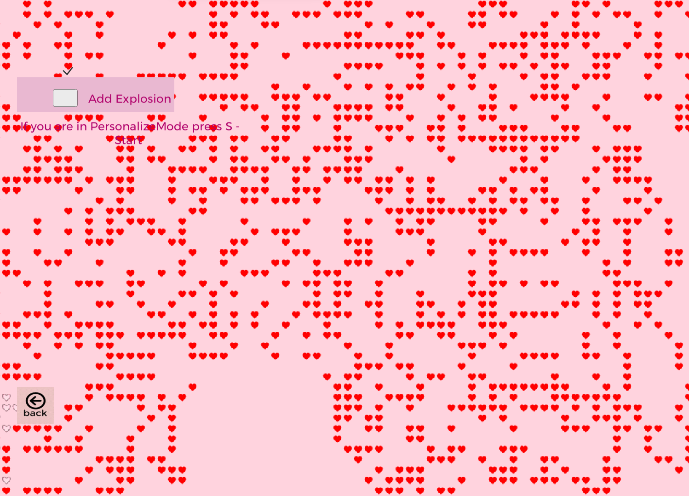

In the first picture, we do not involve Exploding Rule. And as a result in the 100th generation we have few elements left in the game.

And in the second picture, for an approximately similar random grid, we have a completely different result. This proves once again how influential this rule is.

I would add that the final number of generations depends a lot on the rules and implemented areas.

There we can see the Personalize or Customize Mode, where the user can select the grid.And also in this mode, we can analyze our new rules and zone.

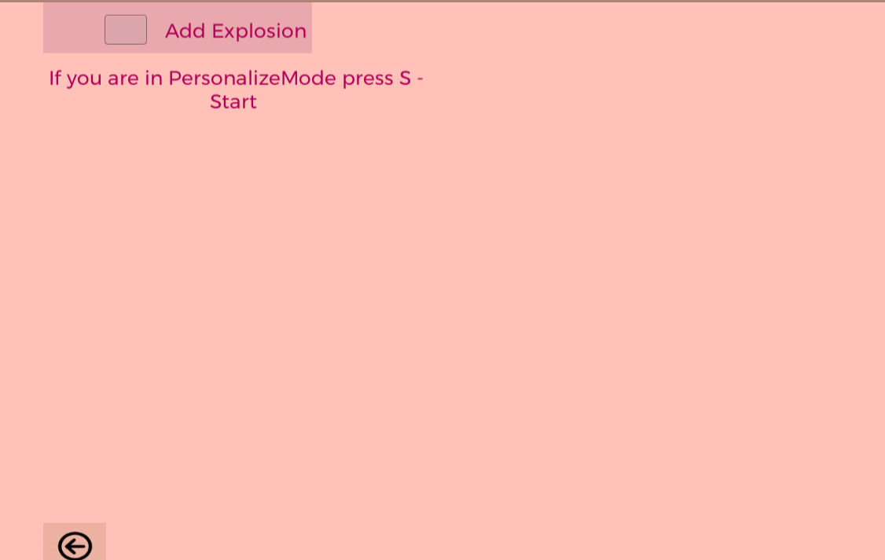

Figure v Customize Mode

Link: <https://daeipheia.itch.io/conways-game-of-life-in-hearts> , Lupascu Felicia, Faf-212

Conclusion: This lab allowed me to develop my own version of Conwoys Life. The whole process was very interesting, due to the dynamism of this game