EIA HOMEWORK

§Time management strategies

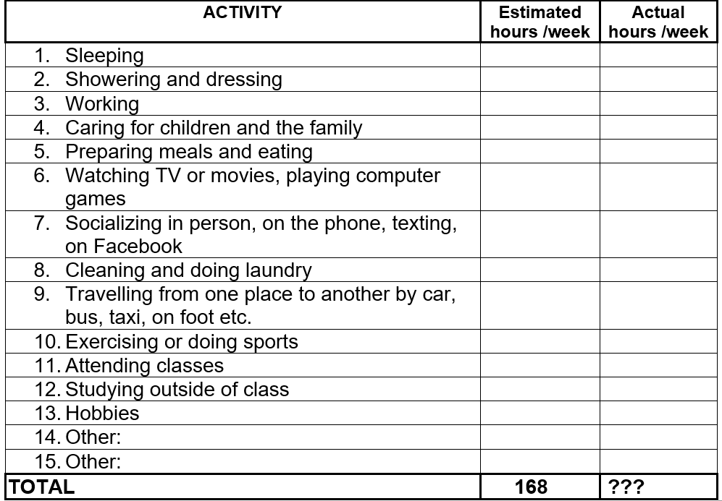

45

10

5

1

10

10

20

5

15

2

25

18

2

6

164

50

10

4

1

10

10

20

4

14

1

25

20

2

6

168

Time management strategies to improve productivity

“Time management” is the process of organizing and planning how to divide your time between specific activities. Good time management enables you to work smarter – not harder – so that you get more done in less time, even when time is tight and pressures are high.

Time management is a separate discipline answering the questions about managing productivity, setting priorities, and effectively organising workflows. So, productivity and time management are interconnected although they exist separately.

For example, at the moment I can't say with persuasion that I have a well thought out time management. But I'm trying to solve this. To improve the way I spend my time, I try to follow some tips.

1. I create a schedule

2. I calculate the time I have available

3. I prioritize important things

4. I remove useless activities

5. I set limits

For greater efficiency and productivity, I follow some similar tips, but they help me a lot more.

* Make a schedule and stick to it. Most people use a work calendar to schedule meetings and events. ...
* Set clear expectations and deadlines. ...
* Break down large tasks into smaller steps. ...
* Take breaks. ...
* Make lists and prioritize tasks. ...
* Link time management to productivity
* Start your day early. ...
* Set priorities and goals when planning your day. ...
* Focus on one task at a time. ...
* Learn to delegate. ...
* Apply the 80/20 rule. ...
* Pencil in some time for distractions and interruptions. ...
* Say no more often and master the art of short meetings.

One of the biggest advantages of time management is that it allows us to be more efficient by being in control of how we spend our time. We can focus better on important tasks, and better focus leads to better efficiency. ... That's what time management can do for us.

Time cannot be bought or sold. Therefore, this priceless resource must be spent wisely.