# Swing components

## AWTAccumulator

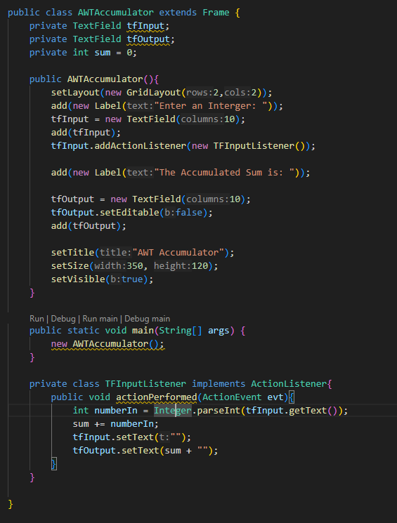

*Figure 1.1: Source code of AWTAccumulator*

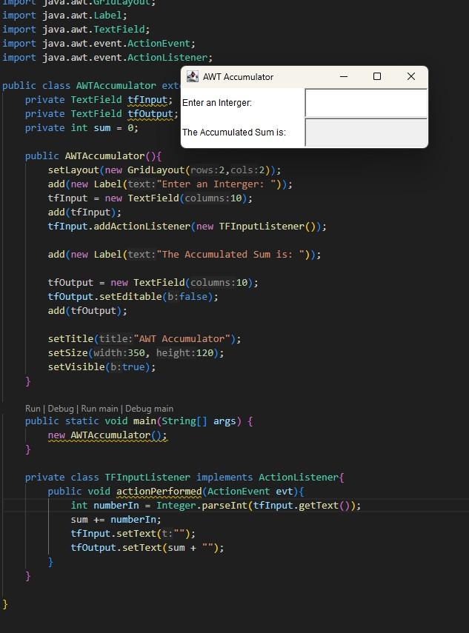

## SwingAccumulator

*Figure 1.2: Demo of AWTAccumulator*

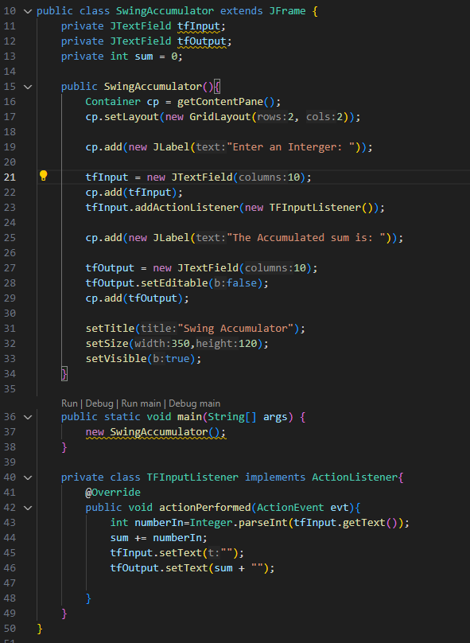

*Figure 1.3: Source code of SwingAccumulator*

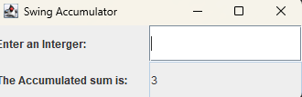

*Figure 1.4: Demo of SwingAccumulator*

# Organizing Swing components with Layout Managers

## Code

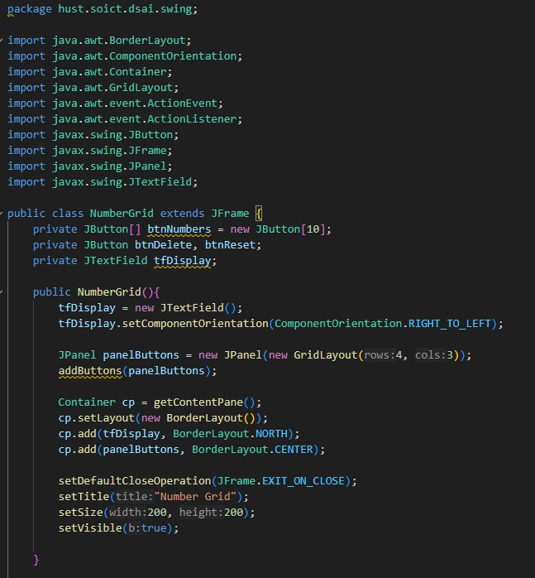

*Figure 2.1: Source code of NumberGrid 1*

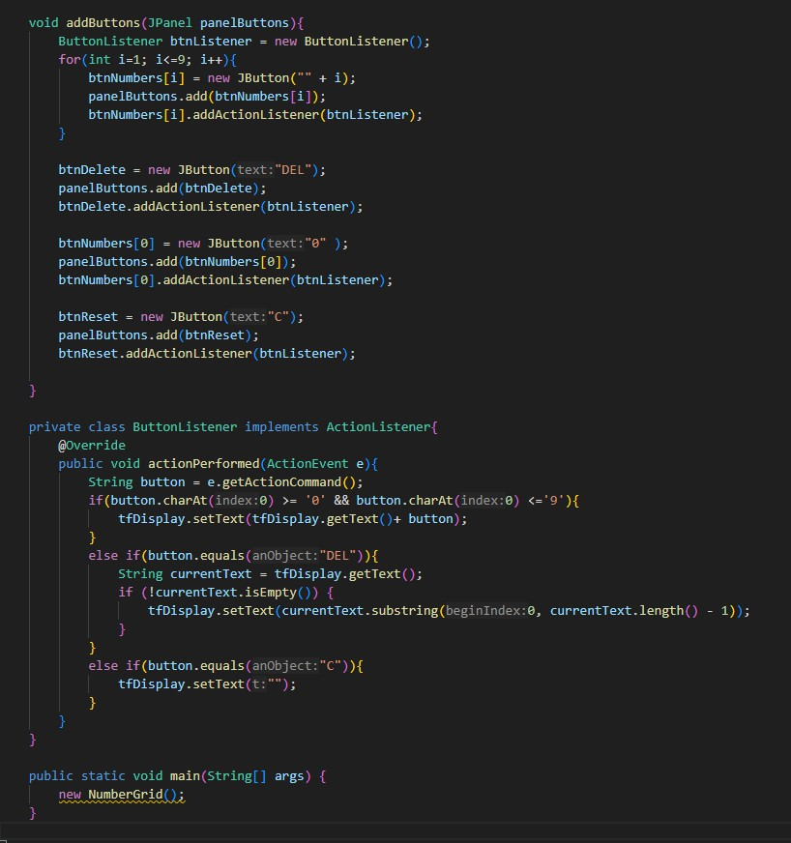

*Figure 2.2: Source code of NumberGrid 2*

## Demo

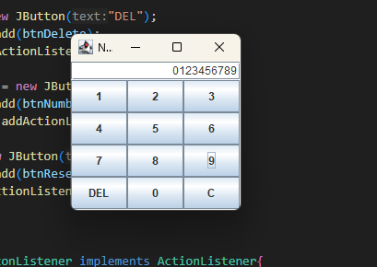

*Figure 2.3: Demo buttons 0-9*

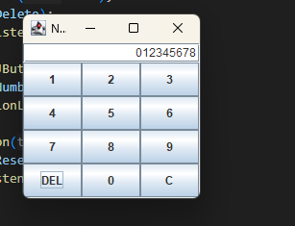

*Figure 2.4: Demo DEL button*

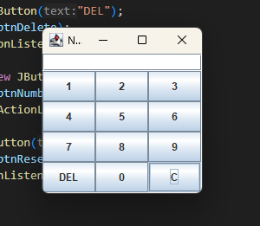

*Figure 2.5: Demo C button*

# Create a graphical user interface for AIMS with Swing

## Create class StoreScreen

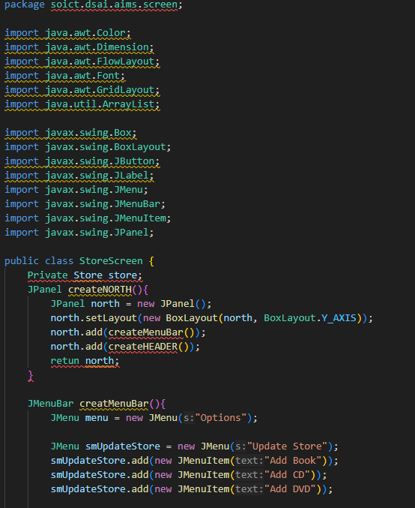

*Figure 3.1: Class StoreScreen 1*

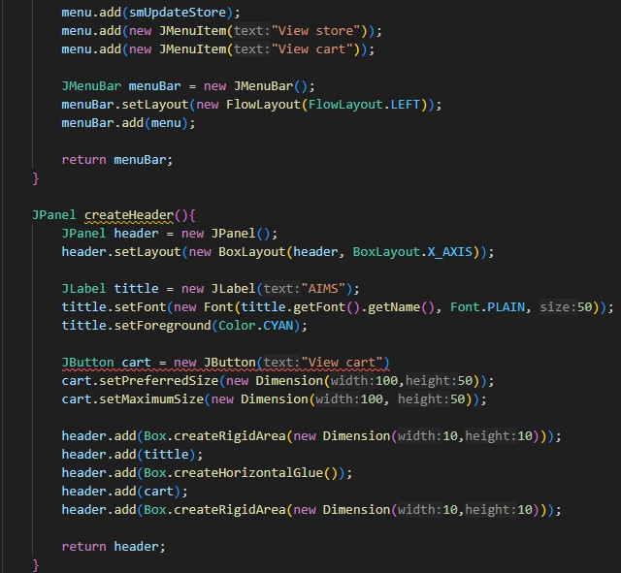

*Figure 3.2: Class StoreScreen 2*

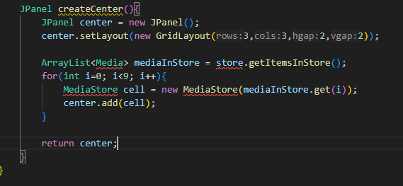

*Figure 3.3: Class StoreScreen 3*

## Create class MediaStore

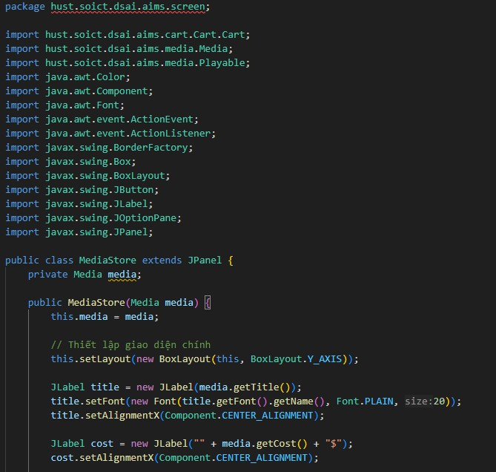

*Figure 3.7: Class MediaStore 1*

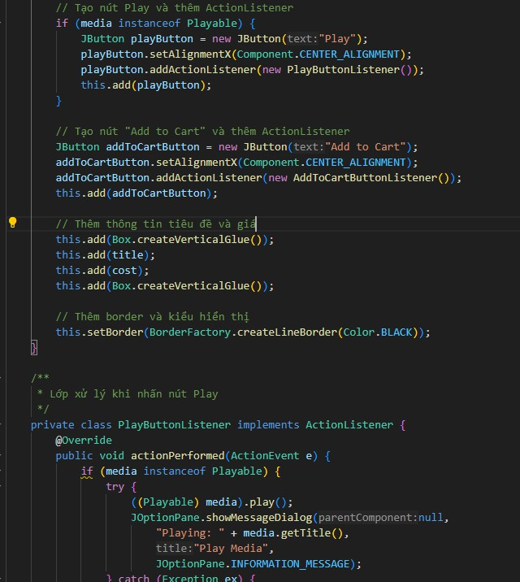

*Figure 3.8: Class MediaStore 2*

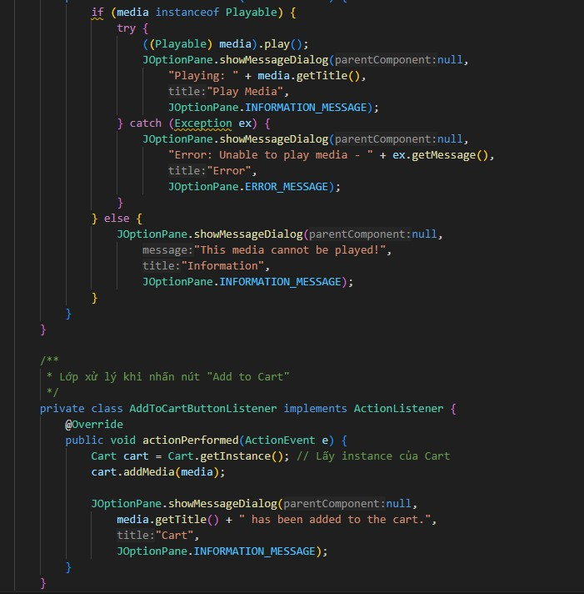

*Figure 3.9: Class MediaStore 3*

## Demo

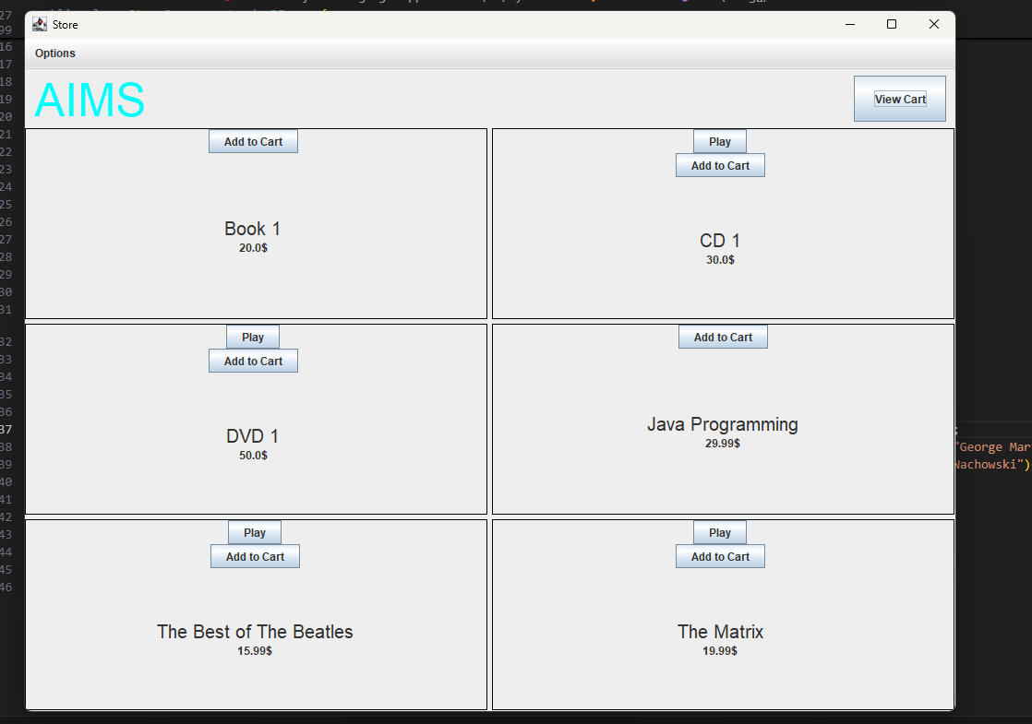

*Figure 3.10: StoreScreen*

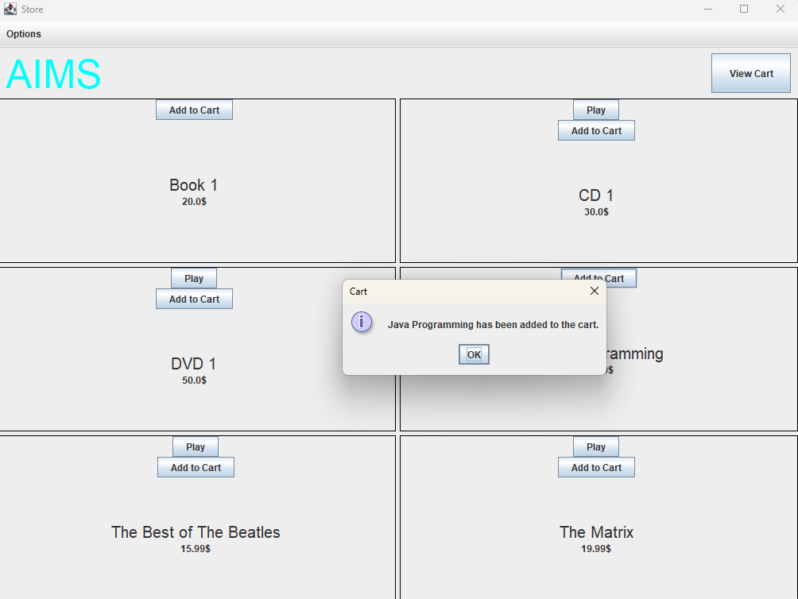

*Figure 3.11 Demo Add to cart button*

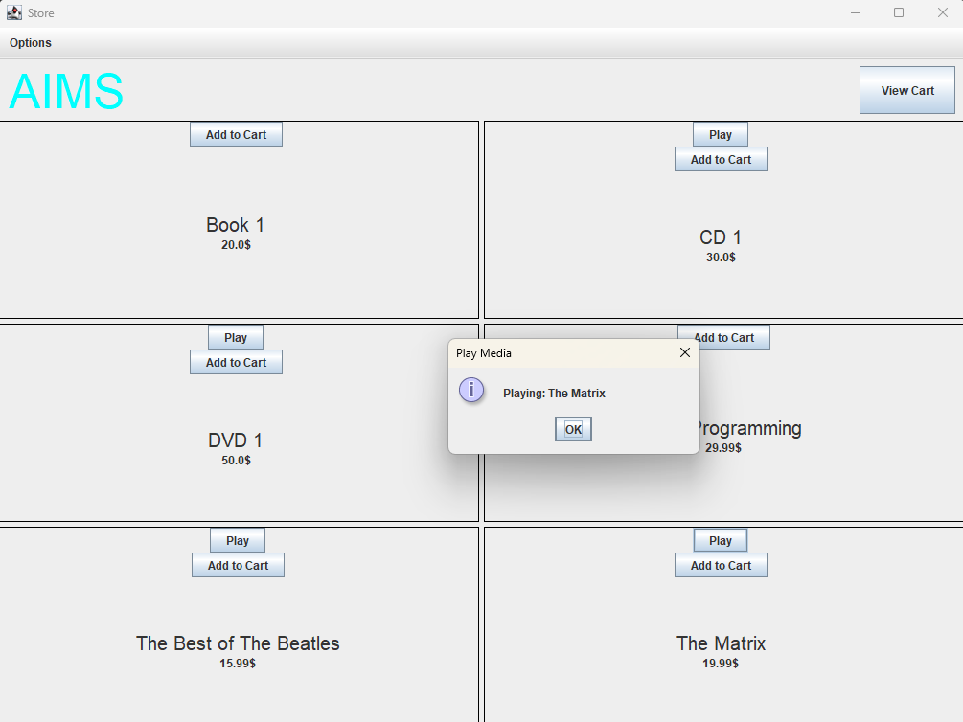

*Figure 3.12 Demo Play button*

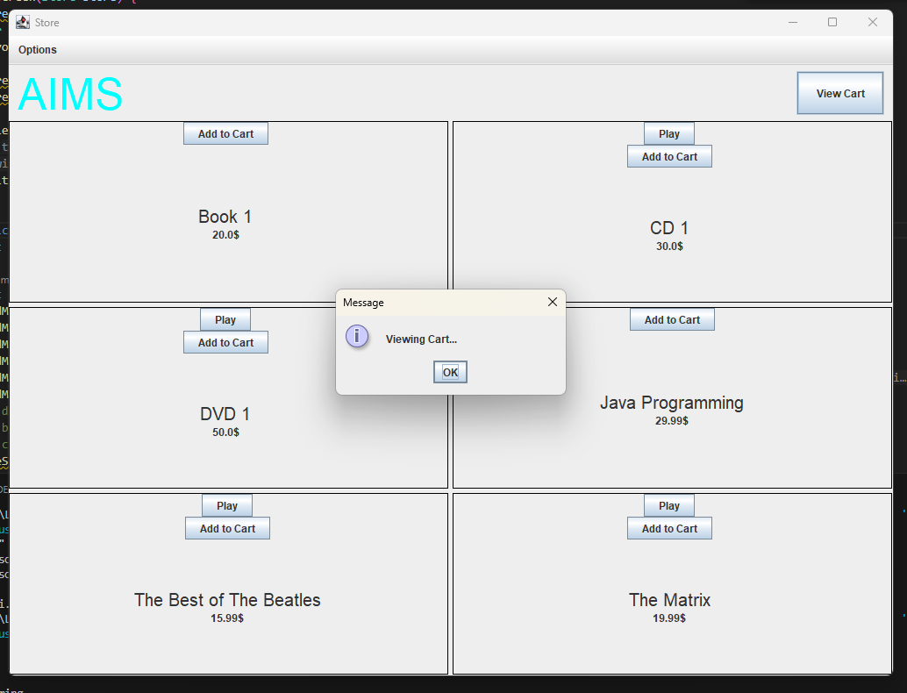

*Figure 3.13 Demo View cart button*

# JavaFX API

## Create class Painter



## Create Painter.fxml

*Figure 4.1: Class Painter*

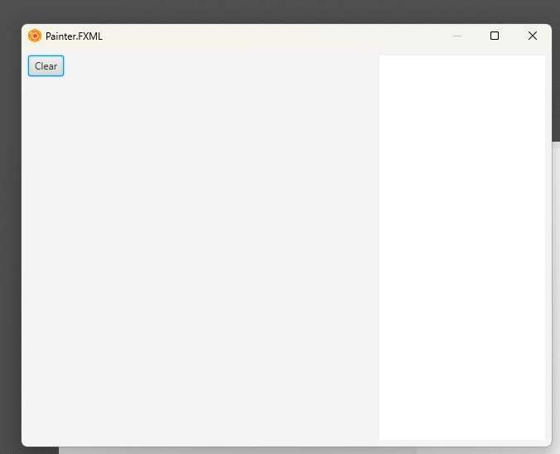*Figure 4.2: Painter.fxml 1*

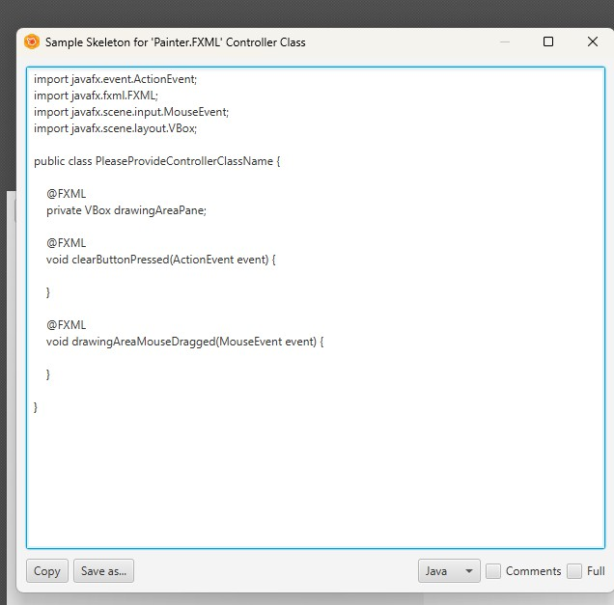

## Create class PainterController

*Figure 4.3: Painter.fxml 2*

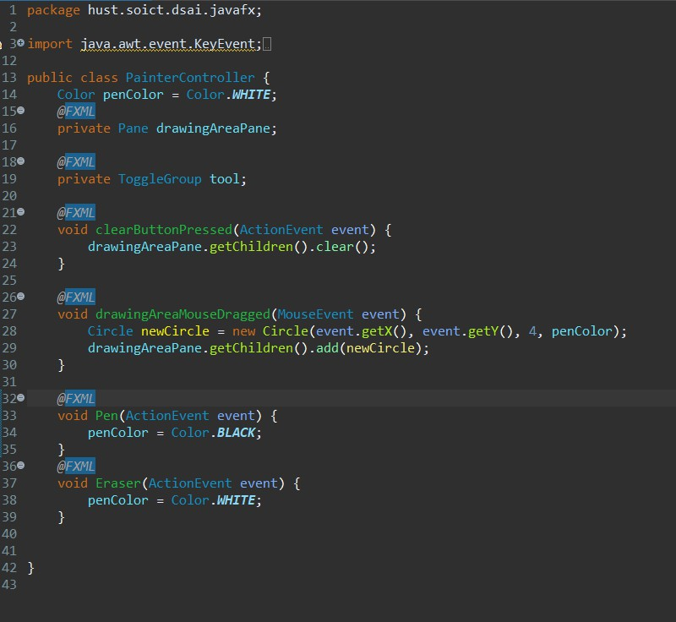

*Figure 4.4: PainterController*

*Figure 4.5: Use Pen*

*Figure 4.6: Use Eraser*

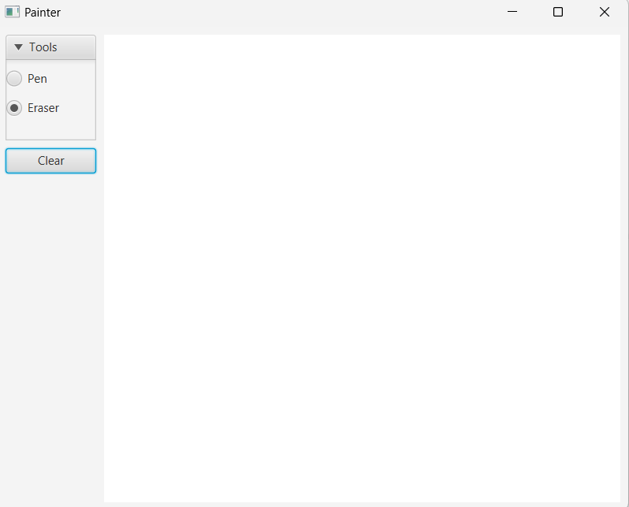

*Figure 4.7: Clear button*

# View Cart Screen

## Create cart.fxml

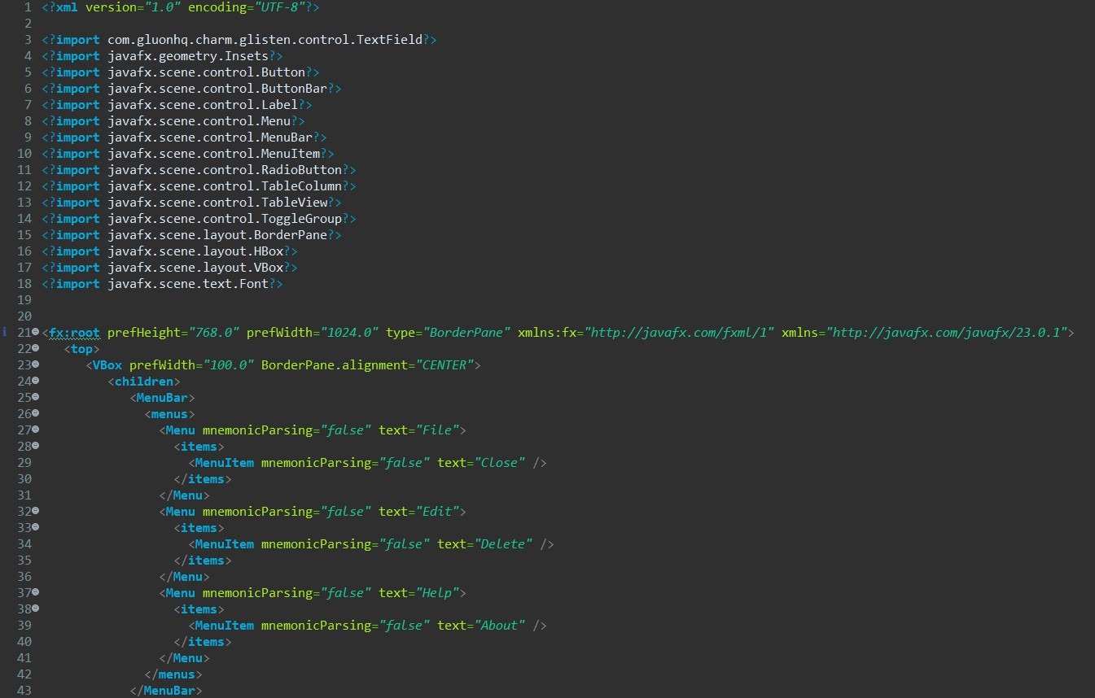

*Figure 5.1: Cart.fxml 1*

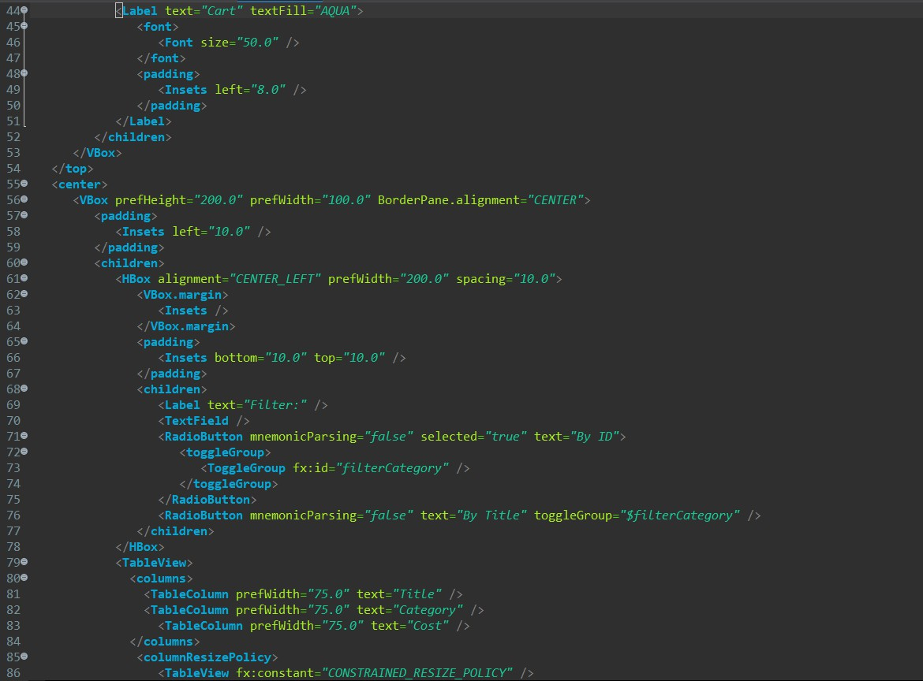

*Figure 5.2: Cart.fxml 2*

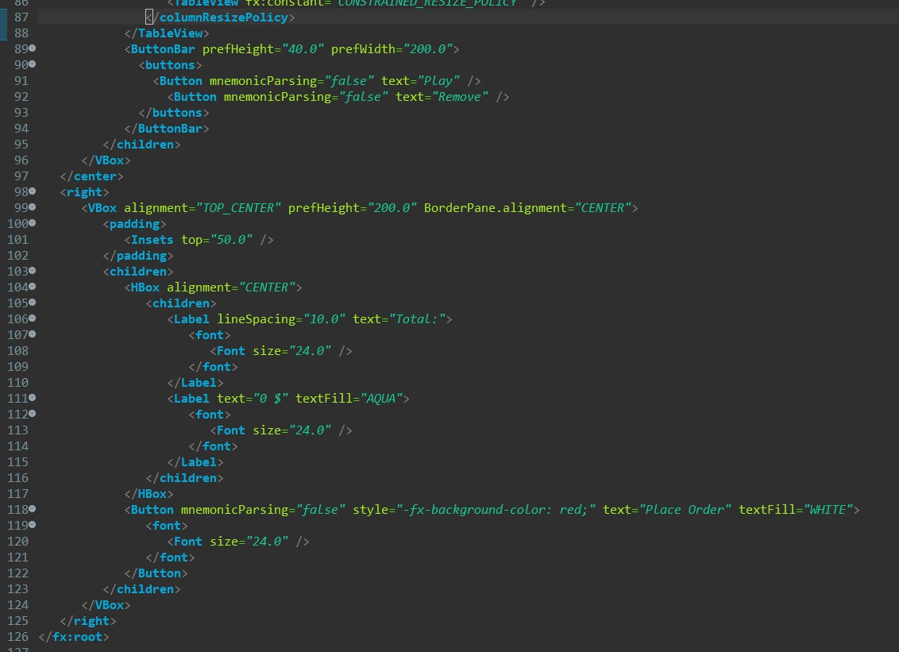

## Create class CartScreen

*Figure 5.3: Cart.fxml 3*

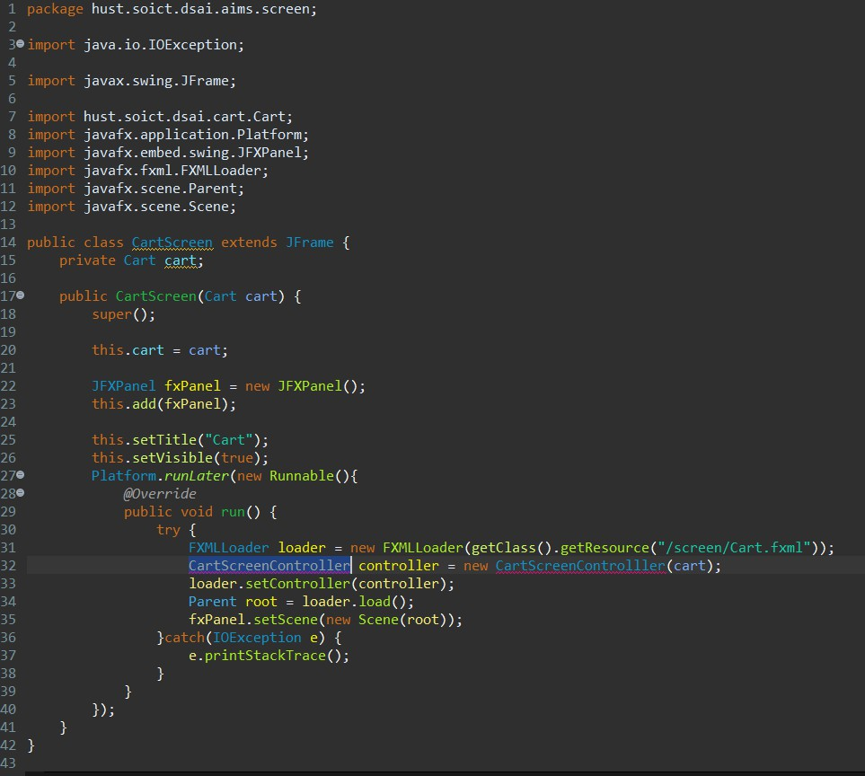

*Figure 5.4: CartScreen class*

## Create class CartScreenController

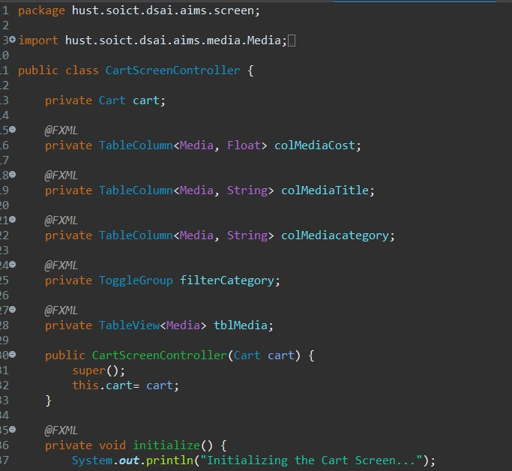

*Figure 5.5: CartScreenController 1*

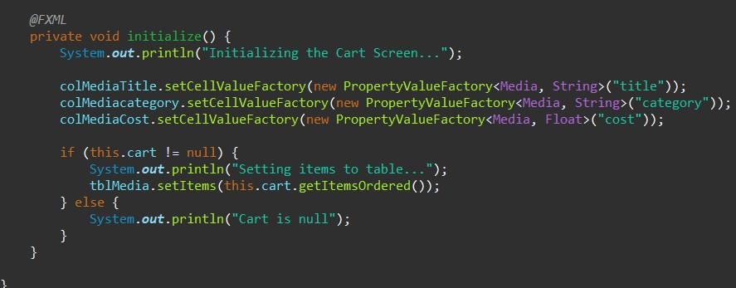

*Figure 5.6: CartScreenController 2*

## Demo

*Figure 5.7: Demo CartScreen*

1. Updating buttons based on selected item in TableView –

ChangeListener

## Edit class CartScreenController

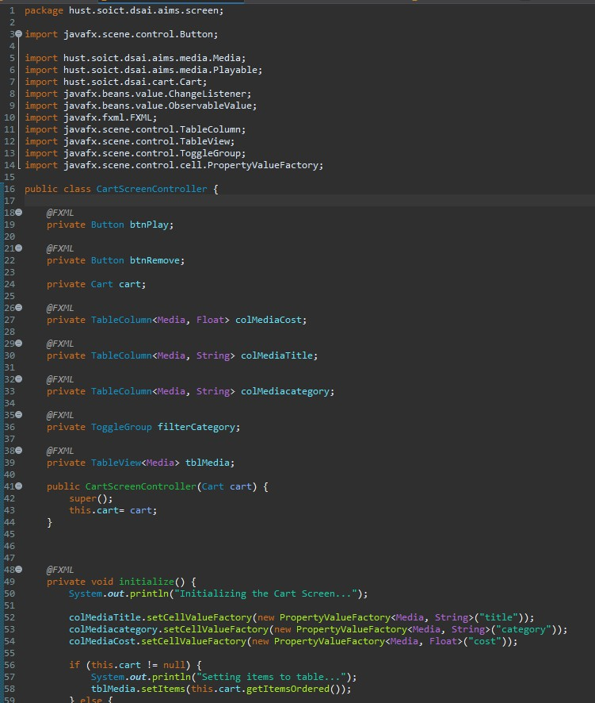

*Figure 6.1: CartScreenController 1*

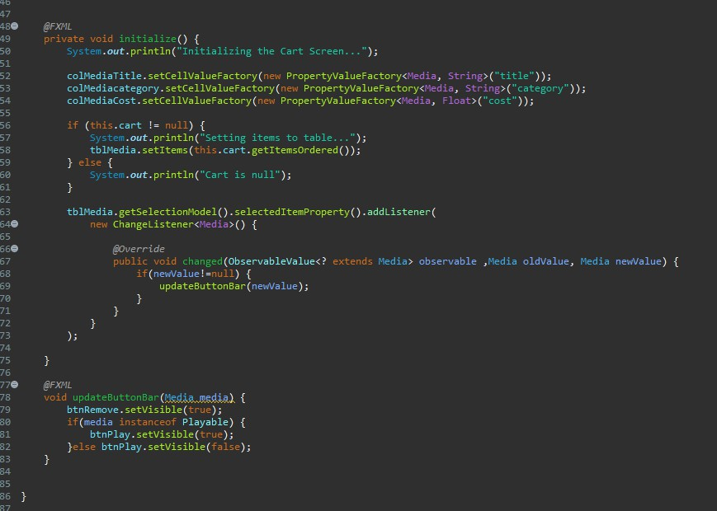

## Demo

*Figure 6.2: CartScreenController 2*

*Figure 6.3: Demo media playable*

*Figure 6.4: Demo media unplayable*

*=*

# Deleting a media

## Code

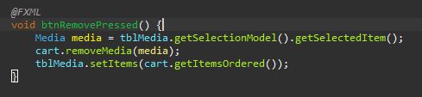

*Figure 7.1: btnRemovePressed Method*

## Demo

*Figure 7.2: button RemoveA screenshot of a computer

Description automatically generated*

*Figure 7.3: button Remove*

# Complete the Aims GUI application

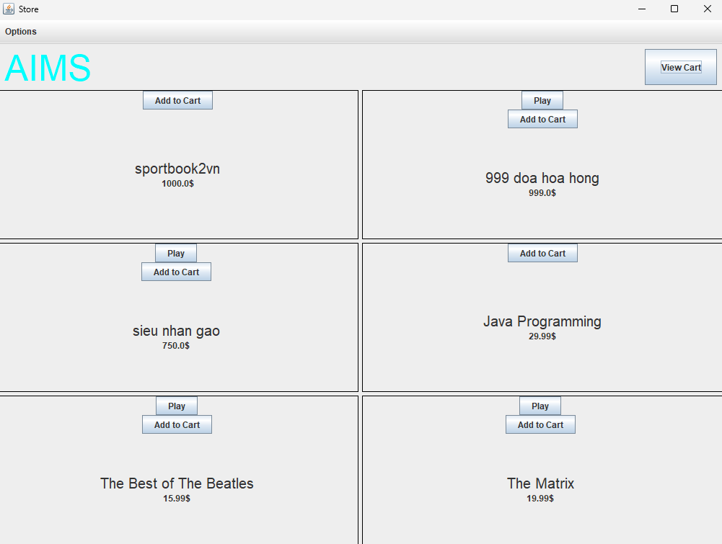

*Figure 8.1: Store before add book*

*Figure 8.2: Add book*

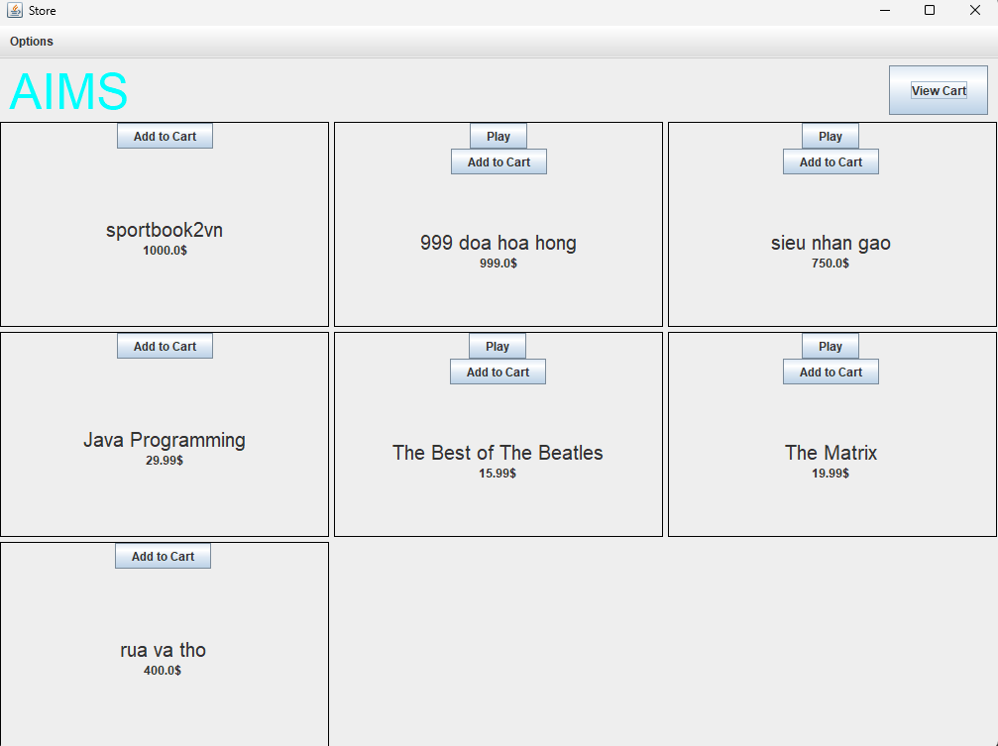

*Figure 8.3: Store after add book*

*Figure 8.4: Add CD*

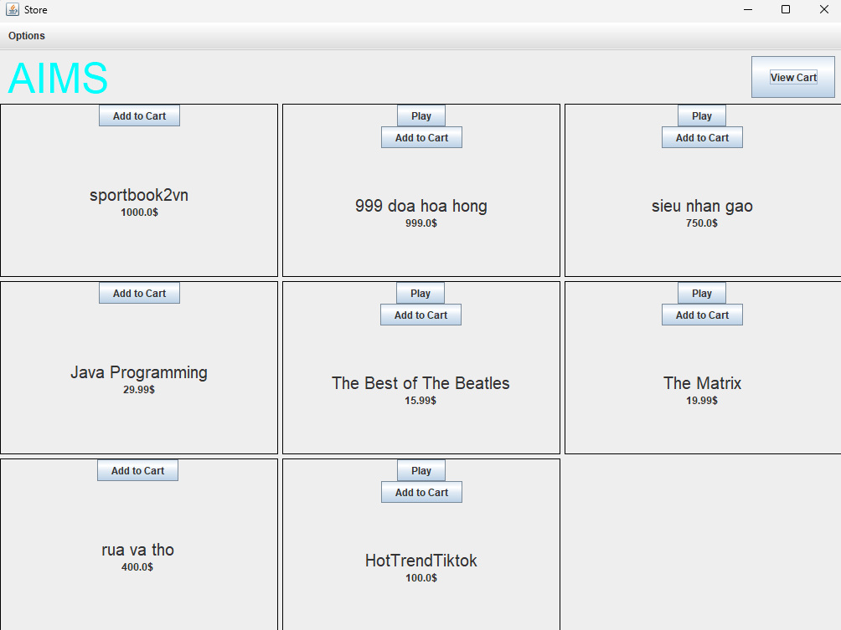

*Figure 8.5: Store after add CD*

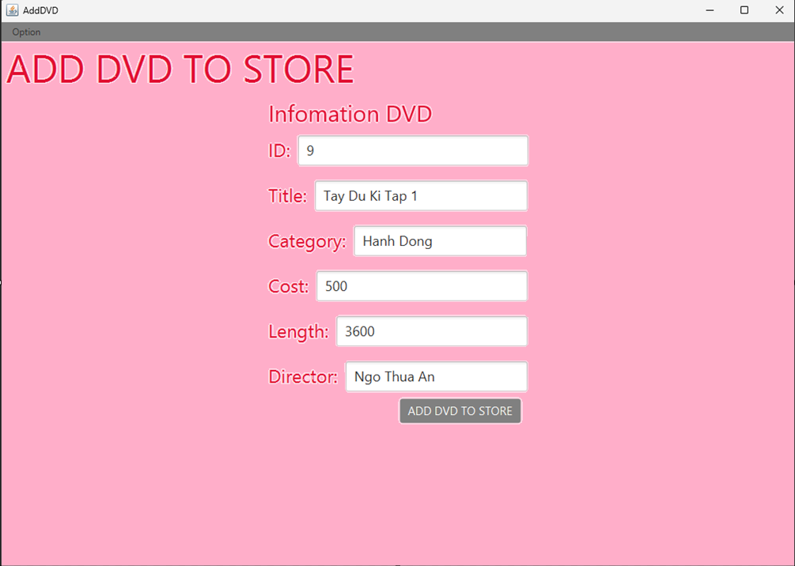

*Figure 8.6 Add DVD*

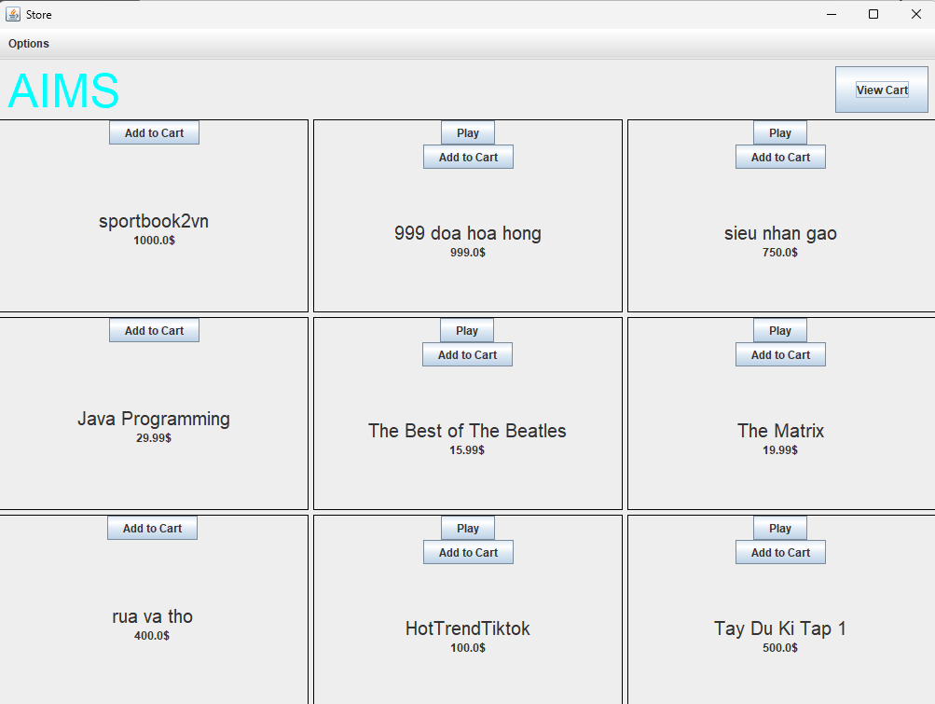

*Figure 8.7: Store after add DVD*

*Figure 8.8: Cart*

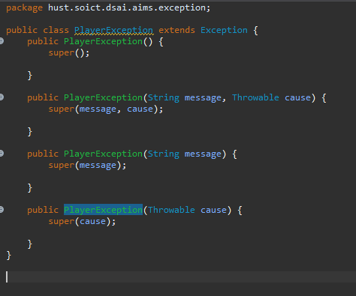

# Use case Diagram

*Figure 8.9: Exception*

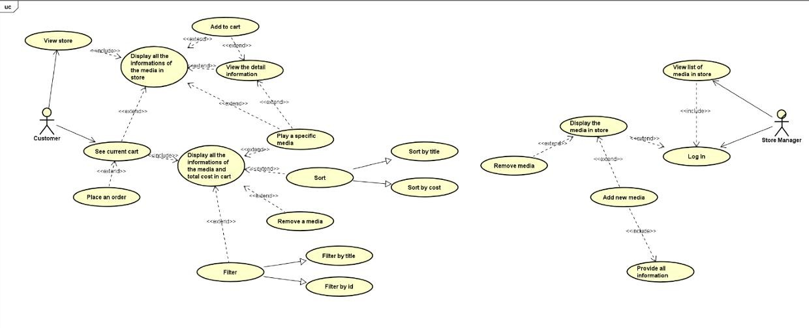

# Class Diagram

