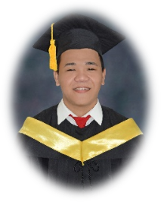
Curriculum Vitae

Richard I. Felicilda

+639555063385

felicildarichard@gmail.com

Education
College
BS Information Technology April 2020
Southern Leyte State University,
Main Campus

Highschool
Don. Agustin F. Escaño National Highschool April 2014
Bogo, Tomas Oppus, Southern Leyte

Career History & Accomplishments
Developer/System Administrator Since 2020- active
Banday, Tomas Oppus Southern Leyte

Job description/Duties
- Maintaining and improving existing software.
- Maintains and upgrades existing systems as required.
- Fixing technical issue on both hardware and software of BIMS Software.

Web Developer 8 months
Smart Start
Las Vegas, Nevada

Job Description/Duties
- Developed a user-friendly website.
- Mostly assigned as backend developer both local and foreign projects.
- One of the Trainor of Smart Start Mentorship Program (SMP).
- Producing efficient and elegant code based on requirements
- Testing and deploying programs and applications

Technical Skills

- HTML, Tailwind CSS, JavaScript, jQuery
- Intermediate knowledge of React JS.
- C#.Net, Php, MVC Framework such as Laravel.
- 3rd Party API Integration.
- Real-Time Communication (RTC) Integration.
- Intermediate knowledge of SEO
- Knowledgeable in Git Repositories.

Software Created/Developed

- Barangay Information Management System (BIMS Software)
- One of the developers of SmartLink System (http://smartstart.us/smartlink/) in Smart Start.

