INFORMATION AND DESCRIPTIVE SYSTEM ISO 25010 EVALUATION FORM

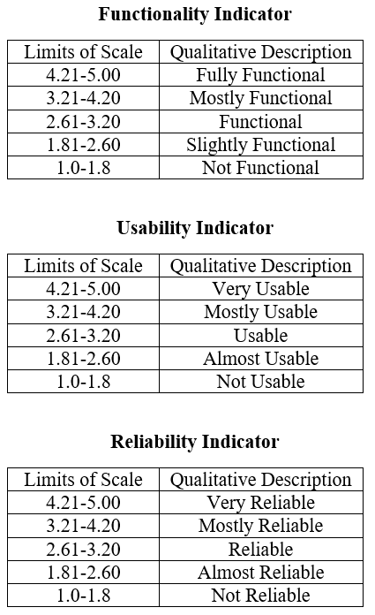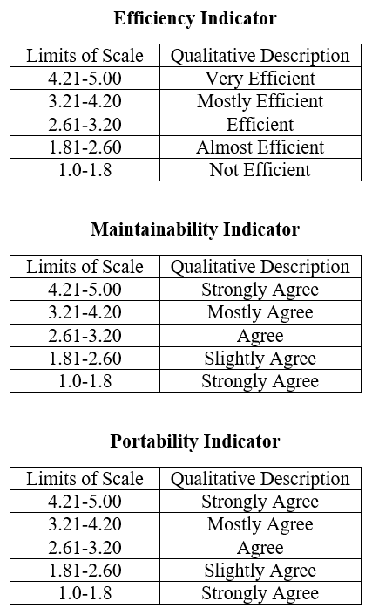
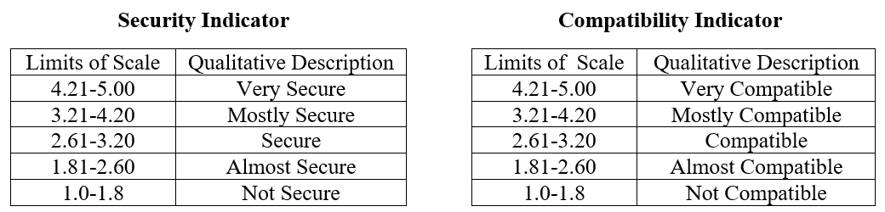

Group: ____________________________________________________________________________________________________________
Title: ______________________________________________________________________________________________________________
EVALUATION SHEET
Criteria |  | Score
Characteristic | Sub Characteristic | 1 | 2 | 3 | 4 | 5
- Functionality | The system performs the tasks required.
- Functionality | The result is as expected.
- Functionality | The system interacts with another system.
- Functionality | The system prevents unauthorized access.
- Reliability | Most of the faults in the system have been eliminated over time.
- Reliability | The system is capable of handling errors.
- Reliability | The system notifies the user about wrong data entry.
- Reliability | The software resumes working and restores lost data after a failure.
- Usability | The user comprehends how to use the system easily.
- Usability | The user learns to use the system easily.
- Usability | The user utilizes the system without much effort.
- Usability | The system’s interface looks good.
- Efficiency | The system responds quickly to the user.
- Efficiency | The system’s execution time is appropriate.
- Efficiency | The software utilizes resources efficiently.
- Maintainability | The system faults can be easily diagnosed.
- Maintainability | The system continues functioning when changes are made.
- Maintainability | The software can be tested easily.
- Portability | The system can be moved to other environments.
- Portability | The software can be installed easily. (for administrator)
- Portability | The software can replace easily other software. (for administrator)
- Security | The software ensures confidentiality of data
- Security | The software prevents unauthorized access and modification to computer programs and/or data
- Security | The software requires authentication of users
- Security | A system log is maintained.
- Compatibility | The software performs its required functions efficiently while sharing a common environment and resources without negatively impacting any other product/s.
- Compatibility | The software allows two or more systems, products, or components to exchange and use the information.

_____________________________________
Evaluator’s Name (optional) and Signature

______________________
Date

