Juvie V. Cano BSIT – Programming 4 – B

**Module 4**

**Assessment 1:** Do the following (20 pts each)

1. Create a Prolog program that will accept a number as input. Determine either the number is odd or even. If even number, repeat asking another value of a number. If odd, the program finishes its execution.

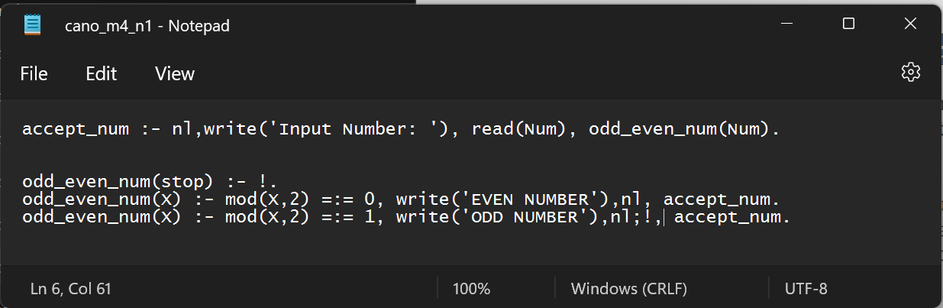**Knowledge Base**

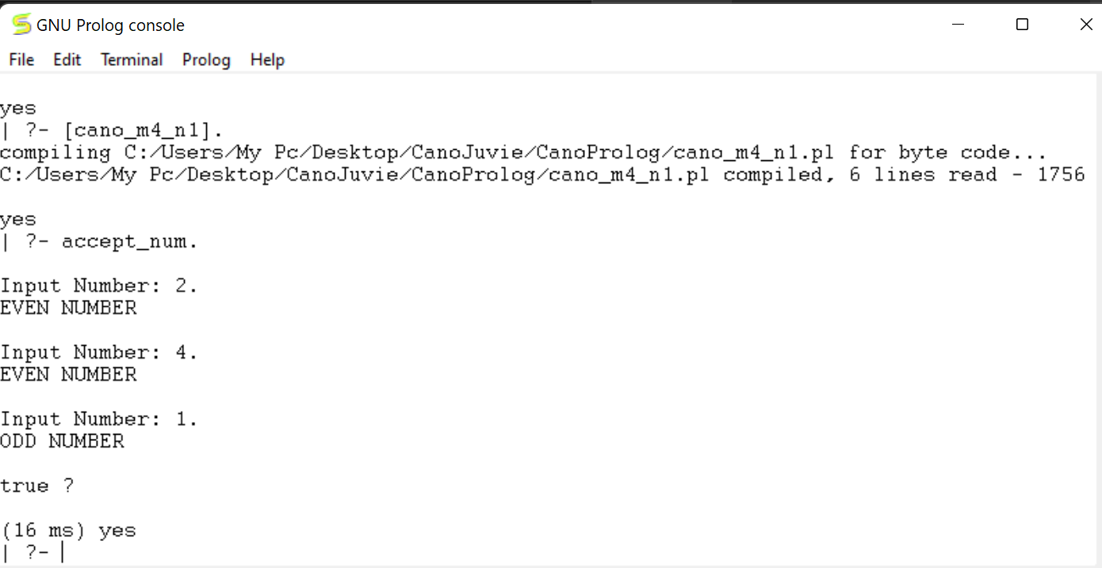**Output**

1. Create a Prolog program to decide for a username and password input. If username and password are incorrect, it will ask all over again. Once the needed username and password were already encoded correctly then the program finishes its execution.

**Knowledge Base**

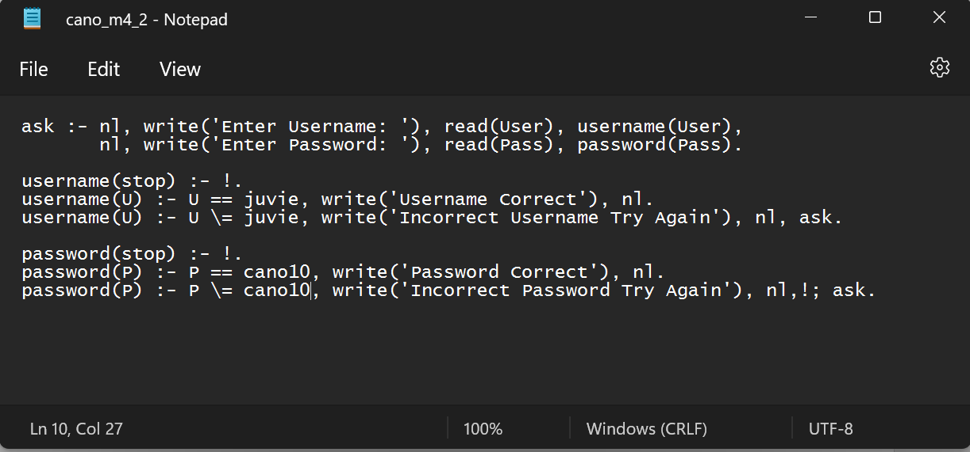

**Output**

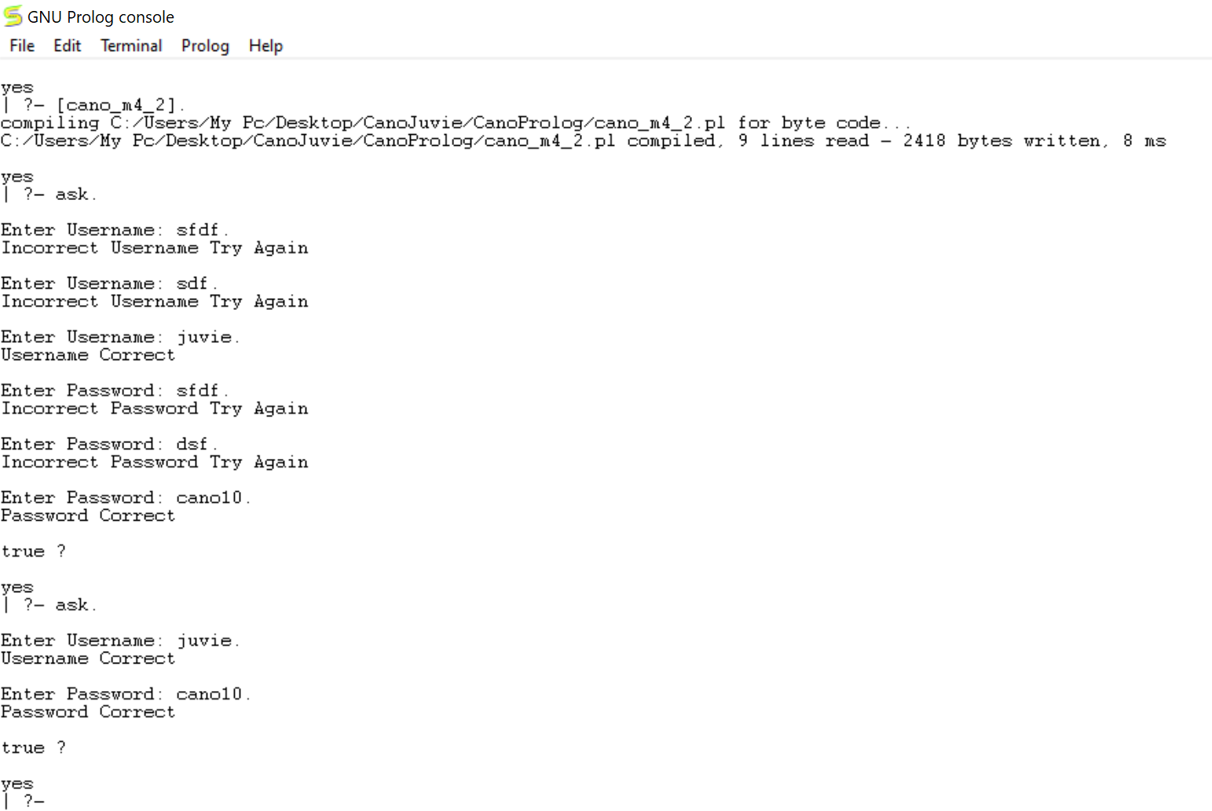

1. Create a Prolog program that accepts a grade input from 1.0 – 5.0. Create also a logic solution based on the following conditions:

If the grade is from 1.0 up to 3.0, display ‘PASSED’.

If the grade is from 3.1 up to 5.0, display ‘FAILED’.

If the grade is not from 1.0 up to 5.0, display ‘INVALID DATA’.

**Knowledge Base**