Juvie V. Cano BSIT – Programming 4 – B

**Module 3**

**Assessment 1**

1. Create a Prolog program with your own concept of a knowledge base that applies conjunction and disjunction logic. Show also an example query and its output.

**Knowledge Base**

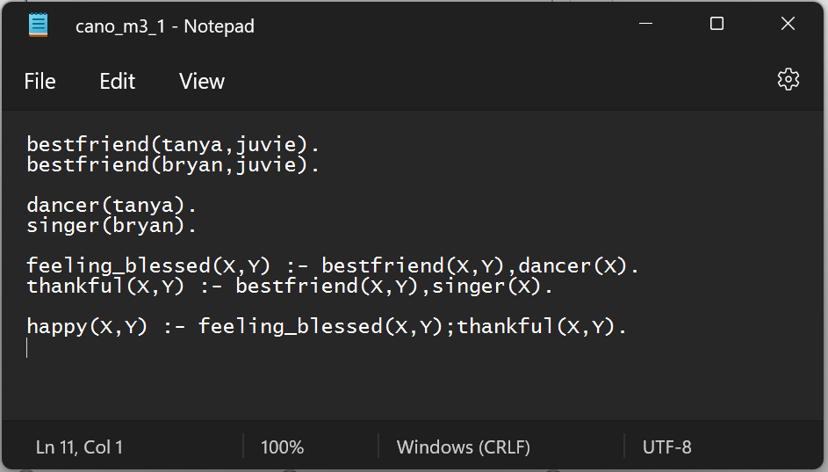

**Output**

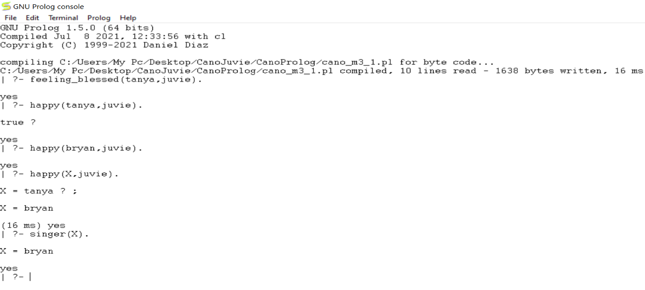

1. With your understanding on Prolog–Lists, create and utilize one (1) of the various operations as your example. Show also an example query and its output.

**Knowledge Base**

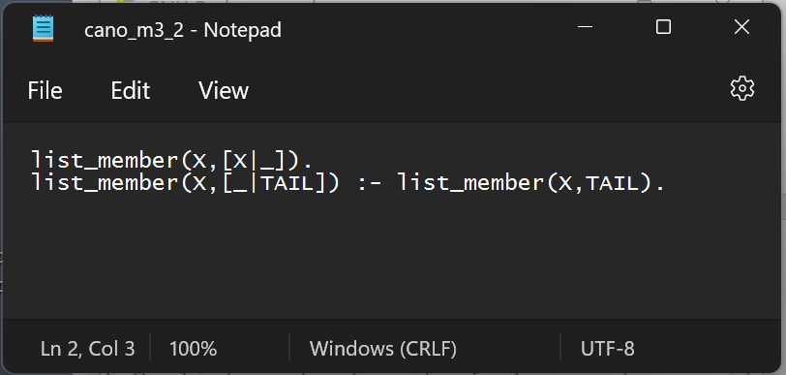

**Output**

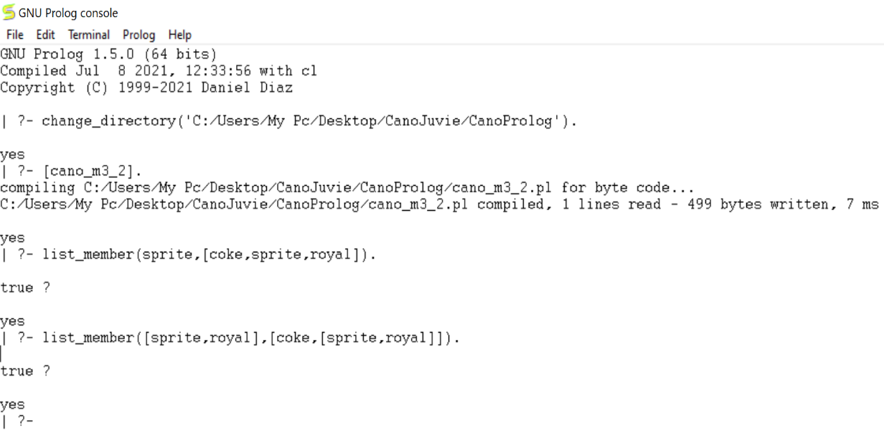

1. Create your own concept of a knowledge base that applies Recursion technique. Show also an example query and its output.

**Knowledge Base**

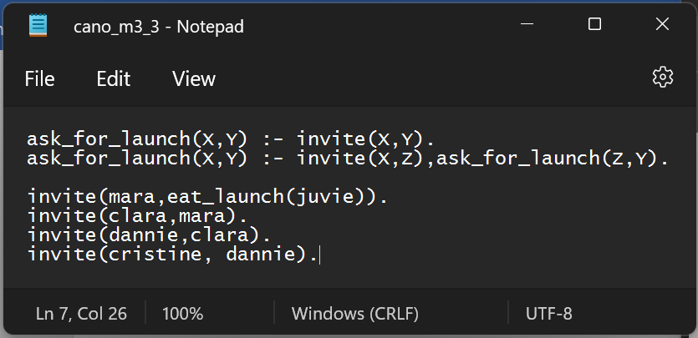

**Output**

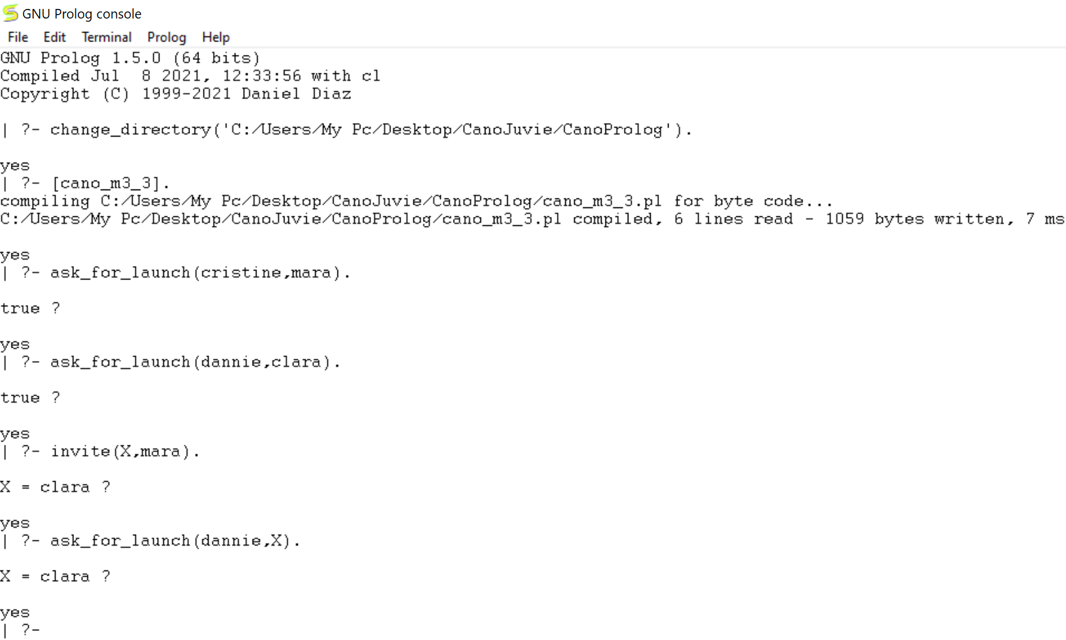

**Assessment 2**

Direction: Create your own example program and/or query and its corresponding output by applying the needed built-in predicate being asked in each number.

1.- 5. Identifying terms group (choose 5 kinds of predicates)

**Output**

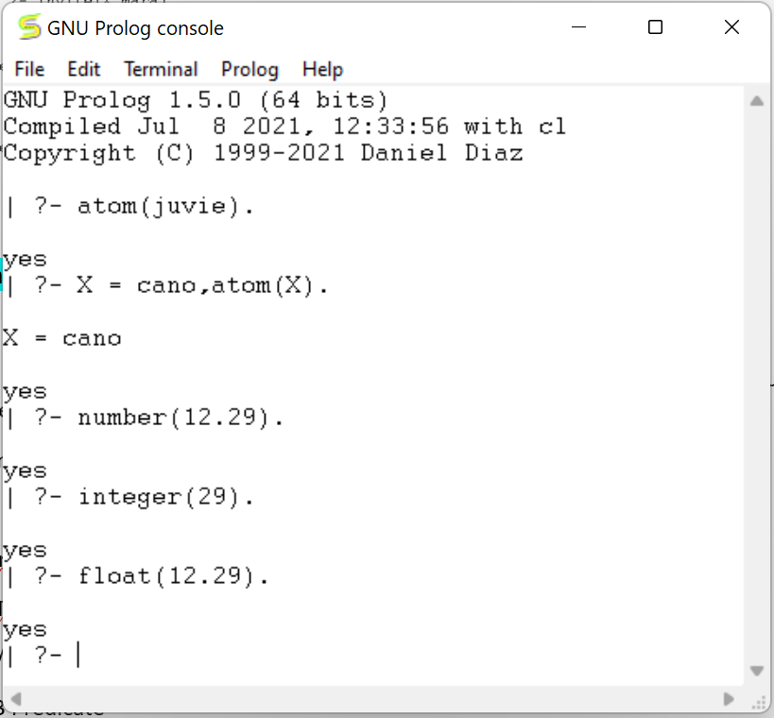

6. functor(T,F,N) Predicate

**Output**

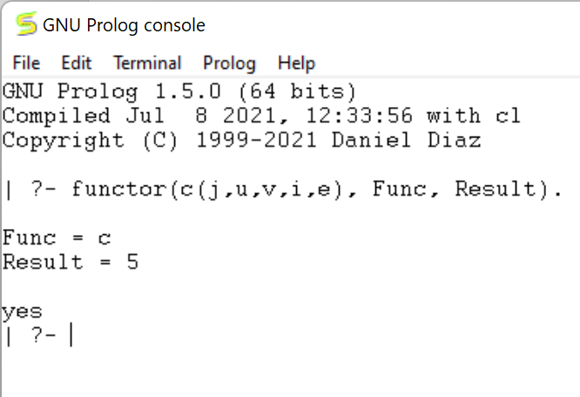

7. arg(N,Term,A) Predicate

**Output**

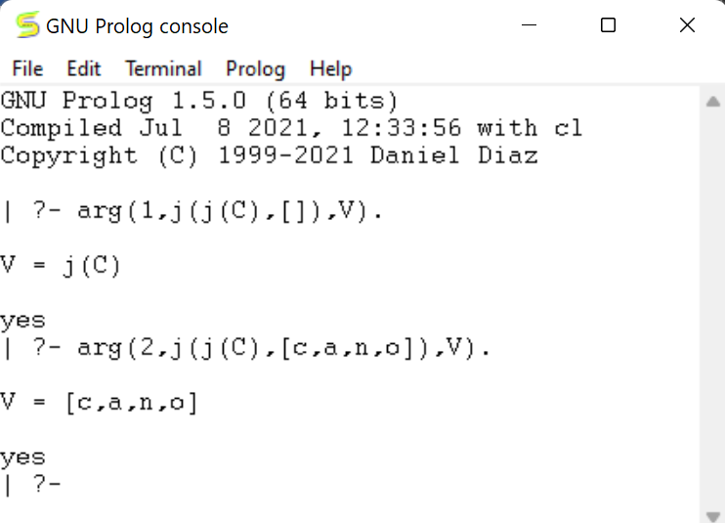

8. findall/3 Predicate

**Output**

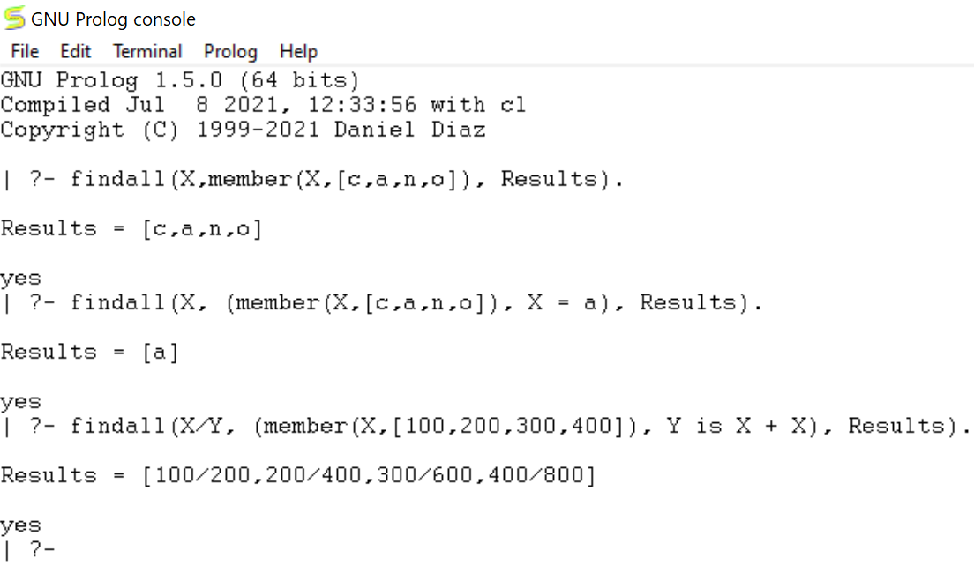

9. setof/3 Predicate

**Knowledge Base**

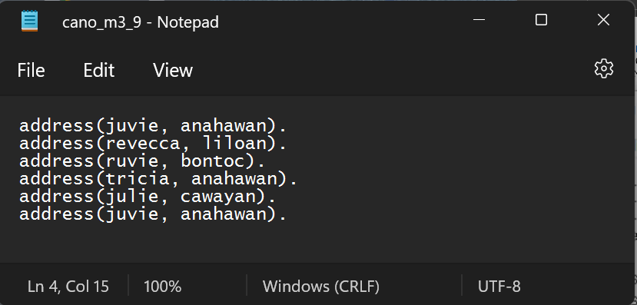

**Output**

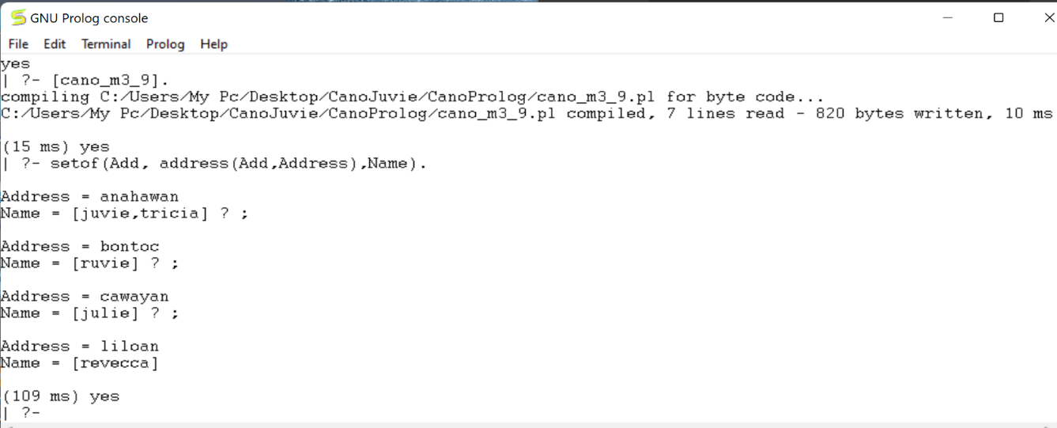

10. bagof/3 Predicate

**Knowledge Base**

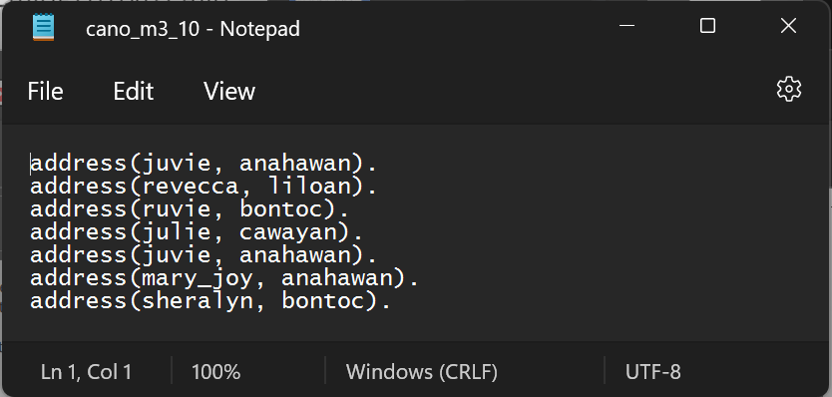

**Output**

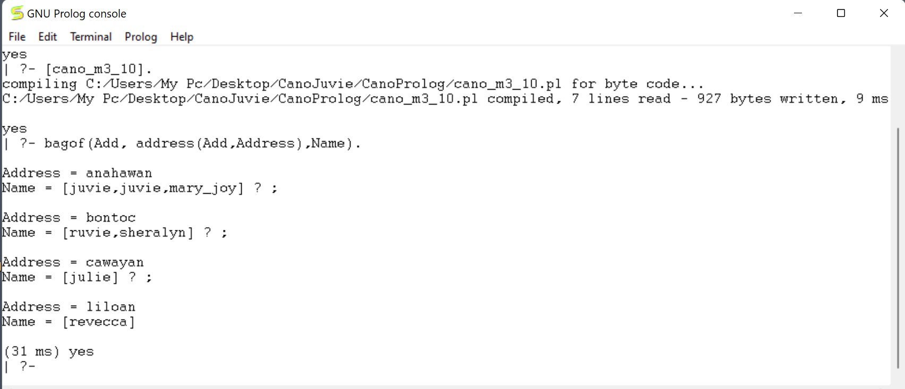

11.-15. Mathematical Predicates (choose 5 kinds of predicates)

**Output**

