**Juvie V. Cano BSIT – Programming 3 - E**

**Assignment 2**

Deadline of Submission: December 1, 2020 11:59 only.

**Topic Covered:**

**Lessons 1: Overview of Relational Database Management Concepts and Terminologies**

**General Instruction:**

1. This Assignment is intended for CAT2 AND CAT3 students only.

2. Put your answer in each of the problems as indicated below.

3. When you use External Application like Microsoft Visio, or any Application whichever you are comfortable in creating your Entity Relation Model (ERM) or Entity Relationship Diagram (ERD). *Make sure to print screen the answer [ERM/ERD] only and paste in the Answers area.*

4. When you finished answering your assignment save this file using this format: lastname_fname@Section_Assignment2.doc

Example: Radaza_Rene@SectionD_Assignment2.doc

5. Expected files to be submitted: 1

**PROBLEM 1**

Jacob Xzavier Pet Store has requested you to design a database to store information on sales on animals and merchandises. The sales form is shown in Figure 1 below. Answer questions 1 and 2.

Figure 1. Sales Form

|  |  |  |  |  |  |  |  |  |  |  |  |  |  |  |  |  |  |  |  |  |  |
| --- | --- | --- | --- | --- | --- | --- | --- | --- | --- | --- | --- | --- | --- | --- | --- | --- | --- | --- | --- | --- | --- |
| **SALES** | | | | | | | | | | | | | | | | | | | | | |
| **Sales No:** | | | |  | | | | | | | | | | | | | | **Date:** | |  | |
| **Customer ID** | | **:** | | |  | | | | |  |  | | Employee ID | | | : |  | | | | |
| **Name** | | **:** | | |  | | | | |  |  | | Name | | | : |  | | | | |
| **Address** | | **:** | | |  | | | | |  |  | |  | |  | | |  | |  |  |
| **City, State, Post Code** | | | | | | : |  | | |  |  | |  | |  | | |  | |  |  |
|  | | | | | | | | | | | | | | | | | | | | | |
| **Animal Sales** | | | | | | | | | | | | | | | | | | | | | |
| **ID** | **Name** | | | | | | | **Category** | | **Breed** | **DoB** | | **Gender** | | **Registration** | | | **Color** | | **List Price** | **Sales Price** |
|  |  | | | | | | |  | |  |  | |  | |  | | |  | |  |  |
|  |  | | | | | | |  | |  |  | |  | |  | | |  | |  |  |
|  |  | | | | | | |  | |  |  | |  | |  | | |  | |  |  |
|  |  | | | | | | |  | |  |  | |  | |  | | |  | |  |  |
|  |  | | | | | | |  | |  |  | |  | |  | | |  | |  |  |
|  |  | | | | | | |  | |  |  | |  | |  | | | **Animal Sub-Total:** | | |  |
|  | | | | | | | | | | | | | | | | | | | | | |
| **Merchandise Sales** | | | | | | | | | | | | | | | | | | | | | |
| **Item** | | | **Description** | | | | | | **Category** | **List Price** | | **Sale Price** | | **Quantity Sold** | | | | | **Total Item Sale Price** | | |
|  | | |  | | | | | |  |  | |  | |  | | | | |  | | |
|  | | |  | | | | | |  |  | |  | |  | | | | |  | | |
|  | | |  | | | | | |  |  | |  | |  | | | | |  | | |
|  | | |  | | | | | |  |  | |  | |  | | | | |  | | |
|  | | |  | | | | | |  |  | |  | |  | | | | |  | | |
|  | | |  | | | | | |  |  | |  | |  | | | | |  | | |
|  | | |  | | | | | |  |  | |  | | **Merchandise Sub-Total:** | | | | |  | | |
|  | | |  | | | | | |  |  | |  | | **Sub-Total:** | | | | |  | | |
|  | | |  | | | | | |  |  | |  | | **Tax:** | | | | |  | | |
|  | | |  | | | | | |  |  | |  | | **Total:** | | | | |  | | |

1. Identify all entities and attributes for each entity from the Sales Form in Figure 1. Provide your answer in the following format.

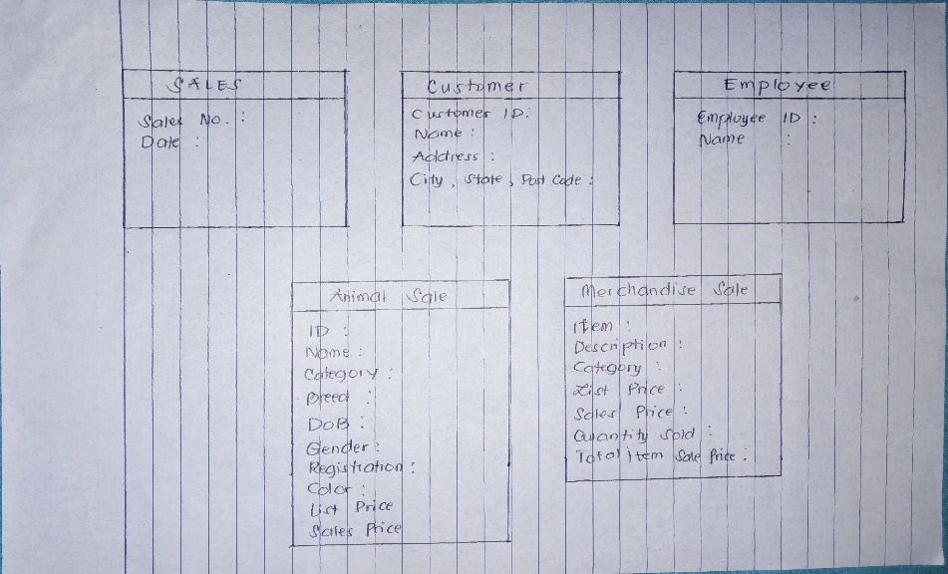

2. Using your answers in Question 1 above, draw a complete conceptual Entity Relationship Model (ERM) to model the data in the Sales Form. Multiplicities and primary keys must be shown on your model.

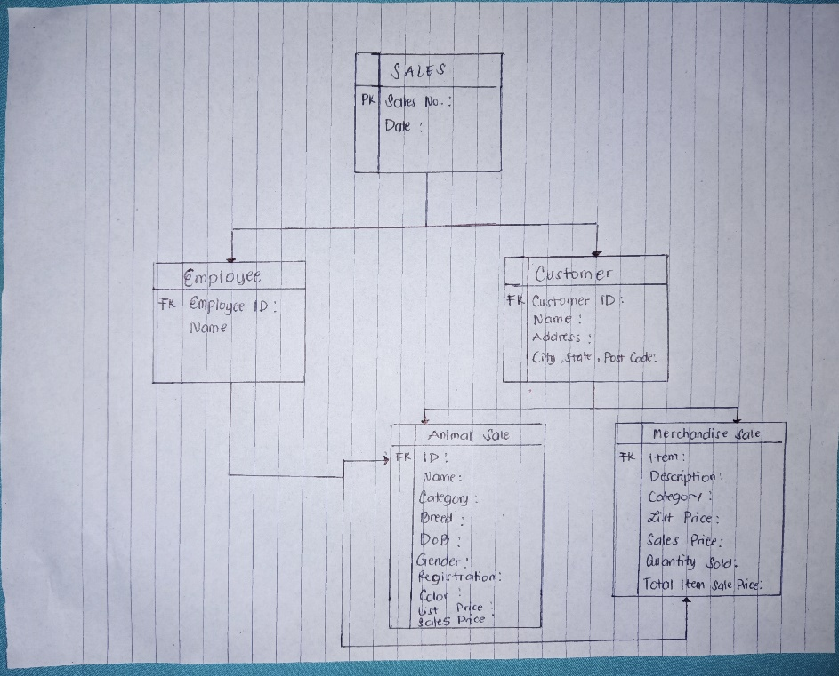

**PROBLEM 2**

You are required to create a conceptual data model of the data requirements for a company that specializes in IT training. The Company has 30 instructors and can handle up to 100 trainees per training session. The Company offers five advanced technology courses, each of which is taught by a teaching team of two or more instructors. Each instructor is assigned to a maximum of two teaching teams or may be assigned to do research. Each trainee undertakes one advanced technology course per training session.

1. Identify the main entity types for the company.

2. Identify the main relationship types and specify the multiplicity for each relationship. State any assumptions you make about the data.

3. Using your answers for (a) and (b), draw a single ER diagram to represent the data requirements for the company.

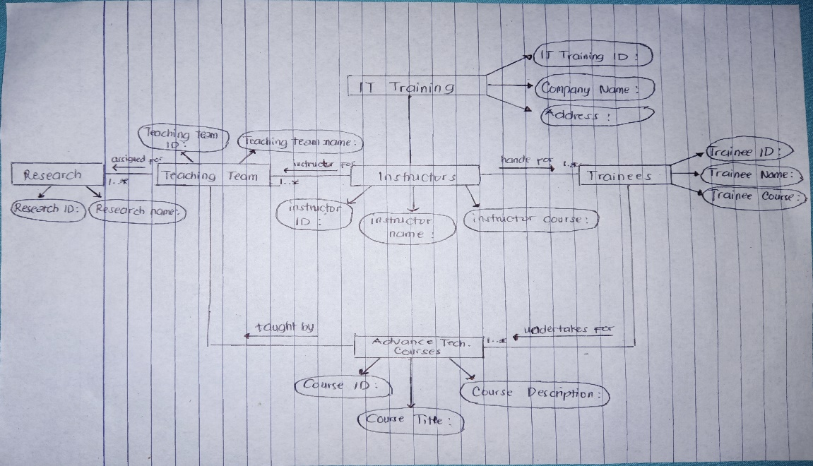

**PROBLEM 3**

Read the following case study, which describes the data requirements for a video rental company. The video rental company has several branches throughout the USA. The data held on each branch is the branch address made up of street, city, state, and zip code, and the telephone number. Each branch is given a branch number, which is unique throughout the company. Each branch is allocated staff, which includes a Manager. The Manager is responsible for the day-today running of a given branch. The data held on a member of staff is his or her name, position, and salary. Each member of staff is given a staff number, which is unique throughout the company. Each branch has a stock of videos. The data held on a video is the catalog number, video number, title, category, daily rental, cost, status, and the names of the main actors, and the director. The catalog number uniquely identifies each video. However, in most cases, there are several copies of each video at a branch, and the individual copies are identified using the video number. A video is given a category such as Action, Adult, Children, Drama, Horror, or Sci-Fi. The status indicates whether a specific copy of a video is available for rent. Before hiring a video from the company, a customer must first register as a member of a local branch. The data held on a member is the first and last name, address, and the date that the member registered at a branch. Each member is given a member number, which is unique throughout all branches of the company. Once registered, a member is free to rent videos, up to maximum of ten at any one time. The data held on each video rented is the rental number, the full name and number of the member, the video number, title, and daily rental, and the date the video is rented out and date returned. The rental number is unique throughout the company.

1. Identify the main entity types of the video rental company.

2. Identify the main relationship types between the entity types described in (1) and represent each relationship as an ER diagram.

3. Determine the multiplicity constraints for each relationship described in (2). Represent the multiplicity for each relationship in the ER diagrams created in (2).

4. Identify attributes and associate them with entity or relationship types. Represent each attribute in the ER diagrams created in (3).

5. Determine candidate and primary key attributes for each (strong) entity type.

6. Using your answers (1) to (5) attempt to represent the data requirements of the video rental company as a single ER diagram. State any assumptions necessary to support your design.

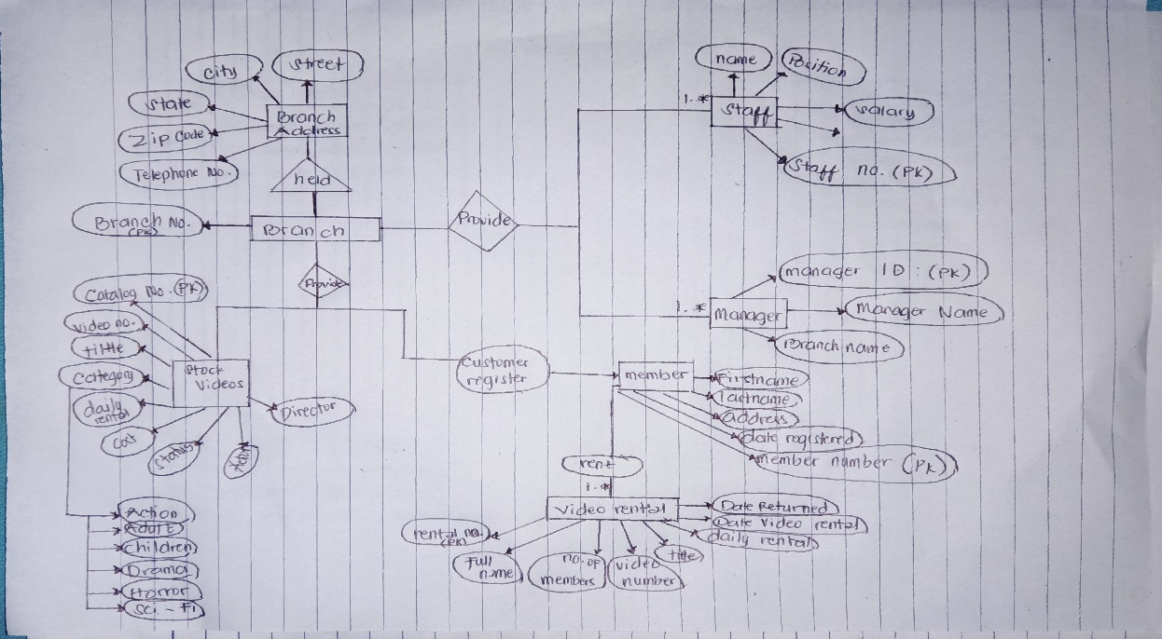

**PROBLEM 4**

Given the following conceptual ERD, transform it into a logical ERD.

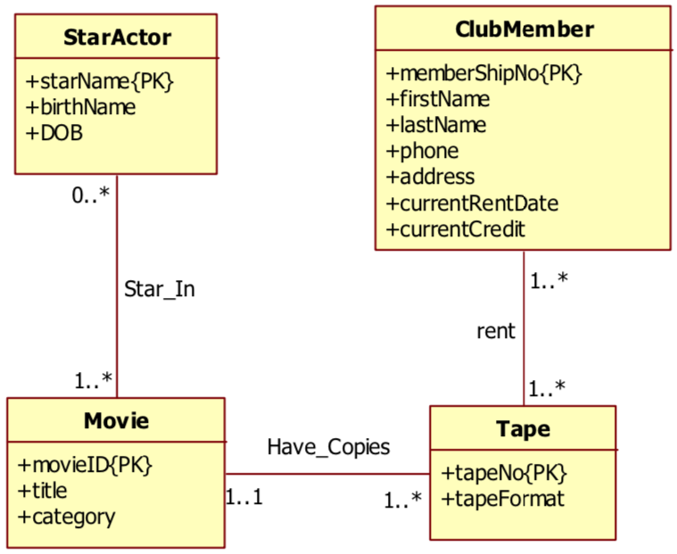

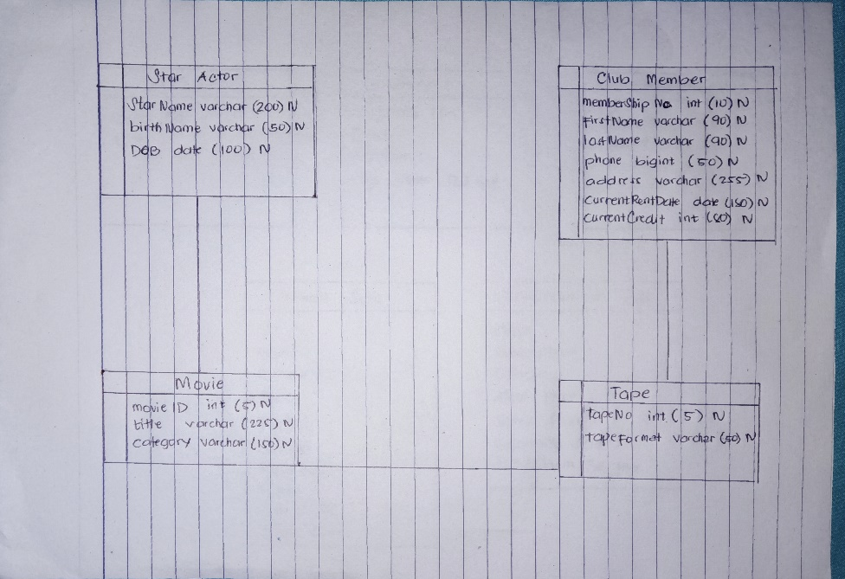

Reference: To better understand the difference between Conceptual ERD and Logical ERD, click on this link: https://online.visual-paradigm.com/knowledge/visual-modeling/conceptual-vs-logical-vs-physical-data-model/