Teoxon, Dave G. BSIT 202

Anime characters

1. Confirmation of creating file

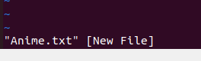

1. Content of the file

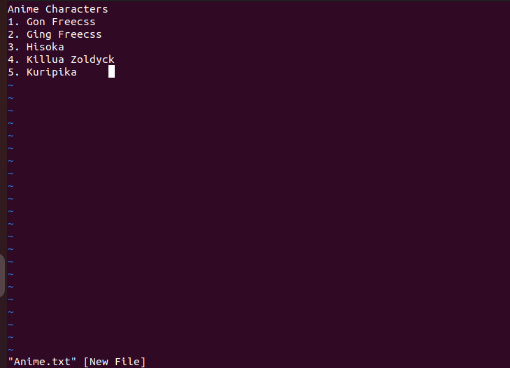

1. Confirmation upon saving the file



Flavors

1. Confirmation of creating the file

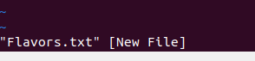

1. Content of the file

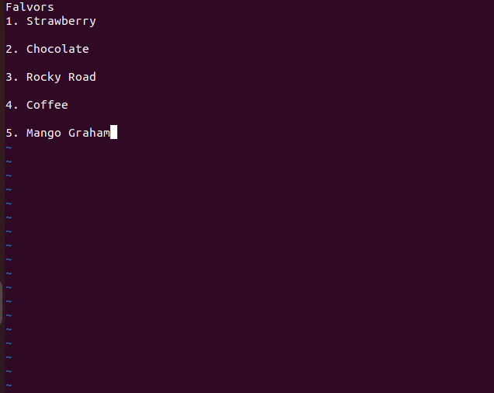

1. Confirmation of the saved file

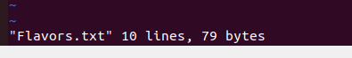

Apps

1. Confirmation of creating the file



1. Content of the file



1. Confirmation of the saved file

