CAS_EUTHENICSII
My Capstone Prelim Journal
System: AbleWork
Jesie Marie Pagado BSIT-4F

Journal Entry #1 for Week 2/Prelim
Date: August 10, 2026
Title: Building the Login Screen
A. Situation or Experience
For this first part of our Prelim period, we started creating the mobile interface for our AbleWork system. I was in charge of using React Native to build the login screen. I had to type a lot of code, like setting up the KeyboardAvoidingView and TextInputs, and styling it with a dark background. It was my first big task for the capstone.
B. Emotional and Cognitive Response
I felt very excited but also a little overwhelmed. I thought, "What if my code looks messy or the design is ugly?" I reacted by being very quiet and just staring at my computer for hours. I was scared to make a mistake because I wanted to prove to my groupmates that I can do a good job.
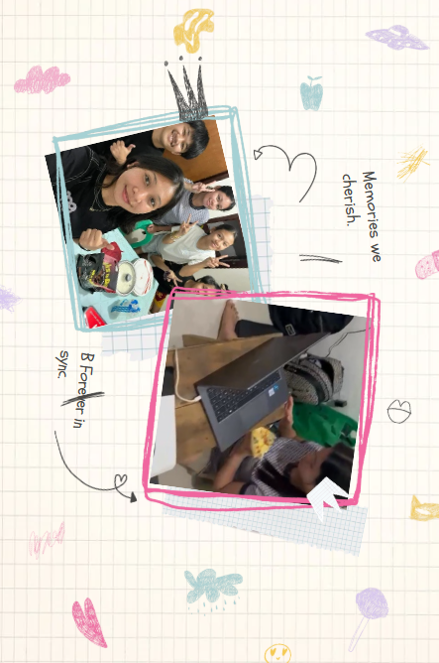

C. SEL Insight
Self-awareness. I learned that I put too much pressure on myself when I start a new task. By recognizing my own fear of failure, I realized it is okay to ask for help or just do it step by step. I am learning to trust my skills more.

Journal Entry #2 for Week 3/Prelim
Date: August 21, 2026
Title: The Firebase Frustration
A. Situation or Experience
This week, we had to connect our app to a database. I was trying to use Firebase to make the user authentication work. I needed to pull the user document from Firestore using the user's UID. But it kept giving me a red error screen. We spent three days just trying to fix this one bug before our check-up.
B. Emotional and Cognitive Response
I felt extremely frustrated and mentally tired. I thought I was not smart enough to finish our AbleWork app. I wanted to just close my laptop and quit. I reacted by complaining to my groupmates and losing my focus because I felt defeated by a simple login error.
C. SEL Insight
Self-management. This experience challenged my ability to stay calm. I failed to manage my stress at first. But after taking a break and drinking water, I went back with a clear mind and finally fixed it. I learned that taking a pause is better than forcing my brain when I am stressed.
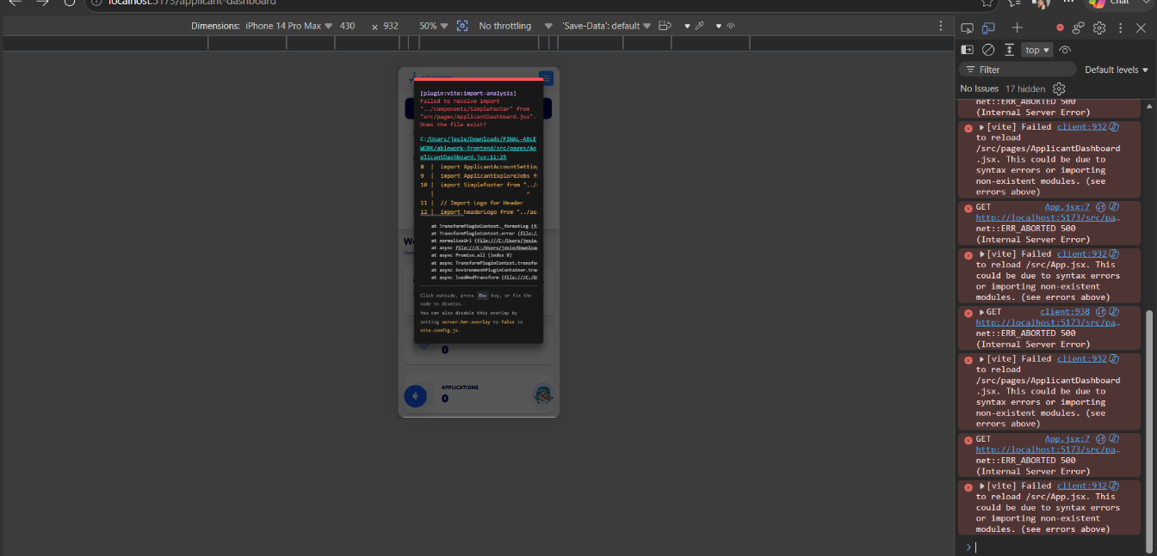


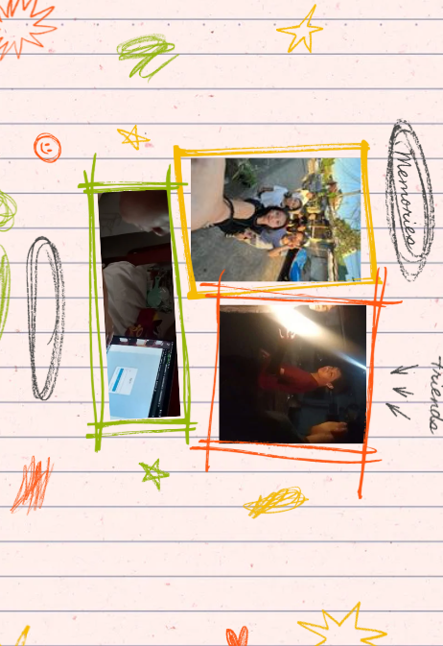
Journal Entry #3 for Week 4/Prelim
Date: September 25, 2026
Title: The Admin Dashboard Flow
A. Situation or Experience
We added a new feature where we needed role-based navigation. If the admin logs in with their username and password, they should go directly to the Admin Dashboard and not the regular Homescreen. I had to explain this logic to my groupmates so we could connect our codes together properly.
B. Emotional and Cognitive Response
I felt confident about the code, but anxious about explaining it. Sometimes my groupmates don't understand my ideas right away. I felt a bit impatient when I had to repeat the dashboard routing logic twice. I believed they should just trust me, but I knew we needed to be on the same page.
C. SEL Insight
Relationship skills & Social awareness. I practiced effective communication. I learned that just because something is clear in my head, doesn't mean it is clear to others. Empathy helped me slow down and explain the Admin Dashboard flow gently without getting annoyed, which made our teamwork much better.

Journal Entry #4 for Week 6/Prelim
Date: September 8, 2026
Title: Our Prelim Milestone
A. Situation or Experience
This week the end of our Prelim period. We had to show our adviser the working login screen and the admin dashboard for AbleWork. We spent the whole night before just testing the app over and over to make sure it doesn't crash during the live demo.
B. Emotional and Cognitive Response
I felt so nervous that my hands were cold. I kept thinking, "What if the Firebase connection fails right now?" But when the adviser saw the app running smoothly and the admin screen showed up, I felt a huge wave of relief and pride. All our late nights were worth it.

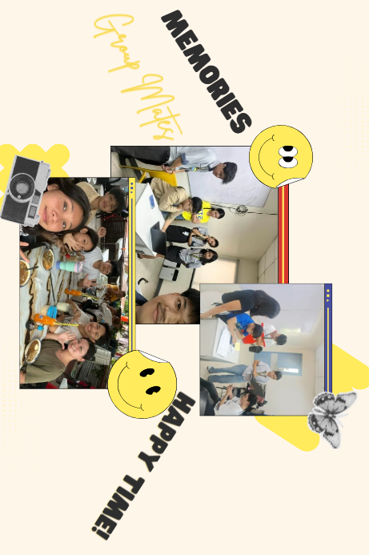
C. SEL Insight
Responsible decision-making. The choice to stay up and test the app multiple times was the right decision. I learned that hard work and double-checking your tasks lead to good results. We chose what was right over what was easy (sleeping early), and it saved our Prelim grade.


IV. Guiding Questions:
1. What did you learn about yourself or others?
I learned that I stress out too much when starting hard coding tasks. But my BSIT groupmates are very nice and helpful when we talk about our problems. I also learned to be more patient because my teammates work at different speeds.
2. How did you manage (or fail to manage) your emotions?
When our database had a big error, I got super frustrated and gave up at first. Then I learned to take a break, calm down, and drink water so I could fix the code with a clear head.
3. What choices did you make, and what would you do differently?
I chose to stay up all night testing our AbleWork app before the presentation. It helped us pass, but next time, I want to manage our time better so we don't have to cram the night before.

V. Sample Entry Prompt Options
1. Handled a stressful situation (Prompt #1): When our Firebase login wouldn't work, I got mad at first, but taking a short break taught me how to stop burnout.
2. Empathy and misunderstanding (Prompt #2): Explaining our admin screen code taught me that my ideas aren't always easy for others to catch right away, so I need to be patient.
3. Easy vs. Right (Prompt #3): Choosing to stay awake and test the app instead of sleeping early was hard, but it was the right choice to make sure our system worked.


VI. Final Reflection
1. How has your understanding of yourself and your emotions evolved during the course?
Before this Prelim period, I didn't know I get frustrated so easily when my code doesn't work. Now, I understand my triggers better. I know that my panic is just temporary, and I have learned to step back and breathe instead of letting my emotions ruin my day.
2. Which SEL domain did you develop the most and why during the course?
I developed Self-management the most. Building the AbleWork system was very stressful, especially the database parts. I had to force myself to stay calm, manage my time properly, and control my stress so I wouldn't fight with my groupmates.
3. How journaling helped (or didn't help) you grow personally and socially during the course?
Writing in this scrapbook helped me a lot. It allowed me to dump my stress on paper. When I read my past entries, I realized that the problems I thought were impossible (like the login error) were actually solvable. It made me more patient with myself and my team.
4. How do you plan to apply these insights in your academic, personal, or professional life after the course?
I will apply these insights in our Midterm and Final capstone journey. When we code harder features, I will remember to communicate clearly with my team, manage my stress, and always double-check our work responsibly. These are skills I will also use when I become a real IT professional.

