Supporting information

Influence of fire history on reproductive traits in congeneric food tree species for a threatened cockatoo

Felicity E. Charles, April E. Reside, Patrick T. Moss, Annabel L. Smith

Germination experiment optimisation methods and results

Incubation temperature optimisation

Water in a thermal gradient bar (CSK Model CSK-TGB, Serial 3310; CSK Group, Wacol, Queensland, Australia) was heated to temperatures ranging between 4 ° to 41 °C, with the ambient temperature in five chambers monitored on an hourly basis for two weeks using data loggers (Tinytag, TGP 4500; Hastings data loggers, Port Macquarie, New South Wales, Australia). Ambient temperatures ranged from ca. 6 ° to 36 °C across 10 insulated chambers, with chambers differing by ca. 3 ° to 4 °C along the gradient (Fig. S1). During incubation, seeds were exposed to a 12-hour photoperiod (Callister et al. 2018) of cool white fluorescent LED light (1200 lumens, 12W). For each species, three individual seed lots, representing three different individuals, were used with 20 seeds per petri dish giving 600 seeds across the thermal gradient bar for incubation temperature optimisation. Incubation temperature optimisation tests were ceased on day 28 as previous studies considered this sufficient time for viable seeds to germinate (Turnbull and Martensz 1982, Crowley and Jackes 1990). Ungerminated, viable seed was considered to be exposed to an unsuitable germination temperature, with germination likely having been slowed by exposure to low temperatures. Optimal incubation temperatures for germination were determined to be 17 °C for A. littoralis and 20 °C for A. torulosa (Fig. S1).

Incubation temperature optimisation tests showed that low temperatures of 6 ° and 10 °C slowed germination rates or stopped germination over the 28-day sampling period, and these temperatures were not considered further (Fig. S1). Allocasuarina littoralis germination was most consistent in chamber temperatures from 14 ° to 32 °C (70-90%, Fig. S1). For Allocasuarina littoralis, 17 °C was determined optimal as this chamber had the highest overall germination for two of the three individuals tested (85-95%, Fig. S1). Germination in Allocasuarina torulosa was similar at 17 ° and 20 °C (85-90%, Fig. S1). Allocasuarina torulosa germination was most consistent across the range of temperatures from 14 ° to 36 °C. I selected 20 °C for the experimental tests as it fell within the range of temperatures suggested by Turnbull and Martensz (1982).

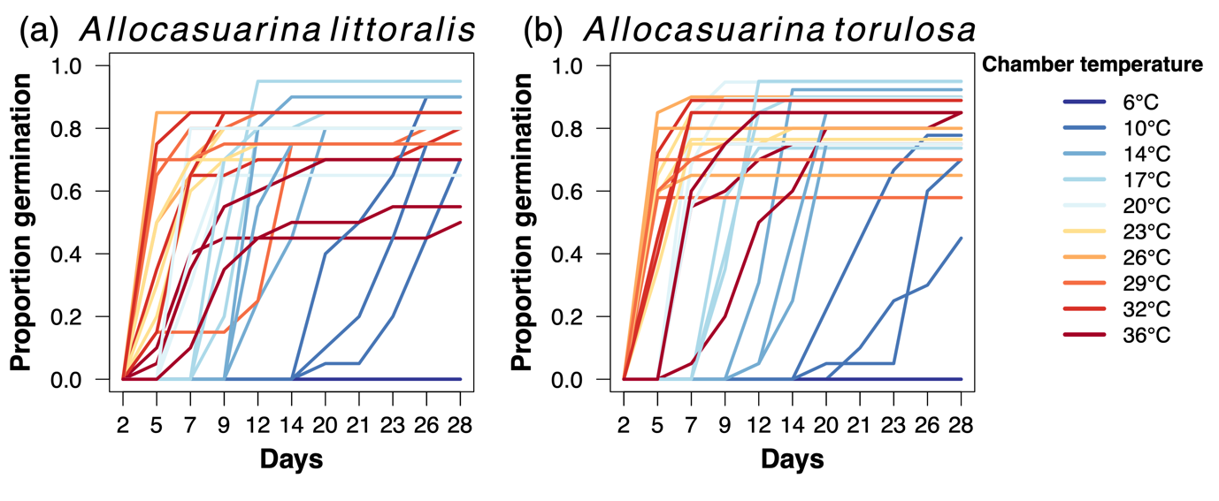
Figure S1 Cumulative proportion of seeds germinated along a thermal gradient bar ranging from 6 ° to 36 °C for (a) Allocasuarina littoralis and (b) A. torulosa. No germination occurred in either species in chambers at 6 °C.

Heat shock optimisation

Preliminary heat shock tests were conducted using a dehydrating oven (Thermoline Scientific, Wetherhill Park, New South Wales, Australia) to determine the lethal temperature threshold. Heat shocks tests were conducted at 80 °, 95 °, 110 °, 125 °, and 150 °C for durations of 0.5, 1, 2, 5 and 10 minutes. Three individual seed lots from both species with a large quantity of seeds were used for these tests, with cones from two A. torulosa individuals collected only for optimisation tests. These tests indicated that temperatures over 100 °C were, in most cases, sufficient to kill loose seeds (Fig. S2). Thus, 80 ° and 95 °C were selected for heat shock temperatures in the full factorial experiment as they were below the lethal temperature threshold but still produced variability in germination rates (Fig. S2).

Heat shock optimisation tests showed consistently high germination in both species at 80 °C, but variable germination responses between the species as temperature and duration increased (Fig. S2). In Allocasuarina littoralis, the lethal temperature threshold was between 110 ° to 120 °C as no germination occurred in seeds exposed to 125 °C (data not plotted). At 110 °C, A. littoralis germination varied widely and began to decline: some individuals had high germination at exposures of 10 minutes, while others had poor germination at this temperature, even with exposure times as low as 1 minute (Fig. S2a). In A. littoralis, exposures of 5 minutes at 80 ° and 95 °C produced relatively consistently high germination rates, with germination being the same or greater than the control, respectively (Fig. S2a). In A. torulosa, the lethal temperature threshold was between 95 ° to 105 °C, as only seeds exposed to short durations at 110 °C germinated (Fig. S2b). Exposure times of 5 minutes at 85 ° and 95 °C produced consistently high germination, which was similar or greater than that of the controls. Therefore, for both species a 5-minute exposure time at 85 ° and 95 °C was selected for heat shock in the main experiment.

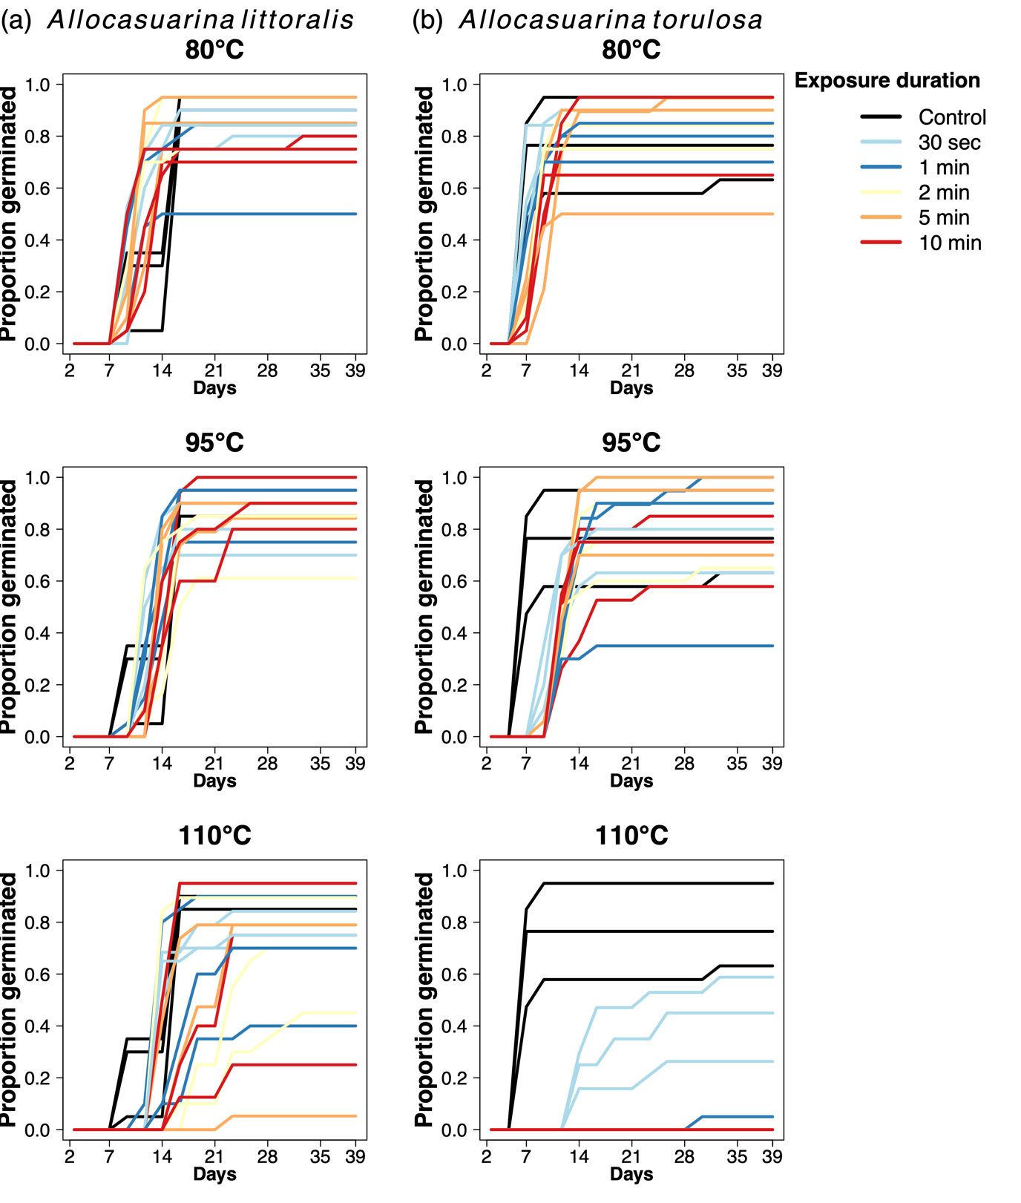
Figure S2 Cumulative proportion of seeds germinated in heat shock optimisation tests at 80 °, 95 °, and 110 °C compared to a control (black) in (a) Allocasuarina littoralis and (b) A. torulosa.

Smoke exposure optimisation

Allocasuarina species produce dense leaf litter, which has an allelopathic effect on other plants (Buehler 2010, Ahmed et al. 2019). As such, we expected smoke responses in our study species could be strongly tied to smoke from their own leaf litter, rather than smoke more generally. Therefore, aerosol smoke tests were conducted to compare germination responses to smoke from Allocasuarina torulosa leaf litter material and to pine sawdust, which promotes germination across a range of species (Keeley and Bond 1997). Leaf litter from A. torulosa was collected from a private property in Seventeen Mile, Queensland, Australia (one of the main sampling locations) and compared to commercially available pine sawdust.

Aerosol smoking was implemented in a modified 54 L rectangular plastic container (65 cm × 28 cm × 41 cm) used as a smoke chamber. The chamber included a 40 cm × 25 cm door on the long edge, attached with hinges and sealed with weatherproof tape to minimise smoke escape while enabling access to samples. A 50 cm PVC pipe with 1 cm holes along its length (spaced ca. 4 cm – 4.5 cm apart) spanned the full length of the container. The pipe passed through a 4.5 cm diameter hole in the bottom of the short side of the container, enabling even smoke dispersal. A beekeepers’ smoker was held at the end of this pipe, with a 20 cm extension pipe extending outside the container to minimise heat transfer into the main chamber. A cluster of small holes were drilled in the opposite corner of the chamber lid from the smoke entry point to create air flow. During smoke exposure, regular smoke flow was maintained by pumping smoke from the beekeepers’ smoker through the PVC pipe and into the chamber to maintain an approximately even amount of smoke in the chamber. Seeds from three A. littoralis and three A. torulosa individuals were used for the smoke optimisation trials. Each individual seed lot of 20 seeds was placed in petri dishes on an approximately 10 cm high shelf inside the smoke chamber. All smoke was released from the chamber between petri dishes with new individual seed lots to maintain a similar amount of smoke across individuals. We tested smoke exposures of 5, 10, and 20 minutes for each individual. To minimise cross contamination between smoke material types, the beekeepers’ smoker was thoroughly cleaned with acetone and the smoke chamber wiped with ethanol between trials. Allocasuarina torulosa leaf litter produced a similar effect to pine sawdust and was most consistent at a 20-minute exposure time in both species (Fig. S3).

Smoke exposure optimisation tests showed similar germination rates between Allocasuarina leaf litter and pine sawdust (Fig. S3). However, short exposures to Allocasuarina leaf litter resulted in more variable germination rates than other treatments (Fig. S3), for unknown reasons. Seeds that remained ungerminated after smoke treatments were all deemed unviable by TTC testing (see seed viability and trait measurements section). A 20-minute exposure to aerosol smoke was selected as optimal as it produced high germination rates for both species and smoke types which was comparable to the controls (Fig. S3). At this 20-minute smoke exposure time, Allocasuarina leaf litter smoke produced higher germination rates than pine sawdust (Fig. S3). Thus, Allocasuarina leaf litter derived smoke was selected for the main experiment.

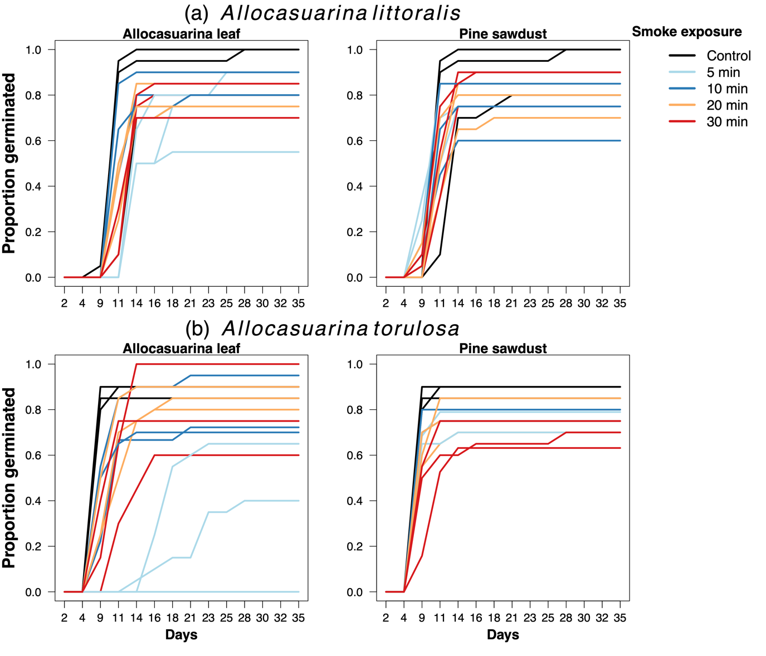
Figure S3 Cumulative proportion of seeds germinated after exposure to aerosol Allocasuarina leaf litter or pine sawdust derived smoke in (a) Allocasuarina littoralis and (b) A. torulosa.

Full factorial germination experiment supplementary results

Seed viability

Viability rates assessed by the x-ray and tetrazolium methods were correlated for both A. littoralis and A. torulosa across experimental replicates (71% and 74%, respectively, Fig. S4), indicating no effect of treatment on seed viability. Despite the expectation that higher heat treatments (e.g., 95 °C) would result in variable post-germination viability, tetrazolium tests (TTC) showed that seed viability across all treatments was high for A. littoralis and A. torulosa (Fig. S5). Furthermore, there was also high correlation between the viability test methods post-treatment and germination (85% and 79% respectively, Fig. S5).

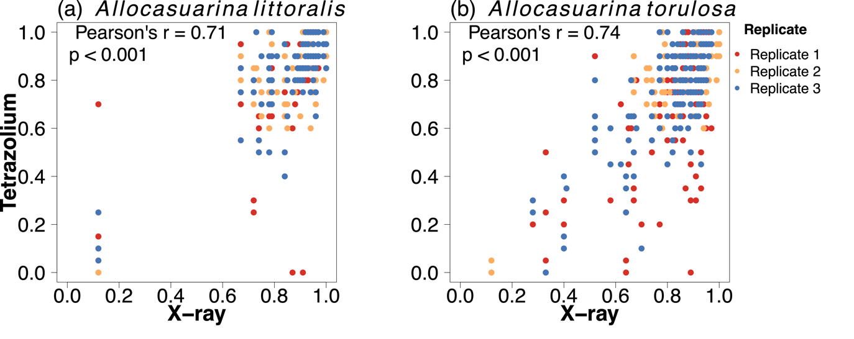Figure S4 Average pre-germination x-ray and post-germination TTC viability rate correlations for (a) Allocasuarina littoralis, and (b) A. torulosa individuals across experimental replicates.

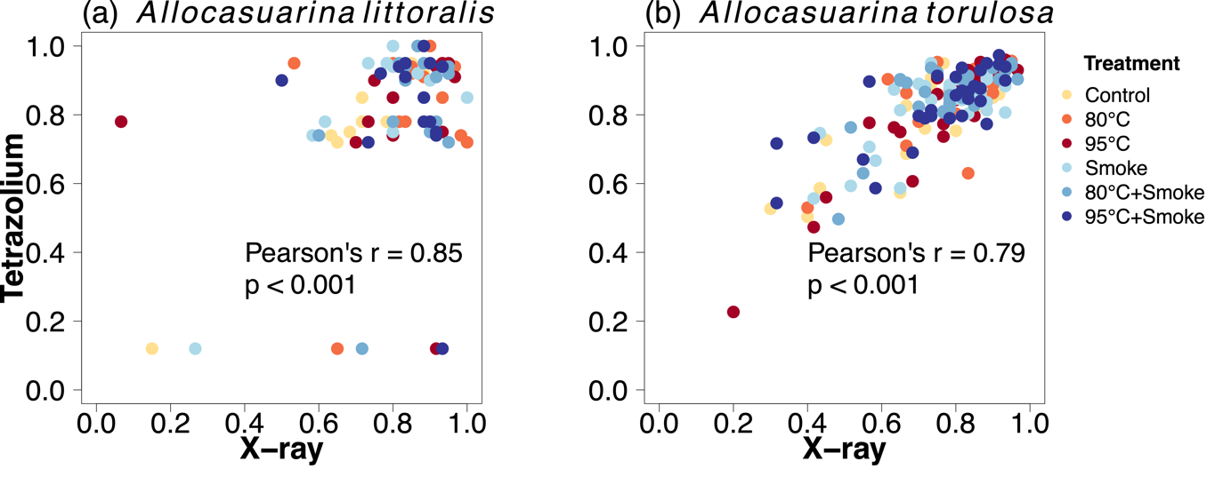
Figure S5 Average pre-germination x-ray and post-germination TTC viability rate correlation for (a) Allocasuarina littoralis, and (b) A. torulosa individuals across seed treatments.

Germination experiment

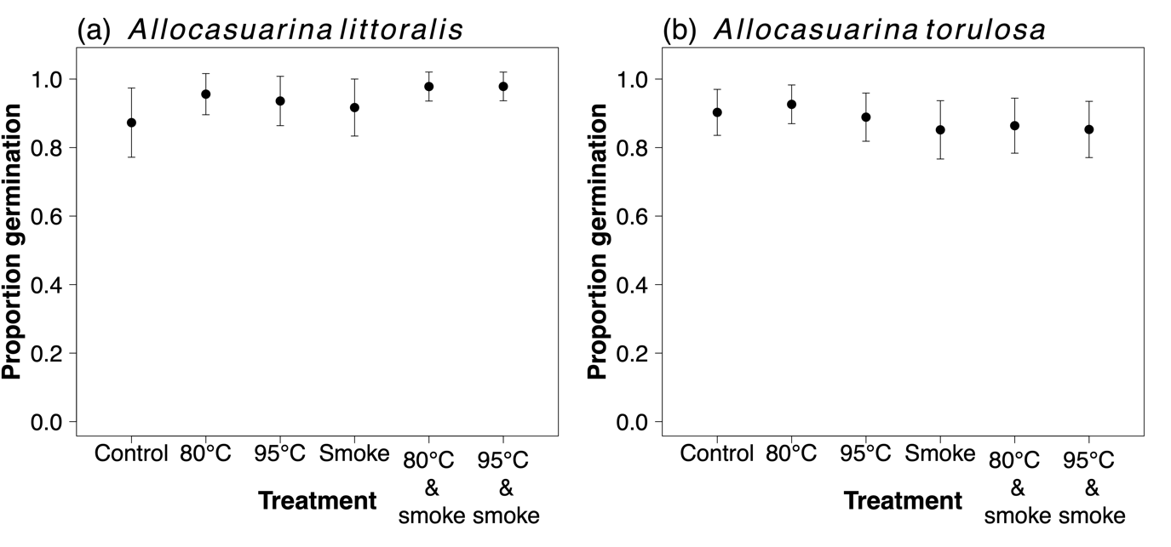
Figure S6 The estimated effect and 95% confidence intervals of seed treatments on proportion germination of (a) Allocasuarina littoralis and (b) A. torulosa.

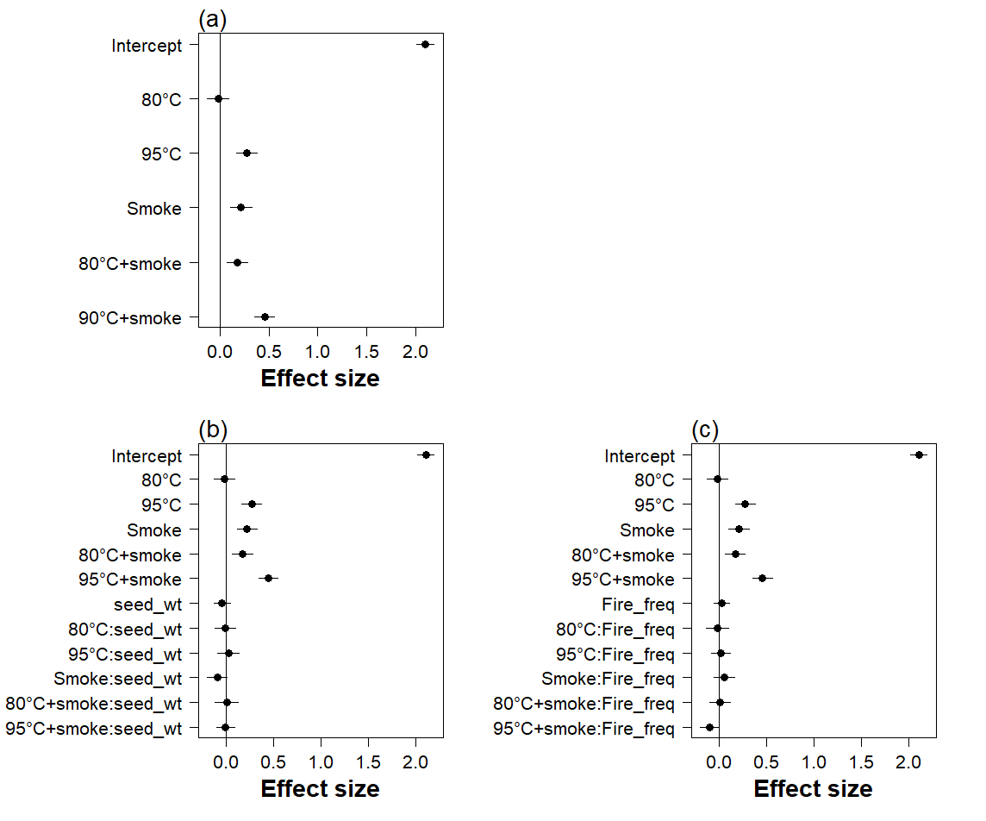
Figure S7 Effect sizes of coefficients and 95% confidence intervals for models examining time to 50% germination in Allocasuarina torulosa. Effect sizes were examined to determine the strength of effects for models including (a) treatment, (b) treatment × seed weight, and (c) treatment ×fire frequency.

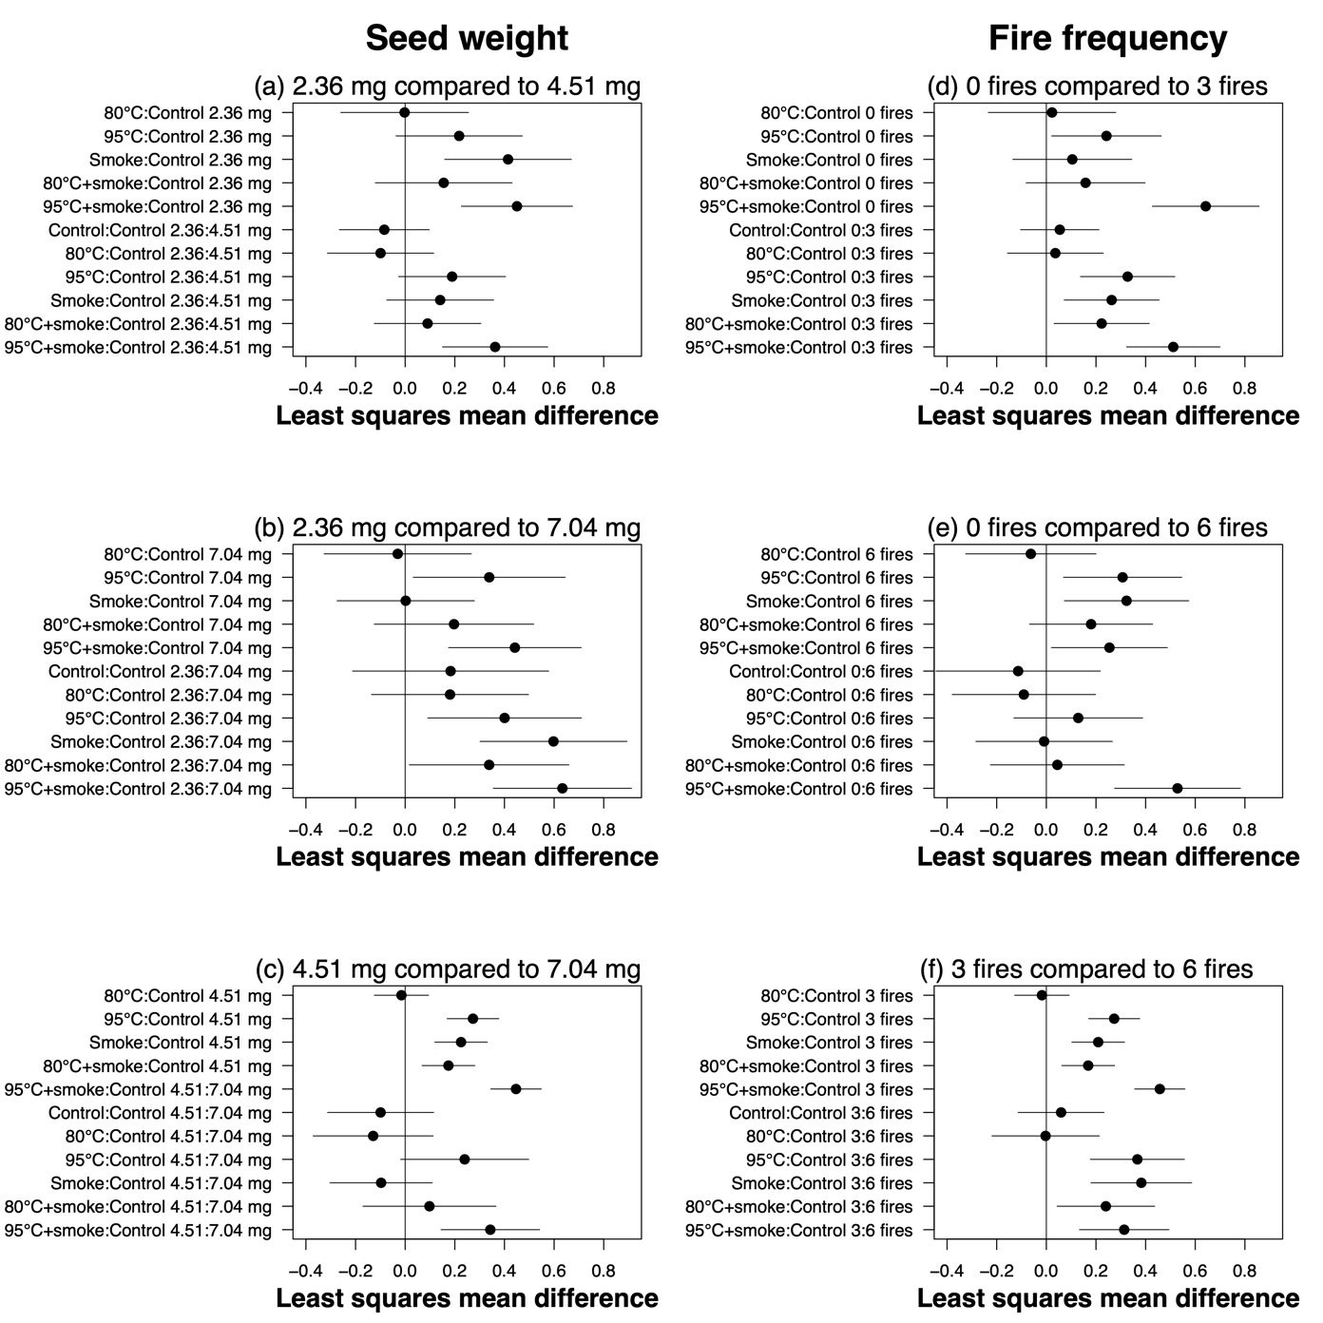
Figure S8 Least squares mean differences and 95% confidence intervals for models examining the effect of seed treatments compared to controls on time to 50% germination in Allocasuarina torulosa. Models included an interaction between treatment and (a-c) seed weight, or (d-f) fire frequency. To aid comparisons between different seed weights or fire frequencies, differences were examined for (a, d) minimum seed weight = 2.36 mg or fire frequency = 0; (b, e) average seed weight = 4.51 mg or fire frequency = 3; and (d, f) maximum seed weight =7.04 or fire frequency = 6.

Reproductive output and population demographic structure supplementary results

Table S1 Models used to examine the influence of fire frequency, time since fire, and environmental variation on reproductive output (i.e., number of cones) in Allocasuarina littoralis and A. torulosa.
Species | Model structure | Number of parameters | AIC_{c} | ∆AIC_{c} | Log Likelihood
Allocasuarina littoralis | Foliage projective cover | 2 | 1167.32 | 0.00 | -579.07
 | Topographic wetness | 2 | 2017.11 | 849.79 | -1004.05
 | Fire frequency | 2 | 2027.42 | 860.10 | -1009.21
 | Null model | 2 | 2044.73 | 877.42 | -1019.07
 | Latitude | 2 | 2045.50 | 878.18 | -1018.25
 | Temperature seasonality | 2 | 2046.23 | 878.91 | -1018.61
 | Precipitation seasonality | 2 | 2046.27 | 878.95 | -1018.63
 | Time since fire | 2 | 2046.27 | 879.25 | -1018.78
Allocasuarina torulosa | Foliage projective cover | 2 | 1221.68 | 0.00 | -606.15
 | Fire frequency | 2 | 1380.78 | 159.10 | -685.72
 | Precipitation seasonality | 2 | 1496.76 | 275.08 | -743.71
 | Null model | 2 | 1503.06 | 281.39 | -748.15
 | Time since fire | 2 | 1504.76 | 283.08 | -747.71
 | Topographic wetness | 2 | 1504.89 | 283.21 | -747.78
 | Latitude | 2 | 1504.25 | 283.57 | -747.96
 | Temperature seasonality | 2 | 1505.52 | 283.84 | -748.09

Table S2 Models used to examine the influence of fire frequency, time since fire, and environmental variation on population demographic structure in Allocasuarina littoralis.
Fire metric | Demographic class | Model structure | Number of parameters | AIC_{c} | ∆AIC_{c} | Log likelihood
Fire frequency | Seedlings | Null model | 2 | 18.03 | 0.00 | -3.01
 |  | Temperature seasonality | 2 | 21.33 | 3.31 | 0.00
 |  | Topographic wetness | 2 | 21.33 | 3.31 | 0.00
 |  | Latitude | 2 | 21.56 | 3.53 | -0.11
 |  | Fire frequency | 2 | 25.52 | 7.49 | -2.09
 |  | Precipitation seasonality | 2 | 27.10 | 9.07 | -2.88
 |  | Foliage projective cover | 2 | 33.74 | 15.71 | -2.87
 |  | Fire frequency × precipitation seasonality | 3 | 96.00 | 77.97 | 0.00
 |  | Fire frequency × temperature seasonality | 3 | 96.00 | 77.97 | 0.00
 |  | Fire frequency × topographic wetness | 3 | 96.00 | 77.97 | 0.00
 |  | Fire frequency × latitude | 3 | 96.02 | 78.00 | -0.01
 |  | Fire frequency × foliage projective cover | 3 | Inf | Inf | 0.00
 | Saplings | Null model | 2 | 18.03 | 0.00 | -3.01
 |  | Fire frequency | 2 | 21.89 | 3.87 | -0.28
 |  | Temperature seasonality | 2 | 22.46 | 4.44 | -0.57
 |  | Latitude | 2 | 23.23 | 5.20 | -0.95
 |  | Precipitation seasonality | 2 | 27.23 | 9.20 | -2.95
 |  | Topographic wetness | 2 | 27.35 | 9.32 | -3.01
 |  | Foliage projective cover | 2 | 28.53 | 10.51 | -0.27
 |  | Fire frequency × precipitation seasonality | 3 | 96.00 | 77.97 | 0.00
 |  | Fire frequency × temperature seasonality | 3 | 96.00 | 77.97 | 0.00
 |  | Fire frequency × latitude | 3 | 96.00 | 77.97 | 0.00
 |  | Fire frequency × topographic wetness | 3 | 96.05 | 78.02 | -0.03
 |  | Fire frequency × foliage projective cover | 3 | Inf | Inf | 0.00
 | Recruits | Null model | 2 | 18.03 | 0.00 | -3.01
 |  | Fire frequency | 2 | 21.89 | 3.86 | -0.28
 |  | Temperature seasonality | 2 | 22.91 | 4.88 | -0.79
 |  | Latitude | 2 | 23.18 | 5.15 | -0.92
 |  | Precipitation seasonality | 2 | 27.23 | 9.20 | -2.95
 |  | Topographic wetness | 2 | 27.35 | 9.32 | -3.01
 |  | Foliage projective cover | 2 | 29.96 | 11.93 | -0.98
 |  | Fire frequency × temperature seasonality | 3 | 96.00 | 77.97 | 0.00
 |  | Fire frequency × precipitation seasonality | 3 | 96.00 | 77.98 | 0.00
 |  | Fire frequency × topographic wetness | 3 | 96.02 | 77.99 | -0.01
 |  | Fire frequency × latitude | 3 | 96.026 | 78.23 | -0.13
 |  | Fire frequency × foliage projective cover | 3 | Inf | Inf | 0.00
Time since fire | Seedlings | Null model | 2 | 18.03 | 0.00 | -3.01
 |  | Temperature seasonality | 2 | 21.33 | 3.31 | 0.00
 |  | Topographic wetness | 2 | 21.33 | 3.31 | 0.00
 |  | Latitude | 2 | 21.56 | 3.53 | -0.11
 |  | Time since fire | 2 | 24.39 | 6.36 | -1.53
 |  | Precipitation seasonality | 2 | 27.10 | 9.07 | -2.88
 |  | Foliage projective cover | 2 | 33.74 | 15.71 | -2.87
 |  | Time since fire × latitude | 3 | 96.00 | 77.97 | 0.00
 |  | Time since fire × precipitation seasonality | 3 | 96.00 | 77.97 | 0.00
 |  | Time since fire × topographic wetness | 3 | 96.00 | 77.97 | 0.00
 |  | Time since fire × temperature seasonality | 3 | 96.17 | 78.14 | -0.09
 |  | Time since fire × foliage projective cover | 3 | Inf | Inf | 0.00
 | Saplings | Null model | 2 | 18.03 | 0.00 | -3.01
 |  | Temperature seasonality | 2 | 22.46 | 4.44 | -0.57
 |  | Latitude | 2 | 23.23 | 5.20 | -0.95
 |  | Time since fire | 2 | 23.86 | 5.83 | -2.26
 |  | Precipitation seasonality | 2 | 27.23 | 9.20 | -2.95
 |  | Topographic wetness index | 2 | 27.53 | 9.32 | -3.01
 |  | Foliage projective cover | 2 | 28,53 | 10.51 | -0.27
 |  | Time since fire × temperature seasonality | 3 | 96.00 | 77.97 | 0.00
 |  | Time since fire × precipitation seasonality | 3 | 96.01 | 77.98 | 0.00
 |  | Time since fire × topographic wetness | 3 | 96.03 | 78.00 | -0.02
 |  | Time since fire × latitude | 3 | 96.11 | 78.08 | -0.06
 |  | Time since fire × foliage projective cover | 3 | Inf | Inf | 0.00
 | Recruits | Null model | 2 | 18.03 | 0.00 | -3.01
 |  | Temperature seasonality | 2 | 22.91 | 4.88 | -0.79
 |  | Latitude | 2 | 23.18 | 5.15 | -0.92
 |  | Time since fire | 2 | 23.81 | 5.78 | -1.24
 |  | Precipitation seasonality | 2 | 27.23 | 9.20 | -2.95
 |  | Topographic wetness | 2 | 27.35 | 9.32 | -3.01
 |  | Foliage projective cover | 2 | 29.96 | 11.93 | -0.98
 |  | Time since fire × temperature seasonality | 3 | 96.00 | 77.97 | 0.00
 |  | Time since fire × topographic wetness | 3 | 96.00 | 77.97 | 0.00
 |  | Time since fire × precipitation seasonality | 3 | 96.01 | 77.98 | -0.01
 |  | Time since fire × latitude | 3 | 96.10 | 78.07 | -0.05
 |  | Time since fire × foliage projective cover | 3 | Inf | Inf | -0.12

Table S3 Models used to examine the influence of fire frequency, time since fire, and environmental variation on population demographic structure in Allocasuarina torulosa.
Fire metric | Demographic class | Model structure | Number of parameters | AIC_{c} | ∆AIC_{c} | Log likelihood
Fire frequency | Seedlings | Foliage projective cover | 2 | 24.62 | 0.00 | -7.54
 |  | Null model | 2 | 26.77 | 2.15 | -9.96
 |  | Precipitation seasonality | 2 | 28.56 | 3.94 | -9.54
 |  | Fire frequency | 2 | 28.72 | 4.10 | -9.62
 |  | Fire frequency × foliage projective cover | 3 | 28.85 | 4.23 | -6.67
 |  | Temperature seasonality | 2 | 29.14 | 4.52 | -9.83
 |  | Latitude | 2 | 29.25 | 4.63 | -9.88
 |  | Topographic wetness | 2 | 29.37 | 4.75 | -9.94
 |  | Fire frequency × precipitation seasonality | 3 | 32.55 | 7.93 | -8.59
 |  | Fire frequency × topographic wetness | 3 | 33.03 | 8.41 | -8.84
 |  | Fire frequency × temperature | 3 | 34.17 | 9.55 | -9.40
 |  | Fire frequency × latitude | 3 | 34.39 | 9.78 | -9.52
 | Saplings | Temperature seasonality | 2 | 39.69 | 0.00 | -15.01
 |  | Latitude | 2 | 43.14 | 3.45 | -16.83
 |  | Fire frequency × temperature seasonality | 3 | 45.33 | 5.64 | -14.99
 |  | Precipitation seasonality | 2 | 45.69 | 6.00 | -18.11
 |  | Null model | 2 | 46.23 | 6.55 | -19.69
 |  | Foliage projective cover | 2 | 46.55 | 6.86 | -18.50
 |  | Topographic wetness | 2 | 48.85 | 9.16 | -19.68
 |  | Fire frequency | 2 | 48.85 | 9.16 | -19.68
 |  | Fire frequency × latitude | 3 | 48.99 | 9.30 | -16.82
 |  | Fire frequency × precipitation seasonality | 3 | 49.27 | 9.58 | -16.95
 |  | Fire frequency × foliage projective cover | 3 | 51.85 | 12.16 | -18.18
 |  | Fire frequency × topographic wetness | 3 | 52.35 | 12.67 | -18.50
 | Recruits | Temperature seasonality | 2 | 37.02 | 0.00 | -13.77
 |  | Latitude | 2 | 42.24 | 5.22 | -16.38
 |  | Fire frequency × temperature seasonality | 3 | 42.77 | 5.74 | -13.70
 |  | Foliage projective cover | 2 | 47.29 | 10.27 | -18.88
 |  | Null model | 2 | 47.51 | 10.48 | -20.32
 |  | Precipitation seasonality | 2 | 47.83 | 10.80 | -19.17
 |  | Fire frequency × latitude | 3 | 47.94 | 10.91 | -16.29
 |  | Topographic wetness | 2 | 50.13 | 13.11 | -20.32
 |  | Fire frequency | 2 | 50.13 | 13.11 | -20.32
 |  | Fire frequency × precipitation | 3 | 51.56 | 14.54 | -18.10
 |  | Fire frequency × foliage projective cover | 3 | 52.61 | 15.59 | -18.56
 |  | Fire frequency × topographic wetness | 3 | 53.56 | 16.54 | -19.10
Time since fire | Seedlings | Foliage projective cover | 2 | 24.62 | 0.00 | -7.54
 |  | Null model | 2 | 26.77 | 2.15 | -9.96
 |  | Precipitation seasonality | 2 | 28.56 | 3.94 | -9.54
 |  | Temperature seasonality | 2 | 29.14 | 4.52 | -9.83
 |  | Latitude | 2 | 29.25 | 4.63 | -9.88
 |  | Topographic wetness | 2 | 29.37 | 4.75 | -9.94
 |  | Time since fire | 2 | 29.37 | 4.76 | -9.95
 |  | Time since fire × foliage projective cover | 3 | 30.26 | 5.64 | -7.38
 |  | Time since fire × topographic wetness | 3 | 32.01 | 7.40 | -8.33
 |  | Time since fire × precipitation seasonality | 3 | 34.29 | 9.68 | -9.47
 |  | Time since fire × temperature seasonality | 3 | 34.92 | 10.31 | -9.78
 |  | Time since fire × latitude | 3 | 35.12 | 10.51 | -9.88
 | Saplings | Temperature seasonality | 2 | 39.39 | 0.00 | -15.10
 |  | Time since fire × precipitation seasonality | 3 | 42.30 | 2.61 | -13.47
 |  | Time since fire × temperature seasonality | 3 | 42.52 | 2.83 | -13.58
 |  | Latitude | 2 | 43.14 | 3.45 | -16.83
 |  | Time since fire | 2 | 45.35 | 5.66 | -17.93
 |  | Time since fire × topographic wetness | 3 | 45.62 | 5.93 | -15.13
 |  | Time since fire × latitude | 3 | 45.62 | 5.93 | -15.13
 |  | Precipitation seasonality | 2 | 45.69 | 6.00 | -18.11
 |  | Null model | 2 | 46.23 | 6.55 | -19.69
 |  | Foliage projective cover | 2 | 46.55 | 6.86 | -18.50
 |  | Time since fire × foliage projective cover | 3 | 48.23 | 8.54 | -16.37
 |  | Topographic wetness | 2 | 48.85 | 9.16 | -19.68
 | Recruits | Temperature seasonality | 2 | 37.02 | 0.00 | -13.77
 |  | Time since fire × temperature seasonality | 3 | 37.88 | 0.85 | -11.26
 |  | Latitude | 2 | 42.24 | 5.22 | -16.38
 |  | Time since fire × latitude | 3 | 43.l3 | 6.33 | -14.00
 |  | Time since fire × precipitation seasonality | 3 | 44.25 | 7.22 | -14.44
 |  | Time since fire × topographic wetness | 3 | 45.65 | 8.63 | -15.15
 |  | Time since fire | 2 | 45.69 | 8.67 | -18.10
 |  | Foliage projective cover | 2 | 47.29 | 10.27 | -18.88
 |  | Null model | 2 | 47.51 | 10.48 | -20.32
 |  | Precipitation seasonality | 2 | 47.83 | 10.80 | -19.17
 |  | Time since fire × foliage projective cover | 3 | 48.63 | 11.61 | -16.57
 |  | Topographic wetness | 2 | 50.13 | 13.11 | -20.32

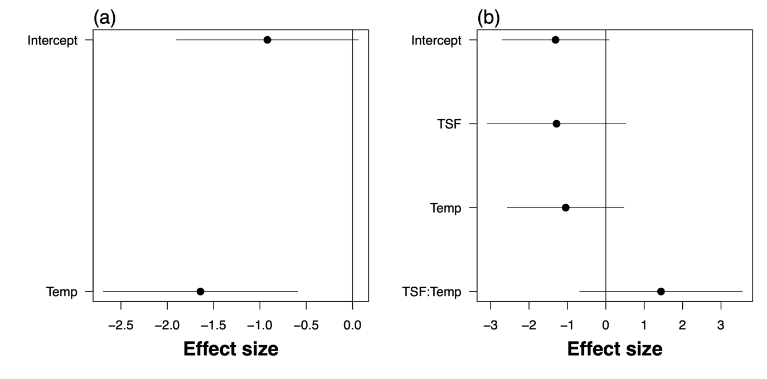
Figure S9 Effect sizes of coefficients and 95% confidence intervals for the influence of (a) temperature seasonality, and (b) temperature seasonality and time since fire (TSF) interaction on the proportion of recruits to mature individuals in Allocasuarina torulosa.

References

Ahmed, T. A., A. A. Elezz, and N. H. Al-Sayed. 2019. Dataset of allelopathic effects of Casuarina equisetifolia-L leaf aquatic extract on seed germination and growth of selected plant crops. Data in Brief 27:104770.
Buehler, C. P. 2010. Soil modification and potential allelopathy: an investigation into how the invasive Casuarina equisetifolia L. (Australian pine) modify their environment. Mississipi State University, Mississipi, United States of America.
Callister, K. E., S. K. Florentine, and M. E. Westbrooke. 2018. An investigation of the soil seedbank and seed germination of perennial species in belah (Casuarina pauper) woodlands in north-west Victoria. Australian journal of botany 66:202-212.
Crowley, G. M., and B. R. Jackes. 1990. Germination characteristics in tropical provenances of Allocasuarina littoralis and A. torulosa. Forest ecology and management 35:227-238.
Keeley, J. E., and W. J. Bond. 1997. Convergent seed germination in South African fynbos and Californian chaparral. Plant ecology 133:153-167.
Turnbull, J. W., and P. N. Martensz. 1982. Aspects of seed collection, storage and germination in Casuarinaceae. Australian Forest Research 12:2810249.

