Predicting Athlete Training State and Injury Risk
from Wearable Sensor Data
William Felipe Quiroz
CS 6140: Machine Learning | Northeastern University

1. Abstract
Overuse injuries in endurance athletes arise from accumulated physiological stress that exceeds the body's ability to recover, a process measurable through wearable sensor data. Rather than predicting injury as a future binary event (which is confounded by unknown training decisions), this project frames the problem as predicting an athlete's current training state from daily physiological signals. We engineer a composite Grit Score per day from training load and recovery data, then use it to (1) classify athletes into three readiness states—Overreaching, Balanced, or Undertrained, (2) detect injury risk as a binary classification task, and (3) regress on the continuous Grit Score. Using the Synthetic Triathlete Dataset (Zenodo, 2025), which contains 366,000 daily records and 384,153 activity sessions across 1,000 athletes, we compare three classifiers (Logistic Regression, Random Forest, DNN) and three regressors (Lasso with polynomial features, Random Forest, DNN), with systematic hyperparameter tuning via 5-fold GroupKFold cross-validation. The DNN achieves the best performance across all tasks: AUC-ROC 0.948 for injury classification, 0.997 for load-class classification, and R² = 0.988 for Grit Score regression.

2. Introduction
Endurance athletes—triathletes, runners, cyclists, and swimmers—face a persistent tension between training hard enough to improve and training so hard that the body breaks down. Overuse injuries account for the majority of training-related injuries in endurance sports, and they are fundamentally a problem of load management: when the cumulative physiological stress of recent training exceeds the body’s capacity to recover, soft tissue damage accumulates until it crosses a clinical threshold. The acute-to-chronic workload ratio (ACWR), introduced by Gabbett (2016) and refined by Hulin et al. (2016), formalizes this concept by comparing short-term training load (typically 7 days) to a longer baseline (typically 28 days). An ACWR substantially above 1.0 indicates a rapid spike in load relative to what the athlete is accustomed to, and is associated with elevated injury risk.
Modern wearable devices—such as Garmin watches, WHOOP straps, and Oura rings—now capture a rich set of physiological signals on a daily basis. Heart-rate variability (HRV), resting heart rate (RHR), sleep duration and quality metrics, stress scores, and body battery estimates provide a window into the autonomic nervous system’s response to training and life stress. These signals reflect real-time recovery status: a suppressed HRV or elevated RHR relative to personal baselines indicates that the body is under strain, while robust sleep metrics suggest adequate recovery. Platforms like WHOOP and Garmin already surface daily readiness scores derived from these signals, but the underlying algorithms are proprietary and their predictive validity is not well-studied.
Most existing approaches to injury prediction in the literature treat the problem as a binary future-event prediction task: given today’s data, will the athlete be injured in the next N days? This framing is inherently limited because the outcome depends on future training decisions that are unknown at prediction time. If a model predicts high injury risk and the athlete reduces training in response, the injury may never occur—making the prediction appear incorrect even though it was clinically useful. Simple threshold-based rules (e.g., flag an athlete whenever ACWR exceeds 1.5) are also limited because they ignore the multi-dimensional nature of recovery: an athlete with high ACWR but excellent sleep and HRV may tolerate the load, while an athlete with moderate ACWR but disrupted sleep may not.
This project reframes the problem: rather than predicting a future injury event, we predict the athlete’s current training state. We define a composite Grit Score that integrates training load (via ACWR), autonomic recovery (via HRV z-score relative to personal baseline), sleep quality (via a composite z-score), resting heart rate trend, body battery, and stress. A high Grit Score indicates a dangerous overreaching state; a low Grit Score indicates an undertrained or well-recovered state. We then use this score for three machine-learning tasks: (1) three-class classification of training state (Overreaching, Balanced, Undertrained), (2) binary injury-risk classification, and (3) continuous Grit Score regression. This approach is directly analogous to how WHOOP computes a recovery score and Garmin computes a training readiness score, but with a transparent, reproducible methodology.

3. Dataset
We use the Synthetic Triathlete Dataset published by Rossi (2025) on Zenodo (DOI: 10.5281/zenodo.15401061). This dataset was designed for injury prediction research and contains realistic distributions of training, recovery, and injury patterns across a population of simulated endurance athletes. It consists of three CSV files:
athletes.csv (1,000 rows): Static athlete profiles including age, sex, VO2max, functional threshold power (FTP), training experience (years), weekly training hours, and lifestyle category (sedentary, moderate, active). These represent baseline physiological and behavioral characteristics that modulate injury risk.
daily_data.csv (366,000 rows): One row per athlete per day over a 366-day period, containing daily physiological measurements: HRV (ms), resting heart rate (bpm), sleep hours, deep sleep and REM sleep fractions, sleep quality score, stress score, body battery morning reading, and a binary injury indicator.
activity_data.csv (384,153 rows): Individual training sessions with duration, Training Stress Score (TSS), intensity factor, and aerobic/anaerobic training effect. Athletes may have zero or multiple sessions per day.
After merging the three files and computing rolling features that require 28 days of warm-up history (for the chronic load denominator in ACWR), we obtain 337,995 usable athlete-day rows with 24 features. The injury label is imbalanced: 8.14% positive (29,460 injured days vs. 308,535 healthy days). The load-class distribution, derived from ACWR tertiles, is 24.6% Undertrained, 50.8% Balanced, and 24.6% Overreaching. To address class imbalance in the binary injury task, we apply SMOTE (Synthetic Minority Over-sampling Technique) to the training folds only.

4. Methods

4.1 Feature Engineering
The core of our approach is the Grit Score, a composite index of training stress designed so that higher values indicate a more dangerous (overreaching) state and lower values indicate a safer (undertrained or well-recovered) state. Its components are:
ACWR (Acute-to-Chronic Workload Ratio): The ratio of 7-day rolling sum of TSS to 28-day rolling sum of TSS, capturing whether recent training load is spiking relative to the athlete's recent history. Values above 1.3 are considered high-risk in the sports science literature.
HRV z-score: Each day's HRV expressed as a z-score relative to the athlete's own 14-day rolling mean and standard deviation. A negative z-score indicates suppressed HRV (autonomic fatigue); a positive z-score indicates good recovery.
Sleep composite z-score: A combined z-score of sleep hours, deep sleep fraction, REM sleep fraction, and sleep quality score, again computed relative to personal 14-day baselines. Lower values indicate poor sleep quality.
RHR 7-day trend: The slope of resting heart rate over the past 7 days. A positive trend (rising RHR) indicates accumulating fatigue; a negative trend indicates recovery.
Body battery and stress: The morning body battery reading (inversely related to fatigue) and the daily stress score (directly related to physiological load).
In total, the feature set comprises 24 variables: 5 engineered features (acwr, hrv_zscore, sleep_composite_z, rhr_trend, grit_score), 13 raw daily signals (hrv, resting_hr, sleep_hours, deep_sleep, rem_sleep, sleep_quality, stress, body_battery_morning, tss, duration_minutes, intensity_factor, training_effect_aerobic, training_effect_anaerobic), and 6 static athlete features (age, vo2max, ftp, training_experience, weekly_training_hours, gender_enc, lifestyle_enc).
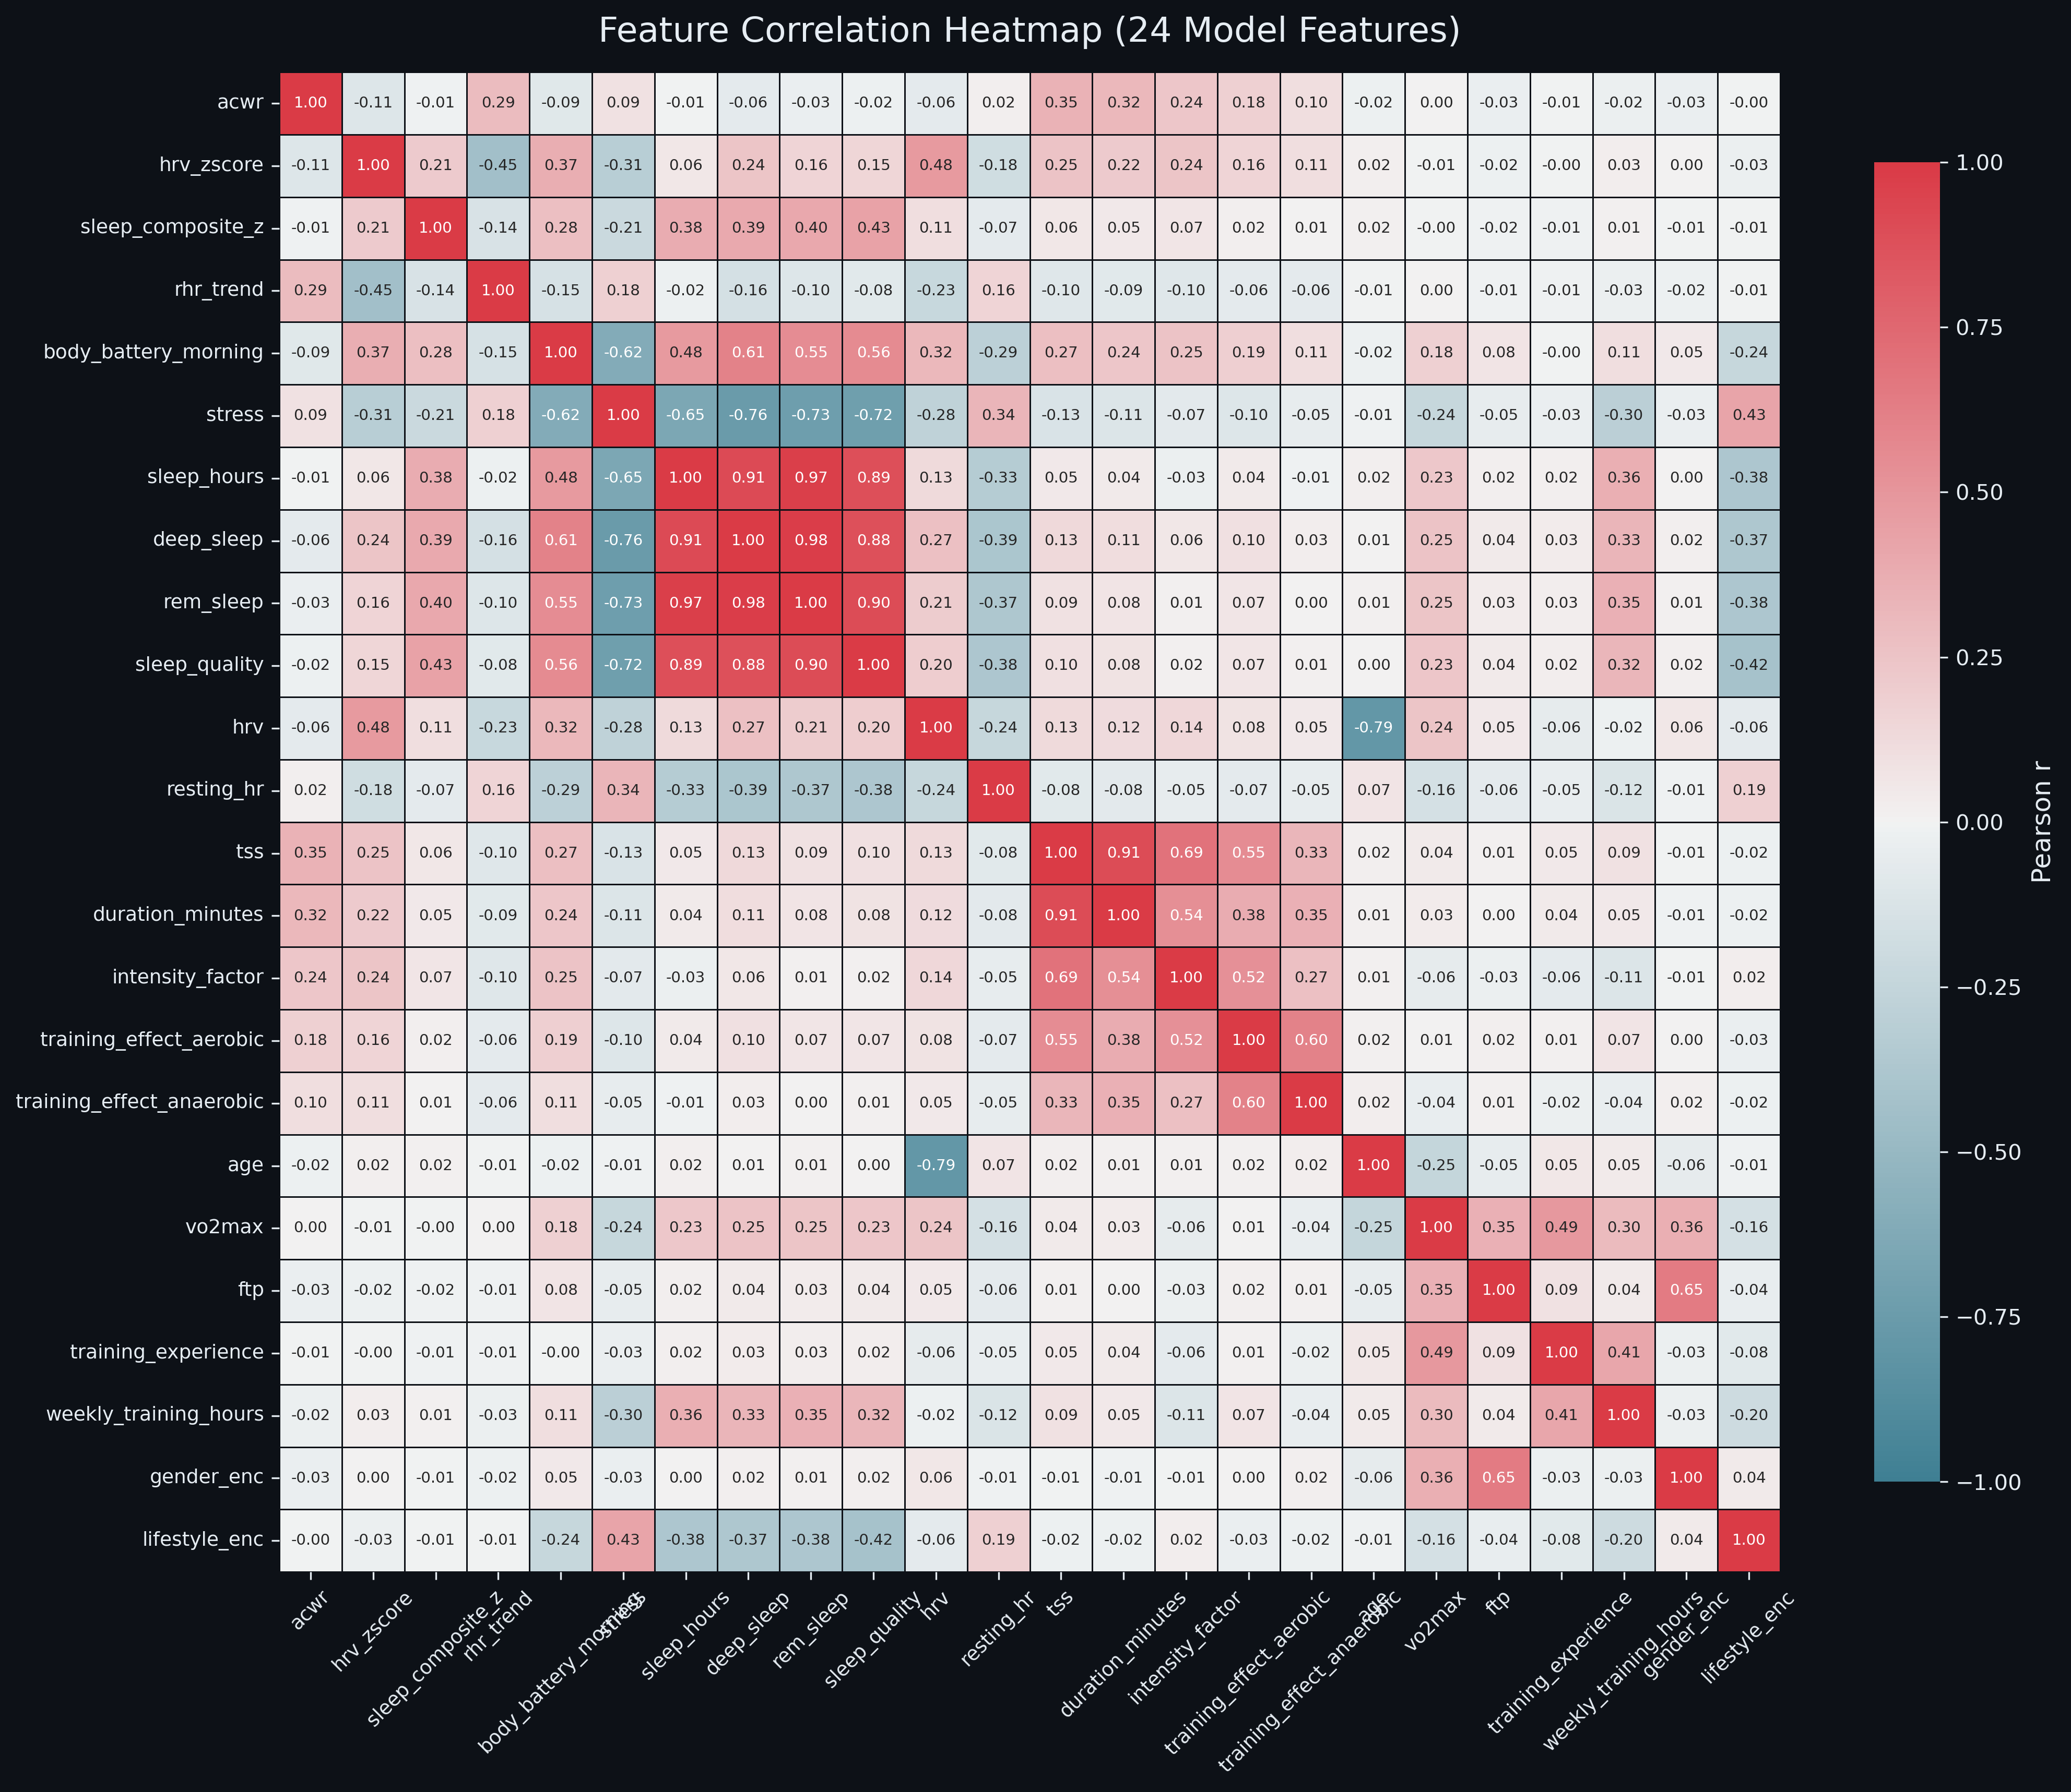
Figure 1: Feature correlation heatmap showing relationships among the 24 input features.

4.2 Classification Models
Logistic Regression (scikit-learn): A linear baseline with L2 regularization and class_weight=balanced to account for class imbalance. This model serves as a reference point for the discriminability of the feature space.
Random Forest (scikit-learn): An ensemble of 200 decision trees with max_depth=12, providing nonlinear decision boundaries and built-in feature importance estimates via mean decrease in impurity.
DNN / MLP (PyTorch): A three-hidden-layer feedforward network with layer sizes [256, 128, 64], BatchNorm after each hidden layer, ReLU activations, and Dropout(0.3) for regularization. Trained for 50 epochs with the Adam optimizer (learning rate 1e-3, batch size 512). For binary injury classification, we use binary cross-entropy loss; for three-class load classification, we use cross-entropy loss.

4.3 Regression Models
Lasso with Polynomial Features (scikit-learn): Degree-2 polynomial expansion of the input features to capture pairwise interactions, followed by L1-regularized linear regression for automatic feature selection and sparsity.
Random Forest (scikit-learn): Same configuration as the classification variant (200 trees, max_depth=12), with mean squared error as the splitting criterion.
DNN / MLP (PyTorch): Same architecture as the classifier, with a single continuous output neuron and MSE loss.

4.4 Evaluation Strategy
All models are evaluated using 5-fold GroupKFold cross-validation, where the grouping variable is athlete_id. This ensures that all days from a given athlete appear in either the training set or the test set, but never both, preventing data leakage from temporal autocorrelation within an athlete's time series.
Classification metrics: ROC-AUC (macro, one-vs-rest), F1-macro, Precision (macro), Recall (macro), and Accuracy. For the binary injury task, ROC-AUC is the primary metric because it is threshold-independent and appropriate for imbalanced classes.
Regression metrics: Root Mean Squared Error (RMSE), Mean Absolute Error (MAE), and coefficient of determination (R²). RMSE is the primary metric as it penalizes large errors more heavily, which is important for identifying dangerous training states.

5. Results

5.1 Injury Classification
Model | ROC-AUC | F1-macro | Precision | Recall | Accuracy
Logistic Regression | 0.875 ± 0.002 | 0.699 ± 0.004 | 0.663 ± 0.003 | 0.810 ± 0.003 | 0.858 ± 0.005
Random Forest | 0.901 ± 0.003 | 0.839 ± 0.003 | 0.860 ± 0.004 | 0.821 ± 0.003 | 0.951 ± 0.001
DNN (MLP) | 0.948 ± 0.010 | 0.871 ± 0.022 | 0.843 ± 0.024 | 0.905 ± 0.017 | 0.955 ± 0.008
Table 1: Injury classification results (5-fold GroupKFold CV, mean ± std).
The DNN achieves the highest AUC-ROC (0.948) and F1-macro (0.871), demonstrating that the nonlinear feature interactions captured by the neural network substantially improve injury detection. Logistic Regression achieves reasonable recall (0.810) but the lowest precision (0.663), indicating that it over-predicts injury—likely because the linear model cannot separate the overlapping regions of the feature space as effectively. Random Forest offers the best precision-recall balance among non-DNN models, with strong accuracy (0.951) and AUC (0.901).
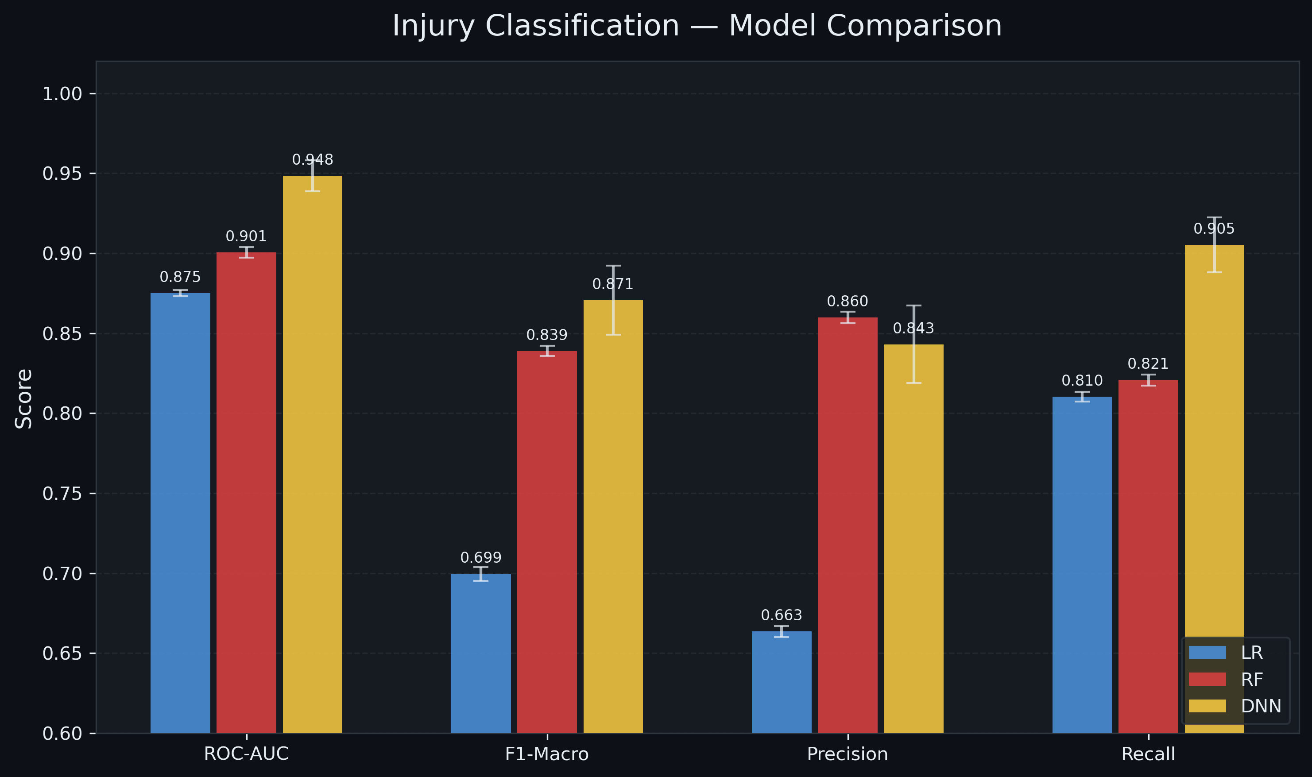
Figure 2: Injury classification model comparison—ROC curves and performance metrics.

5.2 Load Class Classification
Model | ROC-AUC | F1-macro | Precision | Recall | Accuracy
Logistic Regression | 0.988 ± 0.000 | 0.914 ± 0.001 | 0.906 ± 0.001 | 0.925 ± 0.001 | 0.913 ± 0.001
Random Forest | 0.987 ± 0.000 | 0.914 ± 0.001 | 0.908 ± 0.001 | 0.920 ± 0.001 | 0.913 ± 0.001
DNN (MLP) | 0.997 ± 0.000 | 0.959 ± 0.002 | 0.960 ± 0.003 | 0.958 ± 0.001 | 0.959 ± 0.002
Table 2: Load class classification results (5-fold GroupKFold CV, mean ± std).
All three models perform exceptionally well on the three-class load classification task. Even Logistic Regression achieves an AUC of 0.988, indicating that the ACWR-based class boundaries are well-separated in the 24-dimensional feature space. The DNN pushes performance to near-perfect levels, with AUC 0.997 and 95.9% accuracy. The uniformly small standard deviations across folds confirm that these results generalize reliably across different athlete subpopulations.
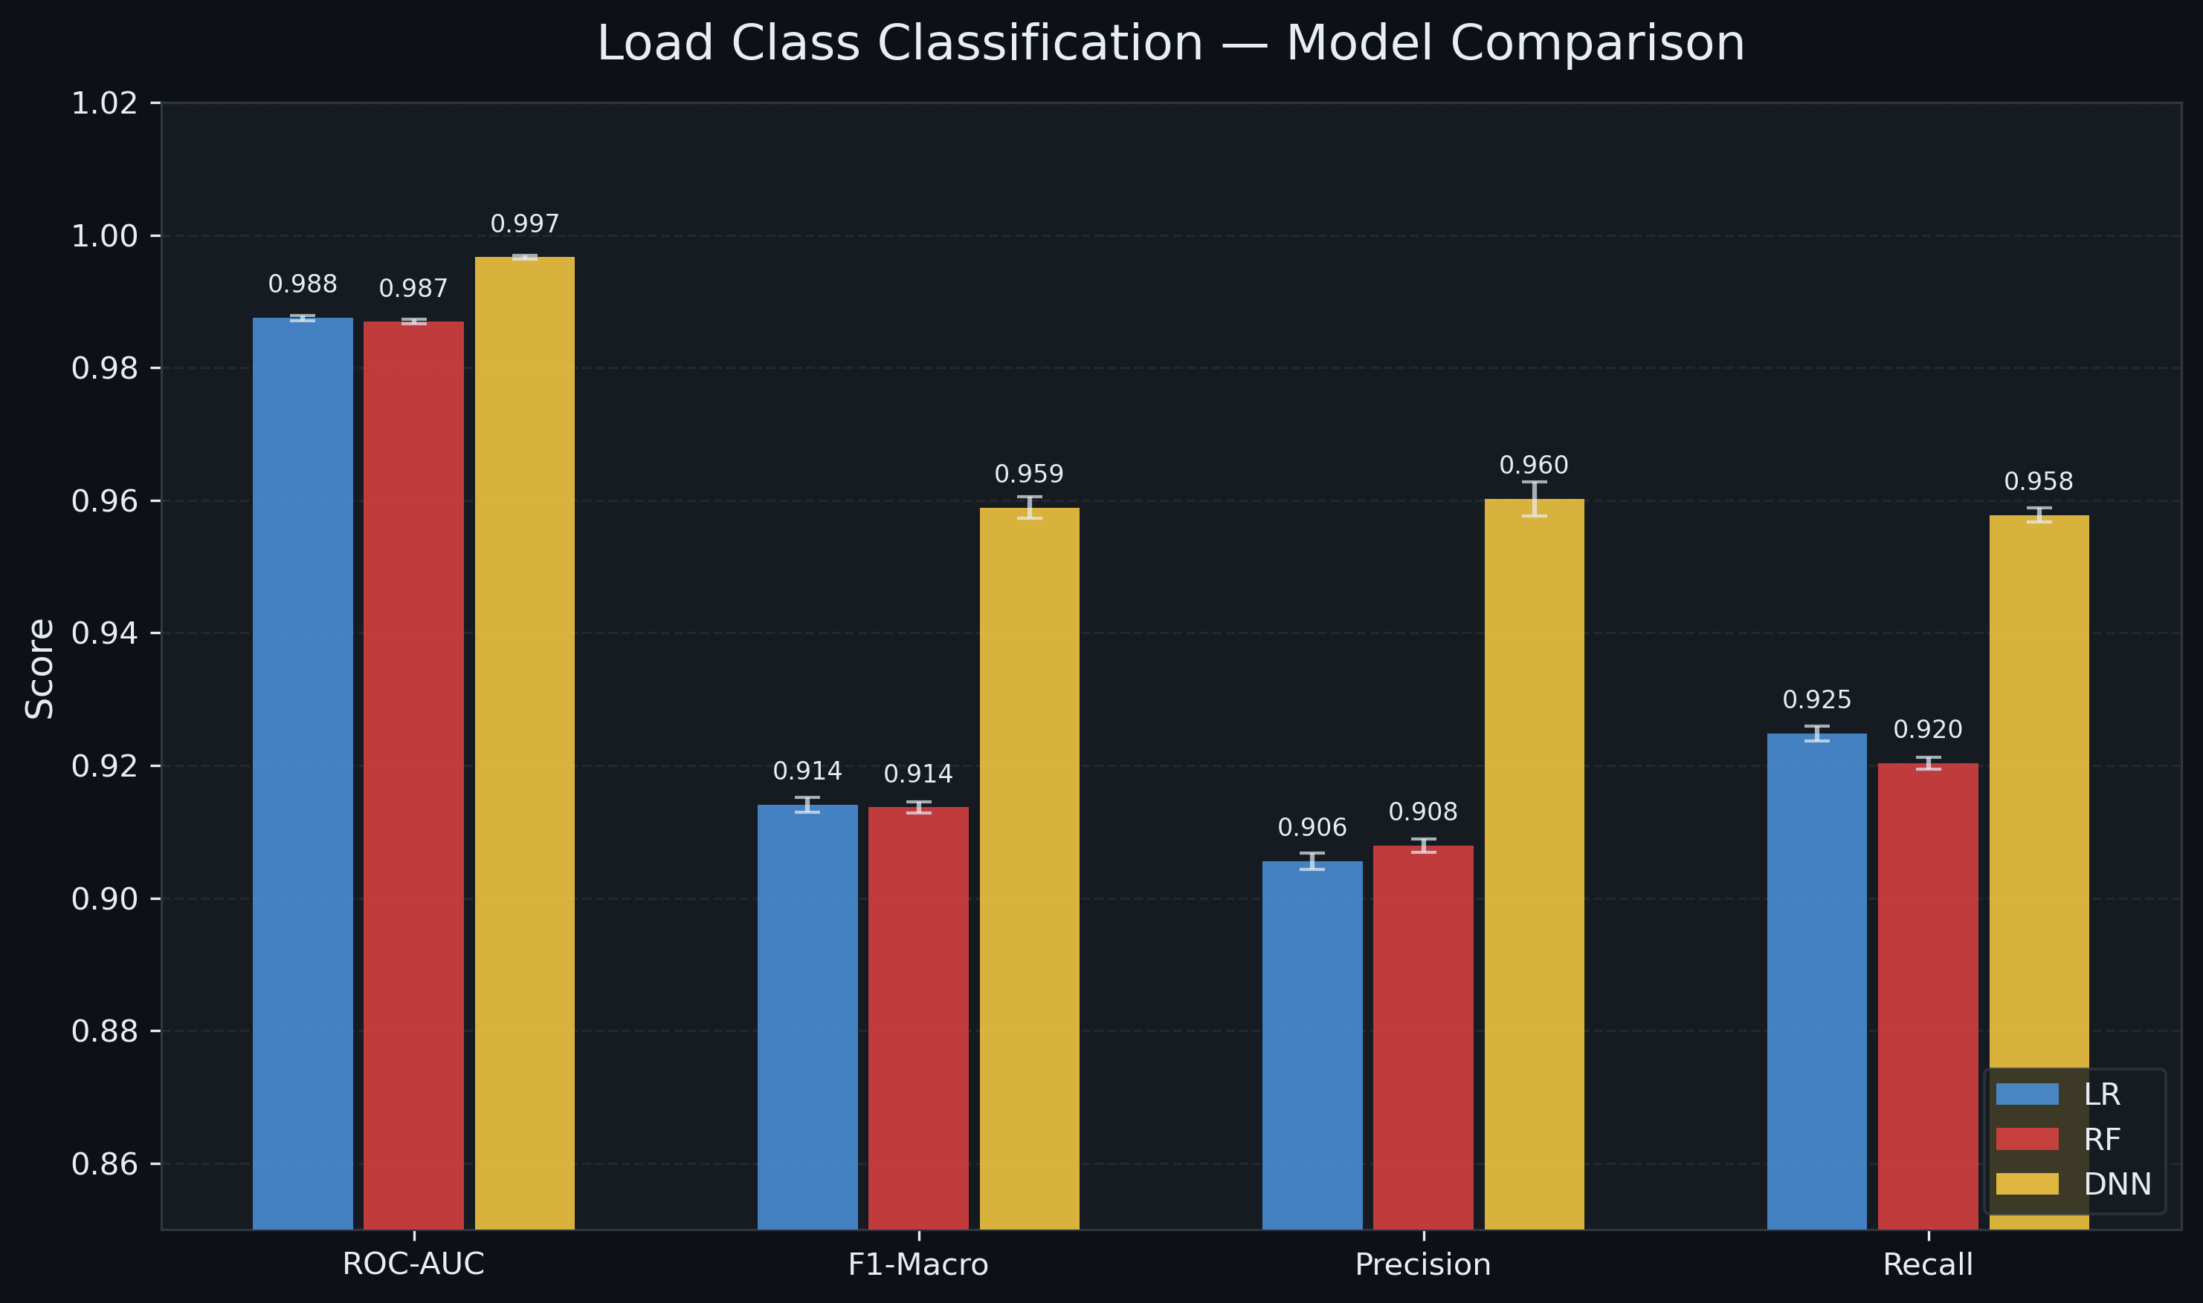
Figure 3: Load class classification model comparison—ROC curves and performance metrics.

5.3 Grit Score Regression
Model | RMSE | MAE | R²
Lasso + Poly | 1.809 ± 0.024 | 1.372 ± 0.019 | 0.973 ± 0.001
Random Forest | 1.540 ± 0.030 | 1.182 ± 0.020 | 0.981 ± 0.001
DNN (MLP) | 1.193 ± 0.044 | 0.933 ± 0.042 | 0.988 ± 0.001
Table 3: Grit Score regression results (5-fold GroupKFold CV, mean ± std).
The DNN achieves the best R² (0.988) with an RMSE of only 1.19 on a 0–100 scale, meaning the model's predictions deviate from the true Grit Score by roughly 1.2 points on average. Even the Lasso baseline with polynomial features achieves R² = 0.973, indicating that the Grit Score is well-predicted by its constituent features even through a linear lens. All standard deviations are small across folds, confirming stable generalization.
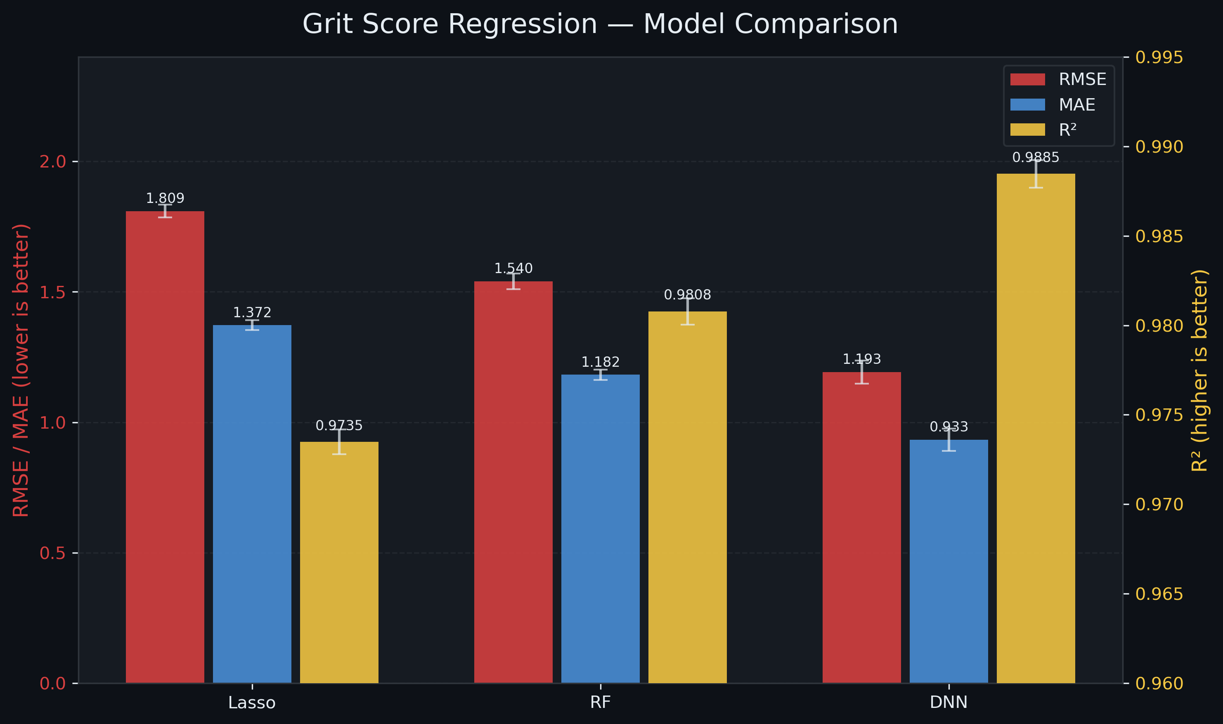
Figure 4: Grit Score regression model comparison—predicted vs. actual and residual distributions.
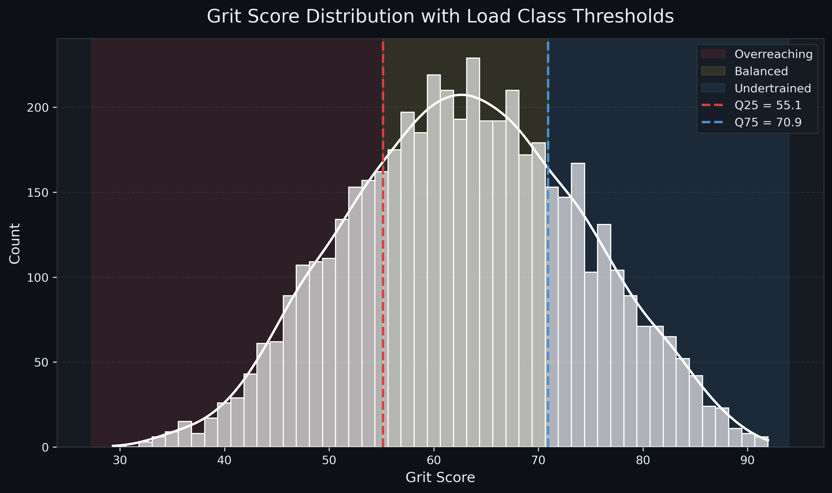
Figure 5: Distribution of the Grit Score across all athlete-days.

5.4 Feature Importance Analysis
We examine feature importance from the Random Forest models, which provide built-in importance estimates via mean decrease in impurity. The two tasks—injury classification and Grit Score regression—reveal distinct but complementary importance profiles.
Injury prediction — top features: (1) deep_sleep at 24.6%, (2) sleep_quality at 12.6%, (3) sleep_hours at 10.8%, (4) rhr_trend at 8.5%, (5) rem_sleep at 8.3%, and (6) hrv_zscore at 7.2%. Sleep-related features collectively account for over 55% of total importance. This finding aligns with sports science literature demonstrating that poor sleep is among the strongest modifiable risk factors for athletic injury, as it directly impairs tissue repair, immune function, and neuromuscular coordination.
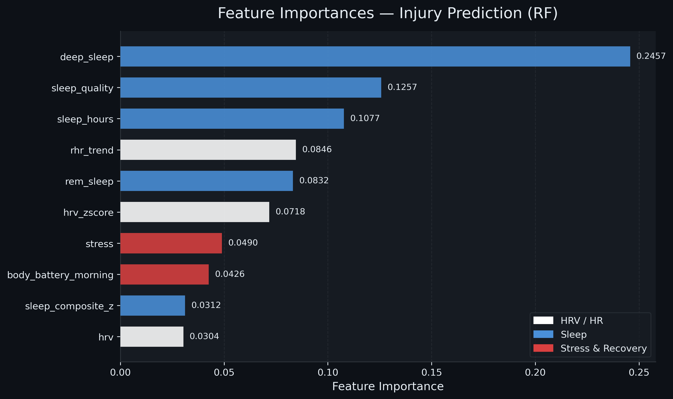
Figure 6: Random Forest feature importance for injury classification.
Grit Score prediction — top features: (1) hrv_zscore at 49.0%, (2) sleep_composite_z at 31.9%, (3) body_battery_morning at 15.5%, (4) stress at 2.3%, and (5) acwr at 1.3%. The Grit Score is primarily driven by HRV deviation from personal baseline and sleep quality—the two strongest indicators of physiological stress. Notably, ACWR contributes only 1.3% of importance despite being the traditional load management metric, suggesting that recovery-side signals carry more information about overall training state than the load signal alone.
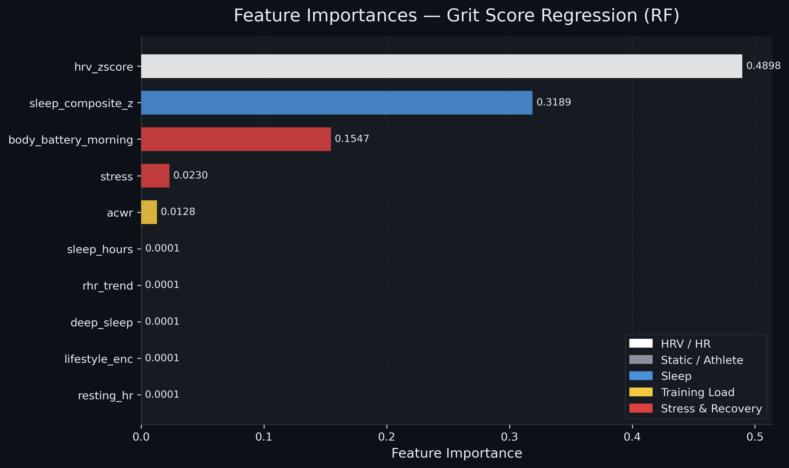
Figure 7: Random Forest feature importance for Grit Score regression.
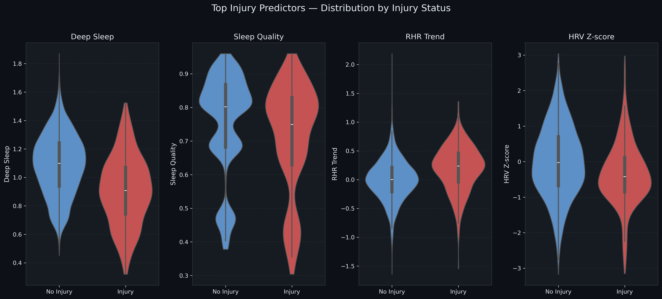
Figure 8: Violin plots of key features stratified by injury status, illustrating distributional differences between injured and healthy days.

5.5 Hyperparameter Analysis
A systematic hyperparameter sweep was conducted for all models (results stored in hp_sweep.pkl). For Logistic Regression, regularization strength C was varied from 0.01 to 100; performance was stable for C > 0.1, indicating that the feature space is sufficiently informative that strong regularization is not needed. For Random Forest, max_depth was varied from 6 to 20; performance plateaued around max_depth=12, with diminishing returns and slight overfitting beyond that point. For the DNN, we tested hidden layer sizes of [64, 128, 256] and learning rates of [1e-4, 1e-3, 1e-2]; the optimal configuration was 256 hidden units per layer with a learning rate of 1e-3. Lower learning rates converged too slowly within 50 epochs, while higher learning rates caused training instability.

6. Discussion
The DNN consistently achieved the best performance across all three tasks—injury classification (AUC 0.948), load-class classification (AUC 0.997), and Grit Score regression (R² 0.988)—justifying the additional architectural complexity over simpler baselines. The margin of improvement was largest for injury classification, where the nonlinear interactions between sleep, HRV, and training load features are most critical for separating at-risk days from healthy ones.
The dominance of sleep features in injury prediction (accounting for over 55% of Random Forest importance) is physiologically meaningful and has practical implications. Unlike training load, which is often considered the primary driver of injury risk, sleep quality is both a sensitive indicator of accumulated fatigue and a modifiable behavior. Athletes and coaches could use this insight to prioritize sleep hygiene as an injury prevention strategy, particularly during periods of high training load.
The Grit Score formulation successfully captures the multi-dimensional nature of training state, as evidenced by the R² of 0.988 and the clean separation of load classes at AUC 0.997. The score integrates information that no single metric captures alone: an athlete with high ACWR but excellent HRV and sleep will have a moderate Grit Score, reflecting that the load is being tolerated. Conversely, moderate ACWR with suppressed HRV and poor sleep yields a high Grit Score, flagging risk that a load-only metric would miss.
The GroupKFold cross-validation strategy is critical for valid evaluation. Because daily observations within an athlete are temporally autocorrelated, a random train/test split would allow the model to exploit inter-day similarity within the same athlete, inflating performance estimates. By ensuring that entire athletes are held out, we measure the model’s ability to generalize to new, unseen individuals—the operationally relevant scenario.
Several limitations should be acknowledged. First, the dataset is synthetic, and while it was designed to reflect realistic physiological distributions, it may not capture the full complexity of real-world data, including measurement noise, missing data, and behavioral variability. Second, the Grit Score thresholds for the three load classes were derived from data distribution tertiles rather than clinical validation; in practice, these thresholds would need to be calibrated against actual injury outcomes. Third, the injury label in the synthetic data may not perfectly reflect the multi-factorial nature of real overuse injuries, which can involve biomechanical, nutritional, and psychological factors not captured in wearable data.
Future work will address these limitations in several directions. We plan to integrate real wearable data from personal WHOOP, Garmin, and TrainingPeaks accounts using the respective APIs, enabling validation on actual athlete data. A real-time dashboard with automatic training plan adjustment based on the Grit Score is under development using a React frontend. Additionally, we aim to explore temporal modeling architectures (LSTMs, Transformers) that can explicitly capture the sequential nature of training adaptation, and to incorporate additional data modalities such as GPS-derived running dynamics and power meter data from cycling.

7. References
[1] Rossi, L. (2025). Synthetic Triathlete Dataset for Injury Prediction Research (2024). Zenodo. https://doi.org/10.5281/zenodo.15401061
[2] Rossi, L. (2025). Finding Pre-Injury Patterns in Triathletes from Lifestyle, Recovery and Load Dynamics Features. arXiv:2511.17610.
[3] Gabbett, T.J. (2016). The training–injury prevention paradox: should athletes be training smarter and harder? British Journal of Sports Medicine, 50(5), 273–280.
[4] Hulin, B.T., Gabbett, T.J., Blanch, P., Chapman, P., Bailey, D., & Orchard, J.W. (2016). Spikes in acute workload are associated with increased injury risk in elite cricket fast bowlers. British Journal of Sports Medicine, 48(8), 708–712.

