3D Modeling Website

Felipe .M Iglesias

CONTENTS

PAGE DESIGNS 2

FONT CHOICE 3

COLOUR PALETTE 4

# PAGE DESIGNS

The design of the page is based on a Z patron. We leave some a space between the margins, so all the content is aligned to the centre. This makes an easy reading display for the user.

The pages consist of the nav-bar which is located at the top of the document and a footer on the bottom. Right to the nav-var we have a search box and a login button.

We have 3 sections in this project: Home, Content and Contact.

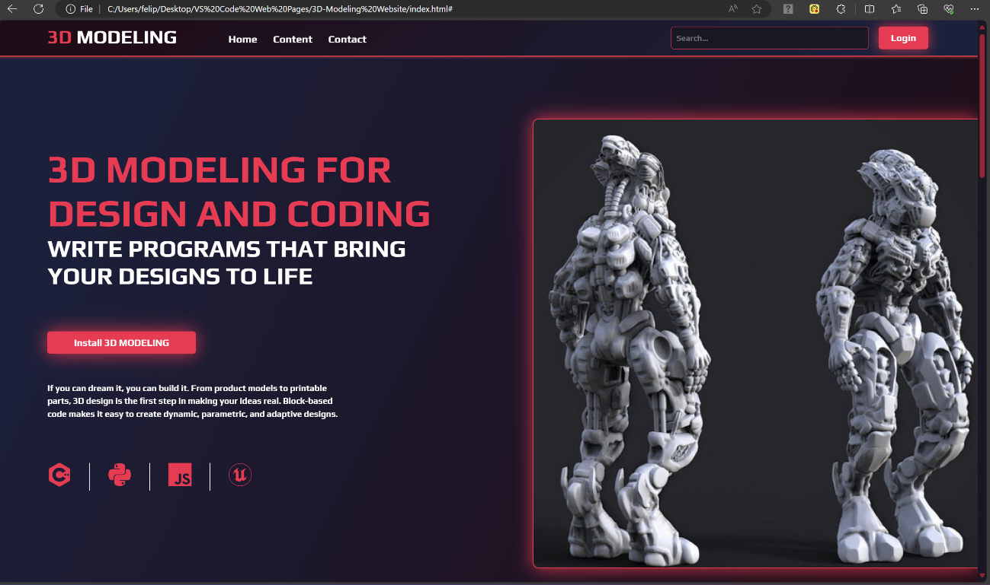

# FONT CHOICE

The font choose is called “PLAY” which has futuristic vibes. This gives us the feeling of a technological product.



# COLOUR PALETTE

The colour palette is based on strong red (#fb1e4e), almost pink and purple (#1b1725). These colours are displayed on gradients. The effect we want to achieve is that the user is exploring a technological and futuristic website. This goes with the idea that we are selling a technological product.

