Guess the Australian States

Felipe .M Iglesias

Python – Turtle and Pandas libraries

# CONTENT

CONTENT 1

EXECUTIVE SUMMARY 2

Python Installation 3

Execute the game 6

APPENDIX 10

# EXECUTIVE SUMMARY

In this document we are going to explain how to run the Australian states game.

# Python Installation

To start with the program, we will need to install the latest version of Python. If you already have it installed skip this part.

1. To do this put your cursor on the link at the appendix section, use Ctrl + right click to follow the link and download the latest version on your computer.

1. Chose the version for your operating system.

1. Once downloaded, run through the installation process. From the install screen, check theadd python.exe to PATH. This means that running Python can be done from anywhere on your system. Once completed, click on close.

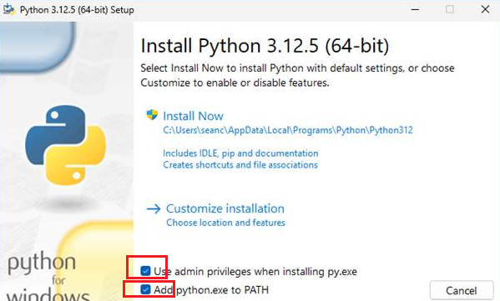

1. From here, click on Disable Path length limit.

1. Once completed, you will see the following:

# Execute the game

Assuming python is already installed in your system, you need to do left click on the downloaded file, chose Extract All from the ZIP file and follow these steps:

1. Open PowerShell. If you don’t find it you can type ‘’PowerShell’ on the search bar on you task bar.

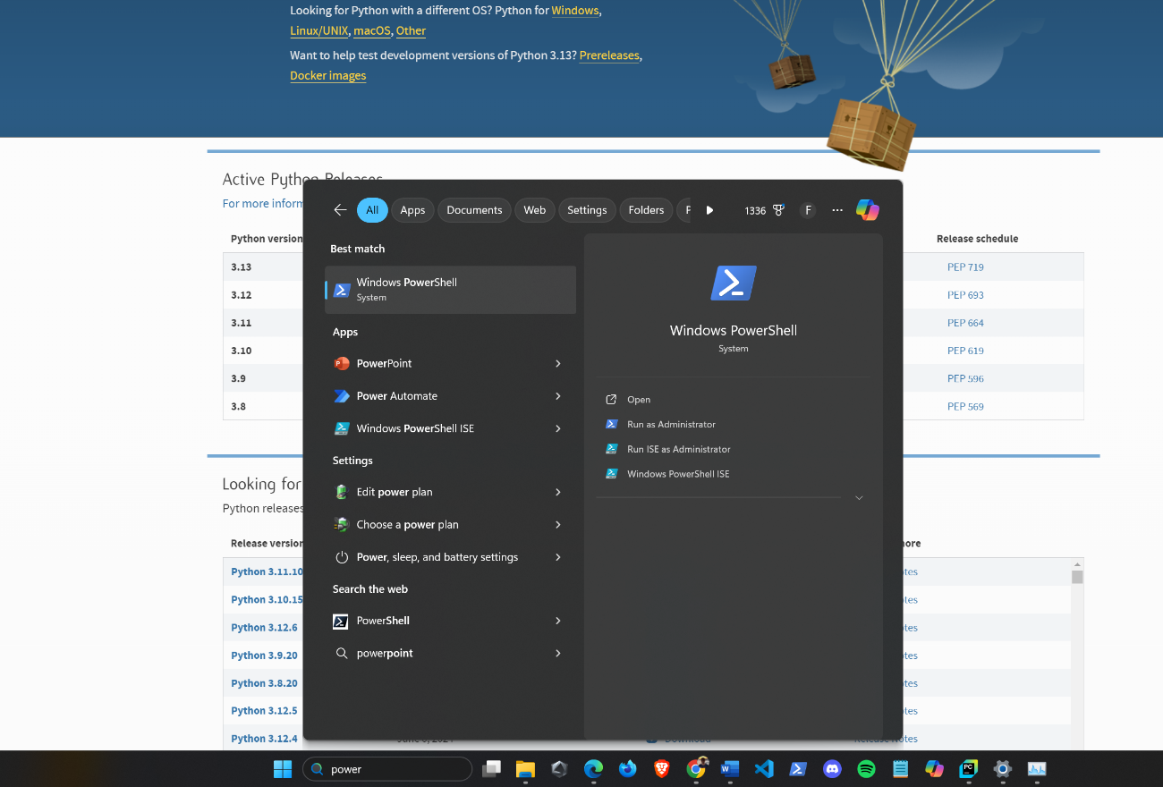

1. Once you have opened the PowerShell run the pip install Pythonturtle and pip install pandas command to install the turtle and pandas libraries.

1. Next, search for the downloaded folder in your system by typing cd followed by quotes ‘ ’ . Inside the quotes start with .\ next type the path where you have allocated the file and press Enter on your keyboard. For most of the cases the folder will be in **Downloads** which command is:



*Suggestion: To automatically fill the path, type the first letters of each folder or file name and press the TAB key until you find the one you are seeking.*

in my case I have it in this path :

C:\Users\felip\Desktop\Development\Python Projects for GitHub\AUSTRALIA Guess the States Game

1. Check that all the files exist inside this folder by typing the ls command

*Suggestion: Type the cls command to clear the screen each time you think is necessary.*



1. Finally execute the command python main.py to execute game.

1. From here, we will type the correct name of the state for increase the score

1. When finishing your answers, type the magic word “exit” and a CSV file names ‘states_to_learn.csv ’will be created inside the AUSTRALIA Guess the States Game folder with the states you are missing and you need to learn.

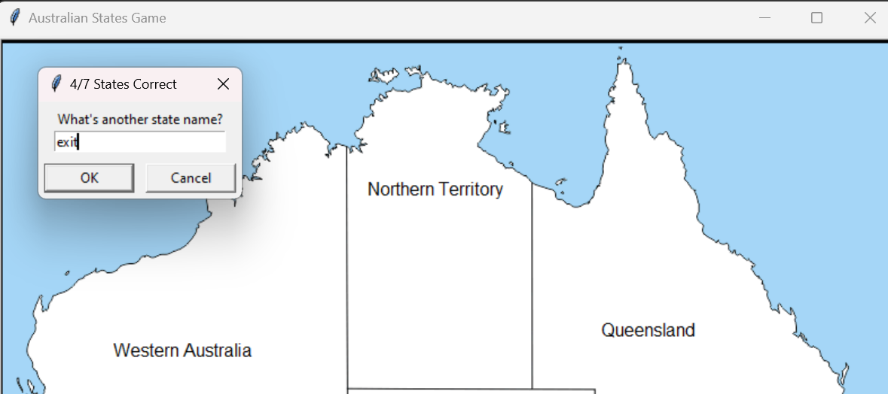

# APPENDIX

* <https://www.python.org/>