Password Vault Program

Felipe .M Iglesias

Python

# CONTENT

CONTENT 1

EXECUTIVE SUMMARY 2

PYTHON INSTALLATION 3

EXECUTE THE PROGRAM 6

APPENDIX 8

# EXECUTIVE SUMMARY

In this project I built a game using Python in which the user has to guess which football legend has the most goals with the national team. The computer will display two players, PLAYER A and PLAYER B. The user will have to select one of these by typing 'A' or 'B'.

Each round in which the answer is correct adds one point to the score. The game ends when the user chooses the wrong answer.

# PYTHON INSTALLATION

To start with the program, we will need to install the latest version of Python. If you already have it installed skip this part.

1. To do this put your cursor on the link at the appendix section, use Ctrl + right click to follow the link and download the latest version on your computer.

1. Chose the version for your operating system.

1. Once downloaded, run through the installation process. From the install screen, check theadd python.exe to PATH. This means that running Python can be done from anywhere on your system. Once completed, click on close.

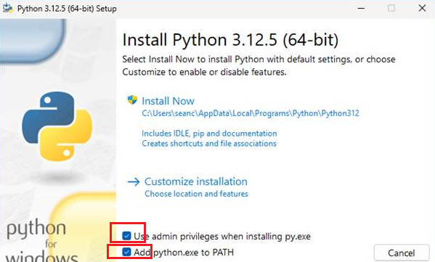

1. From here, click on Disable Path length limit.

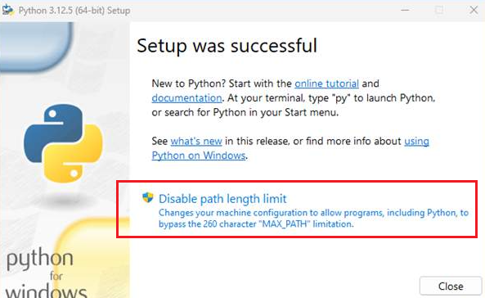

1. Once completed, you will see the following:

# EXECUTE THE PROGRAM

Assuming python is already installed in your system, you need to do left click on the downloaded file, chose Extract All from the ZIP file and follow these steps:

1. Open PowerShell. If you don’t find it you can type ‘’PowerShell’ on the search bar on you task bar.

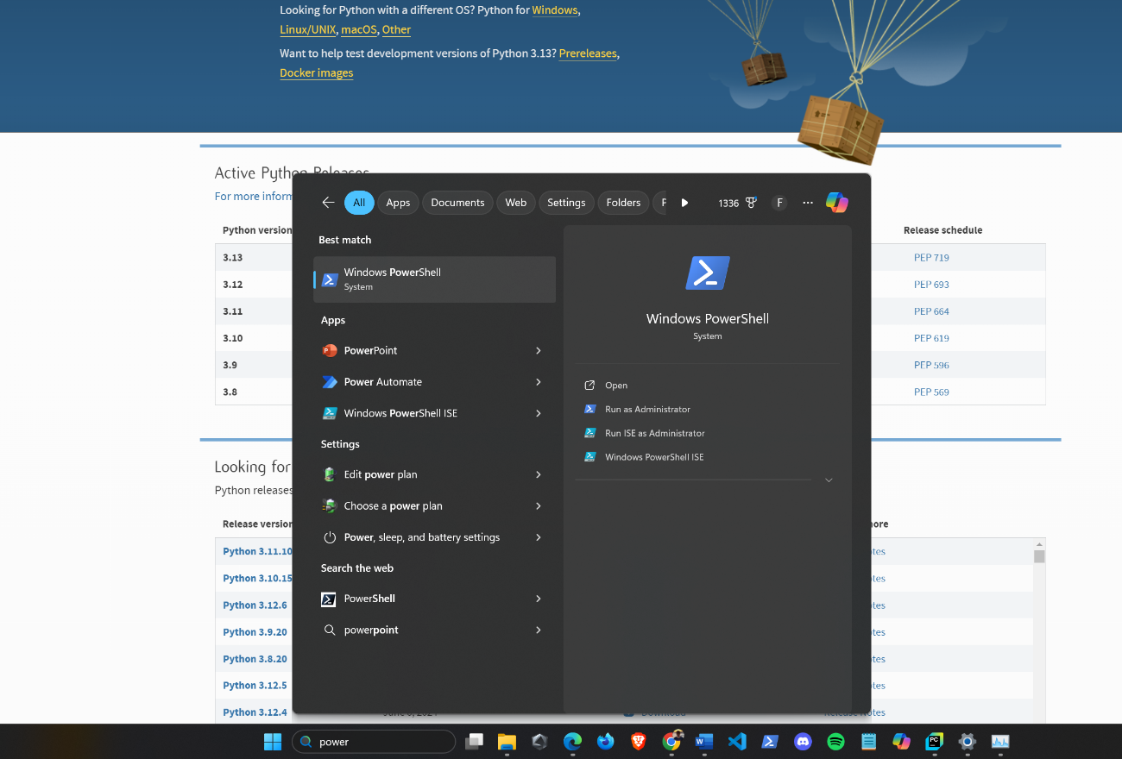

You will need the Tkinter and the pyperclip libraries as well. To install them, run the following command on poweshell:

pip install pyperclip

pip install tkinter

1. Once you have opened the PowerShell, search for the downloaded folder in your system by typing cd followed by quotes ‘ ’ . Inside the quotes start with .\ next type the path where you have allocated the file and press Enter on your keyboard. For most of the cases the folder will be in **Downloads** which command is:

cd ‘ .\Downloads\Password_Vault_Program’

*Suggestion: To automatically fill the path, type the first letters of each folder or file name and press the TAB key until you find the one you are seeking.*

in my case I have it in this path :

C:\Users\felip\Desktop\Python Projects\ Password_Vault_Program’

1. Check that all the files exist inside this folder by typing the ls command
2. Finally execute the command py ./main.py to execute the program

1. To quit use Ctrl + c

# APPENDIX

* <https://www.python.org/>