REGULAR CALCULATOR

Felipe .M Iglesias

Python

# CONTENT

CONTENT 1

EXECUTIVE SUMMARY 2

EXECUTE THE PROGRAM 3

APPENDIX 5

# EXECUTIVE SUMMARY

In this project I made a regular calculator using Python. To install Python click on the link at the appendix section and download the last version on your computer.

# EXECUTE THE PROGRAM

Assuming python is already installed in your system follow these steps:

1. Open PowerShell. If you don’t find it you can type ‘’PowerShell’ on the search bar on you task bar.

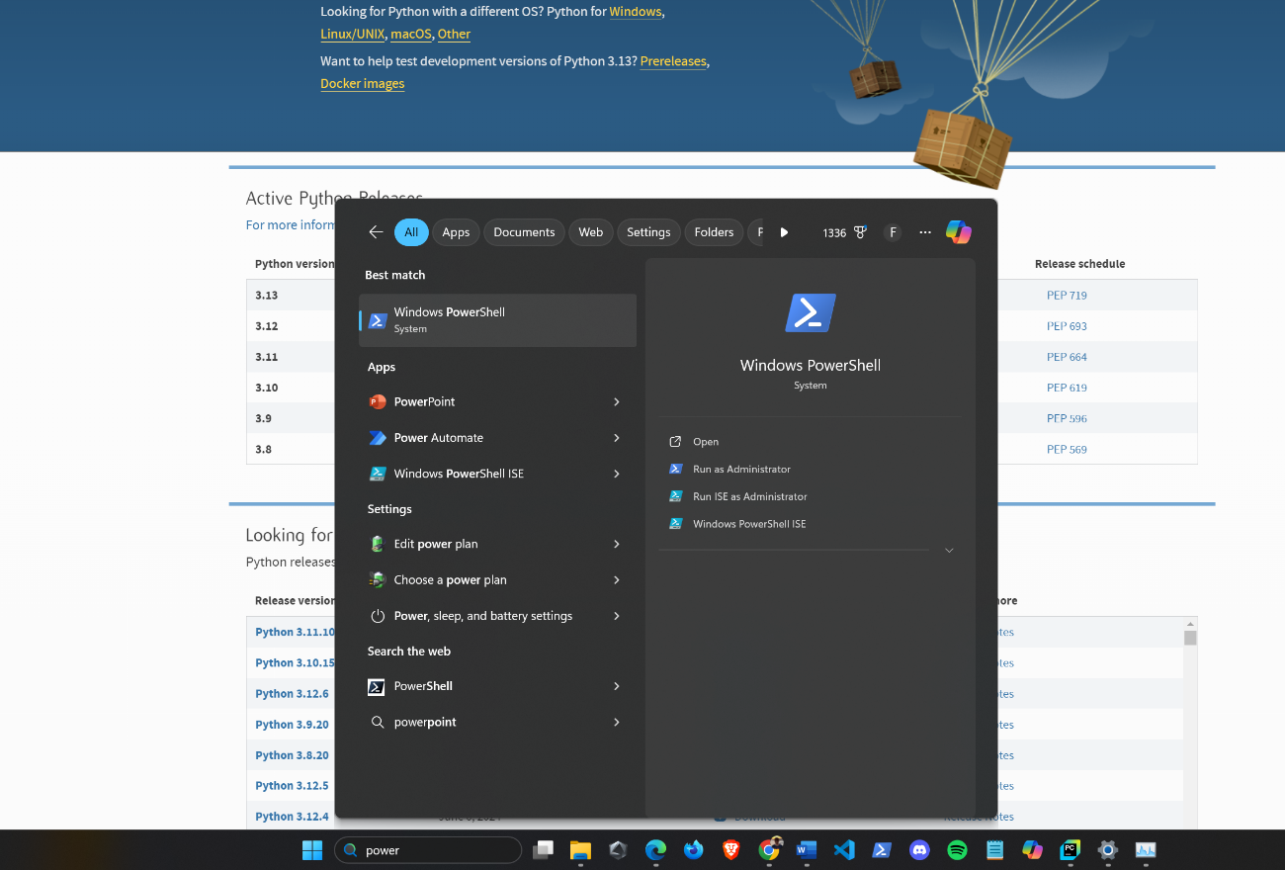

1. Once you have opened, search the path where you have the file allocated using the cd command, in my case I have it in this path :

C:\Users\felip\Desktop\Python Projects\Regular Calculator

Next execute the command py ./index.py to run the file

# APPENDIX

* <https://www.python.org/downloads/>