ROCK, PAPER OR SCISSORS GAME

Felipe .M Iglesias

Python

# CONTENT

CONTENT 1

EXECUTIVE SUMMARY 2

START THE GAME 3

APPENDIX 5

# EXECUTIVE SUMMARY

In this project I made the rock-paper-scissors game using Python. To install Python click on the link at the appendix section and download the last version on your computer.

About the game:

Rock-paper-scissors is a fun and easy game where two people make hand shapes to see who wins. The game has three hand signs:

1. **Rock** (a closed fist)
2. **Paper** (an open hand)
3. **Scissors** (a fist with two fingers out, like a "V")

Here’s how you win:

* **Rock** beats **scissors** because a rock can crush scissors.
* **Scissors** beats **paper** because scissors can cut paper.
* **Paper** beats **rock** because paper can cover a rock.

If both players pick the same hand shape, it’s a **tie**, and no one wins that round.

# START THE GAME

Assuming python is already installed in your system follow these steps:

1. Open PowerShell. If you don’t find it you can type ‘’PowerShell’ on the search bar on you task bar.

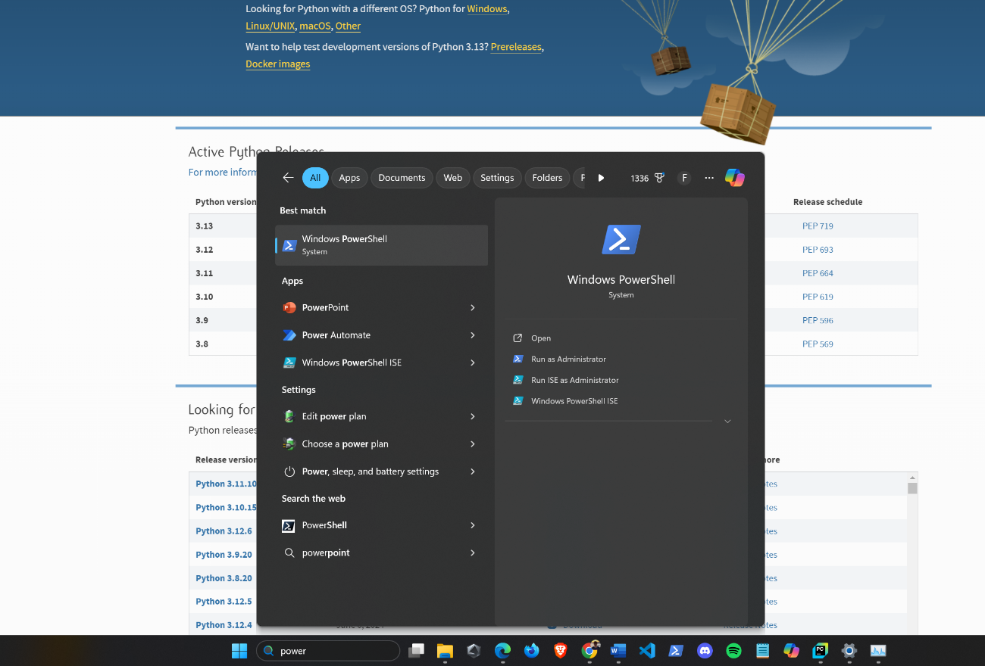

1. Once you have opened, search the path where you have the file allocated using the cd command, in my case I have it in this path C:\Users\felip\Desktop\rock-paper-scissors. Next execute the command py ./index.py to run the game.

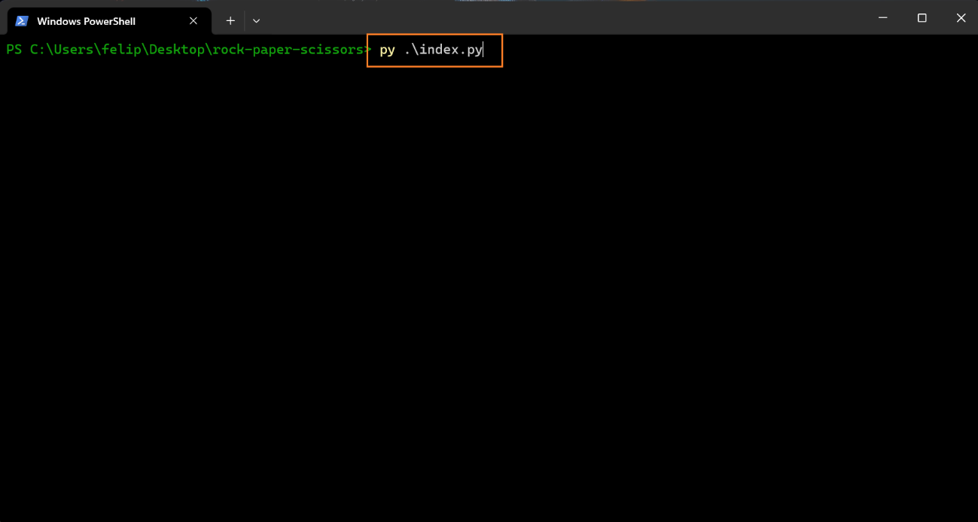

1. Finally, follow the instructions and enjoy!

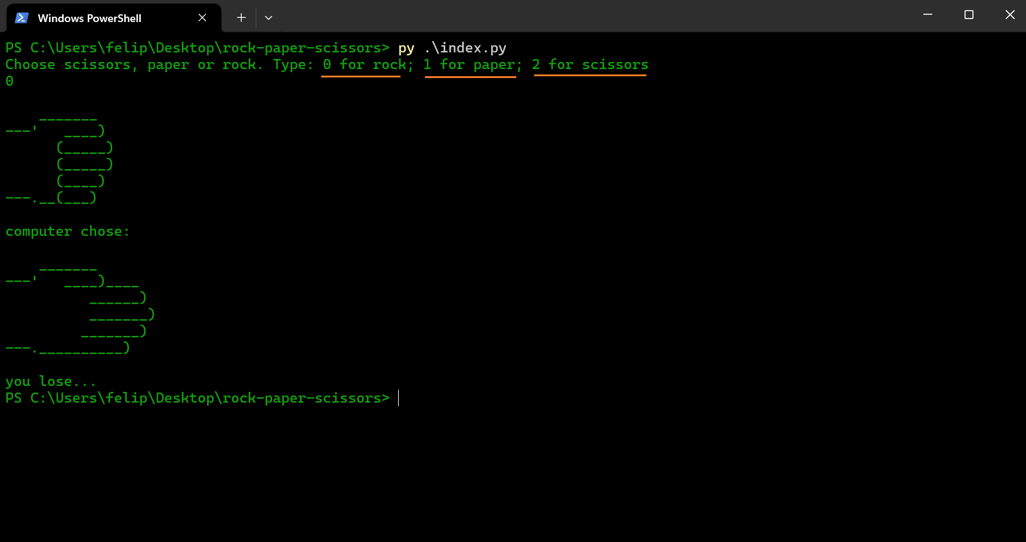

To restart the game again, insert the command py ./index.py again.

# APPENDIX

* <https://www.python.org/downloads/>