The Snake Game

Felipe .M Iglesias

Python – turtle library

# CONTENT

CONTENT 1

EXECUTIVE SUMMARY 2

Python Installation 3

Execute the game 6

APPENDIX 9

# EXECUTIVE SUMMARY

In this document we are going to explain how to run the snake game.

# Python Installation

To start with the program, we will need to install the latest version of Python. If you already have it installed skip this part.

1. To do this put your cursor on the link at the appendix section, use Ctrl + right click to follow the link and download the latest version on your computer.

1. Chose the version for your operating system.

1. Once downloaded, run through the installation process. From the install screen, check theadd python.exe to PATH. This means that running Python can be done from anywhere on your system. Once completed, click on close.

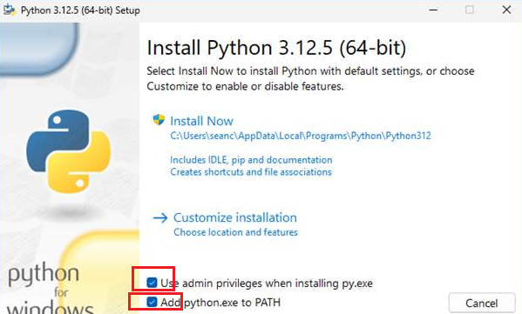

1. From here, click on Disable Path length limit.

1. Once completed, you will see the following:

# Execute the game

Assuming python is already installed in your system, you need to do left click on the downloaded file, chose Extract All from the ZIP file and follow these steps:

1. Open PowerShell. If you don’t find it you can type ‘’PowerShell’ on the search bar on you task bar.

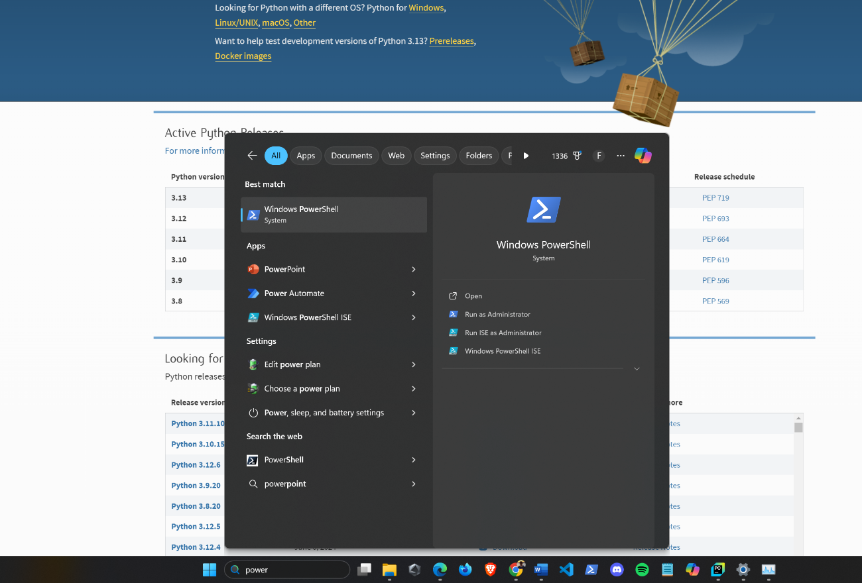

1. Once you have opened the PowerShell run the pip install Pythonturtle command to install the turtle library.

1. Next, if the file is in your Downloads folder, search for the folder in your system by typing cd followed by quotes ‘ ’ . Inside the quotes start with .\ next type the path where you have allocated the file and press Enter on your keyboard.



*Suggestion: To automatically fill the path, type the first letters of each folder or file name and press the TAB key until you find the one you are seeking.*

in my case I have it in this path :

C:\Users\felip\Desktop\Python Projects for GitHub\The Snake Game



1. Check that all the files exist inside this folder by typing the ls command

*Suggestion: Type the cls command to clear the screen each time you think is necessary.*



1. Finally execute the command python main.py to execute game.



Use the arrows to move the snake.

# APPENDIX

* <https://www.python.org/>