Ocean Explorer Kata
API Proof of Execution
R-00272722: D12 Principal Engineer
18 March 2026

1. API Overview
The following screenshots demonstrate the Ocean Explorer API running live in Docker on 18 March 2026. The API was built using FastAPI (Python 3.12) with full OpenAPI/Swagger documentation auto-generated at /docs. All five endpoints and all Pydantic schemas are confirmed present and operational.

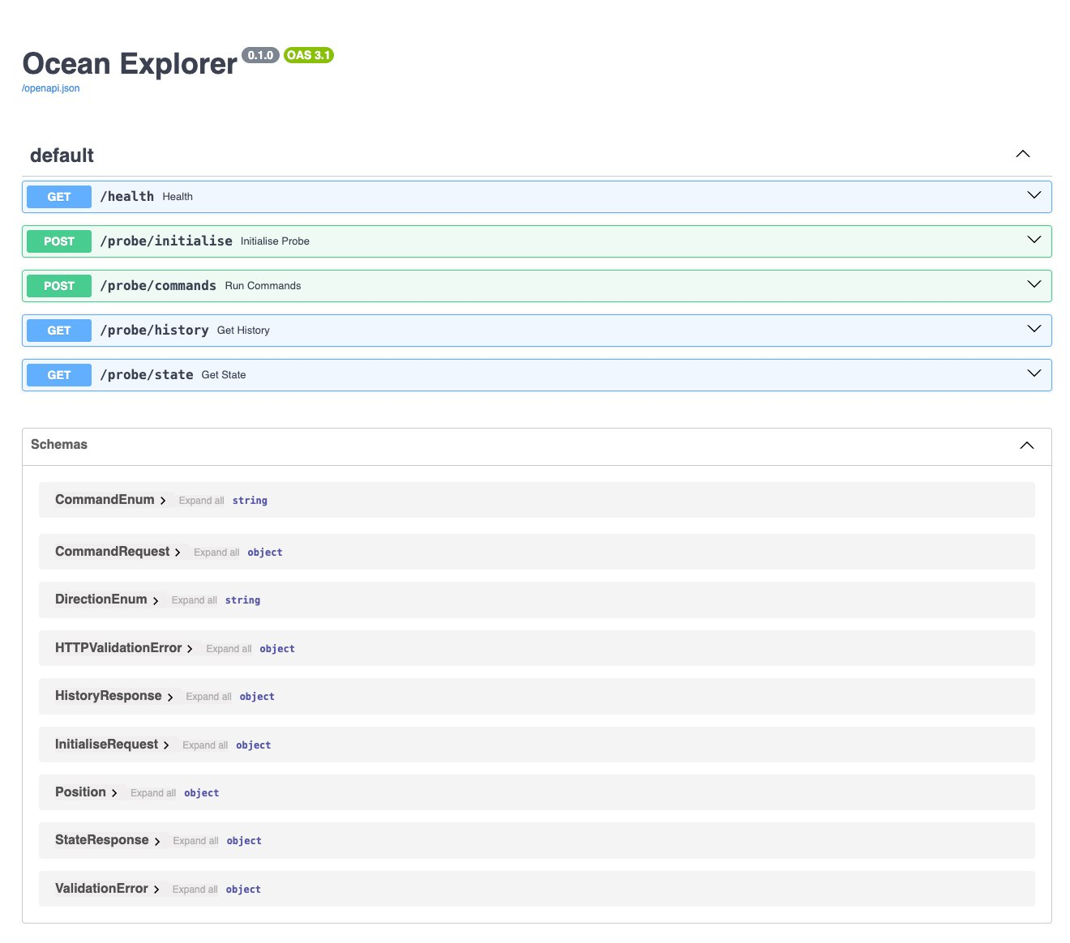
Figure 1 — Swagger UI showing all endpoints (/health, /probe/initialise, /probe/commands, /probe/history, /probe/state) and all Pydantic schemas

2. Health Check — GET /health
The health endpoint confirms the service is live. Returns HTTP 200 with {"status": "ok"}. Server: uvicorn. Timestamp: Wed 18 Mar 2026 22:08:33 GMT.

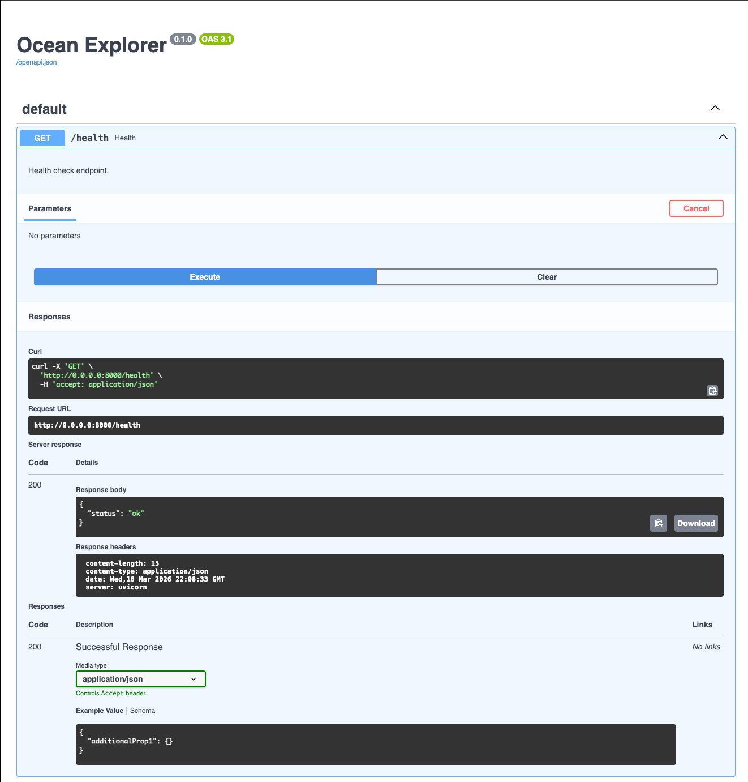
Figure 2 — GET /health returning HTTP 200 {"status": "ok"}

3. Probe Initialisation — POST /probe/initialise
The probe is initialised at position (0,0) facing North on a 10x10 grid, with two obstacles declared at (3,4) and (5,5). The API returns HTTP 200 confirming initial state. Timestamp: Wed 18 Mar 2026 22:09:02 GMT.

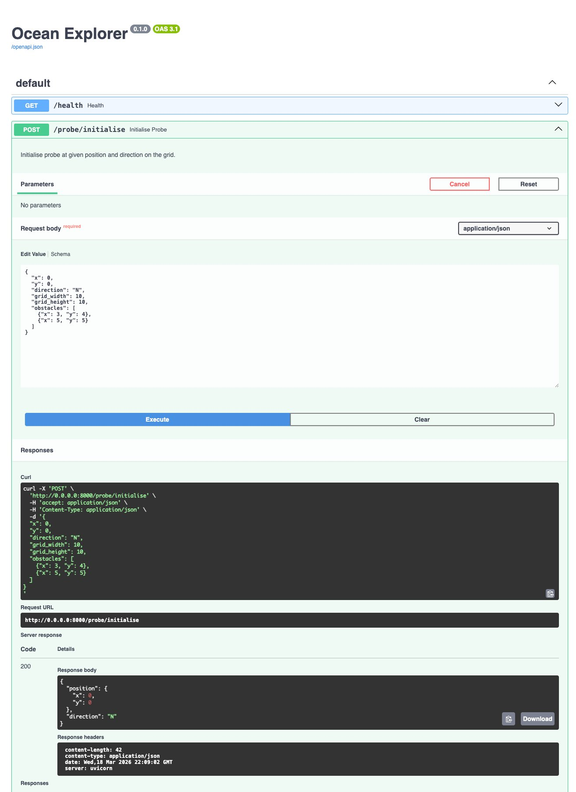
Figure 3 — POST /probe/initialise with x:0, y:0, direction:N, grid 10x10, obstacles at (3,4) and (5,5)

4. Command Execution — POST /probe/commands
A command sequence [F, R, F] is submitted. Starting from (0,0) facing North: F moves to (0,1); R turns to face East; F moves to (1,1). The response confirms final position (1,1) facing East, with visited coordinates and no obstacles encountered. Returns HTTP 200. Timestamp: Wed 18 Mar 2026 22:11:34 GMT.

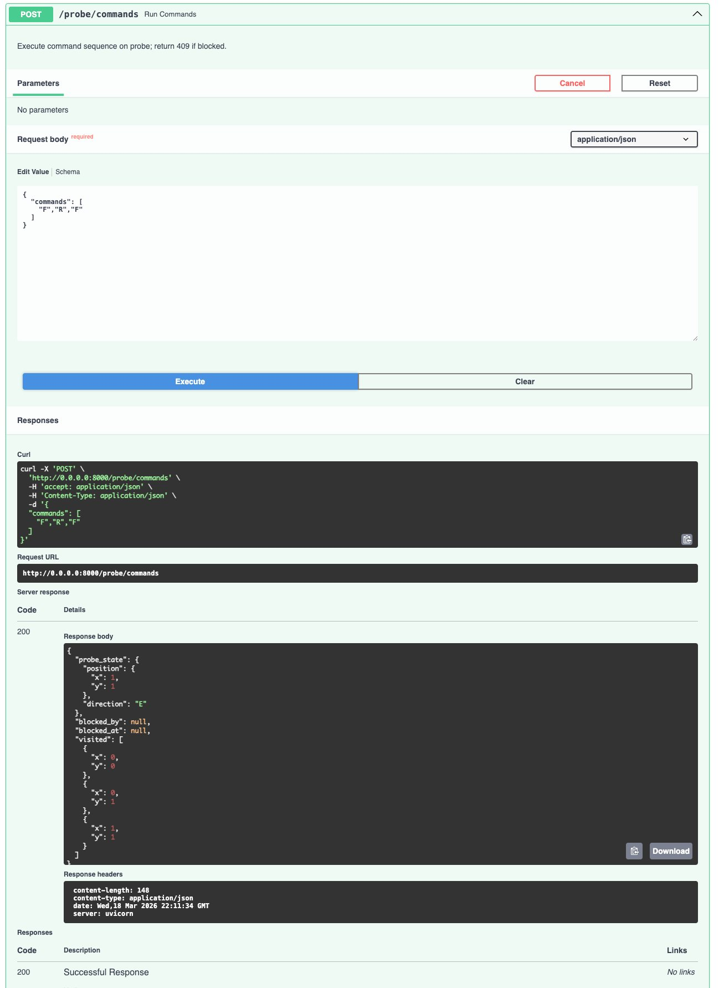
Figure 4 — POST /probe/commands with ["F","R","F"], returning position (1,1) facing East and full visited array

5. Visit History — GET /probe/history
The history endpoint returns the complete ordered list of all coordinates visited in the session: (0,0) → (0,1) → (1,1), current direction East. This satisfies the kata requirement to print a summary of all coordinates visited. Returns HTTP 200. Timestamp: Wed 18 Mar 2026 22:12:17 GMT.

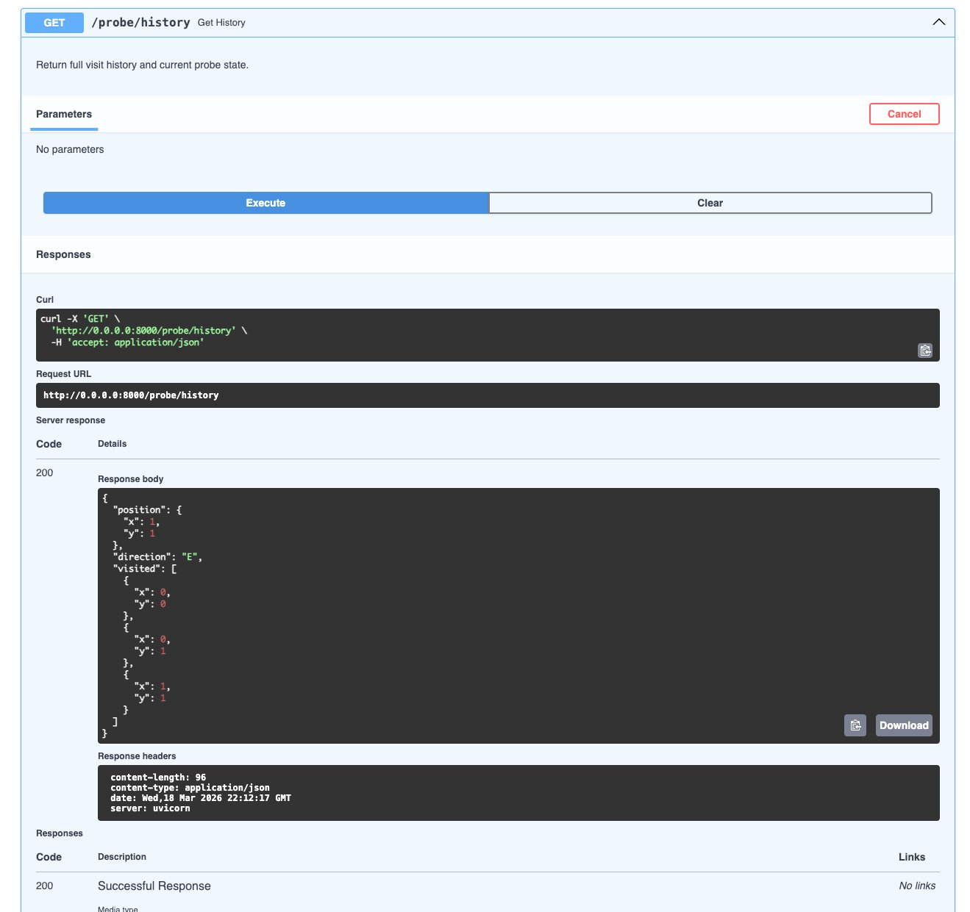
Figure 5 — GET /probe/history returning full visit trail [(0,0), (0,1), (1,1)] with current state

6. Current State — GET /probe/state
The state endpoint confirms current probe position (1,1) facing East, consistent with the command sequence executed above. Returns HTTP 200. Timestamp: Wed 18 Mar 2026 22:13:15 GMT.

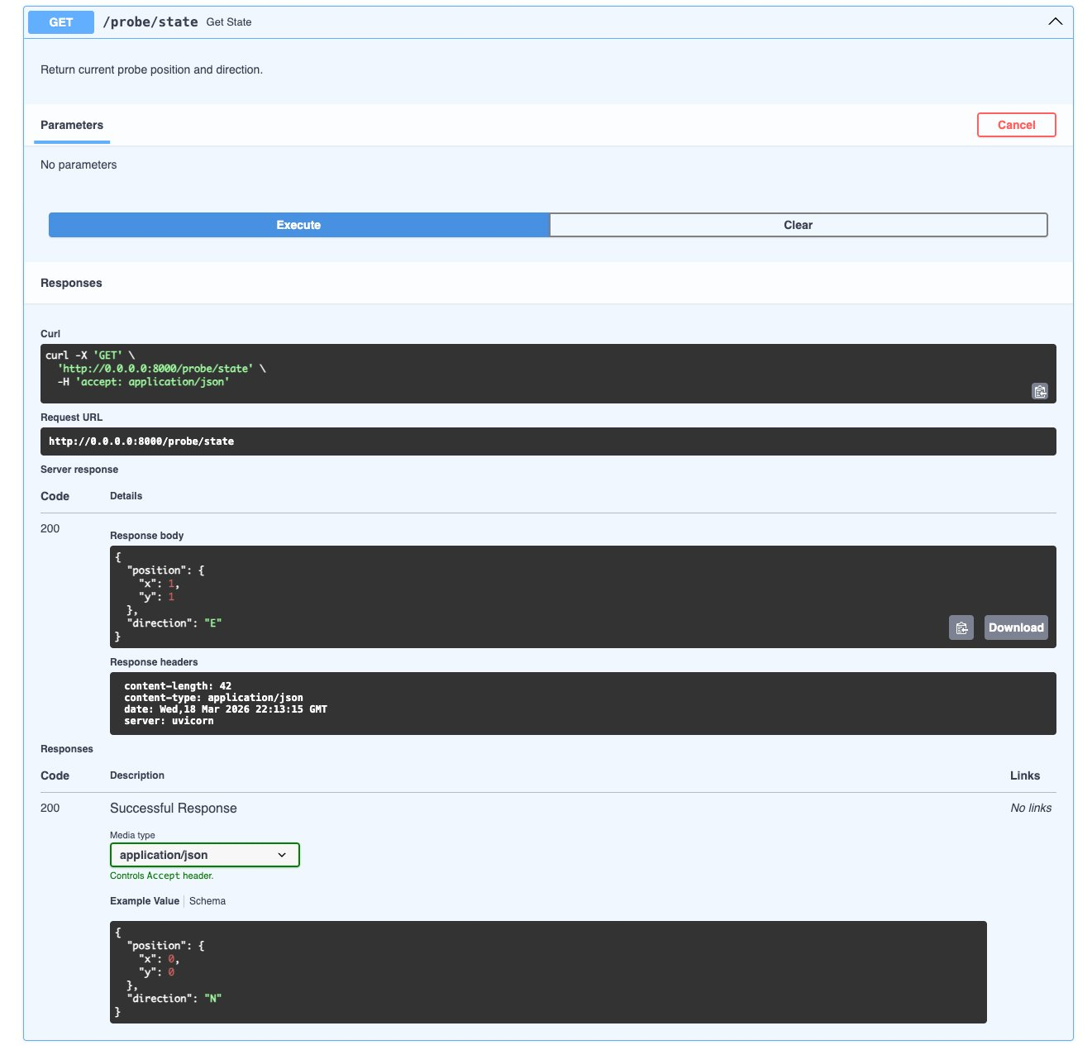
Figure 6 — GET /probe/state confirming position (1,1) direction E

7. Summary
All five API endpoints are confirmed operational. The complete command lifecycle has been demonstrated: initialisation → command execution → history retrieval → state query. The API correctly tracks position, direction, visited coordinates, and is running statelessly within a Docker container using uvicorn.

Endpoint verification matrix:
Endpoint | Method | HTTP | Status
/health | GET | 200 | ✓ PASS
/probe/initialise | POST | 200 | ✓ PASS
/probe/commands | POST | 200 | ✓ PASS
/probe/history | GET | 200 | ✓ PASS
/probe/state | GET | 200 | ✓ PASS

