|  |  |  |
| --- | --- | --- |
| @aprobador | @revisor | @firmante |

**DOCUMENTO FIRMADO DIGITALMENTE**

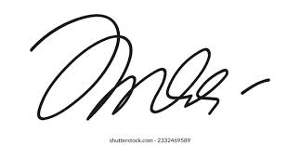

**Firmado por: Juan Pérez**  
Fecha de firma: 26/08/2025 20:26:43

__________________________________________________