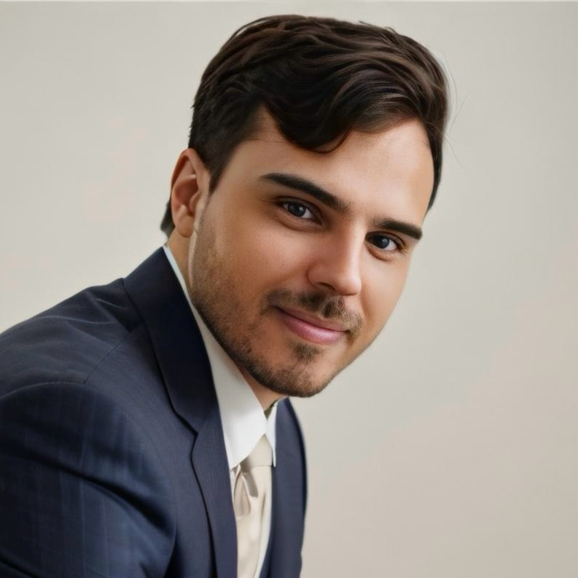 | FELIPI FERNANDES  Performance Specialist | Digital Marketing Expert | AI Researcher  Top 80 Google Ads Expert 2024 | BRL 15MM+ Annual Budget Manager | ROAS 10+  Location: Rio de Janeiro, Brazil | Phone: +55 21 96707-9559 | Email: felipi.fernandes@proton.me | LinkedIn: linkedin.com/in/felipifernandes

PROFESSIONAL SUMMARY
Marketing professional with over 12 years of experience driving growth across agencies, startups, fintechs, and publicly-traded companies. Currently serving as Performance Specialist at Profarma Group S/A, Brazil's second-largest pharmaceutical distributor listed on B3. Managing annual media budget of BRL 15 million generating returns exceeding BRL 180 million with ROAS consistently above 10. Led 20x e-commerce growth transformation since 2022. Fluent in English with expertise in data-driven marketing, AI innovation, and digital transformation, reporting directly to CEO.

KEY ACHIEVEMENTS
- Generated BRL 180+ million annual revenue with BRL 15 million media budget achieving ROAS above 10
- Drove 20x e-commerce growth at Profarma Group from 2022 to present
- Recognized as Top 80 Google Ads Expert globally in 2024
- Exceeded pre-launch targets by 400 percent securing 800+ pre-orders for Klever Safe crypto wallet
- Led digital transformation initiatives recognized as company highlight for 2023-2025 period

PROFESSIONAL EXPERIENCE
Performance Specialist
Profarma Group S/A (B3: PFRM3) | Rio de Janeiro, Brazil | February 2023 - Present
- Manage BRL 15 million annual paid media budget across 4 retail brands, 18,000+ SKUs, and 8 mobile applications
- Generate BRL 180+ million annual revenue maintaining ROAS consistently above 10
- Lead AI research and innovation initiatives reporting directly to Chief Executive Officer
- Achieved 20x e-commerce growth from 2022 baseline through strategic digital transformation
- Recognized as key contributor to digital transformation success 2023-2025
Growth Consultant - LATAM
Proton AG | Switzerland (Remote) | December 2023 - June 2024
- Developed global marketing campaigns for blockchain and fintech sectors
- Created privacy-focused demand generation strategies for Proton ecosystem
Senior Marketing Research Analyst
Klever | Estonia (Remote) | November 2020 - November 2022
- Managed multimillion-dollar global paid media campaigns across multiple markets
- Achieved 800+ pre-orders for Klever Safe hardware wallet exceeding target by 400 percent
- Developed comprehensive performance dashboards and KPI tracking systems
Growth Consultant
Getty/IO Inc. | United States (Remote) | December 2020 - November 2022
- Drove B2B growth strategies utilizing omnichannel marketing campaigns
- Enhanced prospect engagement through CRM optimization securing new business partnerships

TECHNICAL SKILLS
Paid Media Platforms: | Google Ads, Meta Ads, Campaign Manager 360, PPC Management, Affiliate Marketing
Analytics and Data: | Google Analytics 4, Looker Studio, SQL, A/B Testing, Data Analysis, KPI Development
Marketing Technology: | HubSpot, Google Tag Manager, SEO, Growth Marketing, Marketing Automation
Innovation and Strategy: | AI Research, Digital Transformation, Strategic Planning, Budget Management

CERTIFICATIONS AND RECOGNITION
- Google Experts 2024 - Recognized as Top 80 Google Ads Expert globally
- AI Immersion Workshop - Pareto (2025)
- Campaign Manager 360 Certification - Google Digital Academy
- Google Ads Metrics Certification - Google Skillshop
- Inbound Marketing Certification - HubSpot
- Contextual Marketing Certification - HubSpot
- Advanced English VI - CNA

EDUCATION
Bachelor of Marketing and Advertising
Anhembi Morumbi University | São Paulo, Brazil
Relevant Coursework: Digital Marketing, Strategic Planning, Consumer Behavior, Brand Management, Data Analytics, Project Management, Business Law, Product Development, Distribution Channels, Descriptive Statistics, Corporate Social Responsibility

LANGUAGES
- Portuguese - Native proficiency
- English - Full professional proficiency
- Spanish - Limited working proficiency

PROFESSIONAL RECOMMENDATIONS
Tiago Boscariol - HR Management, HR Business Partner
"Felipi is an excellent professional who demonstrates deep knowledge in his area and knows how to share it effectively with other teams."
Ivana Cajú - Strategic HR Business Partner, Global Career Advisor
"Felipi is an outstanding professional, always delivering excellence, proactivity, and dedication. With strong analytical and execution capacity, he brought new solutions to business challenges while collaborating effectively with teams."

