# EXECUTIVE SUMMARY

This report follows the structure of critical phases in a machine learning development process, following MLOps principles. We've progressed through initial phases such as Business and Data Understanding, Data Engineering (Data Preparation), and Machine Learning Model Engineering. Subsequently, we've focused on evaluating our Machine Learning Model, aiming to optimize Airbus fleet maintenance management and reduce Aircraft on Ground time (AOG) by identifying fuel leaks reliably and efficiently. In conclusion, we offer insights into future Deployment considerations and their potential impact on Airbus operations. Please find our code on GitHub.[1]

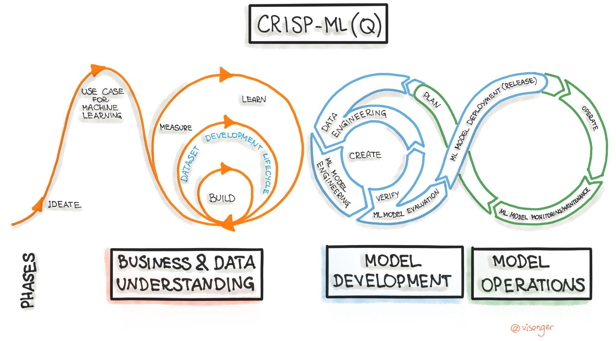[2]

The primary challenge we aim to address in collaboration with Airbus is the inherent inaccuracy of automatic fuel leak detection systems onboard aircraft. This inaccuracy stems from errors in fuel volume measurement within the tanks, often attributed to factors such as tank sealant degradation and structural damage to the fuel tanks themselves. These failures result in a critical problem for Airbus and its operators: the inability to promptly and accurately detect fuel leaks can lead to Aircraft on Ground (AOG) situations, where aircraft become unavailable for service. This not only disrupts individual flight schedules but can also have cascading effects on the entire fleet planning process and overall operational efficiency for operators. Moreover, it's important to note that the current detection system can only identify leaks, a minimum of a total sum of 3000kg, that exceed a certain threshold over time.

In developing our fuel leak detection model, we utilized an LSTM (Long Short-Term Memory) model for its ability to track and remember feature relationships over time. This approach has proven effective; through tests on various aircraft (MSN10-MSN53) ingested with artificial leakages, we've managed to identify about 10% of total leakages. This is significant because it allows us to catch leakages earlier, using just 2.5 minutes of flight data, thereby cutting down on unscheduled maintenance. A key strength of our model is its robustness, evidenced by a very low false-positive rate of less than 0.0136%. Maintaining such a low rate is vital to avoiding unnecessary AOG, crucial for Airbus's efficiency.

After potential future improvement of this model an implementation of it holds the promise of significant benefits for Airbus and its operators. By effectively identifying previously undetected smaller fuel leaks, the model has the potential to minimize unscheduled maintenance activities, thereby reducing associated costs and enhancing the overall availability of the fleet. Reducing high severity maintenance to low severity through earlier leakage detection, our model facilitates a substantial cost saving of approximately $88,622.05 or 54% of savings per early detected leak. This advancement stands to optimize operational efficiency and improve the reliability of Airbus aircraft, contributing to a more streamlined and cost-effective fleet management process.

# ETHICS STATEMENT

Madrid, 11th of March 2024

1. I, **Elisabeth Sophie Oeljeklaus**, hereby certify that this report and the accompanying presentation is my own original work in its entirety, unless where indicated and referenced.

___________________________

1. I, **Mateusz Talaryzck**, hereby certify that this report and the accompanying presentation is my own original work in its entirety, unless where indicated and referenced.

___________________________

1. I, **Felipe Gasparelli Dante**, hereby certify that this report and the accompanying presentation is my own original work in its entirety, unless where indicated and referenced.

___________________________

1. I, **Franco Braconi**, hereby certify that this report and the accompanying presentation is my own original work in its entirety, unless where indicated and referenced.

___________________________

1. I, **John Bolorinos Allard,** hereby certify that this report and the accompanying presentation is my own original work in its entirety, unless where indicated and referenced.

_________________________

# **TABLE OF CONTENTS**

**I. EXECUTIVE SUMMARY** **I**

**II. ETHICS STATEMENT** **II**

**TABLE OF CONTENTS 1**

**BUSINESS & DATA UNDERSTANDING 3**

Current Problem Statement 3

Data Structure and Availability 3

Impact Assessment: Multi-dimensional Analysis 4

Financial Projections: Cost-Benefit Analysis 5

**DATA ENGINEERING 6**

Feature Selection 6

Cleaning 6

Exclusion of Flights Exhibiting Irregular FOB Dynamics in Cruise Flight 7

Noise Reduction for Outliers 7

Feature Engineering 9

Data Augmentation 11

**ML MODEL ENGINEERING 13**

Baseline Model 14

Best Model 15

Model’s Explainability 16

**CONCLUSION 18**

**BIBLIOGRAPHY 20**

**APPENDIX 23**

Figures 23

ML Canvas 29

# 

# 

# **BUSINESS & DATA UNDERSTANDING**

The aviation industry is one of the most data-intensive sectors in the world, with every flight generating terabytes of data from various sources including aircraft sensors, operations, and maintenance logs. The industry’s reliance on data cannot be understated, as it drives safety, efficiency, and reliability in operations. In the context of aircraft carriers, the stakes are even higher due to the scale of operations and the critical nature of the missions undertaken. The detection and management of fuel leakages are paramount among these operational concerns. Historically they can be very dangerous, contributing to multiple tragedies like the China Airlines flight B18616[3], some had a positive ending like the Air Transat flight in 2001[4] or the United Airlines flight in 2023[5]. However, this does not change the fact that the lives of many people were placed in a position of unnecessary danger and the fuel leakage detection system could have detected the issues, sometimes even prior to take-off. Leveraging data to detect and address fuel leakages can not only prevent potential disasters but also save costs and maintain the operational readiness of the fleet.

## Current Problem Statement

The primary challenge we aim to address is the inherent inaccuracy of automatic fuel leak detection systems onboard aircraft. This inaccuracy stems from errors in fuel volume measurement within the tanks, often attributed to factors such as tank sealant degradation and structural damage to the fuel tanks themselves. These failures result in a critical problem for Airbus and its operators: the inability to promptly and accurately detect fuel leaks can lead to Aircraft on Ground (AOG) situations, where aircraft become unavailable for service. This not only disrupts individual flight schedules but can also have cascading effects on the entire fleet planning process and overall operational efficiency for operators. Moreover, it's important to note that the current detection system can only identify leaks, a minimum of a total sum of 3000kg, that exceed a certain threshold over time.

## Data Structure and Availability

We had granted access to flight sensor data from 8 aircraft, comprising approximately 500 flights, including test aircraft and those in active service. MSN02 served as our primary dataset for training and validation due to its significance in feature engineering, which we will discuss later. In total, this aggregated to around 24 million time-series data points. Each aircraft is equipped with 4 engines and 11 kerosene tanks: 5 in each wing and additional tanks for rear stabilization. Please refer to Fig. 1 in the Appendix.

The most pertinent features present in all aircraft include the sensor measurements of Fuel on Board VALUE_FOB in kilograms at each time point, and the fuel used per engine FUEL_USED_i in kilograms per second. Other crucial features include: Timestamp; Date; Flight number; Flight phase (from 1.Pre-Flight to 8. Cruise to 12. Post-Flight); Altitude; Pitch; Roll; Engine status; Fuel flow to each engine; Fuel quantity per collector cell; Pump status; Fuel transfer mode. MSN02 stands out not only for its nearly 100 additional sensor data features but also for the lesser incidence of missing values for fuel consumption compared to other aircraft. That is the reason we set our focus on MSN02. Addressing these missing values is essential, particularly for understanding fuel consumption behavior. It contains 42 flights spread from 2010 to 2017. Please refer to Fig. 2 in the Appendix.

## Impact Assessment: Multi-dimensional Analysis

We have used a machine-learning canvas to outline the steps needed to solve this problem, which allowed us to address all the complications. We identified that catching leaks earlier can save companies from lots of unscheduled maintenance costs. For that reason, we made it our mission to design a model where every second of the flight is considered, and data is processed on the go. By collecting fuel consumption data once per second, we can continuously adjust and improve the machine learning model so that it is constantly growing with current technology without being outdated. This led us to train a supervised multivariate time-series recurrent neural network which is called Long Short-Term Memory (LSTM) model.

We believe that early detection of minor fuel leaks offers significant benefits to Airbus as well as to the wider aviation community. For airlines operating new fleets, this helps strengthen their safety protocols, and improves their operational efficiency when they need it most: mid-air. Pilots, who need reliable information regarding fuel anomalies to make ad-hoc decisions in critical situations. To continue aircraft maintenance, tasks are performed based on flight hours or cycles time intervals. This makes sure that aircraft is checked and repaired in a routine manner thereby ensuring its safety. There are 50 hour inspections and 100 hour inspections done per aircraft, aimed at preemptive identification and rectification of potential issues.[6] Their aim is to identify potential issues in advance and fix them before they escalate. However, sometimes there might be unforeseen problems which will demand immediate attention to avoid any operational disruption and safety hazards, these are classified as unscheduled maintenance.

## Financial Projections: Cost-Benefit Analysis

Our model will significantly impact the financial aspects of aircraft maintenance by enabling the early detection of fuel leakages, thus shifting potential high severity unscheduled maintenance scenarios to low severity ones. In order to determine the costs we will take on 3 main assumptions; there are 5 workers working on the aircraft, each of them has 8 hour shifts, low severity takes 150 man-hours (3.75 working days for 5 employees) and high severity takes 560 man-hours (14 working days for 5 employees). For a low severity issue, the costs include 3.75 days for repairs, worker costs of $7,519.50, plane leasing fees of $24,191.25, airport fees of $780.80, and a one-time flight cancellation fee of $43,000, culminating in a total of $75,491.55. In contrast, high severity issues demand 14 days for resolution, with worker costs escalating to $28,072.80, plane leasing fees at $210,000, airport fees soaring to $210,000.00, alongside the same flight cancellation fee, leading to a staggering total of $164,119.60. By effectively reducing high severity maintenance to low severity through earlier leakage detection, our model facilitates a substantial cost saving of approximately $88,622.05 or 54%. It is important to note that these calculations do not account for potential business losses incurred during maintenance downtime or the variable costs associated with purchasing replacement parts, as these figures can fluctuate based on the specific circumstances surrounding each maintenance event.

| **Low Severity Maintenance** | |  | **High Severity Maintenance** | |
| --- | --- | --- | --- | --- |
| Days needed to fix a leakage | 3.75 |  | Days needed to fix a leakage | 14 |
| Total Worker Cost[7] | $7,519.50 |  | Tota Worker Cost | $28,072.80 |
| Total Plane leasing fee[8] | $24,191.25 |  | Total Plane leasing fee | $210,000.00 |
| Total Airport fee[9] | $780.80 |  | Total Airport fee | $2,732.80 |
| One time flight cancellation fee[10] | $43,000.00 |  | One time flight cancellation fee | $43,000.00 |
| **Total Sum** | **$75,491.55** |  | **Total Sum** | **$164,119.60** |

# **DATA ENGINEERING**

In this chapter, we outline the preparatory procedures conducted before initiating the Machine Learning Model Engineering phase of the MLOps process. This phase is critical, significantly influencing the model's performance and outcomes. Therefore, establishing specific data criteria was essential. The Data Engineering strategies implemented were initially formulated using data from MSN02, chosen for its consistency compared to other available aircraft data sets.

## Feature Selection

First and foremost we had to reduce the amount of features. To understand which features are in direct relation to leakage detection we followed the Airbus Safety Magazine instruction on low fuel awareness. *“The FOB, Fuel prediction and FOB/FU checks in cruise provide powerful means for detecting an abnormal fuel situation.”*[11] Understanding this relationship between the FOB quantity and the expected FOB we concluded to continue with the following features in MSN02: VALUE_FOB, FUEL_USED_1 to FUEL_USED_4 as well as FLIGHT_PHASE_COUNT, Flight, MSN and UTC_TIME.[12]

## Cleaning

Null Values

Now that we continue with only 9% of the initial amount of features in MSN02 we had to decide a strategy handling null values. We considered various strategies for managing these gaps, including interpolation, a common technique for filling in missing data points by making use of the available data. However, after careful consideration, we decided against using interpolation for several reasons:

* The dynamics of fuel usage and onboard fuel levels during flights are complex and subject to numerous variables, including flight phase, altitude, and operational conditions. This complexity makes accurate interpolation challenging, especially given the fluctuations in fuel metrics.
* Interpolating missing values, especially with a polynomial of degree 3, could potentially match the general trends in fuel consumption and levels. However, there was a significant risk that this approach would not capture the nuanced fluctuations accurately, potentially introducing bias into our analysis. Such bias could skew our understanding of normal versus anomalous fuel behavior, leading.

Given the considerations outlined above, our strategy focused on excluding data points with missing values in these critical features. This approach ensured that our analysis was based on the most reliable and accurate data available. By prioritizing data integrity over volume, we decided to discard the 11% of missing values for FLIGHT_PHASE_COUNT and the VALUE_FOB , as well as the 18% of missing values for the FUEL_USED_i columns. Additionally we discarded the second duplicated flight V0889. All this reduced our MSN02 dataset by approximately 19% to now about half a million time-series data points.

### Exclusion of Flights Exhibiting Irregular FOB Dynamics in Cruise Flight

Following the guidelines established in the Feature Selection section and supported by insights from Marani, our analysis will focus on flights during the cruise phase. As illustrated in the subsequent figure, approximately 80% of the data for MSN02 pertains to this phase of flight. While the overall average flight duration for MSN02 is 4 hours, the cruise phase constitutes about 75% of this time, effectively making the average duration of the cruise phase approximately 3 hours. Please refer to Fig. 3 in the Appendix.

To exclude flights from MSN02 which show irregular FOB dynamics, we created features such as DATE, TIME and VALUE_FOB_change. By plotting the VALUE_FOB and its change VALUE_FOB_change of each flight in cruise flight, we were able to identify around 5 flights showing abnormal FOB dynamics and excluded them in the following procedures. We decided to discard them based on the massive range in VALUE_FOB_change and ended up removing 4 flights. Please refer to Fig. 4 and 5 in the Appendix

### Noise Reduction for Outliers

Approximately 50% of the remaining flights in MSN02 exhibited typical FOB patterns, although they occasionally displayed outlier values. To mitigate this noise and minimize its impact on model training, we experimented with several smoothing techniques. Specifically, for addressing outliers in the FUEL_USED_TOTAL column, we opted for a Gaussian filter with a sigma of 10, as it introduced minimal bias while effectively smoothing the data. Our approach, techniques, and methods of comparison for this process were consistent with those we applied to the FOB feature, which is detailed in subsequent sections.

Median Filtered

The Median Filter is a non-linear digital filtering technique, often used to remove noise from images or signals. It operates by moving through the data point by point, replacing each value with the median of neighboring values within a specified window size. This method is particularly effective at preserving edges while removing outliers, making it ideal for applications where the preservation of sharp transitions is crucial. In the context of flight data, applying a median filter to the FOB dynamics can smooth out erratic spikes without significantly altering the underlying trend. Please refer to Fig. 6 in the Appendix.

Gaussian Filter

The Gaussian Filter utilizes a Gaussian function to smooth data, effectively reducing noise and details in the process. By applying a convolution between the data and a Gaussian kernel of a specified standard deviation (sigma), this filter weights neighboring data points according to their distance from the central point, with closer points having a higher influence. The choice of sigma determines the extent of smoothing: a higher sigma value results in greater smoothing.[13] Please refer to Fig. 7 in the Appendix.

Savitzky-Golay (Savgol) Filter

The Savitzky-Golay Filter, or Savgol filter, is designed to preserve higher momentums within a dataset, making it good at maintaining the needed characteristics of the original signal while smoothing. It accomplishes this by fitting successive subsets of adjacent data points with a low-degree polynomial by the method of least squares. This approach allows for smoothing the data while preserving features like peaks, valleys, and width, which are critical for interpreting the dynamics of the dataset accurately. When applied to FOB data, the Savgol filter can effectively reduce noise while maintaining the integrity of significant flight characteristics.[14] We tried out a stronger Savgol (window_size = 51, poly_order=3) and a softer one with (window_size = 31, poly_order=2). Please refer to Fig. 8 in the Appendix.

Comparison

In our comprehensive analysis of various filtering techniques applied to the VALUE_FOB data from MSN02, it became evident that the Gaussian Filter with a Sigma of 10 achieved a remarkable average noise reduction of approximately 73%. This level of noise attenuation underscores the Gaussian filter's efficacy in smoothing the data. However, despite its superior performance in noise reduction, our decision to proceed with the Savitzky-Golay (Savgol) Filter was driven by its qualitative impact on the data representation, particularly its preservation of critical signal features. The Savgol Filter, with an average noise reduction of 65%, demonstrated a balanced approach by effectively reducing noise while maintaining the integrity of the signal's sharper transitions, such as less rounding at the corners. This characteristic is essential for our analysis, where the precise delineation of signal features could be pivotal. Please refer to Fig. 9 in the Appendix.

Moreover, the decision to refine our dataset to include only data from flight phase 8 for subsequent analysis was informed by the observation of edge effects introduced by the filters. Edge effects—distortions at the beginning and end of the signal caused by the filtering process—can significantly impact the accuracy of feature detection and signal interpretation.[15] By focusing on flight phase 8, we aim to erase these edge effects, choosing only cruise phase which is stable and representative, to ensure that our analysis is grounded in the most reliable and undistorted data possible. After filtering for data points we reduced MSN02 to approximately 360.000 time-series data points. This strategy allows us to use the strengths of the Savgol Filter, optimizing our dataset for precision in detecting and analyzing anomalies within the VALUE_FOB measurements.

## Feature Engineering

To understand how a leakage appears we can refer to what Marani mentioned in the Airbus Safety First Magazine: “*Any marked difference in FOB quantity compared to the''* expected FOB in the flight plan, *“may reveal either: A fuel over-burn due to airplane configuration degradation, caused by aerodynamic drag or an external fuel leakage.”*[16]

Understanding relationship between the FOB quantity and the expected FOB we and to identify the best smoothing technique for our data we introduced the following features:

| **No.** | **Name** | **Formular** |
| --- | --- | --- |
| 1 | Total Fuel Consumption per Time Unit (t) |  |
| 2 | Change in Total Fuel Consumption per Time Unit (t) |  |
| 3 | Cumulative Fuel Consumption until Time Unit (t) |  |
| 4 | Estimated Fuel on Board in kg |  |
| 5 | Fuel On Board Discrepancy per Time Unit (t) |  |
| 6 | Change in Fuel On Board Discrepancy per Time Unit (t) |  |
| 7 | Cumulative Fuel On Board Discrepancy until Time Unit (t) |  |
| 8 | Elapsed Time (t) Since Start of Flight |  |
| 9 | Leakage Indicator pe Time Unit (t) |  |

Fig. 10: Overview Feature Engineering

Initially, we aggregated the fuel used by each of the four engines, measured in kilograms per second (Kg/s), to obtain the total fuel consumption rate of the aircraft at any given time (t), denoted as FUEL_USED_TOTAL. This summation provided us with a unified view of the aircraft's fuel consumption rate, encapsulating the collective contribution of all engines to the fuel usage.

Following this, we determined the change in fuel consumption over time by calculating the difference in FUEL_USED_TOTAL between consecutive time points. This calculation, represented as FUEL_USED_TOTAL_change, offered insights into the variations in fuel consumption rates, enabling us to track increases or decreases in fuel usage as the flight progressed.

To further our analysis, we summed these changes in fuel consumption over time to ascertain the cumulative amount of fuel used by the aircraft up until any point in time (t), termed FUEL_USED_TOTAL_cumulative. This cumulative figure allowed us to understand the total fuel expenditure over the course of the flight, providing a comprehensive picture of fuel usage.

Lastly, we estimated the remaining FOB at any time (t) by subtracting the cumulative fuel used from the initial fuel load, denoted by the first value of VALUE_FOB at t=0. This calculation, FOB_EST, yielded an estimated value of the remaining fuel on board, taking into account the total fuel consumed up to that point. This step was crucial for monitoring fuel levels over time, offering a valuable tool for assessing the aircraft's fuel status and ensuring efficient fuel management throughout the flight.

In our analysis, we next tackled the discrepancy between the estimated and actual FOB to identify potential fuel leakage. This was accomplished by calculating the difference between the estimated FOB_EST and the measured VALUE_FOB at each time point (t), denoted as DISCREPANCY. A positive discrepancy, where the estimated FOB exceeds the actual FOB, might suggest a leakage, especially if this error remains consistently positive and exhibits a linear growth over time, indicating ongoing fuel loss.

To delve deeper into the dynamics of this discrepancy, we introduced an additional metric,DISCREPANCY_change, representing the change or growth in discrepancy between consecutive time points. This measure helps us track how the discrepancy evolves during the flight, providing insights into the rate at which potential fuel loss occurs.

Further refining our analysis, we calculated the cumulative change in discrepancy, DISCREPANCY_change_cumulative to quantify the total potential fuel lost up to any given moment during the flight. This cumulative metric aggregates the changes in discrepancy over time, offering a clearer picture of the total fuel potentially leaked as the flight progresses.

Moreover, to enhance the model's understanding of the flight's progress, especially regarding fuel dynamics, we introduced the TIME_ELAPSED metric. This metric calculates the time elapsed since the commencement of flight phase 8, marking a critical phase for analyzing fuel usage and potential leakage. By measuring the difference between the current UTC_TIME and time at the start of phase 8, we provide the model with a temporal context, facilitating a more nuanced analysis of fuel consumption patterns and anomaly detection throughout this crucial flight phase.

## Data Augmentation

We generated artificial flights by introducing a range of constant leakage rates into copies of existing flight data. This involved iterating over selected flights, randomly choosing a point within flight phase 8 to start the leakage, and then adjusting the FOB values to reflect the leakage rate, by subtracting from measured FOB Value the leakage rate per second. We create 3 categories of leakages, big (1 kg/s), medium (0.8 kg/s) and small (0.5 kg/s). This method allowed us to simulate different leakage scenarios systematically.

The leakage simulation was expected to result in a noticeable linear growing discrepancy between the estimated FOB_EST, calculated based on initial FOB values minus cumulative fuel used, and the actual VALUE_FOB. Post-leakage, the actual FOB would decrease more rapidly than estimated due to the unaccounted leakage, manifesting as a consistent and possibly linearly growing negative discrepancy, indicative of potential fuel leakage.

To confirm and visualize the leakage impact, we plotted VALUE_FOB against FOB_EST over time for flights with simulated leakage. The onset of leakage is marked by a continuous linear growing divergence where VALUE_FOB begins to decrease more sharply compared to FOB_EST clearly indicating the leakage starting point. Please refer to Fig. 11 in the Appendix.

We created a set of 36 artificial flights, each with a distinct identifier and a series of new UTC timestamps to maintain a consistent timeline. Additionally, we introduced a REAL_LEAK column that acts as a flag: it's set to 1 at the onset of leakage for the remainder of the flight, allowing for straightforward detection of leaks in the data. Subsequently, these artificial flights were merged with the preprocessed data from MSN02. The final dataset now comprises 36 flights with induced leaks and 38 regular flights without leaks, all recorded during the cruise phase of flight. The artificial flights are evenly distributed, with half placed before and the other half after the standard flights. This balanced distribution across the leakage rate categories (each contributing 6 flights) ensures that our model training is robust, with an equal representation of both classes.

Please refer to Fig. 12 in the Appendix.

# **ML MODEL ENGINEERING**

In the landscape of contemporary analytics, traditional statistical methods and dimensionality reduction techniques like Principal Component Analysis (PCA) are often insufficient for the dynamic demands of long-term deployment. To address the challenges posed by the supervised classification of time-series data—specifically, the detection of anomalies in fuel consumption—we pivoted to the domain of Recurrent Neural Networks (RNNs), with a particular focus on Long Short-Term Memory (LSTM) networks.

LSTMs excel in managing time-series data, thanks to their capacity to maintain long-term dependencies. This ability is particularly advantageous when discerning the gradual, linearly increasing divergence between Estimated FOB and actual FOB, which is symptomatic of leak scenarios. Leveraging the LSTM's prowess, we have crafted a model adept at learning the intricate patterns of fuel consumption over extended periods, including the incremental changes characteristic of fuel leaks. Such sophisticated modeling is imperative for the nuanced task of anomaly detection within aviation data.[17]

In our quest for the optimal model, we undertook approximately four distinct training iterations, each serving as a learning opportunity and a stepping stone toward our final model. The iterative process and the artifacts produced, including code snippets, model parameters, and exploratory notebooks, have been archived in a repository we have named 'Sandbox.' These are the various factors we manipulated in order to get to our current best model:

* Model Architecture: We experimented with different regularization techniques and varied the number of layers to mitigate overfitting and enhance generalization.
* Model Hyperparameters: Adjustments to the learning rate and batch size were made in pursuit of optimal model performance.
* Input Features
* Train/Validation Split Strategies: The division of data into training and validation sets was approached strategically to ensure that the model is tested on a representative sample of unseen data.
* Artificial Leak Ingestion Strategies: To augment the training data, artificial leak scenarios were injected, thereby enriching the dataset with diverse instances of anomalies.
* Time Sequence Generator Strategies: We employed sophisticated techniques to construct time sequence generators, ensuring that each input sequence is appropriately formatted and aligned with the LSTM's requirements.

## Baseline Model

A baseline model was established to set a performance benchmark against which subsequent models could be measured. It began with a straightforward architecture consisting of a singular LSTM layer, with 64 units, followed by a dense output layer. The model had 17,729 trainable parameters. Please refer to Fig. 13 in the Appendix.

In our model, we used the Adam optimizer for its efficiency with large data and its robust performance with noisy input.[18] We chose binary cross-entropy as our loss function because it effectively measures the accuracy of our binary classifications.[19] The model's performance was assessed using the accuracy metric, which simply tracks the percentage of predictions that are correct.

By training over five epochs with a batch size of 64 and processing sequences of 60 seconds, the aim was for the LSTM to assimilate the temporal dynamics of the dataset. Despite the model attaining commendable accuracy during training, a pronounced discrepancy between its performance on the training data versus the validation set was observed. This was indicative of overfitting; the model's high training accuracy failed to materialize on the validation data, suggesting an inclination towards memorization rather than genuine pattern recognition.

When this model was subjected to the test dataset from the remaining aircrafts (MSN10- MSN53), its limitations were visible. The imbalanced data led to a misclassification of over half the instances, revealing the model's inability generalizing to real-world, imbalanced scenarios.

Training and Validation Accuracy

Throughout the training phase, the model's accuracy on the training set saw an upward trajectory, starting at 87.48% and culminating at 92.24% by the final epoch. In contrast, the validation accuracy experienced a peak and a slight dip, commencing at 96.74%, peaking at 97.86%, and then settling at 97.17% by the fifth epoch. The above trends are encapsulated in Figure 14, which portrays the stability and convergence of the model, with validation accuracy consistently outperforming training accuracy—a promising indicator of the model's generalization. Please refer to Fig. 14 in the Appendix.

Confusion Matrix

The confusion matrix depicted in Figure 15 illustrates the model's predictive progress. Notably, the matrix exhibits a high number of true positives and true negatives, with an absence of false negatives and false positives, underscoring the model's discriminative capabilities in this controlled testing environment. Please refer to Fig. 15 in the Appendix.

The baseline model's high validation accuracy relative to its training accuracy, alongside its impeccable confusion matrix, may imply a model that is yet to be fully challenged by data complexity or one that has been evaluated on a non-representative subset of the data. Future iterations will delve into more intricate architectures, incorporate regularization techniques, and explore data augmentation to bolster the model's robustness and ensure reliable performance under varied operational conditions.

A discernible gap between training and validation accuracies was observed, signaling potential overfitting. This phenomenon suggests a model adept at recalling training data but lacking in its capacity to generalize these findings to new, unseen data.

The model's performance on new, unbalanced datasets highlighted a critical flaw in its ability to generalize, evidenced by a misclassification rate exceeding 50%. Such a limitation is untenable in practical applications, where data imbalances are the norm rather than the exception.

## Best Model

In our continuous efforts to improve our anomaly detection system, we have developed an upgraded model, referred to as "Best_Model". This version builds on previous models by incorporating improved data preprocessing techniques and increasing the training sequence length.

We've standardized our feature set using a StandardScaler, which normalizes the data for consistent interpretation by the model. A binary helper column called , Has_Leak, has been added to our dataset to help with the split, ensuring that the distribution of training and validation data accurately reflects normal flights and artificial flights with leaks.

The model's sequence length has been extended from 60 to 150 seconds to allow the model to capture the continuously linear growing divergence between the measured FOB and estimated FOB.

The model consists of two LSTM layers with interspersed Dropout layers at a rate of 0.2 to reduce overfitting. The output layer uses a sigmoid activation function to predict the probability of a leak.[20] Please refer to Fig. 16 in the Appendix.

We have also refined the DataGenerator class to handle sequences of varying lengths, adding padding where needed and adjusting batch sizes dynamically for prediction. This is especially important for accommodating the test data from (MSN10 - MSN53) that does not fit the sequence pattern.

The model's training outcomes have shown variable results, indicating areas where further model adjustments could be beneficial. Moving forward, we will concentrate on hyperparameter optimization, testing different sequence lengths, and improving our sequence padding approach to enhance model accuracy.

## Model’s Explainability

In assessing the performance of our model, we conducted a series of tests on the MSN10 - MSN53 dataset, processed in the same manner as our training set, MSN02. Initially, the model demonstrated a 100% accuracy rate, correctly predicting all instances in a test set devoid of any leaks.

This perfect score prompted further investigation since the absence of errors seemed improbable. Subsequently, we introduced artificial leakages to the test data to mimic potential real-world scenarios more closely.

The first attempt included 30 synthetic flights with varying leak rates: 10 flights with a leak rate of 1 kg/s, 10 flights with 0.8 kg/s, and 10 flights with 0.5 kg/s. The confusion matrix from this test showed that the model retained high accuracy, but the existence of false negatives suggested room for improvement. A second attempt with 20 flights, split evenly between 1 kg/s and 0.8 kg/s leak rates, resulted in similar outcomes, indicating consistent model behavior under altered conditions. Please refer to Fig. 17 in the Appendix.

The third and final test attempt introduced the most extreme conditions, with 10 flights each experiencing a significant leak rate of 20 kg/s. This test aimed to push the model's limits and resulted in a recall rate of 10%, revealing the model's sensitivity to high-variance leakage events. Most importantly though is the low False Positive Percentage of only 0.0137%. Keeping this percentage as low as possible is crucial, because we need to reduce unnecessary aircraft downtime (AOG). These tests underscored the model's robustness against moderate leakages but also its vulnerability to more extreme conditions, thereby providing valuable insights into its operational thresholds and aiding in further calibration for enhanced performance. Please refer to Fig. 18 in the Appendix.

The inability of the model to generalize to unseen test data from other aircraft (MSN10-MSN53), despite its high accuracy on the initial validation set, points to several potential issues. The model may be generalizing to the training data (MSN02), capturing idiosyncratic noise rather than underlying patterns applicable across different datasets. A shift in data distribution between the training set and the new test data can also contribute to this problem, especially if the test data introduces new variables or patterns not present in the training set. This can be exacerbated by class imbalance if the training data did not adequately represent the variety or frequency of leakages that the model encountered during testing.

Additionally, the features used for training might not be robust enough to handle the variability in the new data, suggesting a need for improved feature engineering. The complexity of the model could also be a factor; if it is too simple, it might not capture necessary complexity (underfitting), but if too complex, it might perform well only on the training data (overfitting). Another consideration is the quality and representativeness of the test data — if the artificial leakages introduced do not accurately mimic actual leaks, the model may not respond to them as expected. Improving the model's ability to generalize will likely involve collecting a more diverse set of training data, incorporating regularization techniques, reevaluating the feature set, applying different validation strategies, ensuring realistic leakage simulation, and fine-tuning the model's complexity. This multifaceted approach is essential for developing a robust model capable of accurate predictions across a range of operational scenarios and different aircraft systems

# **CONCLUSION**

To conclude, we believe that working with an LSTM was the right choice regarding its functionality to remember dependencies and relationships of features over time. As a result of testing the model on the other aircrafts (MSN10-MSN53), we are able to truly classify ~10% of the total leakages. Which decreases unscheduled maintenance because we are able to identify those leakages earlier by only monitoring 2,5 min of flight data. Moreover, we want to highlight the most important functionality of our model. Its robustness, which led to an extremely low False-Positive-Percentage of less than 0.014% of falsely predicted leakages. Keeping this percentage as low as possible is crucial as we need to reduce unnecessary aircraft downtime (AOG). This is essential for Airbus’s business efficiency.

Therefore detecting fuel leakages with LSTM is possible, but we still have room for improvement even with our best model. The data quality of the train and validation data was better than the data quality of the test data (MSN10-MSN53), likely due to longer cruise flight sequences or better noise reduction techniques.

We want to add some future improvement in the Pre-Deployment phase. Our goal is to further improve Recall and therefore also our Precision. Meaning, classify as many leakages as possible and do that with a high accuracy. We want to continue working on the LSTM but we believe the following changes in the training process of the model might help us with that goal:

1. Add an additional created training feature called FOB_BASE. Which is the sum of TOTAL_FUEL_USED and VALUE_FOB at any given time t. If FOB_BASE is then decreasing compared to VALUE_FOB it is another approach to make sure the leakage is classified as one in our training data. Please refer to Fig. 19 in the Appendix.
2. We need a higher quality of data, by reducing noise of FUEL_USED and VALUE_FOB more confidently. We believe that by integrating an additional neural network architecture, which could provide a more granular understanding of the data, and act as a filter, would improve the early leakage detection furthermore. The introduction of an autoencoder pre-model to sieve out stable flights will improve the data quality of the training and validation data, focusing our resources on high-risk scenarios..[21]
3. Experiment and find a better test / validation split strategy as well as more robust Time Sequence Generation when training the model.
4. Experiment during training with libraries like Keras Tuner[22] for hyperparameter selection in the modeling process such as increasing the number of epochs with access to more GPU power, finding the right learning rate, and changing the optimizer.

Future Perspective & Deployment  
When looking ahead, we anticipate further refinement in the Post-Deployment stage, by collecting new and diverse data. This continuous learning cycle ensures our model evolves in step with the complexities of real-world operations. Furthermore, a robust model governance framework will be paramount to oversee the model's performance and ethical considerations, maintaining transparency and accountability in its deployment.

To end this project, we would like to state the possible implementation of the model developed by our team would mark a significant advancement in Airbus's diagnostic capabilities. By identifying leaks that may go unnoticed during routine visual inspections our model aims to improve the accuracy and efficiency of leak detection within aircraft fuel tanks. Successful implementation of this model holds the promise of significant benefits for Airbus and its operators. By effectively identifying previously undetected fuel leaks, the model has the potential to minimize unscheduled maintenance activities, thereby reducing associated costs and enhancing the overall availability of the fleet. Reducing high severity maintenance to low severity through earlier leakage detection, our model facilitates a substantial cost saving of approximately $88,622.05 or 54% of savings per early detected leak. This advancement stands to optimize operational efficiency and improve the reliability of Airbus aircraft, contributing to a more streamlined and cost-effective fleet management process.

# **BIBLIOGRAPHY**

Aena (2023) ‘Price Guide’, February Edition. Available at: https://empresas.aena.es/ae-statics/Lists/Documentos%20generales/Attachments/96/Aena%20price%20guide.pdf (Accessed: 8 March 2024).

Airbus (2010) 'Maintenance Briefing Notes', October. Available at: https://skybrary.aero/sites/default/files/bookshelf/4021.pdf (Accessed: 29 February 2024).

Airlines for America (2023) 'U.S. Passenger Carrier Delay Costs', 24 May. Available at: https://www.airlines.org/dataset/u-s-passenger-carrier-delay-costs/ (Accessed: 1 March 2024). © 2024 Airlines for America (A4A). All rights reserved.

Chandler, Charles (2012)‘MRO Operation: Finding and Fixing Fuel System Leaks*’*, Aviation Pros, 27 February, Available at:<https://www.aviationpros.com/engines-components/aircraft-airframe-accessories/fuel-systems/article/10618623/mro-operation-finding-and-fixing-fuel-system-leaks> (Accessed: 28 February 2024).

Cummins, N. (2020) 'How Much Does It Cost To Have An Aircraft On Ground (AOG)?', *Eways Aviation*, 9 June. Available at: https://www.eways-aviation.com/blog/how-much-does-it-cost-to-have-an-aircraft-on-ground-aog (Accessed: 8 March 2024).

Dolphin, R. (2020) 'LSTM Networks: A Detailed Explanation', *Towards Data Science*, 21 October. Available at: https://towardsdatascience.com/lstm-networks-a-detailed-explanation-8fae6aefc7f9 (Accessed: 29 February 2024).

Ellis, R. (2020) 'What Is Scheduled and Unscheduled Aircraft Maintenance?', ASAP AOG, 7 February. Available at: https://www.asapaog.com/blog/what-is-scheduled-and-unscheduled-aircraft-maintenance/ (Accessed: 29 February 2024).

Finlay, M. (2023) 'How Much Do Canceled Flights Cost Airlines?', Simple Flying, 22 September. Available at: https://simpleflying.com/how-much-do-canceled-flights-cost-airlines/ (Accessed: 1 March 2024).

Godoy, D. (2018) 'Understanding Binary Cross-Entropy / Log Loss: A Visual Explanation', *Towards Data Science*, 21 November. Available at: https://towardsdatascience.com/understanding-binary-cross-entropy-log-loss-a-visual-explanation-a3ac6025181a (Accessed: 1 March 2024).

Japan Transport Safety Board (2009) 'Aircraft Accident Investigation Report: China Airlines B18616', Ministry of Land, Infrastructure, Transport and Tourism, 28 August, Available at: https://www.mlit.go.jp/jtsb/eng-air_report/B18616.pdf (Accessed: 27 February 2024). Translated by the Japan Transport Safety Board.

Jaroch, Walker (2021) 'Detecting and Mitigating Fuel Leaks with Technology', Aviation Pros, 7 October. Available at: https://www.aviationpros.com/gse/fueling-equipment-accessories/fuel-leak-detection/article/21237817/detecting-and-mitigating-fuel-leaks-with-technology (Accessed: 28 February 2024).

Jet Solutions 4U (no date) *Best Practices for Fuel System Maintenance and Repair in Aviation*. Available at:<https://www.jetsolutions4u.com/post/best-practices-for-fuel-system-maintenance-and-repair-in-aviation> (Accessed: [Access Date]).

Keras (no date) 'Adam optimizer', Keras API documentation. Available at: https://keras.io/api/optimizers/adam/ (Accessed: 2 March 20204).

Keras (no date) ‘Keras Tuner’, Keras API documentation. Available at:<https://keras.io/keras_tuner/> (Accessed: 8 March 2024)

Larzalere, B. (2019) 'LSTM Autoencoder for Anomaly Detection', *Towards Data Science*, 25 September. Available at: https://towardsdatascience.com/lstm-autoencoder-for-anomaly-detection-e1f4f2ee7ccf (Accessed: 29 February 2024).

Marani, F. (2008) 'Low Fuel Situations Awareness', Safety First, Airbus S.A.S, 6 July. Available at: https://safetyfirst.airbus.com/app/themes/mh_newsdesk/documents/archives/low-fuel-situations-awareness.pdf (Accessed: 29 February 2024).

Phillips, A. (2023) 'United Airlines Flight Emergency as Fuel Leaks Out of Plane After Takeoff', Newsweek, 12 December. Available at: https://www.newsweek.com/united-airlines-flight-emergency-fuel-leak-newark-nj-1851577 (Accessed: 27 February 2024).

Sharma, S. (2017) 'Activation Functions Neural Networks', *Towards Data Science*, 6 September. Available at: https://towardsdatascience.com/activation-functions-neural-networks-1cbd9f8d91d6 (Accessed: [Access Date]).

Smith, S.W. (1997) The Scientists and Engineers Guide to Digital Signal Processing.

Transfer Travel (no date) *How Much Airlines Really Make from Your Ticket*. Available at:<https://www.transfertravel.com/blog-posts/how-much-airlines-really-make-from-your-ticket> (Accessed: [Access Date]).

Visengeriyeva, L., Kammer, A., Bär, I., Kniesz, A., & Plöd, M. (no date) 'CRISP-ML', ML Ops, attributed to INNOQ. Available at: https://ml-ops.org/content/crisp-ml#acknowledgements (Accessed: 28 February 2024). Design by Sebastian Eberstaller. Published under Creative Commons Attribution 4.0 International Public License.

Wikipedia (no date) *Air Transat Flight 236*. Available at:<https://en.wikipedia.org/wiki/Air_Transat_Flight_236> (Accessed: [Access Date]).

Wroński, B. (2021) 'Practical Gaussian filtering: Binomial filter and small sigma Gaussians', 31 October. Available at: https://bartwronski.com/2021/10/31/practical-gaussian-filter-binomial-filter-and-small-sigma-gaussians/ (Accessed: 29 February 2024).

Wroński, B. (2021) 'Study of Smoothing Filters: Savitzky-Golay Filters', 3 November. Available at: https://bartwronski.com/2021/11/03/study-of-smoothing-filters-savitzky-golay-filters/ (Accessed: 29 February 2024).

# **APPENDIX**

## Figures

Fig.1 Dataset Overview - page

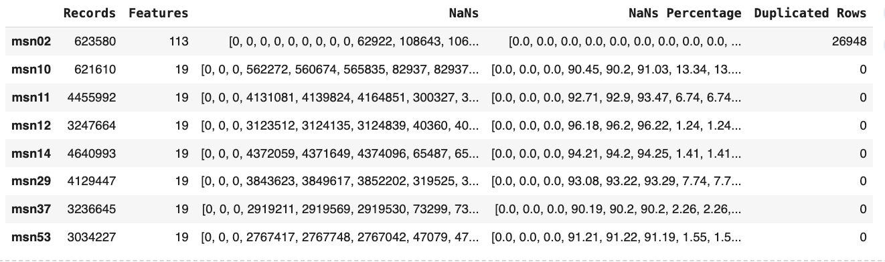

Fig.2: Gantt Overview Flights in MSN02

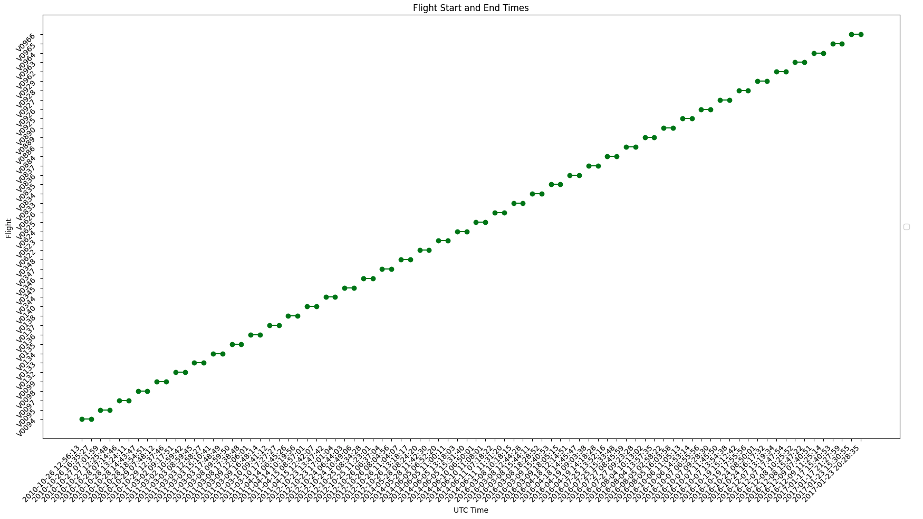

Fig. 3 Importance of Cruise Flight Data

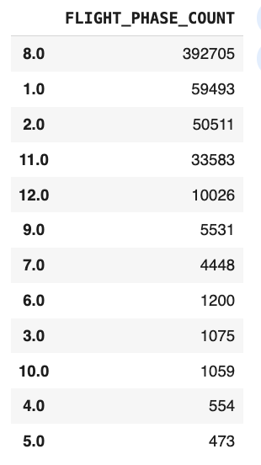

Fig.4: Normal FOB Dynamic with a maximum fluctuation of only |20| kg/s

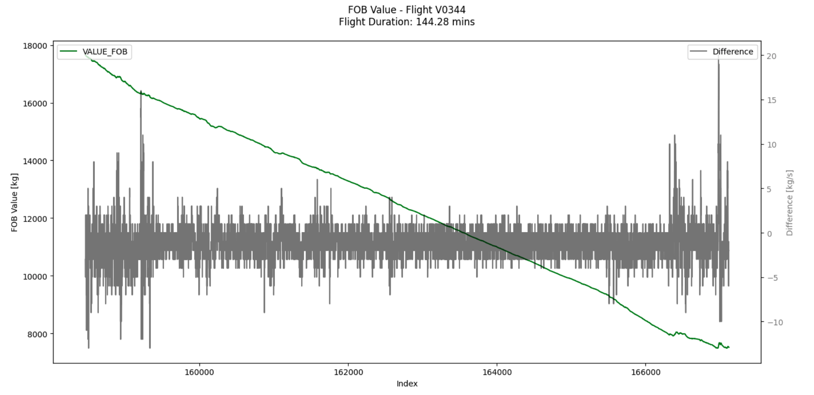

Fig.5: Irregular FOB Dynamic with a maximum fluctuation of over |60| kg/s

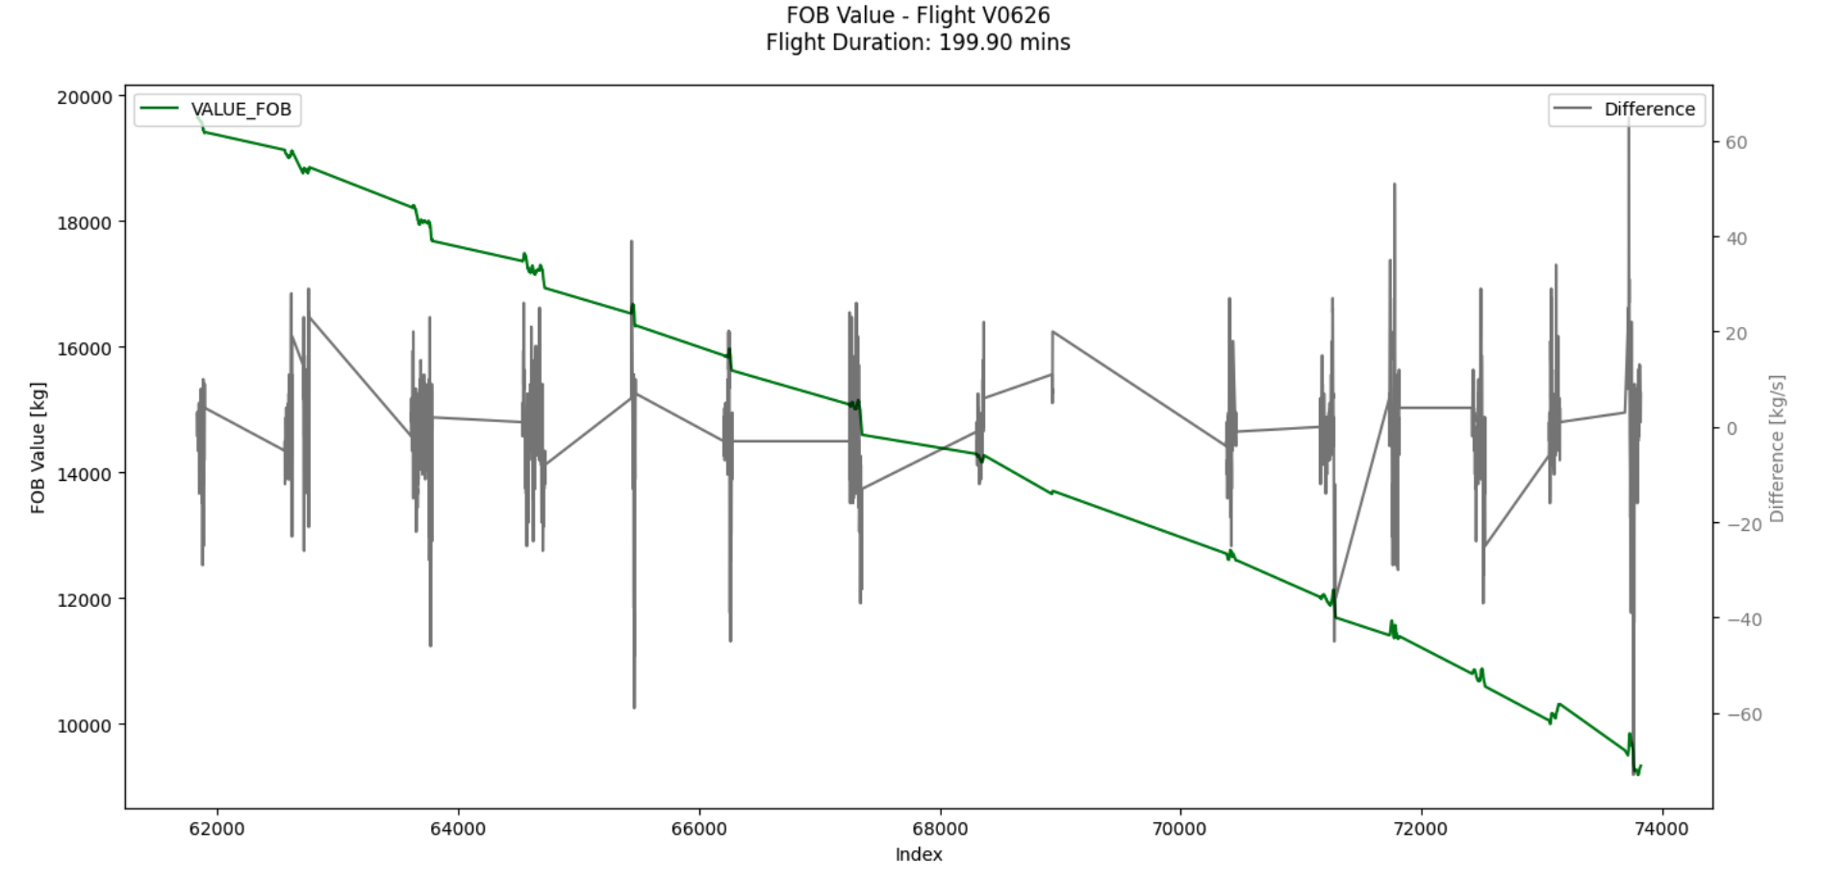

Fig. 6: Comparison of median filtered FOB change and original FOB change

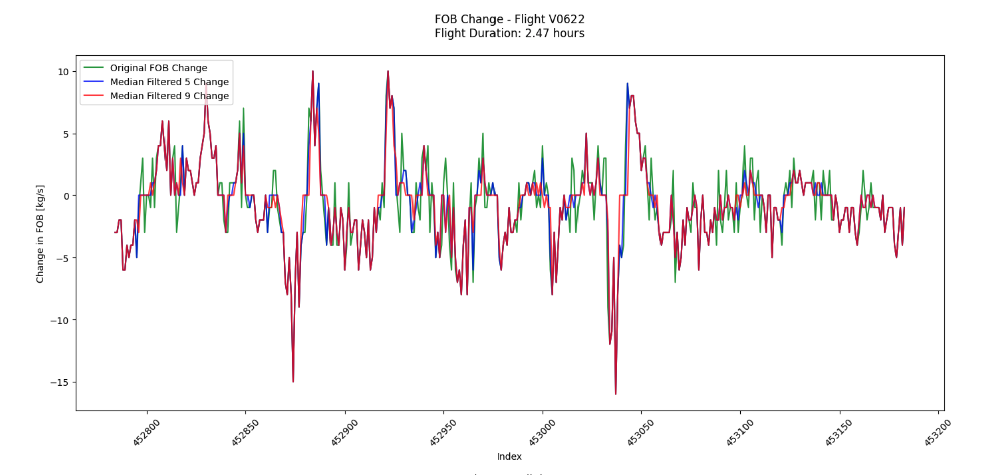

Fig. 7: Comparison of gaussian filtered FOB change and original FOB change

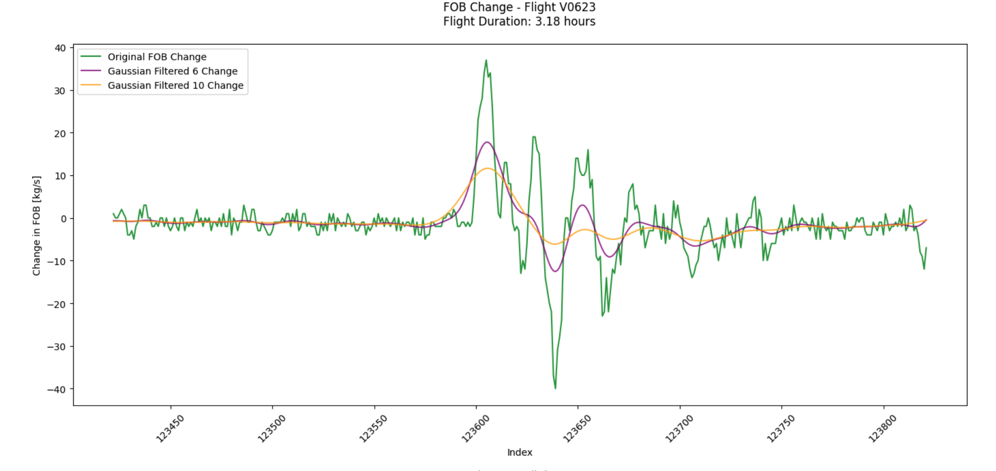

Fig. 8: Comparison of savgol filtered FOB change and original FOB change

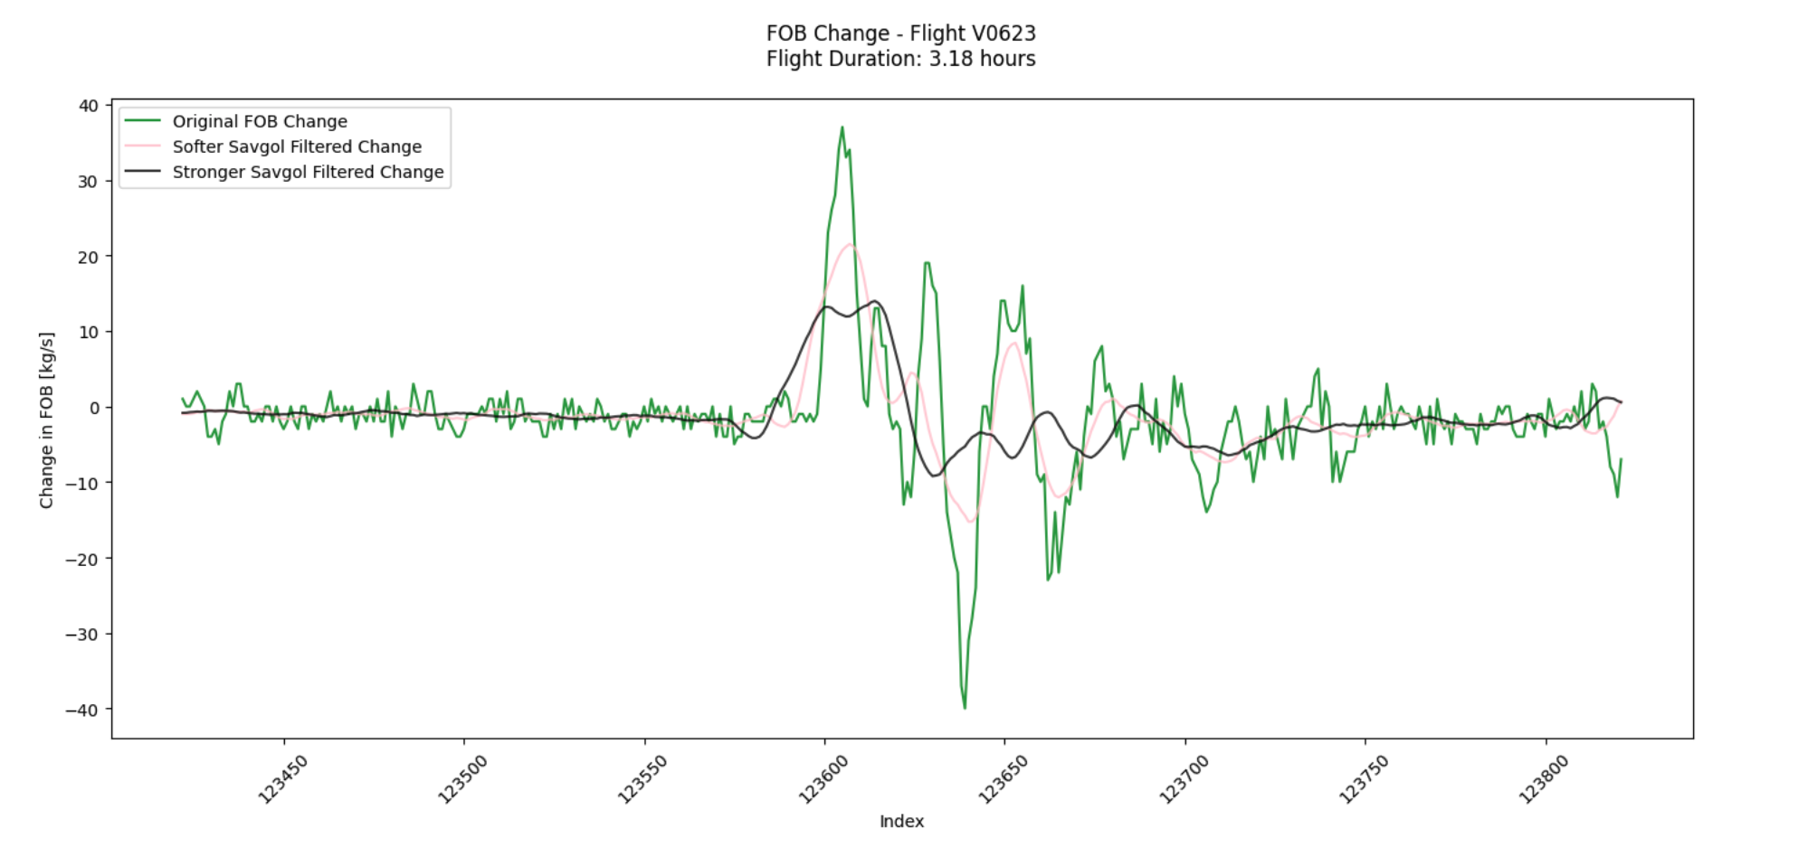

Fig. 9: Comparison of Noise Reduction by Filter across remaining flights in phase 8

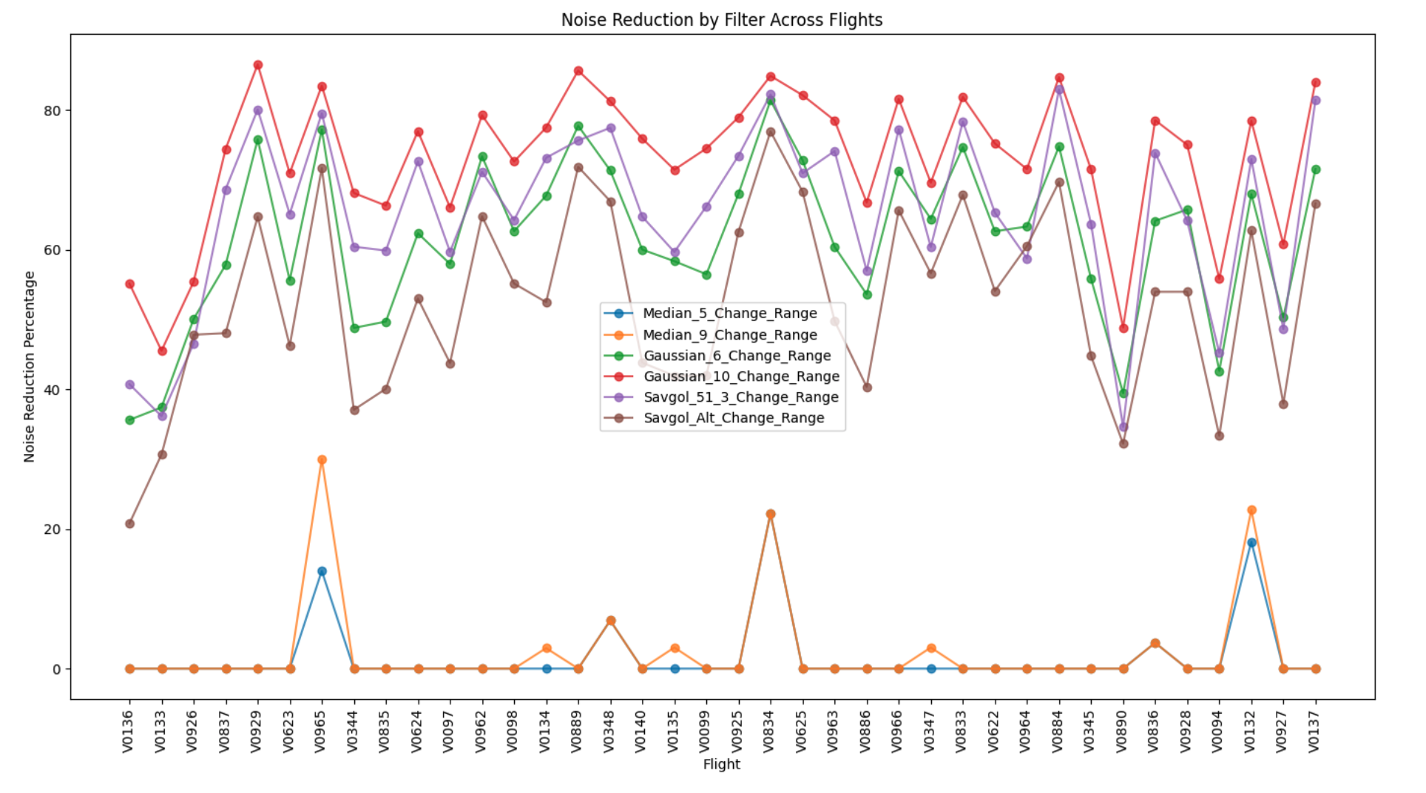

Fig. 11: Example of Discrepancy between FOB and EST. FOB for artificial leak

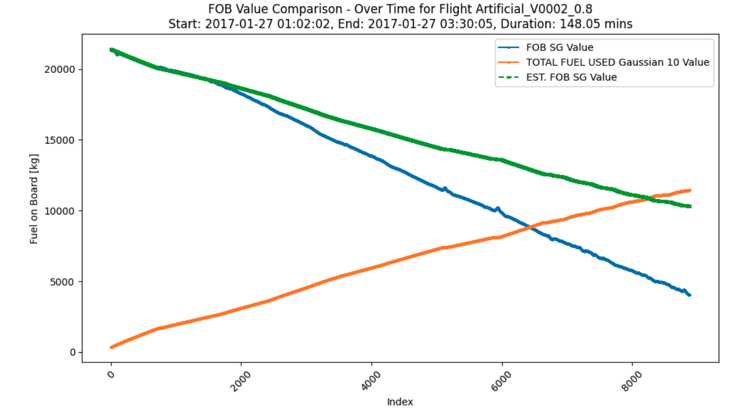

Fig 12: MSN02 with additional artificial flights with different leakage rates sorted by time

(GREEN = original Flights ; RED= artificial flights with leakage)

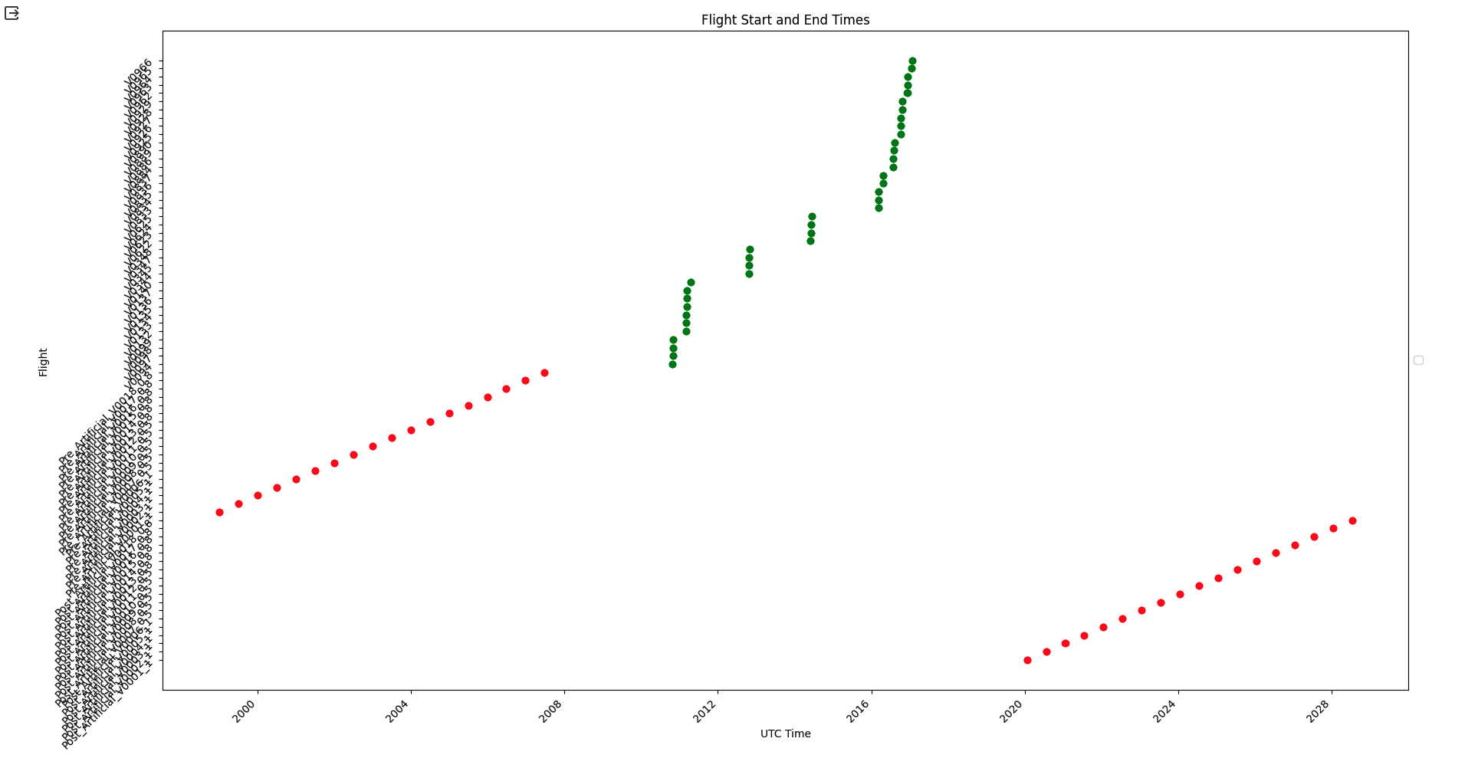

Fig 13: Baseline Model Architecture

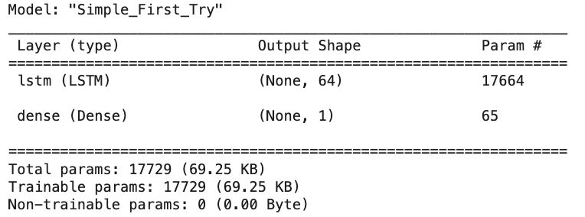

Fig. 14: Training and Validation over 5 epochs

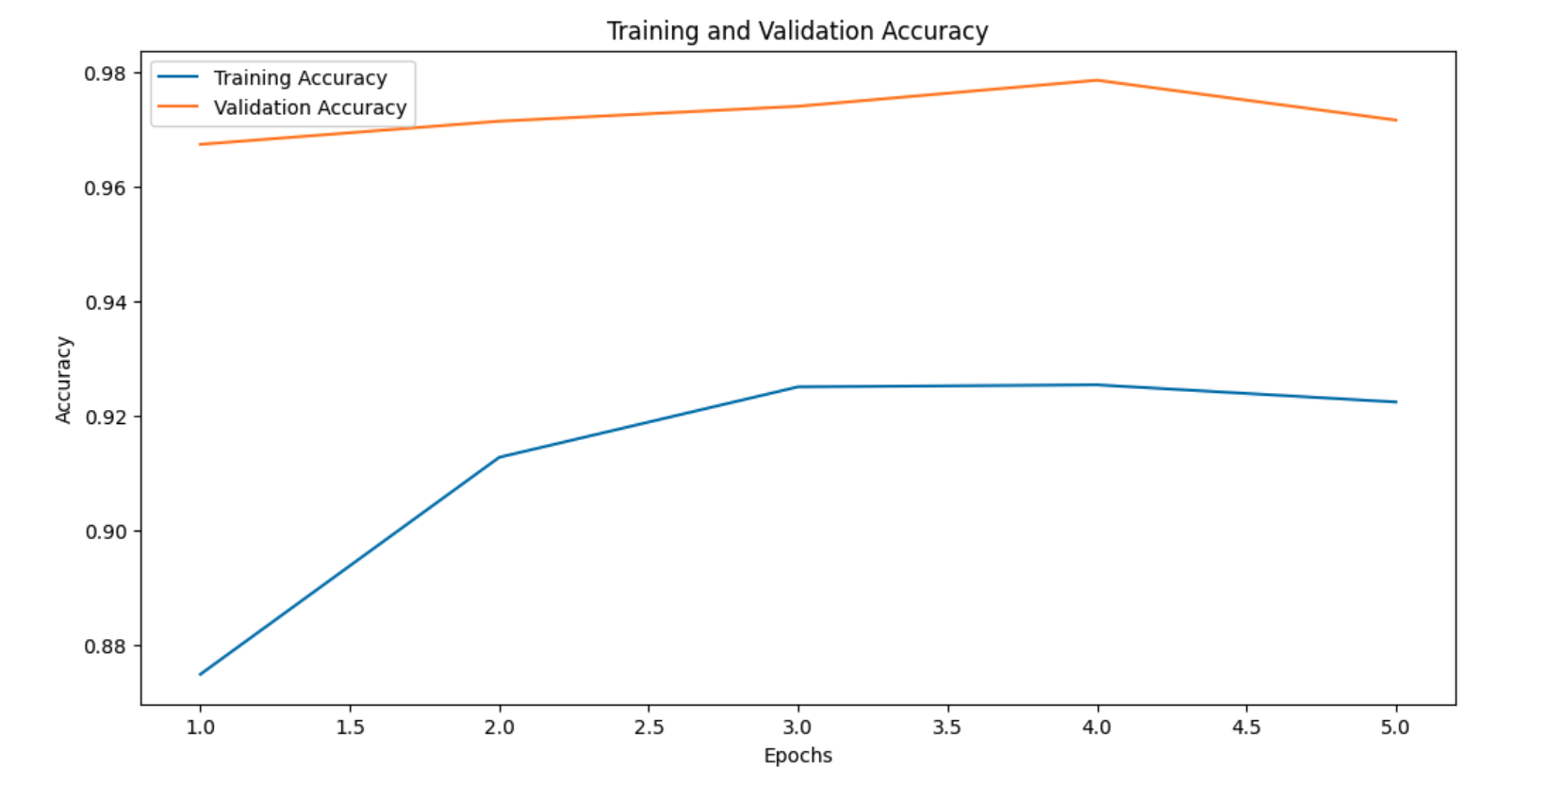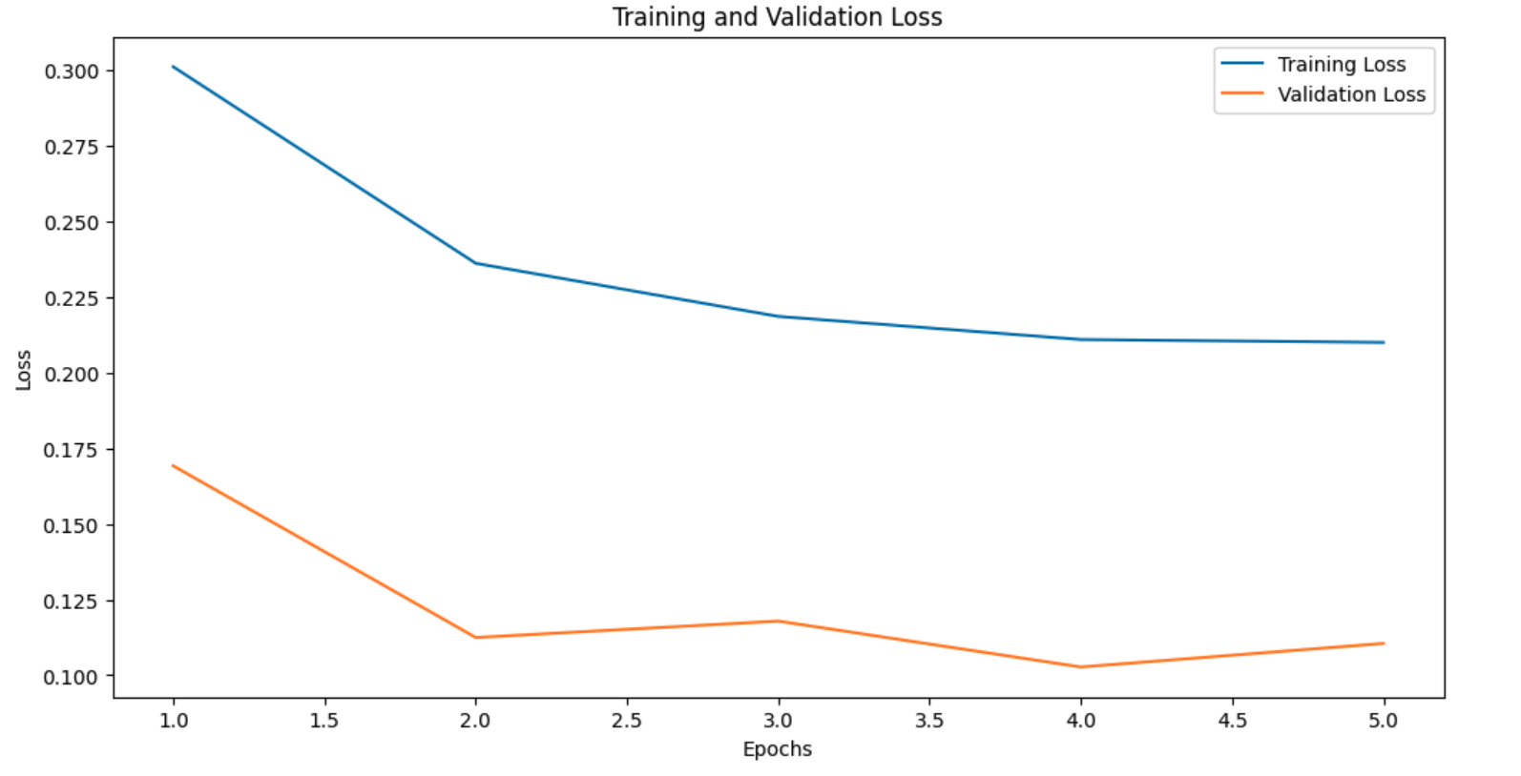

Fig. 15: Confusion matrix for Baseline Model on other MSN(10-53)

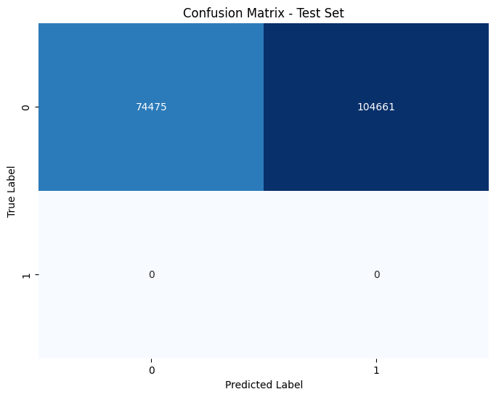

Fig. 16: Best Model Architecture

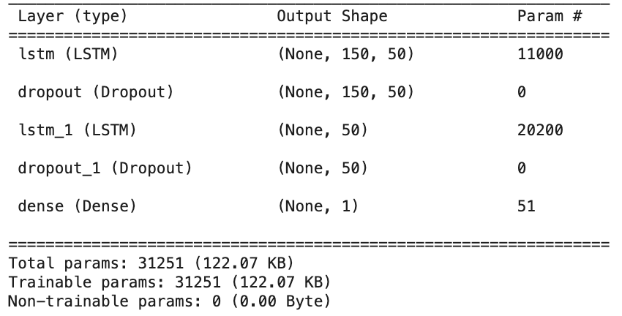

Fig. 17: Best Model Test with leaks - second attempt   
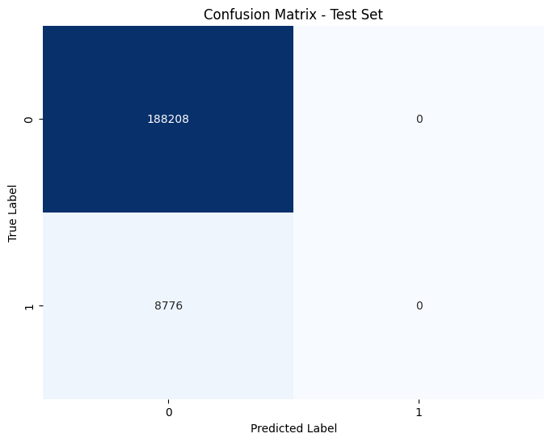

Fig. 18: Best Model Test with leaks - third attempt  
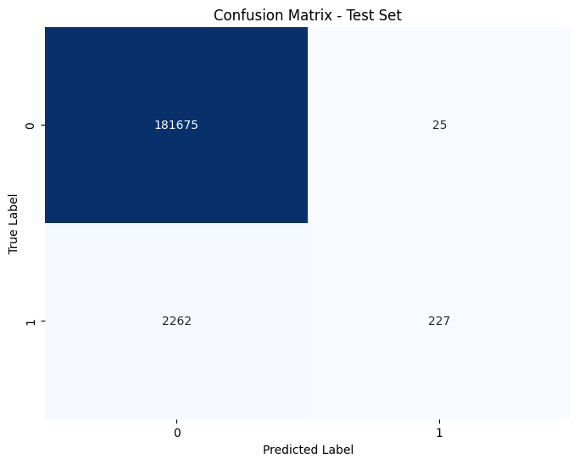

Fig. 19: Future Improvement of Model by adding FOB_BASE feature 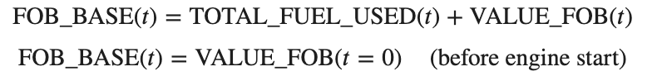

## ML Canvas

1. TBD
2. <https://ml-ops.org/content/crisp-ml#acknowledgements>
3. <https://www.mlit.go.jp/jtsb/eng-air_report/B18616.pdf>
4. <https://en.wikipedia.org/wiki/Air_Transat_Flight_236>
5. <https://www.newsweek.com/united-airlines-flight-emergency-fuel-leak-newark-nj-1851577>
6. <https://www.asapaog.com/blog/what-is-scheduled-and-unscheduled-aircraft-maintenance/>
7. <https://www.eways-aviation.com/blog/how-much-does-it-cost-to-have-an-aircraft-on-ground-aog>
8. <https://www.eways-aviation.com/blog/how-much-does-it-cost-to-have-an-aircraft-on-ground-aog>
9. <https://empresas.aena.es/ae-statics/Lists/Documentos%20generales/Attachments/96/Aena%20price%20guide.pdf>
10. <https://simpleflying.com/how-much-do-canceled-flights-cost-airlines/>
11. https://safetyfirst.airbus.com/app/themes/mh_newsdesk/documents/archives/low-fuel-situations-awareness.pdf
12. From now on, names of features from the data will be presented in Courier New font with a light gray background.
13. https://bartwronski.com/2021/10/31/practical-gaussian-filter-binomial-filter-and-small-sigma-gaussians/
14. https://bartwronski.com/2021/11/03/study-of-smoothing-filters-savitzky-golay-filters/https://bartwronski.com/2021/11/03/study-of-smoothing-filters-savitzky-golay-filters/
15. https://www.st-andrews.ac.uk/~wjh/dataview/tutorials/filter
16. https://safetyfirst.airbus.com/app/themes/mh_newsdesk/documents/archives/low-fuel-situations-awareness.pdf
17. https://towardsdatascience.com/lstm-networks-a-detailed-explanation-8fae6aefc7f9
18. <https://keras.io/api/optimizers/adam/>
19. <https://towardsdatascience.com/understanding-binary-cross-entropy-log-loss-a-visual-explanation-a3ac6025181a>
20. https://towardsdatascience.com/activation-functions-neural-networks-1cbd9f8d91d6
21. https://towardsdatascience.com/lstm-autoencoder-for-anomaly-detection-e1f4f2ee7ccf
22. https://keras.io/keras_tuner/