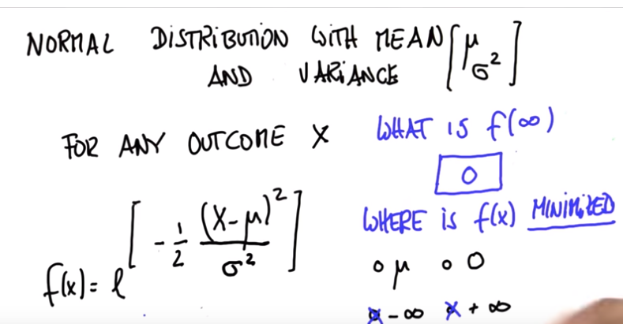

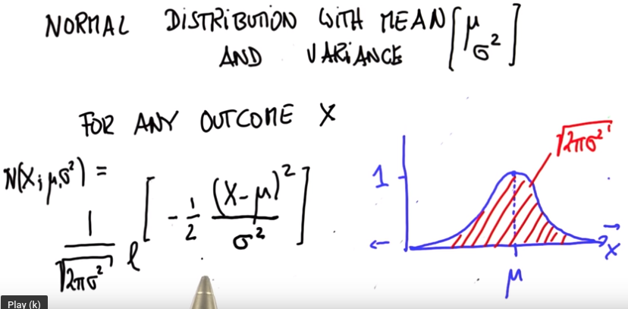

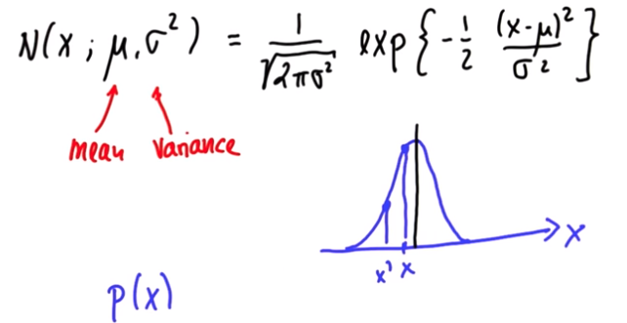
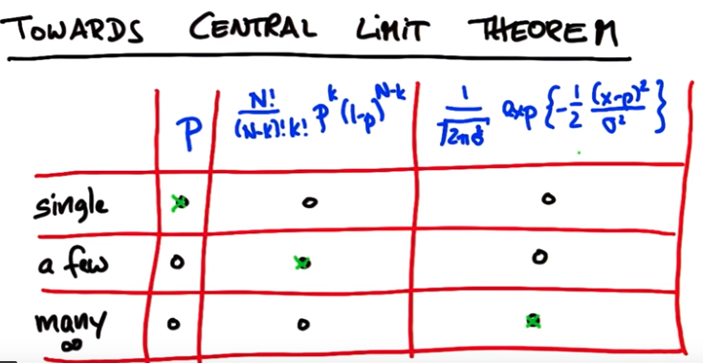
To clarify:
For 1 coin flip: What is the formula for figuring out the probability of the flip being heads?
For many coin flips: What is the formula for figuring out the probability of a given number of flips being heads?
For infinitely many flips: What is the formula for figuring out the probability of a given proportion of flips being heads?
For formula 2: sigma^2=p(1-p)/N

