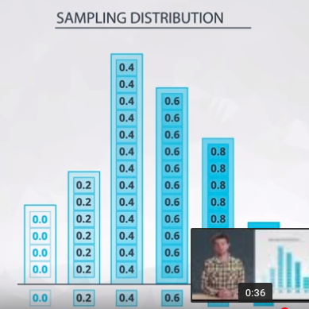
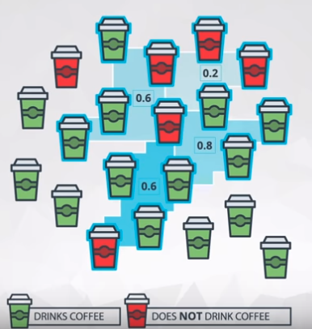

A sampling distribution is the distribution of a statistic. Here we looked the distribution of the proportion for samples of 5 students. This is key to the ideas covered not only in this lesson, but in future lessons.

Sampling Distributions Notes
We have already learned some really valuable ideas about sampling distributions:

First, we have defined sampling distributions as the distribution of a statistic.
This is fundamental - I cannot stress the importance of this idea. We simulated the creation of sampling distributions in the previous ipython notebook for samples of size 5 and size 20, which is something you will do more than once in the upcoming concepts and lessons.

Second, we found out some interesting ideas about sampling distributions that will be iterated later in this lesson as well. We found that for proportions (and also means, as proportions are just the mean of 1 and 0 values), the following characteristics hold.
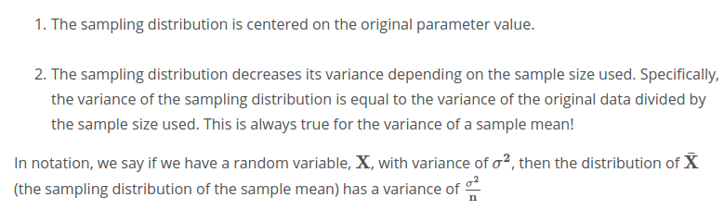

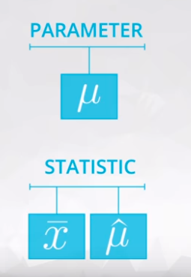

we commonly use Greek symbols as parameters and lowercase letters as the corresponding statistics. Sometimes in the literature, you might also see the same Greek symbols with a "hat" to represent that this is an estimate of the corresponding parameter.
Below is a table that provides some of the most common parameters and corresponding statistics, as shown in the video.
Remember that all parameters pertain to a population, while ll statistics pertain to a sample.
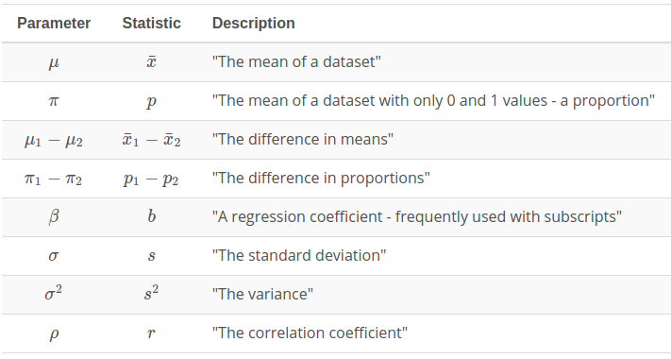

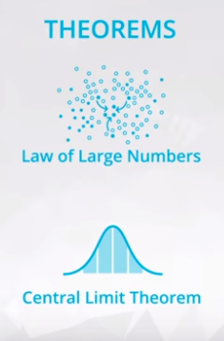
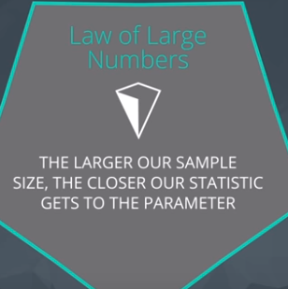

Two important mathematical theorems for working with sampling distributions include:
- Law of Large Numbers
- Central Limit Theorem
The Law of Large Numbers says that as our sample size increases, the sample mean gets closer to the population mean, but how did we determine that the sample mean would estimate a population mean in the first place? How would we identify another relationship between parameter and statistic like this in the future?
Three of the most common ways are with the following estimation techniques:
- Maximum Likelihood Estimation
- Method of Moments Estimation)
- Bayesian Estimation
Though these are beyond the scope of what is covered in this course, these are techniques that should be well understood for Data Scientist's that may need to understand how to estimate some value that isn't as common as a mean or variance. Using one of these methods to determine a "best estimate", would be a necessity.
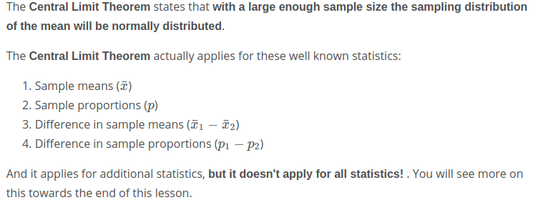

Central Limit Theorem - Part III
You saw how the Central Limit Theorem worked for the sample mean in the earlier concept. The Central Limit Theorem states that with a large enough sample size the sampling distribution of the mean will be normally distributed.
The Central Limit Theorem actually applies for these well known statistics:
- Sample means (x¯)
- Sample proportions (p)
- Difference in sample means (x¯1​−x¯2​)
- Difference in sample proportions (p1​−p2​)
And it applies for additional statistics, but it doesn't apply for all statistics! . Here, you will simulate the sampling distribution for the sample variance. Try out the notebook and quizzes.

Bootstrapping is sampling with replacement. Using random.choice in python actually samples in this way. Where the probability of any number in our set stays the same regardless of how many times it has been chosen. Flipping a coin and rolling a die are kind of like bootstrap sampling as well, as rolling a 6 in one scenario doesn't mean that 6 is less likely later.

You can learn more about Bradley Efron here.
- Additional notes on why bootstrapping works as a technique for inference can be found here.

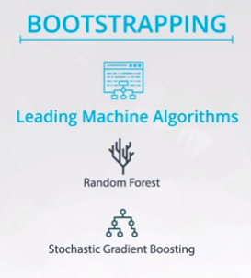
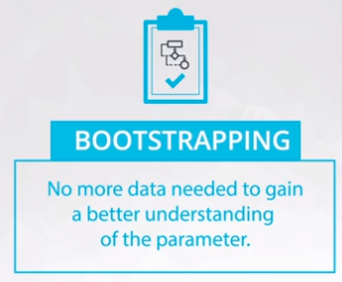

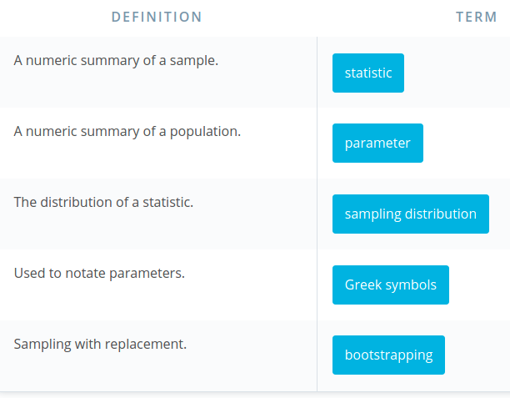

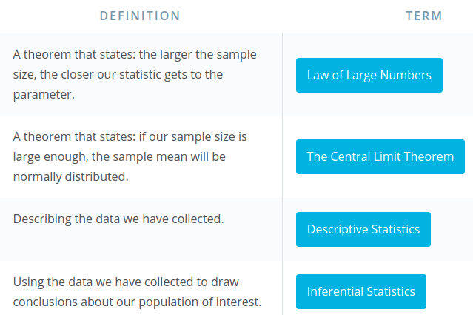

Recap
In this lesson, you have learned a ton! You learned:

Sampling Distributions
- Sampling Distributions are the distribution of a statistic (any statistic).
- There are two very important mathematical theorems that are related to sampling distributions: The Law of Large Numbers and The Central Limit Theorem.
- The Law of Large Numbers states that as a sample size increases, the sample mean will get closer to the population mean. In general, if our statistic is a "good" estimate of a parameter, it will approach our parameter with larger sample sizes.
- The Central Limit Theorem states that with large enough sample sizes our sample mean will follow a normal distribution, but it turns out this is true for more than just the sample mean.

Bootstrapping
- Bootstrapping is a technique where we sample from a group with replacement.
- We can use bootstrapping to simulate the creation of sampling distribution, which you did many times in this lesson.
- By bootstrapping and then calculating repeated values of our statistics, we can gain an understanding of the sampling distribution of our statistics.

