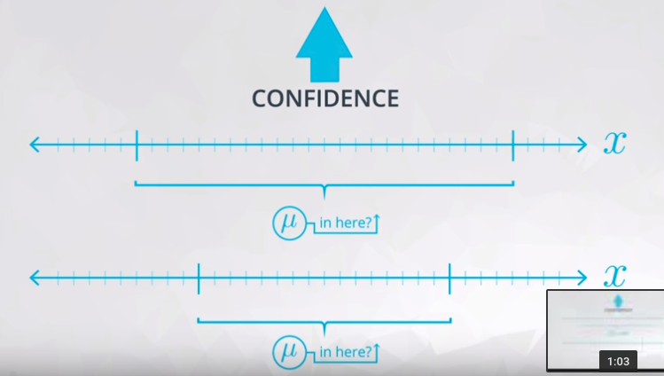
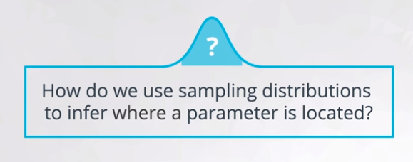
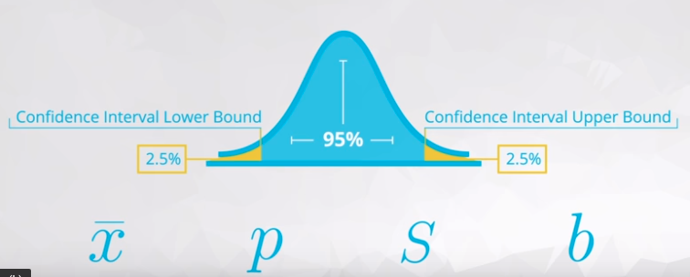

hough you were comparing the average heights of coffee drinkers to non-coffee drinkers, there are a number of other applications that use a comparison for the means of two groups.
A/B testing is one of the most important to businesses around the world. In this technique, you are changing something about your web layout to understand how it impacts users. You ideally want to provide a page that leads to more clicks, higher revenue, and/or higher customer satisfaction.

is also important to take into consideration practical significance in making decisions.Practical significance takes into consideration other factors of your situation that might not be considered directly in the results of your hypothesis test or confidence interval. Constraints like space, time, or money are important in business decisions. However, they might not be accounted for directly in a statistical test.



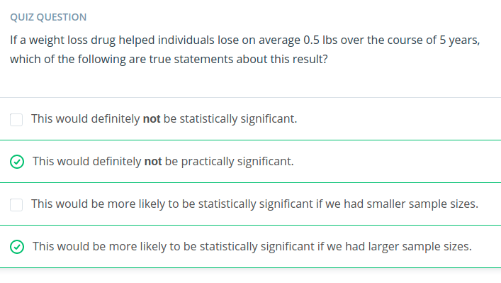
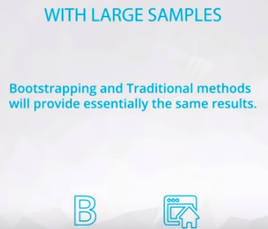

e educated, but potentially biased opinion on the traditional methods is that these methods are no longer necessary with what is possible with statistics in modern computing, and these methods will become even less important with the future of computing. Therefore, memorizing these formulas to throw at a particular situation will be a glazed-over component of this class. However, there are resources below should you want to dive into a few of the hundreds if not thousands of hypothesis tests that are possible with traditional techniques.
To learn more about the traditional methods, see the documentation here on the Stat Trek site on the corresponding hypothesis tests. In the left margin of this Stat Trek page, you will see a drop-down list of the hypothesis tests available, as shown in the image below.

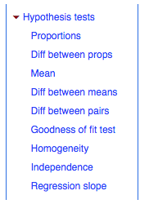

Each of these hypothesis tests is linked to a corresponding confidence interval, but again the bootstrapping approach can be used in place of any of these! Simply by understanding what you would like to estimate, and simulating the sampling distribution for the statistic that best estimates that value.

With large sample sizes, these end up looking very similar. With smaller sample sizes, using a traditional methods likely has assumptions that are not true of your interval. Small sample sizes are not ideal for bootstrapping methods though either, as they can lead to misleading results simply due to not accurately representing your entire population well.

It is important to understand the way that your sample size and confidence level relate to the confidence interval you achieve at the end of your analysis.
Assuming you control all other items of your analysis:
- Increasing your sample size will decrease the width of your confidence interval.
- Increasing your confidence level (say 95% to 99%) will increase the width of your confidence interval.
You saw that you can compute:
- The confidence interval width as the difference between your upper and lower bounds of your confidence interval.
- The margin of error is half the confidence interval width, and the value that you add and subtract from your sample estimate to achieve your confidence interval final results.
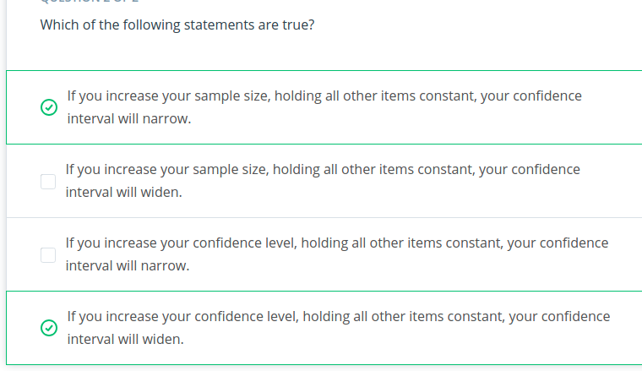

Confidence Intervals (& Hypothesis Testing) vs. Machine Learning
Confidence intervals take an aggregate approach towards the conclusions made based on data, as these tests are aimed at understanding population parameters (which are aggregate population values).
Alternatively, machine learning techniques take an individual approach towards making conclusions, as they attempt to predict an outcome for each specific data point.
In the final lessons of this class, you will learn about two of the most fundamental machine learning approaches used in practice: linear and logistic regression.

