
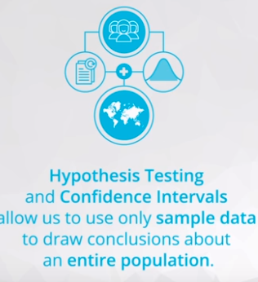

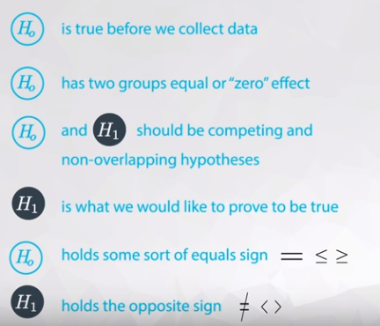

In this video, you learned a few rules for setting up null and alternative hypotheses:
- The H0​ is true before you collect any data.
- The H0​ usually states there is no effect or that two groups are equal.
- The H0​ and H1​ are competing, non-overlapping hypotheses.
- H1​ is what we would like to prove to be true.
- H0​ contains an equal sign of some kind - either =, ≤, or ≥.
- H1​ contains the opposition of the null - either ≠, >, or <.
You saw that the statement, "Innocent until proven guilty" is one that suggests the following hypotheses are true:
H0​: Innocent
H1​: Guilty
We can relate this to the idea that "innocent" is true before we collect any data. Then the alternative must be a competing, non-overlapping hypothesis. Hence, the alternative hypothesis is that an individual is guilty.

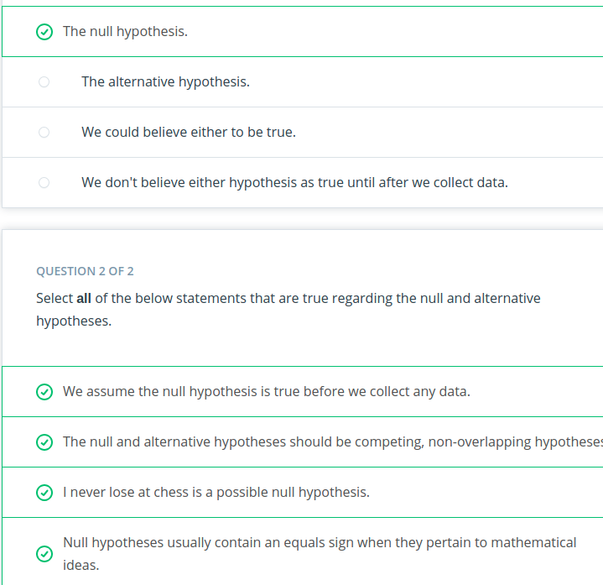

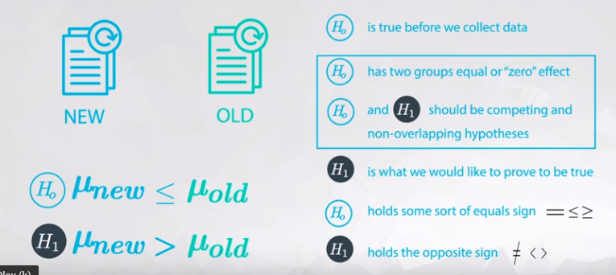

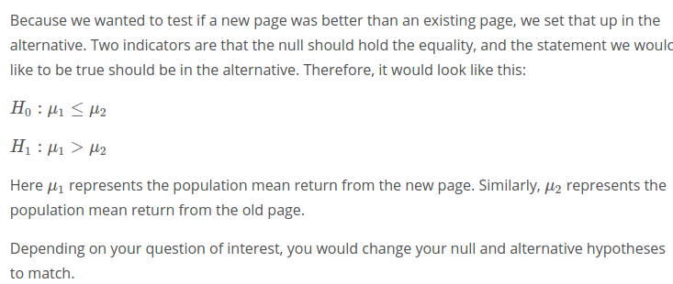

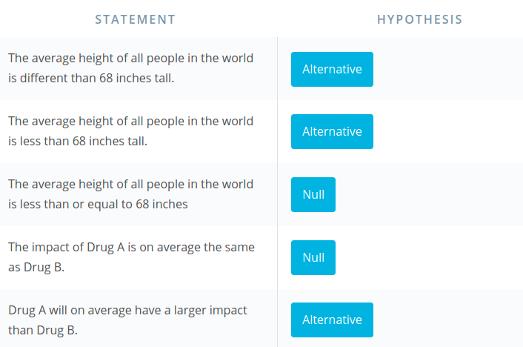

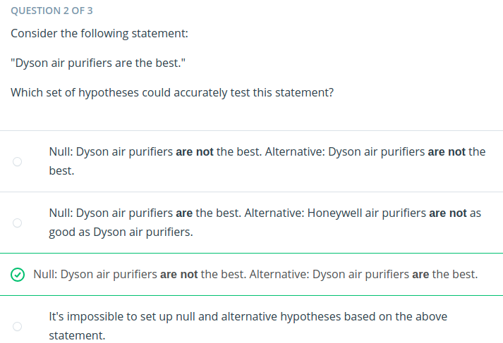
...................

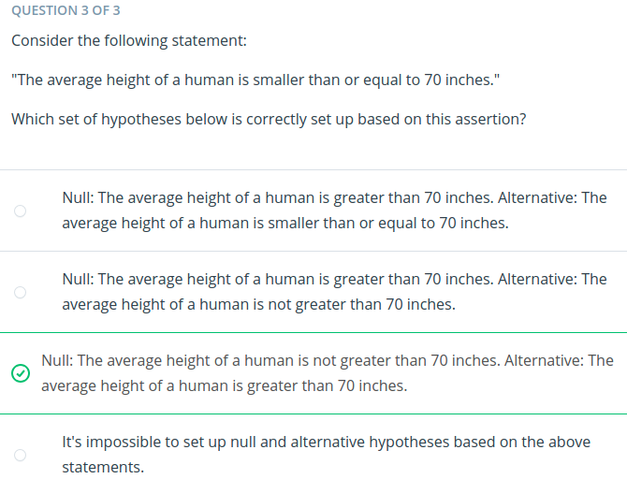

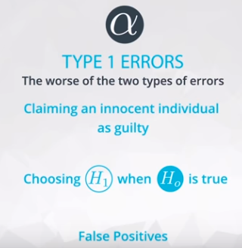
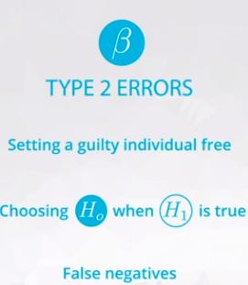

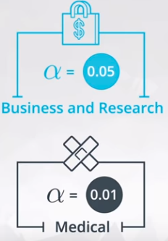

Type I Errors
Type I errors have the following features:
- You should set up your null and alternative hypotheses, so that the worse of your errors is the type I error.
- They are denoted by the symbol α.
- The definition of a type I error is: Deciding the alternative (H1​) is true, when actually (H0​) is true.
- Type I errors are often called false positives.

Type II Errors
- They are denoted by the symbol β.
- The definition of a type II error is: Deciding the null (H0​) is true, when actually (H1​) is true.
- Type II errors are often called false negatives.
In the most extreme case, we can always choose one hypothesis (say always choosing the null) to ensure that a particular error never occurs (never a type I error assuming we always choose the null). However, more generally, there is a relationship where with a single set of data decreasing your chance of one type of error, increases the chance of the other error occurring.

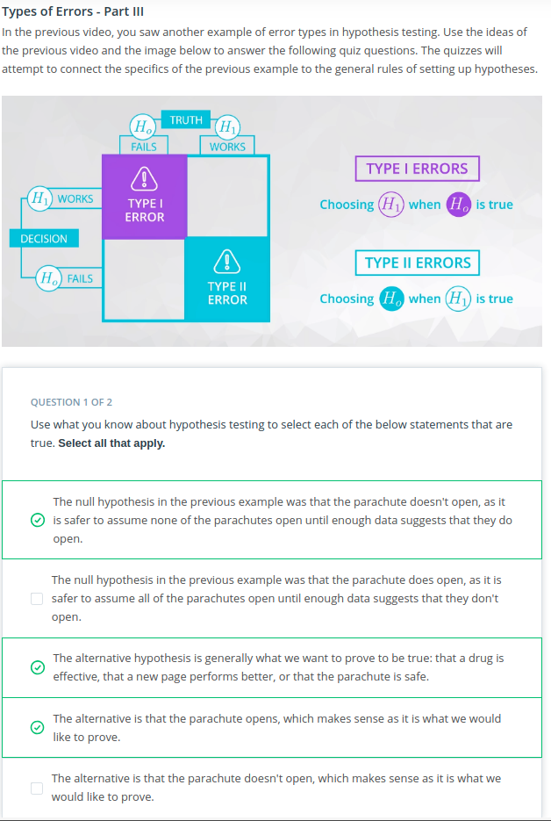

Types of test

You are always performing hypothesis tests on population parameters, never on statistics. Statistics are values that you already have from the data, so it does not make sense to perform hypothesis tests on these values.
Common hypothesis tests include:
- Testing a population mean (One sample t-test).
- Testing the difference in means (Two sample t-test)
- Testing the difference before and after some treatment on the same individual (Paired t-test)
- Testing a population proportion (One sample z-test)
- Testing the difference between population proportions (Two sample z-test)
You can use one of these sites to provide a t-table or z-table to support one of the above approaches:
- t-table
- t-table or z-table
There are literally hundreds of different hypothesis tests! However, instead of memorizing how to perform all of these tests, you can find the statistic(s) that best estimates the parameter(s) you want to estimate, you can bootstrap to simulate the sampling distribution. Then you can use your sampling distribution to assist in choosing the appropriate hypothesis.

P-Value.

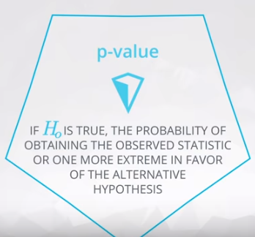

What Is A P-value Anyway?
The definition of a p-value is the probability of observing your statistic (or one more extreme in favor of the alternative) if the null hypothesis is true.
In this video, you learned exactly how to calculate this value. The more extreme in favor of the alternative portion of this statement determines the shading associated with your p-value.
Therefore, you have the following cases:
If your parameter is greater than some value in the alternative hypothesis, your shading would look like this to obtain your p-value:
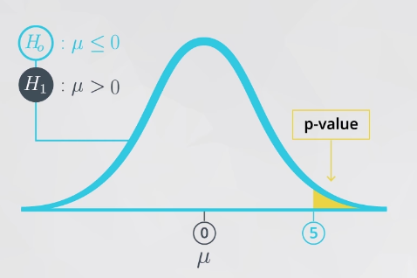

If your parameter is less than some value in the alternative hypothesis, your shading would look like this to obtain your p-value:
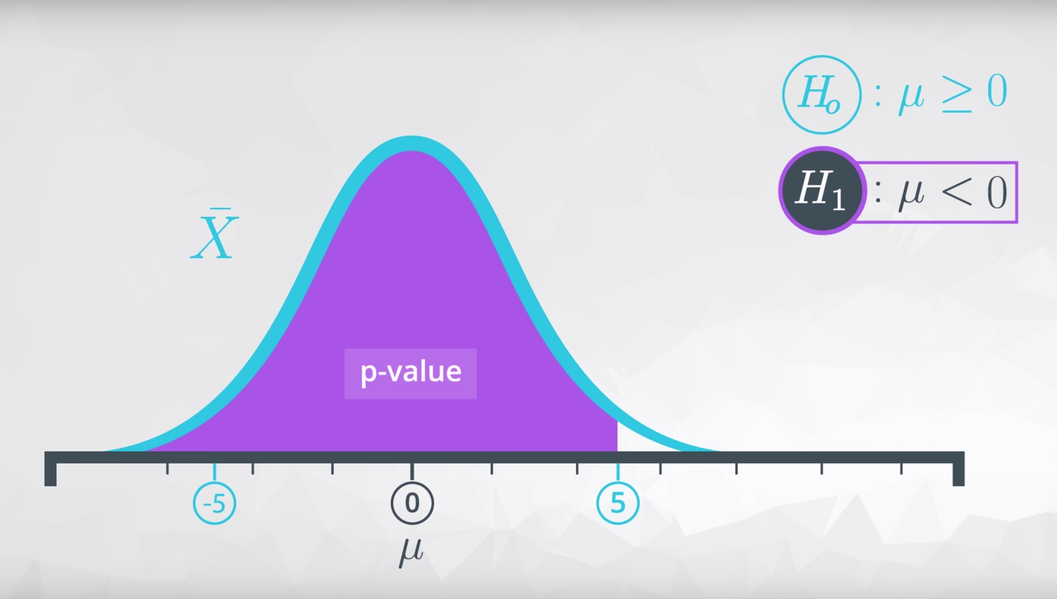

If your parameter is not equal to some value in the alternative hypothesis, your shading would look like this to obtain your p-value:

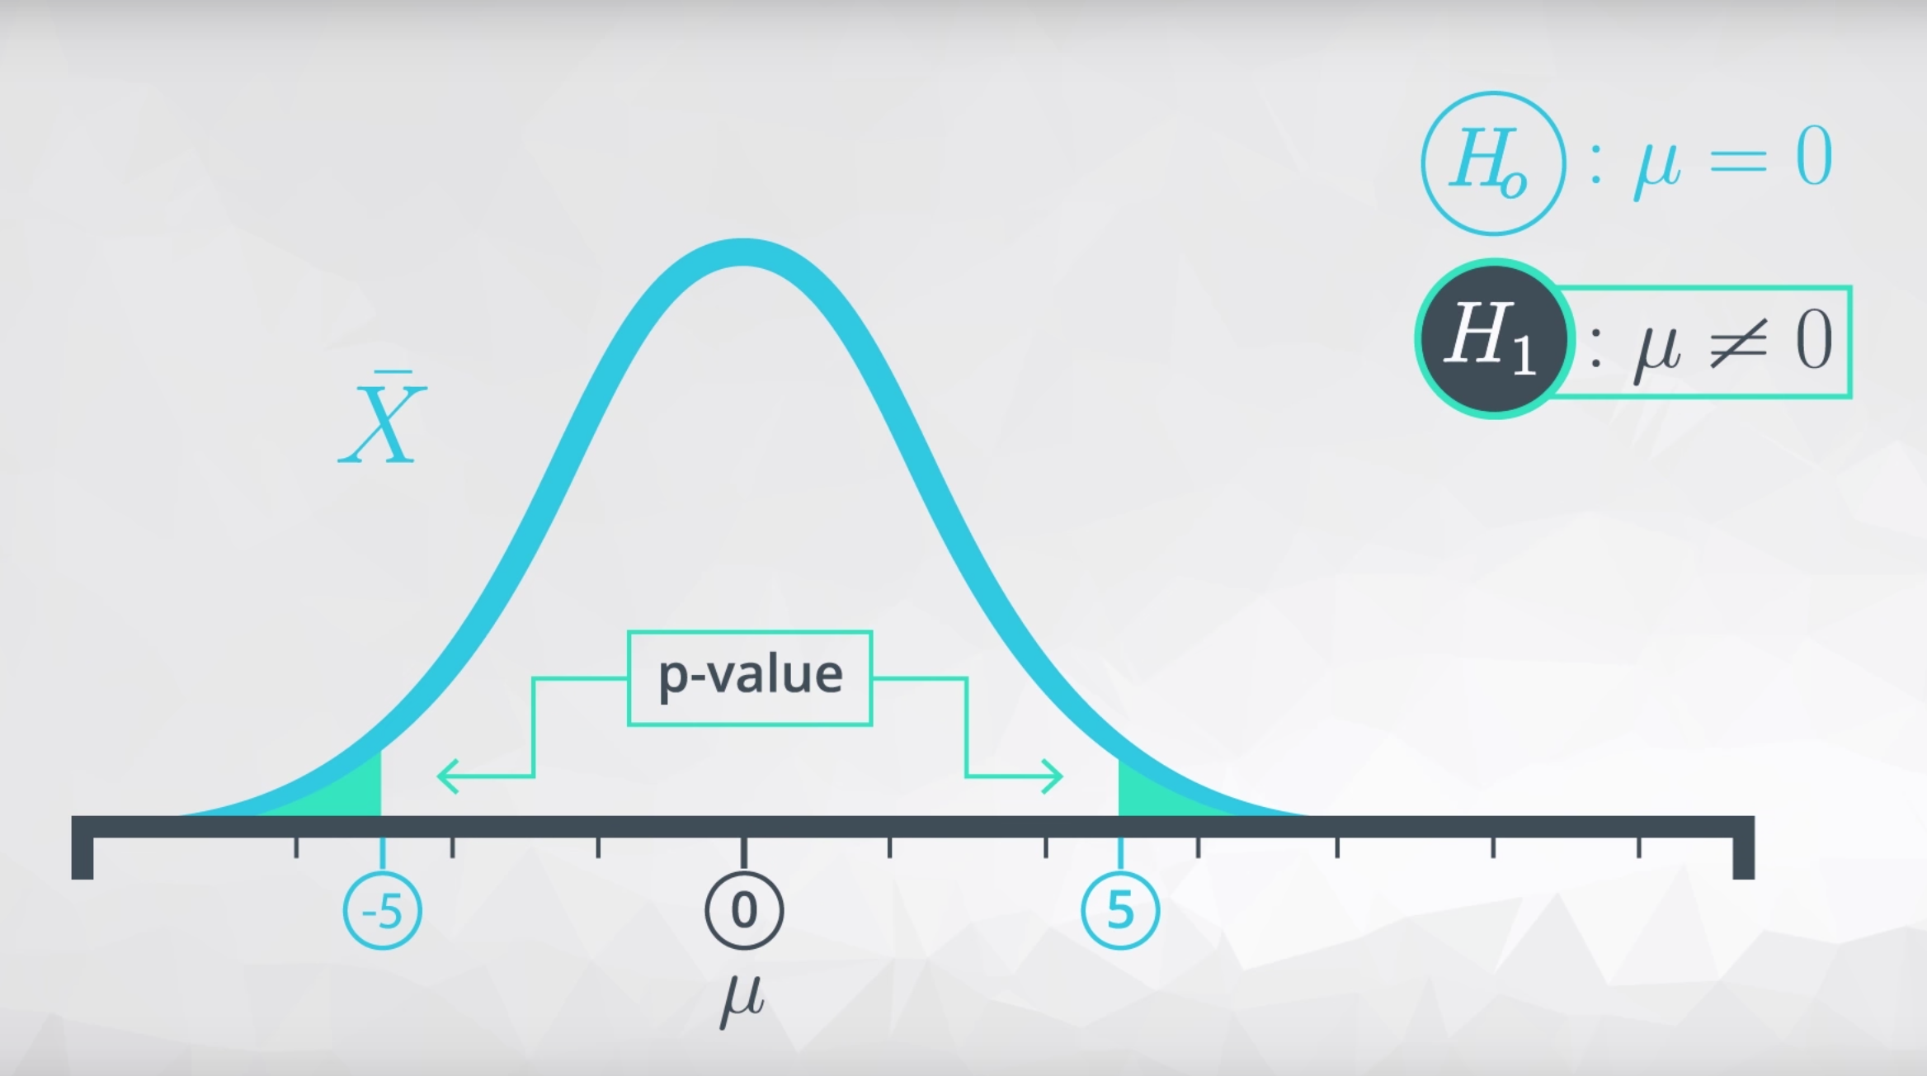

You could integrate the sampling distribution to obtain the area for each of these p-values.
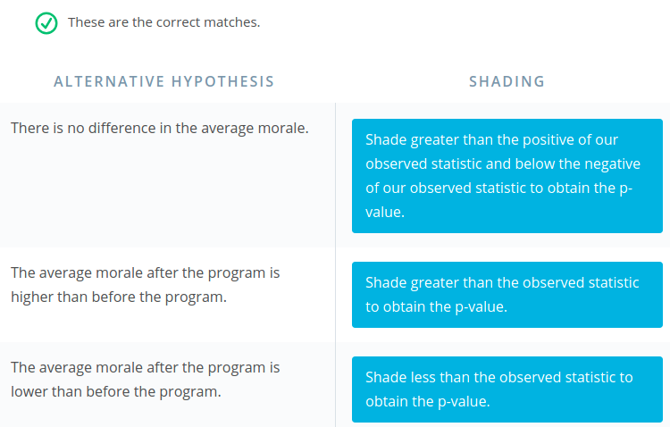

The p-value is the probability of getting our statistic or a more extreme value if the null is true.
Therefore, small p-values suggest our null is not true. Rather, our statistic is likely to have come from a different distribution than the null.
When the p-value is large, we have evidence that our statistic was likely to come from the null hypothesis. Therefore, we do not have evidence to reject the null.
By comparing our p-value to our type I error threshold (α), we can make our decision about which hypothesis we will choose.
pval≤α⇒ Reject H0​
pval>α⇒ Fail to Reject H0​
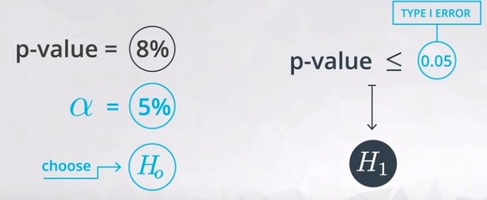

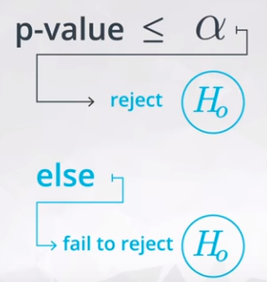

The word accept is one that is avoided when making statements regarding the null and alternative. You are not stating that one of the hypotheses is true. Rather, you are making a decision based on the likelihood of your data coming from the null hypothesis with regard to your type I error threshold.
Therefore, the wording used in conclusions of hypothesis testing includes: We reject the null hypothesis or We fail to reject the null hypothesis. This lends itself to the idea that you start with the null hypothesis true by default, and "choosing" the null at the end of the test would have been the choice even if no data were collected.
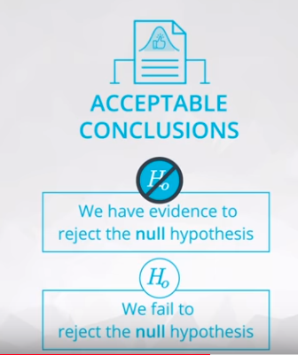

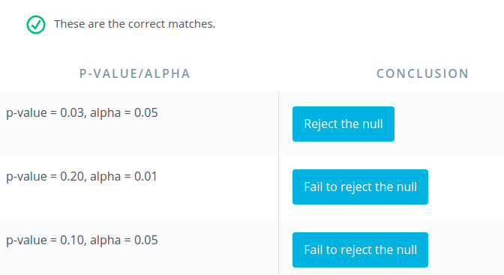

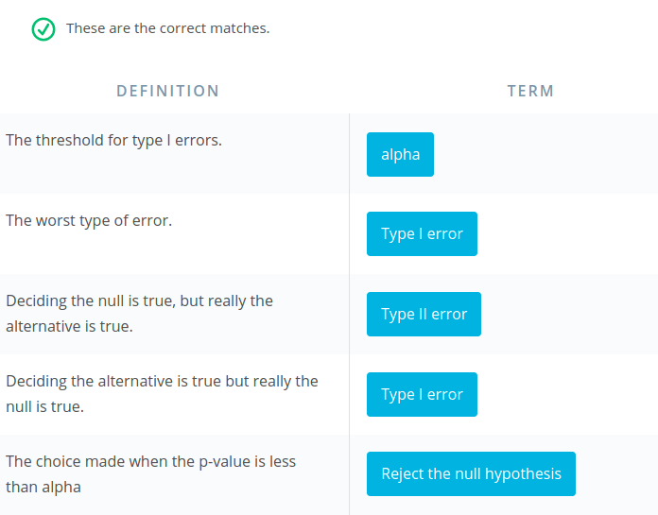

Factors to consider
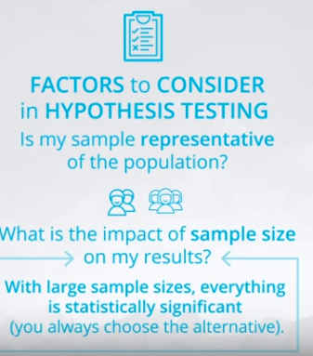
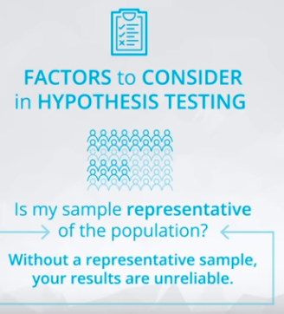

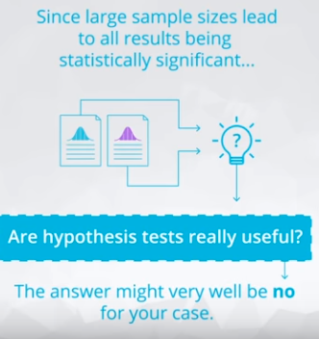

One of the most important aspects of interpreting any statistical results (and one that is frequently overlooked) is assuring that your sample is truly representative of your population of interest.
Particularly in the way that data is collected today in the age of computers, response bias is so important to keep in mind. In the 2016 U.S election, polls conducted by many news media suggested a staggering difference from the reality of poll results. You can read about how response bias played a role here.

Hypothesis Testing vs. Machine Learning
With large sample sizes, hypothesis testing leads to even the smallest of findings as statistically significant. However, these findings might not be practically significant at all.
For example, imagine you find that statistically more people prefer beverage 1 to beverage 2 in a study of more than one million people. Based on this you decide to open a shop to sell beverage 1. You then find out that beverage 1 is only more popular than beverage 2 by 0.0002% (but a statistically significant amount with your large sample size). Practically, maybe you should have opened a store that sold both.
Hypothesis testing takes an aggregate approach towards the conclusions made based on data, as these tests are aimed at understanding population parameters (which are aggregate population values).
Alternatively, machine learning techniques take an individual approach towards making conclusions, as they attempt to predict an outcome for each specific data point.
In the final lessons of this class, you will learn about two of the most fundamental machine learning approaches used in practice: linear and logistic regression.
T

When performing more than one hypothesis test, your type I error compounds. In order to correct for this, a common technique is called the Bonferroni correction. This correction is very conservative, but says that your new type I error rate should be the error rate you actually want divided by the number of tests you are performing.
Therefore, if you would like to hold a type I error rate of 1% for each of 20 hypothesis tests, the Bonferroni corrected rate would be 0.01/20 = 0.0005. This would be the new rate you should use as your comparison to the p-value for each of the 20 tests to make your decision.

Other Techniques
Additional techniques to protect against compounding type I errors include:
- Tukey correction
- Q-values

A two-sided hypothesis test (that is a test involving a ≠ in the alternative) is the same in terms of the conclusions made as a confidence interval as long as:
1−CI=α
For example, a 95% confidence interval will draw the same conclusions as a hypothesis test with a type I error rate of 0.05 in terms of which hypothesis to choose, because:
1−0.95=0.05
assuming that the alternative hypothesis is a two sided test.
Video on effect size here.

Recap
Wow! That was a ton. You learned:
- How to set up hypothesis tests. You learned the null hypothesis is what we assume to be true before we collect any data, and the alternative is usually what we want to try and prove to be true.
- You learned about Type I and Type II errors. You learned that Type I errors are the worst type of errors, and these are associated with choosing the alternative when the null hypothesis is actually true.
- You learned that p-values are the probability of observing your data or something more extreme in favor of the alternative given the null hypothesis is true. You learned that using a confidence interval from the bootstrapping samples, you can essentially make the same decisions as in hypothesis testing (without all of the confusion of p-values).
- You learned how to make decisions based on p-values. That is, if the p-value is less than your Type I error threshold, then you have evidence to reject the null and choose the alternative. Otherwise, you fail to reject the null hypothesis.
- You learned that when sample sizes are really large, everything appears statistically significant (that is you end up rejecting essentially every null), but these results may not be practically significant.
- You learned that when performing multiple hypothesis tests, your errors will compound. Therefore, using some sort of correction to maintain your true Type I error rate is important. A simple, but very conservative approach is to use what is known as a Bonferroni correction, which says you should just divide your α level (or Type I error threshold) by the number of tests performed.
This lesson is often the most challenging for students throughout the entire nanodegree program. In order to really have the ideas here stick, it can help to put them down in your own words.
Below are some quizzes to test that you are leaving with the main ideas from this lesson, as well as a link to a great blog post, written by one of your fellow classmates, to assist with the ideas of this lesson!

QUESTION 1 OF 2

Review Quiz
Match the best related term to the definitions below regarding the lesson topics.
These are the correct matches.
Checkmark

DEFINITION

TERM
What we assume to be true before collecting any data.
null hypothesis
The threshold for the percent of type I errors we are willing to commit.
alpha
The probability of observing our statistic or a more extreme statistic from the null hypothesis.
p-value
An alternative (and conceptually more simple for most) method of obtaining the results of a hypothesis test.
confidence intervals from bootstrapping samples

QUESTION 2 OF 2

Review Quiz
Match the best related term to the definitions below regarding the lesson topics.
These are the correct matches.
Checkmark

DEFINITION

TERM
These statistical techniques are generally aimed at helping us understand population parameters.
Hypothesis Testing & Confidence Intervals
Techniques in this area are aimed at helping us draw conclusions about individuals in our population.
Machine Learning
One method for correcting our type I error threshold when we perform more than one hypothesis test.
Bonferroni Correction
With larger sample sizes, this becomes less relevant.
Statistical Significance

A/B Testing

A/B tests are used to test changes on a web page by running an experiment where a control groupsees the old version, while the experiment group sees the new version. A metric is then chosen to measure the level of engagement from users in each group. These results are then used to judge whether one version is more effective than the other. A/B testing is very much like hypothesis testing with the following hypotheses:
- Null Hypothesis: The new version is no better, or even worse, than the old version
- Alternative Hypothesis: The new version is better than the old version
If we fail to reject the null hypothesis, the results would suggest keeping the old version. If we reject the null hypothesis, the results would suggest launching the change. These tests can be used for a wide variety of changes, from large feature additions to small adjustments in color, to see what change maximizes your metric the most.
A/B testing also has its drawbacks. It can help you compare two options, but it can't tell you about an option you haven’t considered. It can also produce bias results when tested on existing users, due to factors like change aversion and novelty effect.
- Change Aversion: Existing users may give an unfair advantage to the old version, simply because they are unhappy with change, even if it’s ultimately for the better.
- Novelty Effect: Existing users may give an unfair advantage to the new version, because they’re excited or drawn to the change, even if it isn’t any better in the long run.
You'll learn more about factors like these later.

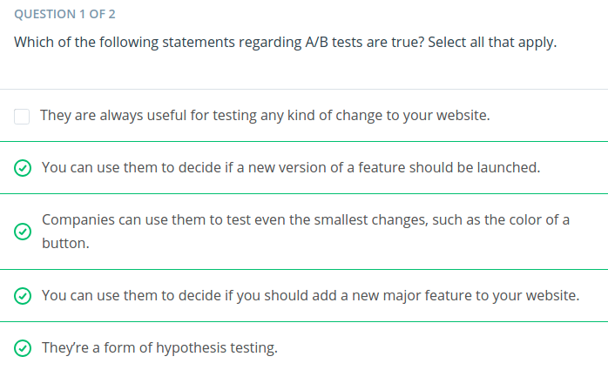

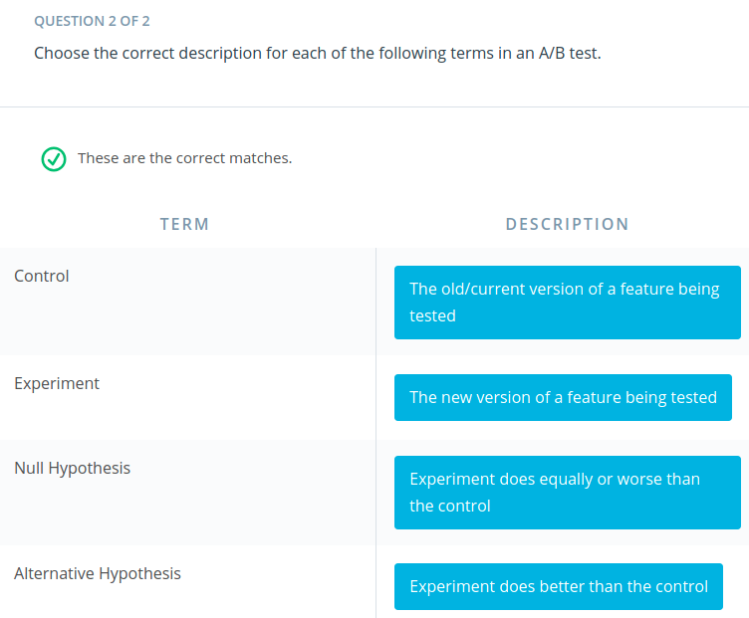

The first change Audacity wants to try is on their homepage. They hope that this new, more engaging design will increase the number of users that explore their courses, that is, move on to the second stage of the funnel.
The metric we will use is the click through rate for the Explore Courses button on the home page. Click through rate (CTR) is often defined as the the number of clicks divided by the number of views. Since Audacity uses cookies, we can identify unique users and make sure we don't count the same one multiple times. For this experiment, we'll define our click through rate as:
CTR: # clicks by unique users / # views by unique users
Now that we have our metric, let's set up our null and alternative hypotheses:
H0​:CTRnew​≤CTRold​
H1​:CTRnew​>CTRold​
Our alternative hypothesis is what we want to prove to be true, in this case, that the new homepage design has a higher click through rate than the old homepage design. And the null hypothesis is what we assume to be true before analyzing data, which is that the new homepage design has a click through rate that is less than or equal to that of the old homepage design. As you’ve seen before, we can rearrange our hypotheses to look like this:
H0​:CTRnew​−CTRold​≤0
H1​:CTRnew​−CTRold​>0

he second change Audacity is A/B testing is a more career focused description on a course overview page. They hope that this change may encourage more users to enroll and complete this course. In this experiment, we’re going to analyze the following metrics:
- Enrollment Rate: Click through rate for the Enroll button the course overview page
- Average Reading Duration: Average number of seconds spent on the course overview page
- Average Classroom Time: Average number of days spent in the classroom for students enrolled in the course
- Completion Rate: Course completion rate for students enrolled in the course
First, let's determine if the difference observed for each metric is statistically significant individually.

Again, let's recap the steps we took to analyze the results of this A/B test.
- We computed the observed difference between the metric, average reading duration, for the control and experiment group.
- We simulated the sampling distribution for the difference in means (or average reading durations).
- We used this sampling distribution to simulate the distribution under the null hypothesis, by creating a random normal distribution centered at 0 with the same spread and size.
- We computed the p-value by finding the proportion of values in the null distribution that were greater than our observed difference.
- We used this p-value to determine the statistical significance of our observed difference.

Bonferroni Correction
If you remember from the previous lesson, the Bonferroni Correction is one way we could handle experiments with multiple tests, or metrics in this case. To compute the new bonferroni correct alpha value, we need to divide the original alpha value by the number of tests.

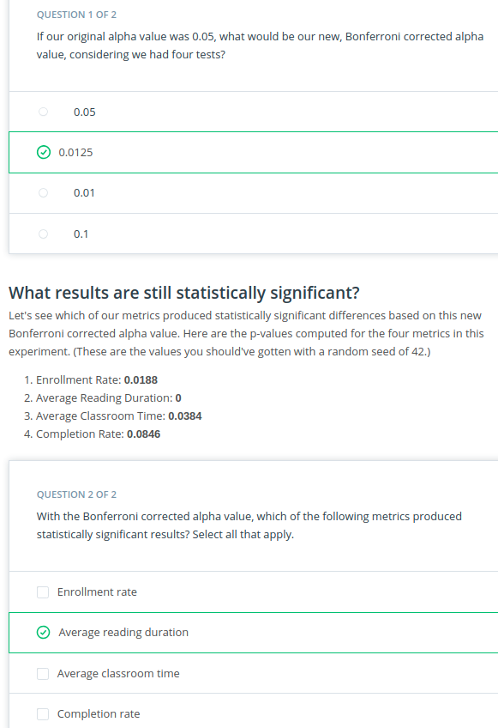

Since the Bonferroni method is too conservative when we expect correlation among metrics, we can better approach this problem with more sophisticated methods, such as the closed testing procedure, Boole-Bonferroni bound, and the Holm-Bonferroni method. These are less conservative and take this correlation into account.
If you do choose to use a less conservative method, just make sure the assumptions of that method are truly met in your situation, and that you're not just trying to cheat on a p-value. Choosing a poorly suited test just to get significant results will only lead to misguided decisions that harm your company's performance in the long run.
