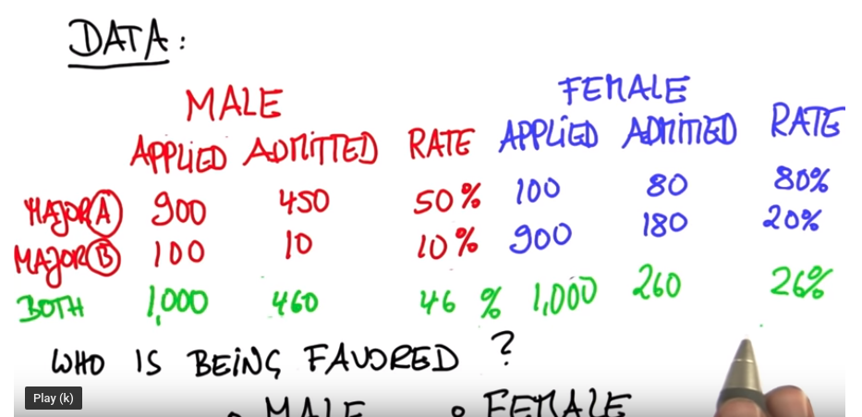

Simpson's Paradox
In this lesson, you learned about Simpson's Paradox, and had the opportunity to apply it to a small example with Sebastian.
In the lessons ahead, you will learn a lot by following along with Sebastian, but it is really important to put these ideas to practice using data and computing, because that is how you will apply these skills in a day to day environment as a Data Analyst or Data Scientist.
It is so easy to get caught up in looking at full aggregates of your data. Hopefully, the examples here serve as a reminder to look at your data multiple ways.

Upcoming Lessons
In the upcoming lessons, you will learn the fundamentals of probability by working through some examples. After finishing the lessons on probability with Sebastian, you will put what you learned to practice using Python!

Simpson's Paradox
Use admission_data.csv for this exercise.
In [2]:
# Load and view first few lines of dataset
import pandas as pd
admits = pd.read_csv('admission_data.csv')
admits.head()
Out[2]:
 | student_id | gender | major | admitted
0 | 35377 | female | Chemistry | False
1 | 56105 | male | Physics | True
2 | 31441 | female | Chemistry | False
3 | 51765 | male | Physics | True
4 | 53714 | female | Physics | True

Proportion and admission rate for each gender
In [12]:
print (len(admits[admits['gender']=='female']))
print (admits.shape[0])
257
500
In [13]:
# Proportion of students that are female
(len(admits[admits['gender']=='female']))/admits.shape[0]
Out[13]:
0.514
In [14]:
# Proportion of students that are male
(len(admits[admits['gender']=='male']))/admits.shape[0]
Out[14]:
0.486
In [15]:
# Admission rate for females
len(admits[(admits['gender']=='female') & (admits['admitted'])])/(len(admits[admits['gender']=='female']))
Out[15]:
0.28793774319066145
In [16]:
# Admission rate for males
len(admits[(admits['gender']=='male') & (admits['admitted'])])/(len(admits[admits['gender']=='male']))
Out[16]:
0.48559670781893005

Proportion and admission rate for physics majors of each gender
In [17]:
# What proportion of female students are majoring in physics?
fem_phys_rate = admits.query("gender == 'female' & major == 'Physics'").count()/ \
(admits.query("gender == 'female'").count())
print (fem_phys_rate)
student_id 0.120623
gender 0.120623
major 0.120623
admitted 0.120623
dtype: float64
In [18]:
# What proportion of male students are majoring in physics?
fem_phys_rate = admits.query("gender == 'male' & major == 'Physics'").count()/ \
(admits.query("gender == 'male'").count())
print (fem_phys_rate)
student_id 0.925926
gender 0.925926
major 0.925926
admitted 0.925926
dtype: float64
In [26]:
# Admission rate for female physics majors
len(admits[(admits["gender"]=='female') & (admits["major"] == 'Physics') & admits["admitted"]]) / len(admits[(admits["gender"]=='female') & (admits["major"] == 'Physics')])
Out[26]:
0.7419354838709677
In [27]:
# Admission rate for male physics majors
len(admits[(admits["gender"]=='male') & (admits["major"] == 'Physics') & admits["admitted"]]) / len(admits[(admits["gender"]=='male') & (admits["major"] == 'Physics')])
Out[27]:
0.5155555555555555

Proportion and admission rate for chemistry majors of each gender
In [28]:
# What proportion of female students are majoring in chemistry?
len(admits[(admits['gender']=='female') & (admits['major'] == 'Chemistry')]) / len(admits[admits['gender']=='female'])
Out[28]:
0.8793774319066148
In [29]:
# What proportion of male students are majoring in chemistry?
len(admits[(admits['gender']=='male') & (admits['major'] == 'Chemistry')]) / len(admits[admits['gender']=='male'])
Out[29]:
0.07407407407407407
In [30]:
# Admission rate for female chemistry majors
len(admits[(admits['gender']=='female') & (admits['major'] == 'Chemistry') & admits['admitted']]) / len(admits[(admits['gender']=='female') & (admits['major'] == 'Chemistry')])
Out[30]:
0.22566371681415928
In [31]:
# Admission rate for male chemistry majors
len(admits[(admits['gender']=='male') & (admits['major'] == 'Chemistry') & admits['admitted']]) / len(admits[(admits['gender']=='male') & (admits['major'] == 'Chemistry')])
Out[31]:
0.1111111111111111

Admission rate for each major
In [32]:
# Admission rate for physics majors
len(admits[(admits['major'] == 'Physics') & admits['admitted']]) / len(admits[(admits['major'] == 'Physics')])
Out[32]:
0.54296875
In [33]:
# Admission rate for chemistry majors

len(admits[(admits['major'] == 'Chemistry') & admits['admitted']]) / len(admits[(admits['major'] == 'Chemistry')])
Out[33]:
0.21721311475409835

