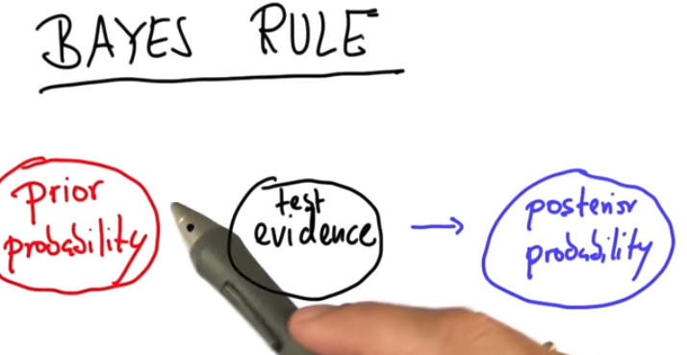

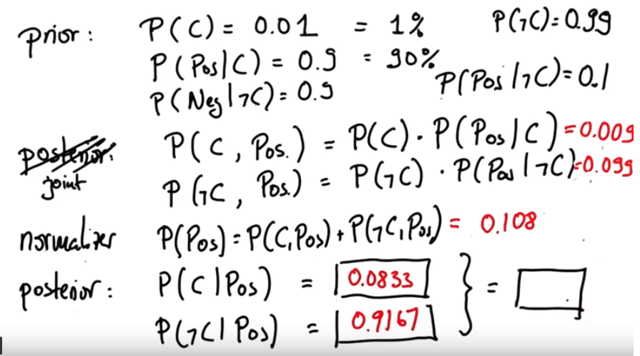

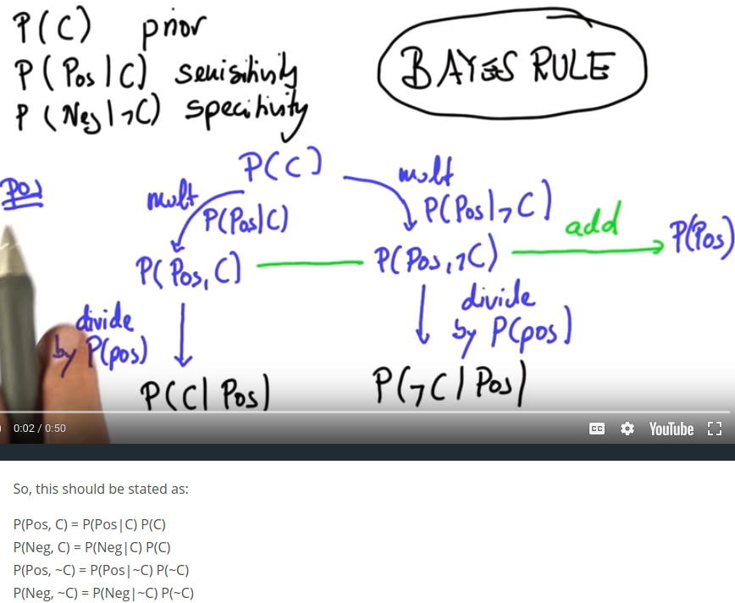

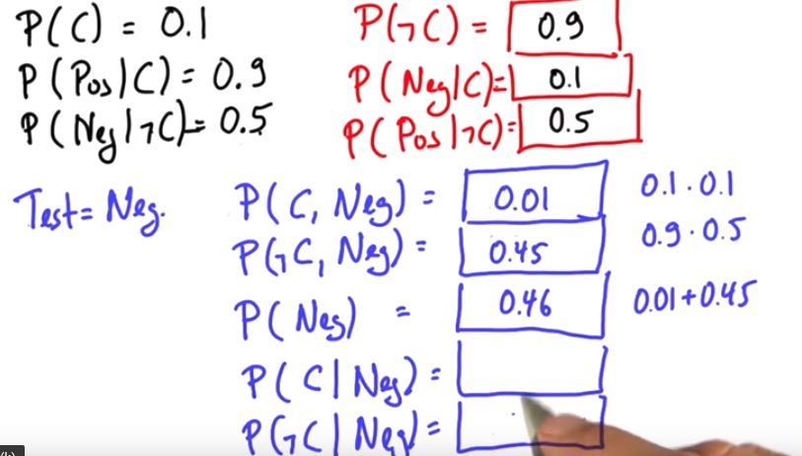

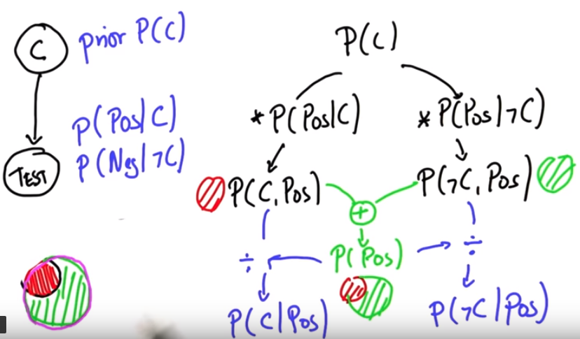

Step by Step Walkthrough
The step-by-step breakdown of the solution is pretty quick. Let's recap what's covered in the solution video.
Let's start with what we know:

Prior Probabilities
The robot is perfectly ignorant about where it is, so prior probabilities are as follows:
P(at red)=0.5
P(at green)=0.5

Conditional Probabilities
The robot's sensors are not perfect. Just because the robot sees red does not mean the robot is at red.
P(see red∣at red)=0.8
P(see green∣at green)=0.8

Posterior Probabilities
From these prior and posterior probabilities we are asked to calculate the following posterior probabilities after the robot sees red:
- P(at red∣see red)
- P(at green∣see red)
and as a reminder, Bayes' rule looks like this:
P(A∣B)=P(B)P(B∣A)⋅P(A)​
or, if we want to use our "versions" of A and B (for posterior #1)...
P(at red∣see red)=P(see red)P(see red∣at red)⋅P(at red)​
Now, we can read two of those terms from what we already know about our prior and conditional probabilities which means we can rewrite this as...
P(at red∣see red)=P(see red)0.8⋅0.5​
But we still have one unknown! What was the probability that we would see red? The answer is 0.5 and there are two ways I can convince myself of that. The first is intuitive and the second is mathematical.

Why is P(see red) 0.5?

Argument 1: Intuitive
Of course it's 0.5! What else could it be? The robot had a 50% belief that it was in red and a 50% belief that it was in green. Sure, its sensors are unreliable but that unreliability is symmetric and not biased towards mistakenly seeing either color.
So whatever the probability of seeing red is, that will also be the probability of seeing green. Since these two colors are the only possible colors the probability MUST be 50% for each!

Argument 2: Mathematical (Law of Total Probability)
There are exactly two situations where the robot would see red.
- When the robot is in a red square and its sensors work correctly.
- When the robot is in a green square and its sensors make a mistake.
I just need to add up these two probabilities to get the total probability of seeing red.
P(see red)=P(at red)⋅P(see red∣at red)+P(at green)⋅P(see red∣at green)
I can read these quantities from above!
P(see red)=0.5⋅0.8+0.5⋅0.2
P(see red)=0.4+0.1
P(see red)=0.5

Robot sensing sample

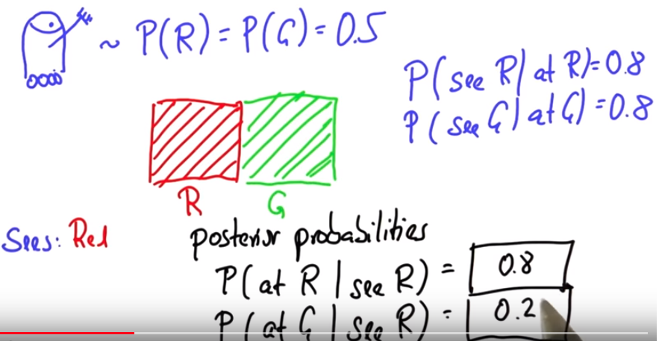

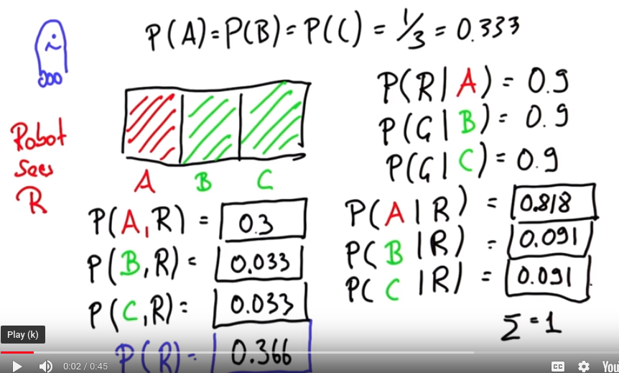

Conditional Probability & Bayes Rule Quiz
In the previous section, you found the following proportions from the cancer results dataset.
- Patients with cancer: 0.105
- Patients without cancer: 0.895
- Patients with cancer who tested positive: 0.905
- Patients with cancer who tested negative: 0.095
- Patients without cancer who tested positive: 0.204
- Patients without cancer who tested negative: 0.796
Based on the above proportions observed in the data, we can assume the following probabilities.
Probability | Meaning
P(cancer) = 0.105 | Probability a patient has cancer
P(~cancer) = 0.895 | Probability a patient does not have cancer
P(positive|cancer) = 0.905 | Probability a patient with cancer tests positive
P(negative|cancer) = 0.095 | Probability a patient with cancer tests negative
P(positive|~cancer) = 0.204 | Probability a patient without cancer tests positive
P(negative|~cancer) = 0.796 | Probability a patient without cancer tests negative

Quiz Questions
Use the probabilities given above and Bayes rule to compute the following probabilities.
- Probability a patient who tested positive has cancer, or P(cancer|positive)
- Probability a patient who tested positive doesn't have cancer, or P(~cancer|positive)
- Probability a patient who tested negative has cancer, or P(cancer|negative)
- Probability a patient who tested negative doesn't have cancer, or P(~cancer|negative)
Then, use the Jupyter notebook to compare them to true proportions in the dataset.

QUESTION 1 OF 2
Using the probabilities above and Bayes rule, compute the following probabilities.
These are the correct matches.
Checkmark

PROBABILITY

VALUE
P(cancer|positive)
0.342
P(~cancer|positive)
0.658
P(cancer|negative)
0.014
P(~cancer|negative)
0.986

