Felipe Guth

14210231

Question 1

1- Mean: 29.96296296 Median: 25

2- Mode: 25. Bimodal data, since 35 also appears 4 times.

3- Midrange: 41.5

4- Q1 = 20.5, Q3 =35

5- Five number summary:

|  |  |
| --- | --- |
| Minimum | 13 |
| Q1 | 20.5 |
| Median | 25 |
| Q3 | 35 |
| Maximum | 70 |

6- Boxplot of data

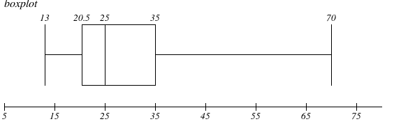

7- The q-q plot is a way to compare the data distribution of a data-set against another desired distribution, while the normal quantile simply displays the data distribution offering a first look on the data and their quantities.

-----------------

Question 2

1 - 0.3859649123

2 - 0.3892609766

3 - 2.413793103

4- I prefer the min-max range method because it provides a simple normalization way to standardize e represent data, maintaining the numerical variability in a more clear fashion.