Felipe Guth

14210231

Question 1

1

Unselecting count.

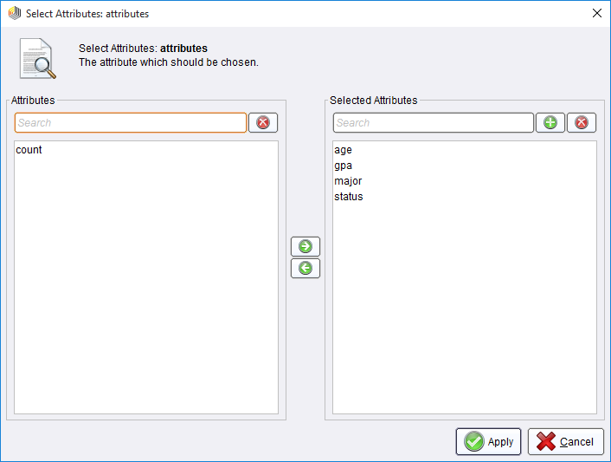

2 – 3

**W-Apriori**

Apriori

=======

Minimum support: 0.1 (3 instances)

Minimum metric <confidence>: 0.9

Number of cycles performed: 18

Generated sets of large itemsets:

Size of set of large itemsets L(1): 12

Large Itemsets L(1):

major=French 6

major=cs 3

major=engineering 3

major=math 3

status=M.S 4

status=Ph.D 5

status=senior 4

age=over 30 4

age=26...30 8

age=21...25 4

gpa=2.8_3.2 6

gpa=3.6_4.0 7

Size of set of large itemsets L(2): 3

Large Itemsets L(2):

major=French age=over 30 3

major=French gpa=2.8_3.2 3

status=Ph.D age=26...30 4

Best rules found:

4

# W-Apriori

Apriori

=======

Minimum support: 0.1 (3 instances)

Minimum metric <confidence>: 0.7

Number of cycles performed: 18

Generated sets of large itemsets:

Size of set of large itemsets L(1): 12

Large Itemsets L(1):

major=French 6

major=cs 3

major=engineering 3

major=math 3

status=M.S 4

status=Ph.D 5

status=senior 4

age=over 30 4

age=26...30 8

age=21...25 4

gpa=2.8_3.2 6

gpa=3.6_4.0 7

Size of set of large itemsets L(2): 3

Large Itemsets L(2):

major=French age=over 30 3

major=French gpa=2.8_3.2 3

status=Ph.D age=26...30 4

Best rules found:

1. status=Ph.D 5 ==> age=26...30 4 conf:(0.8)

2. age=over 30 4 ==> major=French 3 conf:(0.75)

--------------------------------------------------------------------------------------

Question 2

1

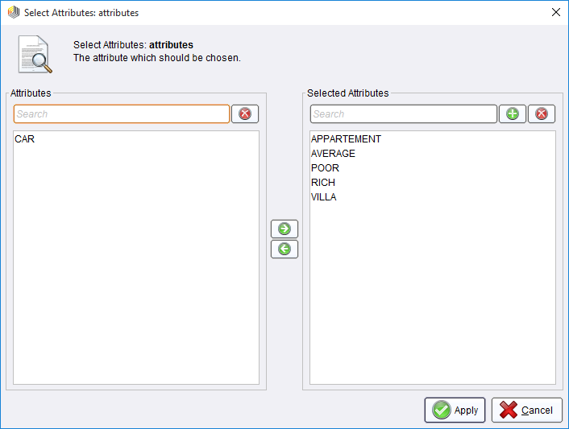

2-3-4

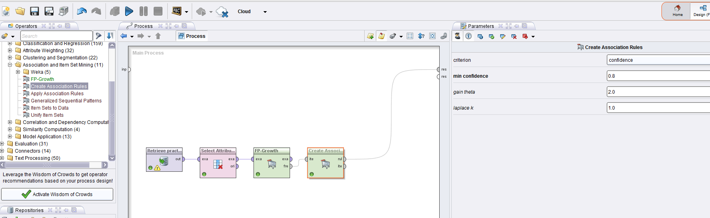

NO RULES FOUND.

5

# AssociationRules

Association Rules

[VILLA] --> [RICH] (confidence: 0.600)

[APPARTEMENT] --> [RICH] (confidence: 0.667)

Question 3

1

Selecting attributes.

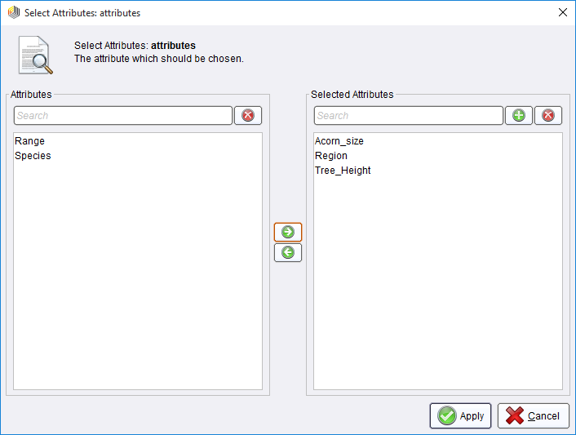

2-3-4

# W-Apriori

Apriori

=======

Minimum support: 0.03 (1 instances)

Minimum metric <confidence>: 0.9

Number of cycles performed: 20

Generated sets of large itemsets:

Size of set of large itemsets L(1): 5

Size of set of large itemsets L(2): 7

Size of set of large itemsets L(3): 2

Best rules found:

1. Acorn_size=range3 [11.500 - ∞] 1 ==> Tree_Height=range2 [10.200 - 20.100] 1 conf:(1)

2. Acorn_size=range3 [11.500 - ∞] 1 ==> Region=California 1 conf:(1)

3. Acorn_size=range2 [5.900 - 11.500] Tree_Height=range2 [10.200 - 20.100] 1 ==> Region=California 1 conf:(1)

4. Acorn_size=range3 [11.500 - ∞] Region=California 1 ==> Tree_Height=range2 [10.200 - 20.100] 1 conf:(1)

5. Acorn_size=range3 [11.500 - ∞] Tree_Height=range2 [10.200 - 20.100] 1 ==> Region=California 1 conf:(1)

6. Acorn_size=range3 [11.500 - ∞] 1 ==> Tree_Height=range2 [10.200 - 20.100] Region=California 1 conf:(1)

5 –

# W-Apriori

Apriori

=======

Minimum support: 0.03 (1 instances)

Minimum metric <confidence>: 0.4

Number of cycles performed: 20

Generated sets of large itemsets:

Size of set of large itemsets L(1): 5

Size of set of large itemsets L(2): 7

Size of set of large itemsets L(3): 2

Best rules found:

1. Acorn_size=range3 [11.500 - ∞] 1 ==> Tree_Height=range2 [10.200 - 20.100] 1 conf:(1)

2. Acorn_size=range3 [11.500 - ∞] 1 ==> Region=California 1 conf:(1)

3. Acorn_size=range2 [5.900 - 11.500] Tree_Height=range2 [10.200 - 20.100] 1 ==> Region=California 1 conf:(1)

4. Acorn_size=range3 [11.500 - ∞] Region=California 1 ==> Tree_Height=range2 [10.200 - 20.100] 1 conf:(1)

5. Acorn_size=range3 [11.500 - ∞] Tree_Height=range2 [10.200 - 20.100] 1 ==> Region=California 1 conf:(1)

6. Acorn_size=range3 [11.500 - ∞] 1 ==> Tree_Height=range2 [10.200 - 20.100] Region=California 1 conf:(1)

7. Region=California 11 ==> Tree_Height=range2 [10.200 - 20.100] 5 conf:(0.45)

8. Tree_Height=range2 [10.200 - 20.100] 11 ==> Region=California 5 conf:(0.45)

9. Acorn_size=range2 [5.900 - 11.500] 7 ==> Region=California 3 conf:(0.43)

Question 4

1

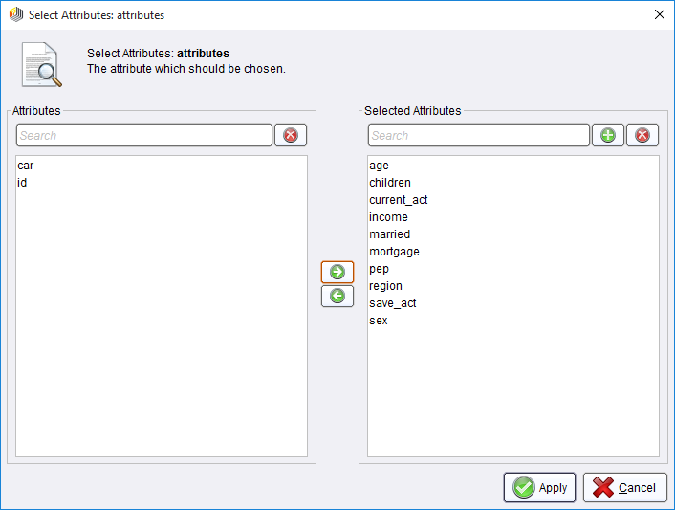

2-3-4-5-6

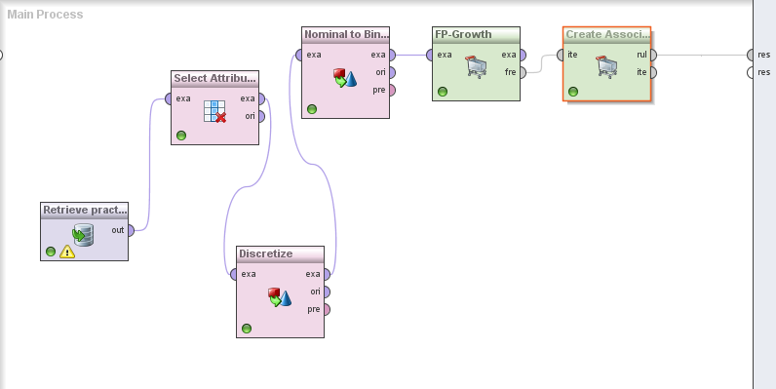

# AssociationRules

Association Rules

[sex] --> [current_act] (confidence: 0.750)

[children = range1 [-∞ - 1], pep] --> [current_act] (confidence: 0.750)

[pep, income = range1 [-∞ - 24386.173]] --> [current_act] (confidence: 0.750)

[income = range2 [24386.173 - 43758.137]] --> [current_act] (confidence: 0.753)

[children = range1 [-∞ - 1]] --> [current_act] (confidence: 0.754)

[age = range3 [50.667 - ∞]] --> [current_act] (confidence: 0.754)

[income = range1 [-∞ - 24386.173]] --> [current_act] (confidence: 0.754)

[children = range1 [-∞ - 1], pep] --> [save_act] (confidence: 0.760)

[save_act, income = range2 [24386.173 - 43758.137]] --> [current_act] (confidence: 0.761)

[save_act, pep] --> [current_act] (confidence: 0.762)

[region = INNER_CITY] --> [current_act] (confidence: 0.762)

[married, region = INNER_CITY] --> [current_act] (confidence: 0.764)

[save_act, sex] --> [current_act] (confidence: 0.764)

[save_act, children = range1 [-∞ - 1]] --> [current_act] (confidence: 0.766)

[save_act] --> [current_act] (confidence: 0.771)

[save_act, income = range1 [-∞ - 24386.173]] --> [current_act] (confidence: 0.772)

[age = range1 [-∞ - 34.333]] --> [current_act] (confidence: 0.785)

[save_act, region = INNER_CITY] --> [current_act] (confidence: 0.786)

[age = range3 [50.667 - ∞]] --> [save_act] (confidence: 0.791)

[income = range1 [-∞ - 24386.173], age = range1 [-∞ - 34.333]] --> [current_act] (confidence: 0.793)

[children = range1 [-∞ - 1], pep] --> [married] (confidence: 0.812)

[age = range1 [-∞ - 34.333]] --> [income = range1 [-∞ - 24386.173]] (confidence: 0.892)

[current_act, age = range1 [-∞ - 34.333]] --> [income = range1 [-∞ - 24386.173]] (confidence: 0.902)

Most interesting rules

[children = range1 [-∞ - 1], pep] --> [save_act] (confidence: 0.760)

This pattern shows that people that have a number maximum of 1 children have a strong probability in having a saving account. The agency can use this pattern to offer different financial solutions of investment and products of merchandising.

[age = range3 [50.667 - ∞]] --> [save_act] (confidence: 0.791)

This pattern shows that clients in the 3rd range of the dimension age have a high probability in having a save account. This information can be useful for the agency for promotions of products that take account specific demands and services of this group such as health insurance and travel options.