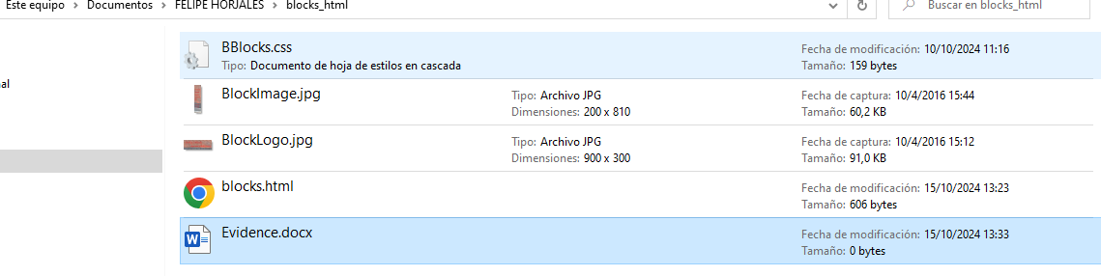

The imagen does not maintain the aspect ratio