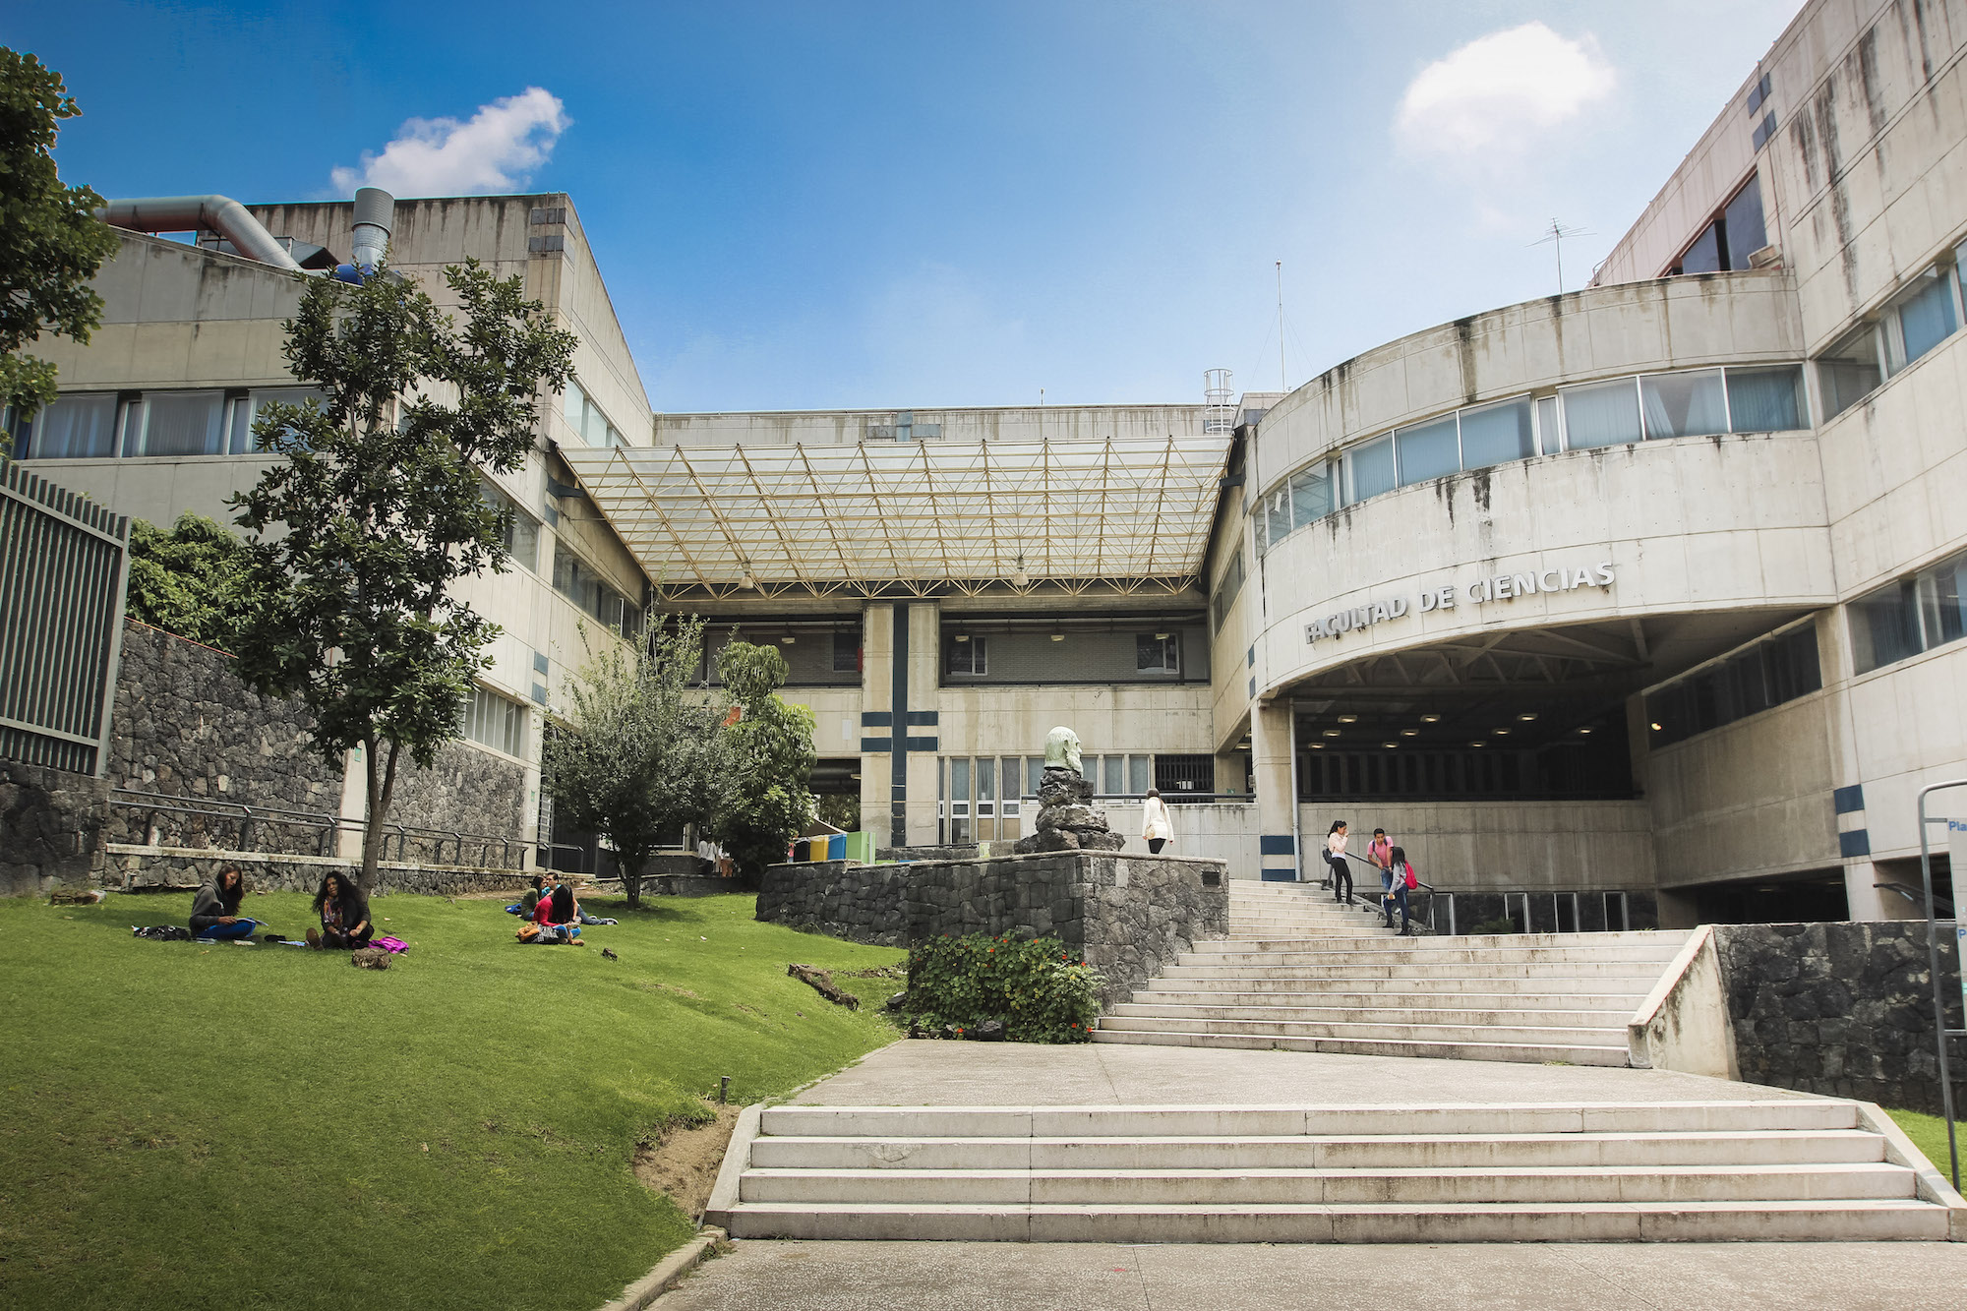

Complejidad Computacional – Tarea 6

Profesor: María de Luz Gasca Soto  
Ayudante: José Luis Vázquez Lázaro

Cova Pacheco Felipe de Jesús

Actividades: 1. Leer el artículo An Overview of Heuristic Solution Methods (de E. A.Silver). 2. Elaborar un escrito en donde describas a detalle las 9 metaheur ́ısticaspresentadas en el art ́ıculo. Adem ́as deber ́as indicar y justificar a cu ́altipo de heur ́ıstica b ́asica pertenecen.

**Problema del Agente Viajero & Algoritmos Genéticos**

*Considere los padres P1 , P2 , P3 , P4 dados.*

*P1: (1,2,3,4,5,6,7)*

*P2: (3,1,4,2,7,6,5)*

*P3: (1,3,5,7,2,4,6)*

*P4: (7,3,2,4,6,1,5)*

*Construya una generación más, de cuatro elementos, para cada uno de los siguientes operadores de cruce y mutación.*

c1) One Point Crossover

|  |  |  |  |  |  |  |  |  |  |  |  |  |  |  |  |  |  |  |  |
| --- | --- | --- | --- | --- | --- | --- | --- | --- | --- | --- | --- | --- | --- | --- | --- | --- | --- | --- | --- |
| **P1** | 1 | 2 | 3 | 4 | 5 | 6 | 7 |  | **H1** | 1 | 2 | 3 | 4 | 7 | 6 | 5 |  | **W(H1)** | 34 |
| **P2** | 3 | 1 | 4 | 2 | 7 | 6 | 5 |  | **H2** | 3 | 1 | 4 | 2 | 5 | 6 | 7 |  | **W(H2)** | 29 |
|  | | | | | | | | | | | | | | | | | | | |
| **P3** | 1 | 3 | 5 | 7 | 2 | 4 | 6 |  | **H3** | 1 | 3 | 5 | 7 | 6 | 1 | 5 |  | **W(H3)** | 21 |
| **P4** | 7 | 3 | 2 | 4 | 6 | 1 | 5 |  | **H4** | 7 | 3 | 2 | 4 | 2 | 4 | 6 |  | **W(H4)** | 31 |

c2) Two point Crossover

|  |  |  |  |  |  |  |  |  |  |  |  |  |  |  |  |  |  |  |  |
| --- | --- | --- | --- | --- | --- | --- | --- | --- | --- | --- | --- | --- | --- | --- | --- | --- | --- | --- | --- |
| **P1** | 1 | 2 | 3 | 4 | 5 | 6 | 7 |  | **H5** | 1 | 2 | 3 | 2 | 7 | 6 | 7 |  | **W(H5)** | 40 |
| **P2** | 3 | 1 | 4 | 2 | 7 | 6 | 5 |  | **H6** | 3 | 1 | 4 | 4 | 5 | 6 | 5 |  | **W(H6)** | 22 |
|  | | | | | | | | | | | | | | | | | | | |
| **P3** | 1 | 3 | 5 | 7 | 2 | 4 | 6 |  | **H7** | 1 | 3 | 5 | 4 | 6 | 4 | 6 |  | **W(H7)** | 24 |
| **P4** | 7 | 3 | 2 | 4 | 6 | 1 | 5 |  | **H8** | 7 | 3 | 2 | 7 | 2 | 1 | 5 |  | **W(H8)** | 29 |

c3) Partially Maped Crossover

|  |  |  |  |  |  |  |  |  |  |  |  |  |  |  |  |  |  |  |  |
| --- | --- | --- | --- | --- | --- | --- | --- | --- | --- | --- | --- | --- | --- | --- | --- | --- | --- | --- | --- |
| **P1** | 1 | 2 | 3 | 4 | 5 | 6 | 7 |  | **H9** | 1 | 4 | 3 | 2 | 7 | 6 | 5 |  | **W(H9)** | 34 |
| **P2** | 3 | 1 | 4 | 2 | 7 | 6 | 5 |  | **H10** | 3 | 1 | 2 | 4 | 5 | 6 | 7 |  | **W(H10)** | 29 |
| Mapping (p1,p2): 4 – 2 , 5 – 7 , 6 – 6  Mapping (p3, p4): 7 – 4 – 1 , 2 – 6 | | | | | | | | | | | | | | | | | | | |
| **P3** | 1 | 3 | 5 | 7 | 2 | 4 | 6 |  | **H11** | 7 | 3 | 5 | 4 | 6 | 1 | 2 |  | **W(H11)** | 24 |
| **P4** | 7 | 3 | 2 | 4 | 6 | 1 | 5 |  | **H12** | 1 | 3 | 6 | 7 | 2 | 4 | 5 |  | **W(H12)** | 33 |

c4) Cycle Crossover

|  |  |  |  |  |  |  |  |  |  |  |  |  |  |  |  |  |  |  |  |
| --- | --- | --- | --- | --- | --- | --- | --- | --- | --- | --- | --- | --- | --- | --- | --- | --- | --- | --- | --- |
| **P1** | 1 | 2 | 3 | 4 | 5 | 6 | 7 |  | **H13** | 1 | 2 | 3 | 4 | 7 | 6 | 5 |  | **W(H13)** | 34 |
| **P2** | 3 | 1 | 4 | 2 | 7 | 6 | 5 |  | **H14** | 3 | 1 | 4 | 2 | 5 | 6 | 7 |  | **W(H14)** | 29 |
| Mapping(P1): 1-3-4-2-1  Mapping(P2): 3-1-2-4-3  Mapping(P3): 1-7-4-1  Mapping(P4): 7-1-4-7 | | | | | | | | | | | | | | | | | | | |
| **P3** | 1 | 3 | 5 | 7 | 2 | 4 | 6 |  | **H15** | 1 | 3 | 2 | 7 | 6 | 4 | 5 |  | **W(H15)** | 32 |
| **P4** | 7 | 3 | 2 | 4 | 6 | 1 | 5 |  | **H16** | 7 | 3 | 5 | 4 | 2 | 1 | 6 |  | **W(H16)** | 25 |

c5) Cut & Splice

|  |  |  |  |  |  |  |  |  |  |  |  |  |  |  |  |  |  |  |  |  |  |
| --- | --- | --- | --- | --- | --- | --- | --- | --- | --- | --- | --- | --- | --- | --- | --- | --- | --- | --- | --- | --- | --- |
| **P1** | 1 | 2 | 3 | 4 | 5 | 6 | 7 |  | **H17** | 1 | 2 | 3 | 4 | 4 | 2 | 7 | 6 | 5 |  | **W(H17)** | 41 |
| **P2** | 3 | 1 | 4 | 2 | 7 | 6 | 5 |  | **H18** | 3 | 1 | 5 | 6 | 7 |  |  |  |  |  | **W(H18)** | 20 |
|  | | | | | | | | | | | | | | | | | | | | | |
| **P3** | 1 | 3 | 5 | 7 | 2 | 4 | 6 |  | **H19** | 1 | 3 | 5 | 7 | 2 | 4 | 6 | 1 | 5 |  | **W(H19)** | 28 |
| **P4** | 7 | 3 | 2 | 4 | 6 | 1 | 5 |  | **H20** | 7 | 3 | 2 | 4 | 6 |  |  |  |  |  | **W(H20)** | 23 |

c6) Order Crossover

|  |  |  |  |  |  |  |  |  |  |  |  |  |  |  |  |  |  |  |  |
| --- | --- | --- | --- | --- | --- | --- | --- | --- | --- | --- | --- | --- | --- | --- | --- | --- | --- | --- | --- |
| **P1** | 1 | 2 | 3 | 4 | 5 | 6 | 7 |  | **H21** | 1 | 2 | 3 | 4 | 7 | 6 | 5 |  | **W(H21)** | 34 |
| **P2** | 3 | 1 | 4 | 2 | 7 | 6 | 5 |  | **H22** | 2 | 1 | 4 | 3 | 5 | 6 | 7 |  | **W(H22)** | 30 |
|  | | | | | | | | | | | | | | | | | | | |
| **P3** | 1 | 3 | 5 | 7 | 2 | 4 | 6 |  | **H23** | 7 | 3 | 5 | 2 | 4 | 6 | 1 |  | **W(H23)** | 23 |
| **P4** | 7 | 3 | 2 | 4 | 6 | 1 | 5 |  | **H24** | 1 | 3 | 2 | 5 | 7 | 4 | 6 |  | **W(H24)** | 29 |

m1) Inversión

|  |  |  |  |  |  |  |  |  |  |  |  |  |  |  |  |  |  |  |  |
| --- | --- | --- | --- | --- | --- | --- | --- | --- | --- | --- | --- | --- | --- | --- | --- | --- | --- | --- | --- |
| **H1** | 1 | 2 | 3 | 4 | 7 | 6 | 5 |  | **H25** | 1 | 2 | 3 | 7 | 4 | 6 | 5 |  | **W(H25)** | 28 |
| **H2** | 3 | 1 | 4 | 2 | 5 | 6 | 7 |  | **H26** | 3 | 1 | 4 | 5 | 2 | 6 | 7 |  | **W(H26)** | 25 |
|  | | | | | | | | | | | | | | | | | | | |
| **H3** | 1 | 3 | 5 | 7 | 6 | 1 | 5 |  | **H27** | 1 | 3 | 5 | 6 | 7 | 1 | 5 |  | **W(H27)** | 24 |
| **H4** | 7 | 3 | 2 | 4 | 2 | 4 | 6 |  | **H28** | 7 | 3 | 2 | 2 | 4 | 4 | 6 |  | **W(H28)** | 23 |

m2) Intercambio Reciproco

|  |  |  |  |  |  |  |  |  |  |  |  |  |  |  |  |  |  |  |  |
| --- | --- | --- | --- | --- | --- | --- | --- | --- | --- | --- | --- | --- | --- | --- | --- | --- | --- | --- | --- |
| **H5** | 1 | 2 | 3 | 2 | 7 | 6 | 7 |  | **H29** | 1 | 7 | 3 | 2 | 2 | 6 | 7 |  | **W(H29)** | 23 |
| **H6** | 3 | 1 | 4 | 4 | 5 | 6 | 5 |  | **H30** | 3 | 5 | 4 | 4 | 1 | 6 | 5 |  | **W(H30)** | 18 |
|  | | | | | | | | | | | | | | | | | | | |
| **H7** | 1 | 3 | 5 | 4 | 6 | 4 | 6 |  | **H31** | 1 | 6 | 5 | 4 | 3 | 4 | 6 |  | **W(H31)** | 30 |
| **H8** | 7 | 3 | 2 | 7 | 2 | 1 | 5 |  | **H32** | 7 | 2 | 2 | 7 | 3 | 1 | 5 |  | **W(H32)** | 21 |

m3) Inserción y Desplazamiento simple (una ciudad)

|  |  |  |  |  |  |  |  |  |  |  |  |  |  |  |  |  |  |  |  |  |
| --- | --- | --- | --- | --- | --- | --- | --- | --- | --- | --- | --- | --- | --- | --- | --- | --- | --- | --- | --- | --- |
| **H9** | 1 | 4 | 3 |  | 2 | 7 | 6 | 5 |  | **H33** | 1 | 4 | 3 | 7 | 2 | 6 | 5 |  | **W(H33)** | 25 |
| **H10** | 3 | 1 | 2 |  | 4 | 5 | 6 | 7 |  | **H34** | 3 | 1 | 2 | 5 | 4 | 6 | 7 |  | **W(H34)** | 28 |
|  | | | | | | | | | | | | | | | | | | | | |
| **H11** | 7 | 3 | 5 |  | 4 | 6 | 1 | 2 |  | **H35** | 7 | 3 | 5 | 6 | 4 | 1 | 2 |  | **W(H35)** | 26 |
| **H12** | 1 | 3 | 6 |  | 7 | 2 | 4 | 5 |  | **H36** | 1 | 3 | 6 | 2 | 7 | 4 | 5 |  | **W(H36)** | 29 |

m4) Inserción y Desplazamiento no-simple (un subtour)

|  |  |  |  |  |  |  |  |  |  |  |  |  |  |  |  |  |  |  |  |
| --- | --- | --- | --- | --- | --- | --- | --- | --- | --- | --- | --- | --- | --- | --- | --- | --- | --- | --- | --- |
| **H13** | 1 | 2 | 3 | 4 | 7 | 6 | 5 |  | **H37** | 1 | 4 | 7 | 2 | 3 | 6 | 5 |  | **W(H37)** | 34 |
| **H14** | 3 | 1 | 4 | 2 | 5 | 6 | 7 |  | **H38** | 3 | 2 | 5 | 1 | 4 | 6 | 7 |  | **W(H38)** | 28 |
|  | |  |  |  |  |  | | | | | | | | | | | | | | |
| **H15** | 1 | 3 | 2 | 7 | 6 | 4 | 5 |  | **H39** | 1 | 7 | 6 | 3 | 2 | 4 | 5 |  | **W(H39)** | 33 |
| **H16** | 7 | 3 | 5 | 4 | 2 | 1 | 6 |  | **H40** | 7 | 4 | 2 | 3 | 5 | 1 | 6 |  | **W(H40)** | 29 |

Intercambio Recíproco

|  |  |  |  |  |  |  |  |  |  |  |  |  |  |  |  |  |  |  |  |  |  |  |  |
| --- | --- | --- | --- | --- | --- | --- | --- | --- | --- | --- | --- | --- | --- | --- | --- | --- | --- | --- | --- | --- | --- | --- | --- |
| **H17** | 1 | 2 | 3 | 4 | 4 | 2 | 7 | 6 | 5 |  | **H41** | 1 | 4 | 3 | 4 | 2 | 2 | 7 | 6 | 5 |  | **W(H41)** | 35 |
| **H18** | 3 | 1 | 5 | 6 | 7 |  |  |  |  |  | **H42** | 3 | 7 | 5 | 6 | 1 |  |  |  |  |  | **W(H42)** | 17 |
| **H19** | 1 | 3 | 5 | 7 | 2 | 4 | 6 | 1 | 5 |  | **H43** | 1 | 2 | 5 | 7 | 3 | 4 | 6 | 1 | 5 |  | **W(H43)** | 29 |
| **H20** | 7 | 3 | 2 | 4 | 6 |  |  |  |  |  | **H44** | 7 | 6 | 2 | 4 | 3 |  |  |  |  |  | **W(H44)** | 20 |
| **H21** | 1 | 2 | 3 | 4 | 7 | 6 | 5 |  |  |  | **H45** | 1 | 7 | 3 | 4 | 2 | 6 | 5 |  |  |  | **W(H45)** | 24 |
| **H22** | 2 | 1 | 4 | 3 | 5 | 6 | 7 |  |  |  | **H46** | 2 | 5 | 4 | 3 | 1 | 6 | 7 |  |  |  | **W(H46)** | 34 |
| **H23** | 7 | 3 | 5 | 2 | 4 | 6 | 1 |  |  |  | **H47** | 7 | 4 | 5 | 2 | 3 | 6 | 1 |  |  |  | **W(H47)** | 34 |
| **H24** | 1 | 3 | 2 | 5 | 7 | 4 | 6 |  |  |  | **H48** | 1 | 7 | 2 | 5 | 3 | 4 | 6 |  |  |  | **W(H48)** | 28 |

**Bibliografía:**

* Algorítmo Genético, Wikipedia. Recuperado de: https://es.wikipedia.org/wiki/Algoritmo_gen%C3%A9tico
* Algorítmos genéticos, recuperado de un archivo PDF en linea de: http://www.sc.ehu.es/ccwbayes/docencia/mmcc/docs/temageneticos.pdf
* Algorítmos genéticos, recuperado de: http://eddyalfaro.galeon.com/geneticos.html