1. Go to: *yoursite*/admin/config/services/rest

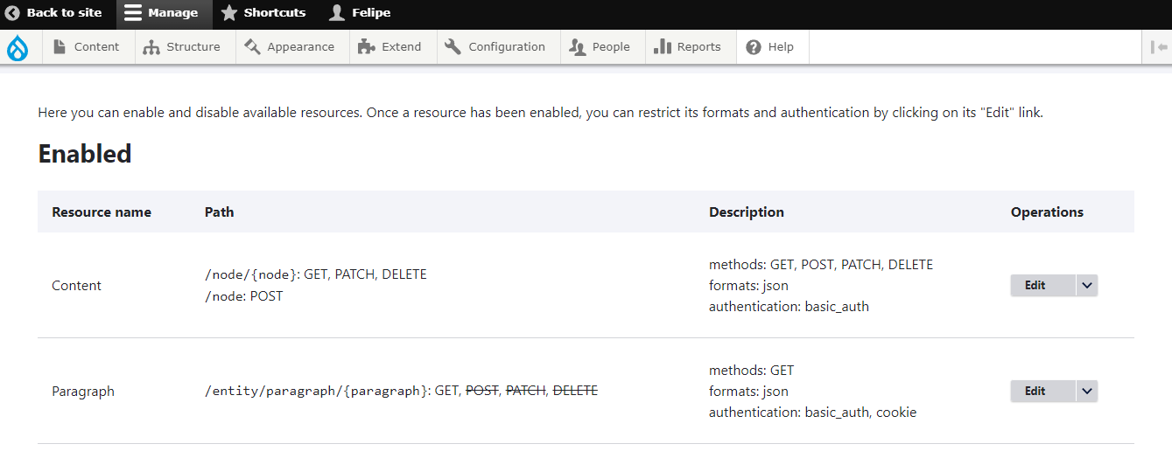

1. Insert data listed below in the form:

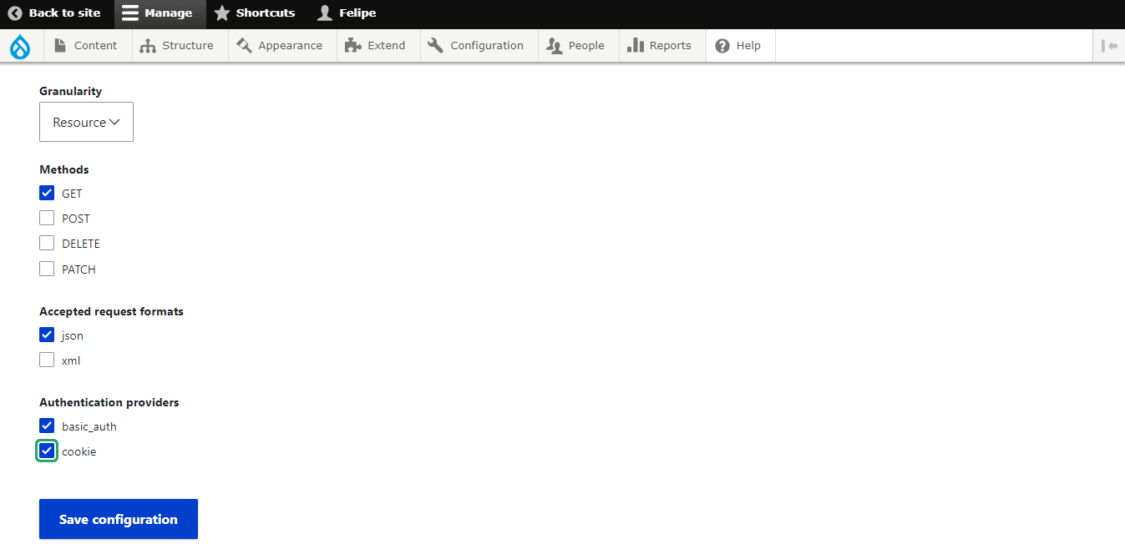

1. Click on save configuration.
2. Go to: *yoursite*/admin/structure/block
3. Place the Charts block in the region of your preference

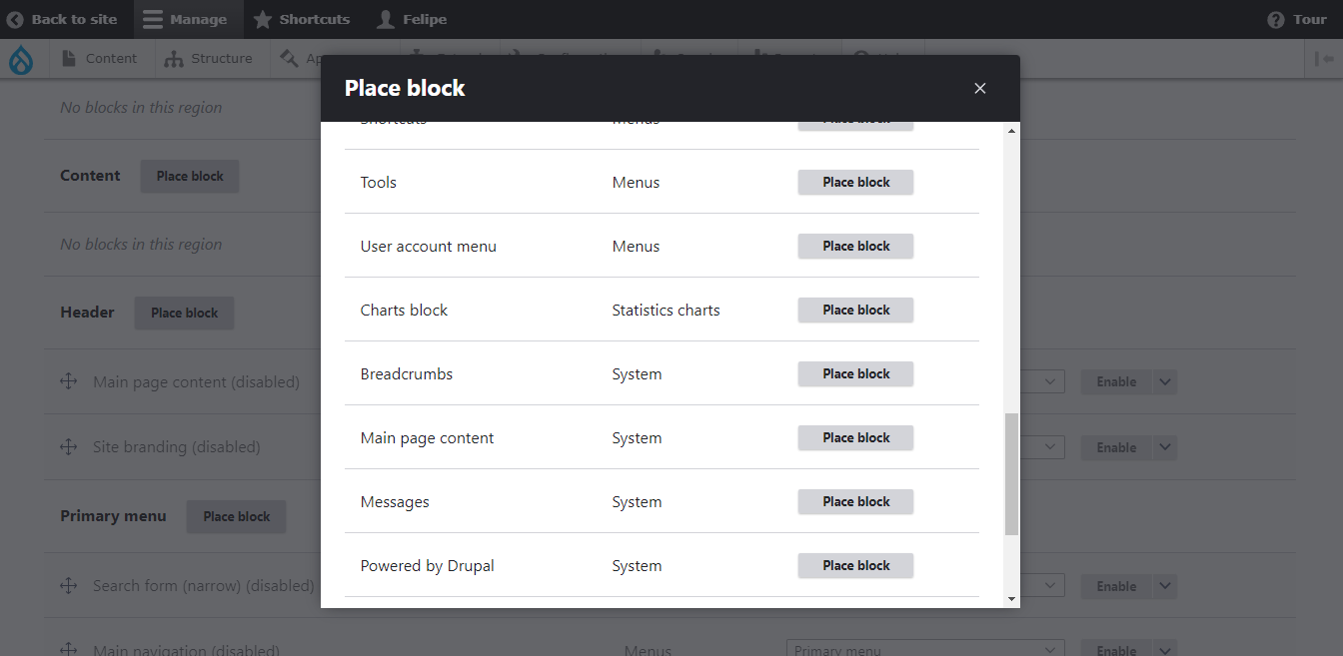

1. Save blocks.
2. Go to *yoursite*/node/add/chart.
3. Fill the form and remember to unmark published.

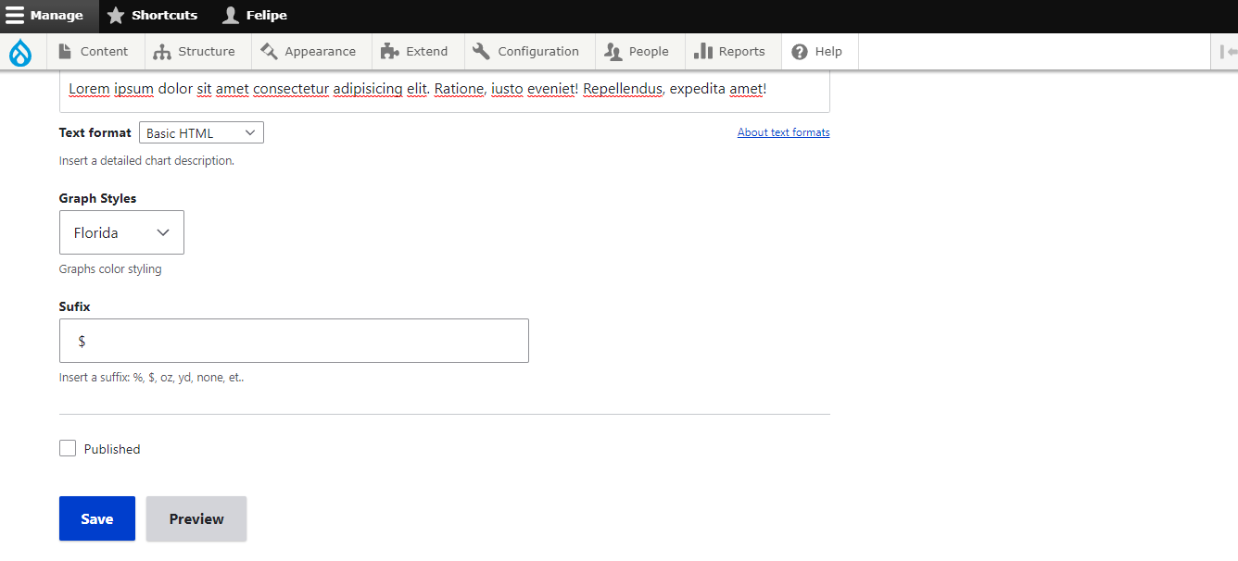

1. Start adding new charts to your new Chart block, enjoy.