Hiren CRM Edits

Let’s start with page - <http://cryptdata.com/qt/quotes>

Here, pagination is - Home Quotes **We Do not want pagination. It’s just adding extra to pages. Remove it!**

And page heading is > Manage Quotes. We do not want this heading as the read heading works well in most cases. Instead we will add a description that will come below the Heading.

Menu is > View Matched Leads

Increase the height of the Red bar that says “quotes” here to match the original metronic height of headings.

Red Menu: read Quotes. Rename it to View Matched Leads. And remove the “Manage quotes”

Below “manage quotes” we also need to add a quick description line. I will give you pagination, page heading, and quick description for each crm page.

There are very good designed metronic element for description. , for example –

Also, all ACTION buttons need to be Rounded. Metronic already has this, tell designer to use it. And also change color of it, red on red is not readable.

<http://cryptdata.com/qt/quotes>

Pagination: Home > Quote System > View Received Leads

Heading: View Received Leads

Red Menu: View Matched Leads

Description: Here are all the leads you have received. Click on any Lead to learn more about the buyer and send them a quote.

Hiren: add a button at page bottom right end that says “Request More Leads”

In the fields, I see

| **Title** | **Buyer Name** | **Company Name** | **Expiry Date** | **Status** | **Action** |
| --- | --- | --- | --- | --- | --- |

I don’t know how this is implemented as I can’t test it as MYSQL categories are not working so no matching is being Done. (Fix it so I can test),. But each entry needs to be expandable. Refer to my Mockups.

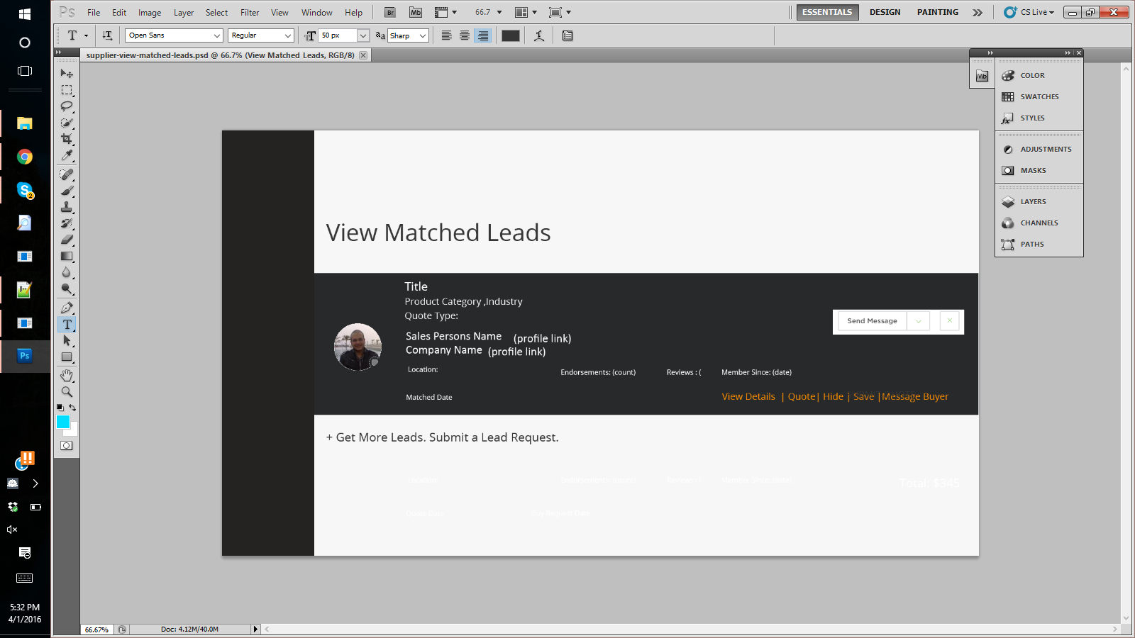

There is no sort drop down ? there needs to be a sort function that sorts by expiry date, or by date submitted. The

<http://cryptdata.com/qt/supplier-leads>

Heading: Manage Lead Requests

Menu : Manage Lead Requests

Description: Manage the posted Lead requests. You can pause, edit or delete your existing lead pipelines effective immediately.

<http://cryptdata.com/qt/supplier-leads/1/edit>

Heading: Edit your Lead Request

Set expiry date – add text (optional). Or make it italicized and add a mouse over that says optional.

<http://cryptdata.com/qt/supplier-leads/create>

Menu: Get New Leads

Heading: Get New Leads

Description: Ready to create new lead pipelines? Add new product types or categories to your portfolio and we will send you their leads. You can also upload your Catalog online for us to automatically select all the product types and categories that you work in .

<Hiren> add the “UPLOAD your catalog” message here. This will also interface with API. User can either select category manually or Upload a file here. Make sure to make it as , type to search , OR upload .

Rename categories to: Select Product Types or Categories

Rename industries to: Select Applicable Industries.

Also split categories and industries field into different lines.

This isn’t still working, I was expecting this to run using mysql until we introduce elasticsearch.

Forward Leads –

This page is not there. Hide this from the menu, as what we can do is interface it from the “Received Leads” page.

Okay, so most of the things I am checking aren’t able to check as fields aren’t working, and just the design isn’t as expected from the psd. Have CRM designer once again look at psd files, and fix these changes given and ill work on doing others but, without being able to check completely with data, it’s useless as we will keep going back and forth a lot.