*Frameworx Specification*

Privacy Management API REST Specification

**TMF644**

**Release 16.0.0**

**June 2016**

|  |  |
| --- | --- |
| **Latest Update: Frameworx Release 14.5** | **Member Evaluation** |
| **Version 1.1.0** | **IPR Mode: RAND** |

# NOTICE

Copyright © TM Forum 2016. All Rights Reserved.

This document and translations of it may be copied and furnished to others, and derivative works that comment on or otherwise explain it or assist in its implementation may be prepared, copied, published, and distributed, in whole or in part, without restriction of any kind, provided that the above copyright notice and this section are included on all such copies and derivative works. However, this document itself may not be modified in any way, including by removing the copyright notice or references to TM FORUM, except as needed for the purpose of developing any document or deliverable produced by a TM FORUM Collaboration Project Team (in which case the rules applicable to copyrights, as set forth in the [TM FORUM IPR Policy](http://www.tmforum.org/IPRPolicy/11525/home.html), must be followed) or as required to translate it into languages other than English.

The limited permissions granted above are perpetual and will not be revoked by TM FORUM or its successors or assigns.

This document and the information contained herein is provided on an "AS IS" basis and TM FORUM DISCLAIMS ALL WARRANTIES, EXPRESS OR IMPLIED, INCLUDING BUT NOT LIMITED TO ANY WARRANTY THAT THE USE OF THE INFORMATION HEREIN WILL NOT INFRINGE ANY OWNERSHIP RIGHTS OR ANY IMPLIED WARRANTIES OF MERCHANTABILITY OR FITNESS FOR A PARTICULAR PURPOSE.

Direct inquiries to the TM Forum office:

240 Headquarters Plaza,

East Tower – 10th Floor,

Morristown, NJ  07960 USA

Tel No.  +1 973 944 5100

Fax No.  +1 973 944 5110

TM Forum Web Page: [www.tmforum.org](http://www.tmforum.org/)

# Table of Contents

NOTICE 2

Table of Contents 3

List of Tables 5

Introduction 6

SAMPLE USE CASES 7

RESOURCE MODEL 8

Managed Entity and Task Resource Models 8

PARTY PRIVACY PROFILE TYPE Resource 8

PARTY PRIVACY PROFILE Resource 15

PARTY PRIVACY Agreement Resource 19

Export Job Resource 25

Import Job Resource 26

Notification Resource Models 29

API OPERATION TEMPLATES 38

GET /privacyManagement/partyPrivacyProfileType/{ID} 39

GET /privacyManagement/partyPrivacyProfile/{ID} 44

GET /privacyManagement/partyPrivacyAgreement/{ID} 47

PATCH /privacyManagement/partyPrivacyProfileType/{ID} 50

PATCH /privacyManagement/partyPrivacyProfile/{ID} 52

PATCH /privacyManagement/partyPrivacyAgreement/{ID} 56

POST /privacyManagement/partyPrivacyProfileType 58

POST /privacyManagement/partyPrivacyProfile 69

POST /privacyManagement/partyPrivacyAgreement 75

DELETE /privacyManagement/partyPrivacyProfileType/{ID} or /partyPrivacyProfile/{ID} or /partyPrivacyAgreement/{ID} 79

POST /privacyManagement/importJob 80

POST /privacyManagement/exportJob 80

GET privacyManagement/exportJob 81

GET privacyManagement/importJob 82

API NOTIFICATION TEMPLATES 84

REGISTER LISTENER POST /hub 84

UNREGISTER LISTENER DELETE hub/{id} 84

publish {EventTYPE} POST /listener 85

Notes 87

RELEASE HISTORY 88

Contributors to Document 88

# List of Tables

N/A

# Introduction

The following document is the specification of the REST API Privacy Management.

The Privacy management API provides standardized mechanism for privacy profile types, privacy profiles and privacy agreements such as creation, update, retrieval, deletion and notification of events.

Privacy management API manages the following data resources:

* **Privacy Profile Type**
  + Privacy profile type represents a description for privacy profiles.
  + Main privacy profile type attributes are its identifier, name, description, version, last update, lifecycle status, validity period, characteristics and their values, related parties, applicable roles.
* **Privacy Profile**
  + Privacy profile represents the set of Privacy settings defined for a Party
  + Main privacy profile attributes are its identifier, name, description, date of creation, status, validity period, privacy profile type, characteristics values, agreement, the party who has agreed.
* **Privacy Agreement**
  + Privacy agreement represents the approval made by the Party about a Party Privacy Profile
  + Main privacy agreement attributes are its identifier, name, description, agreement period, initial date, completion date, document number, statement of intent, status, type, version, agreement specification, agreement items, engaged party, agreement authorization, characteristics, associated agreements, privacy profile and privacy profile characteristic values.

Privacy management API performs the following operations on privacy profile types, privacy profiles and privacy agreements:

* Retrieval of a privacy profile type, a privacy profile or a privacy agreement, or of a collection of them depending on filter criteria
* Partial update of a privacy profile type, a privacy profile or a privacy agreement
* Creation of a privacy profile type, a privacy profile or a privacy agreement
* Deletion of a privacy profile type, a privacy profile or a privacy agreement (for administration purposes)
* Notification of events:
  + privacy profile type create
  + privacy profile type update
  + privacy profile type delete
  + privacy profile create
  + privacy profile update
  + privacy profile delete
  + privacy agreement create
  + privacy agreement update
  + privacy agreement delete

# SAMPLE USE CASES

Reader will find example of use cases using Privacy management API in “Open Digital Business Scenarios and Use Cases” document.

# RESOURCE MODEL

## Managed Entity and Task Resource Models

For every single resource managed by the API provide a JSON based representation of the managed entities and tasks.

### PARTY PRIVACY PROFILE TYPE Resource

A Party Privacy Profile Type represents a description for Party Privacy Profiles.

JSON representation of a Party Privacy Profile Type:

|  |
| --- |
| {  "href": "http://serverlocation:port/privacyManagement/partyPrivacyProfileType/103",  "id": "103",  "version": "1.0",  "lastUpdate": "2013-04-19T16:42:23-04:00",  "name": "Customer Mass Market Privacy",  "description": "This is the customer mass market privacy",  "lifecycleStatus": "active",  "validFor": {  "startDateTime": "2013-04-19T16:42:23-04:00",  "endDateTime": "2013-06-19T00:00:00-04:00"  },  "relatedParty": [  {  "id": "1066",  "href": "http://serverlocation:port/partyManagement/individual/1066",  "role": "Profile Type Admin",  "name": "James Smith"  }  ],  "applicableRole": [  {  "role": "Customer"  }  ],  "partyPrivacyProfileTypeCharacteristic": [  { // ALWAYS example  "id": "42",  "name": "eMailAddress",  "privacyUsagePurpose": "ADMIN",  "description": "this is the email address privacy for internal ADMIN purpose",  "privacyType": "Internal Purpose",  "criticalityLevel": "low",  "validFor": {  "startDateTime": "2013-04-19T16:42:23-04:00",  "endDateTime": ""  },  "partyPrivacyProfileTypeCharValue": [  {  "valueType": "string",  "default": true,  "value": "Authorized",  "validityDuration": "Always"  }  ],  "relatedRole": [  {  "role": "Administrator"  }  ]  },  { // OPT-OUT example  "id": "43",  "name": "eMailAddress",  "privacyUsagePurpose": "INFORMATION",  "description": "this is the email address privacy attributes for internal INFORMATION purpose",  "privacyType": "Internal Purpose",  "criticalityLevel": "low",  "validFor": {  "startDateTime": "2013-04-19T16:42:23-04:00",  "endDateTime": ""  },  "partyPrivacyProfileTypeCharValue": [  {  "valueType": "string",  "default": true,  "value": "Authorized",  "validityDuration": "Always"  },  {  "valueType": "string",  "default": false,  "value": "Unauthorized",  "validityDuration": "Always"  }  ],  "relatedRole": [  {  "role": "Vendor"  },  {  "role": "Employee"  }  ]  },  { // OPT-IN example  "id": "44",  "name": "eMailAddress",  "privacyUsagePurpose": "MARKETING",  "description": "this is the email address privacy attributes for internal MARKETING purpose",  "privacyType": "Internal Purpose",  "criticalityLevel": "high",  "validFor": {  "startDateTime": "2013-04-19T16:42:23-04:00",  "endDateTime": ""  },  "partyPrivacyProfileTypeCharValue": [  {  "valueType": "string",  "default": true,  "value": "Unauthorized",  "validityDuration": "Always"  },  {  "valueType": "string",  "default": false,  "value": "Authorized",  "validityDuration": "3 months"  }  ],  "relatedRole": [  {  "role": "Vendor"  }  ]  },  { // NEVER example  "id": "45",  "name": "eMailAddress",  "privacyUsagePurpose": "RESEARCH",  "description": "this is the email address privacy attributes for internal RESEARCH purpose",  "privacyType": "Internal Purpose",  "criticalityLevel": "low",  "validFor": {  "startDateTime": "2013-04-19T16:42:23-04:00",  "endDateTime": ""  },  "partyPrivacyProfileTypeCharValue": [  {  "valueType": "string",  "default": true,  "value": "Unauthorized",  "validityDuration": "Always"  }  ],  "relatedRole": [  {  "role": "Employee"  }  ]  },  { // External purpose example  "id": "46",  "name": "eMailAddress",  "privacyUsagePurpose": "ADMIN",  "description": "this is the email address privacy attributes for external ADMIN purposes",  "privacyType": "External Purpose",  "criticalityLevel": "low",  "validFor": {  "startDateTime": "2013-04-19T16:42:23-04:00",  "endDateTime": ""  },  "partyPrivacyProfileTypeCharValue": [  {  "valueType": "string",  "default": true,  "value": "UnAuthorized",  "validityDuration": "Always"  }  ],  "relatedRole": [  {  "role": "Administrator"  }  ]  },  { // Internal Retention example  "id": "47",  "name": "eMailAddress",  "description": "this is the internal retention privacy rule for email address",  "privacyType": "Internal Retention",  "criticalityLevel": "low",  "validFor": {  "startDateTime": "2013-04-19T16:42:23-04:00",  "endDateTime": ""  },  "partyPrivacyProfileTypeCharValue": [  {  "valueType": "string",  "default": true,  "value": "Indefinitly",  "validityDuration": "Always"  }  ]  },  { // External Retention example  "id": "48",  "name": "eMailAddress",  "description": "this is the external retention privacy rule for email address",  "privacyType": "External Retention",  "criticalityLevel": "low",  "validFor": {  "startDateTime": "2013-04-19T16:42:23-04:00",  "endDateTime": ""  },  "partyPrivacyProfileTypeCharValue": [  {  "valueType": "string",  "default": true,  "value": "No-retention",  "validityDuration": "Always"  }  ]  },  { // choice of Internal Retention example  "id": "49",  "name": "Invoice Amount",  "description": "this is the retention privacy rule for invoice amount",  "privacyType": "Internal Retention",  "criticalityLevel": "low",  "validFor": {  "startDateTime": "2013-04-19T16:42:23-04:00",  "endDateTime": ""  },  "partyPrivacyProfileTypeCharValue": [  {  "valueType": "numeric",  "default": true,  "unitOfMeasure": "Year",  "value": "15",  "validityDuration": "Always"  },  {  "valueType": "numeric",  "default": false,  "unitOfMeasure": "Year",  "fromValue": "10",  "toValue": "20",  "rangeInterval": "1",  "validityDuration": "Always"  }  ]  }  ]  } |

Field Descriptions:

ApplicableRole: defines for which Roles the Party Privacy Profile Type is applicable.

|  |  |
| --- | --- |
| Field | Description |
| role | Name of the role |

Party Privacy Profile Type: represents a description for Party Privacy Profiles.

|  |  |
| --- | --- |
| Field | Description |
| description | Description of the privacy profile type |
| href | Reference URL of the privacy profile type |
| id | Unique identifier for the privacy profile type |
| lastUpdate | Date and time of the last update |
| lifecycleStatus | Used to indicate the current lifecycle status (In Design, Active, Rejected, Retired) |
| name | Name of the privacy profile type |
| validFor | The period for which the privacy profile type is valid |
| version | Privacy profile type version |

PartyPrivacyProfileTypeCharacteristic: represents the Characteristics concerned by the Party Privacy Profile Type.

|  |  |
| --- | --- |
| Field | Description |
| criticalityLevel | Level of criticality for the set of personal identifiable information |
| description | Description of the profile type characteristic |
| id | Index of the profile type characteristic in the list |
| name | Name of the characteristic (makes the link with the characteristic specification) |
| partyPrivacyProfileTypeCharValue | Possible privacy rules for the characteristic |
| privacyType | Type of privacy (e.g. Internal Purpose, External Purpose, Internal Retention, External Retention) |
| privacyUsagePurpose | Defines the “Purpose” authorized or refused for the characteristic (e.g. ADMIN, INFORMATION, MARKETING, RESEARCH, …) |
| relatedRole | Name of the roles for which the profile type characteristic is defined |
| validFor | The period for which the profile type characteristic is valid |

PartyPrivacyProfileTypeCharValue: defines a possible Privacy rule for a Characteristic.

|  |  |
| --- | --- |
| Field | Description |
| default | If true, indicates that is the default privacy rule |
| fromValue | Lower value for a customizable numeric value type |
| rangeInterval | Range interval for a customizable numeric value type |
| toValue | Upper value for a customizable numeric value type |
| unitOfMeasure | Unit of measure for a numeric value type |
| validityDuration | Duration of validity |
| value | Value of the privacy rule (e.g. Authorized, Unauthorized, No-retention, …) |
| valueType | Type of the value |

RelatedParty: defines Party or Party Role linked to a specific entity; those who manage the Party Privacy Profile Type.

|  |  |
| --- | --- |
| Field | Description |
| id | Unique identifier of the related party |
| href | Reference URL of the related party, could be a party reference or a party role reference |
| name | Name of the related party |
| role | Role of the related party |

UML Model:

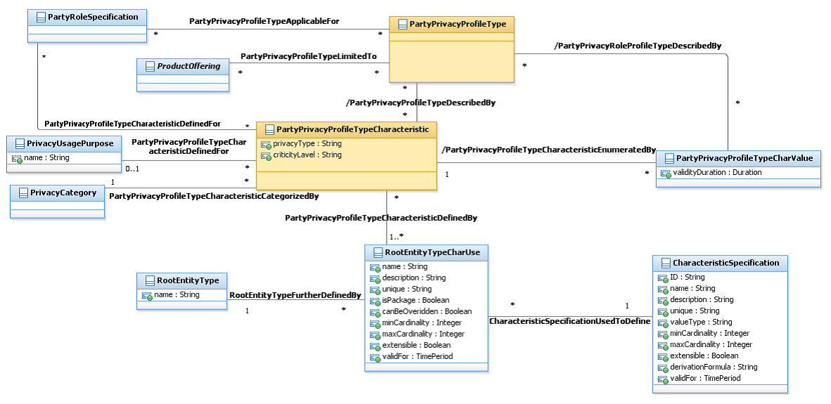

Lifecycle:

The Party Privacy Profile Type lifecycle is tracked using the lifecycleStatus field. The typical lifecycle values that can be taken are: In Design, Active, Rejected and Retired. The state machine specifying the typical state change transitions is provided below.

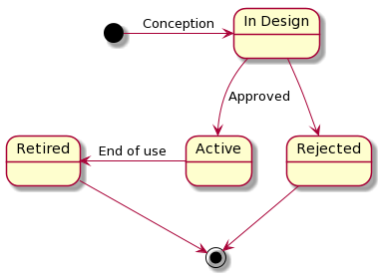

### PARTY PRIVACY PROFILE Resource

A Party Privacy Profile represents the set of Privacy settings defined for a Party.

JSON representation of a Party Privacy Profile:

|  |
| --- |
| {  "href": "http://serverlocation:port/privacyManagement/partyPrivacyProfile/394",  "id": "394",  "name": "John Doe's Privacy Profile",  "description": "This is John Does Privacy profile",  "dateCreated": "2016-03-16T15:15:51.209Z",  "status": "agreed",  "validFor": {  "startDateTime": "2016-03-16T15:15:51.209Z",  "endDateTime": ""  },  "agreedByParty": {  "id": "2345",  "href": "http://serverLocation:port/partyManagement/individual/2345",  "role": "Customer",  "name": "John Doe"  },  "partyPrivacyProfileType": {  "id": "103",  "href": "http://serverlocation:port/privacyManagement/partyPrivacyProfileType/103"  },  "partyPrivacyProfileCharValue": [  {  "name": "eMailAddress",  "privacyUsagePurpose": "ADMIN",  "value": "Authorized",  "validFor": {  "startDateTime": "2016-03-16T15:15:51.209Z",  "endDateTime": ""  },  "relatedParty": [  {  "id": "10",  "href": "http://serverLocation:port/partyManagement/organization/10",  "role": "Administrator",  "name": "Orange"  }  ]  },  {  "name": "eMailAddress",  "privacyUsagePurpose": "INFORMATION",  "value": "Authorized",  "validFor": {  "startDateTime": "2016-03-16T15:15:51.209Z",  "endDateTime": ""  },  "relatedParty": [  {  "id": "11",  "href": "http://serverLocation:port/partyManagement/individual/11",  "role": "Vendor",  "name": "Alice"  },  {  "id": "12",  "href": "http://serverLocation:port/partyManagement/individual/12",  "role": "Employee",  "name": "Bob"  }  ]  },  {  "name": "eMailAddress",  "privacyUsagePurpose": "MARKETING",  "value": "Authorized",  "validFor": {  "startDateTime": "2016-03-16T15:15:51.209Z",  "endDateTime": "2016-06-16T15:15:51.209Z"  },  "relatedParty": [  {  "id": "11",  "href": "http://serverLocation:port/partyManagement/individual/11",  "role": "Vendor",  "name": "Alice"  }  ],  "characteristicAgreement": {  "id": "6810",  "href": "http://serverlocation:port/privacyManagement/partyPrivacyAgreement/6810"  }  },  {  "name": "eMailAddress",  "privacyUsagePurpose": "RESEARCH",  "value": "Unauthorized",  "validFor": {  "startDateTime": "2016-03-16T15:15:51.209Z",  "endDateTime": ""  },  "relatedParty": [  {  "id": "12",  "href": "http://serverLocation:port/partyManagement/individual/12",  "role": "Employee",  "name": "Bob"  }  ]  }  ],  "agreement": {  "id": "6810",  "href": "http://serverlocation:port/privacyManagement/partyPrivacyAgreement/6810",  "type": "commercial"  }  } |

Field Descriptions:

AgreedByParty: defines the Party or Party Role who has agreed the Party Privacy Profile.

|  |  |
| --- | --- |
| Field | Description |
| id | Unique identifier of related party |
| href | Reference URL of the related party, could be a party reference or a party role reference |
| role | Role of the related party |
| name | Name of the related party |

Agreement: describes the Party Privacy Agreement linked to this Party Privacy Profile.

|  |  |
| --- | --- |
| Field | Description |
| id | Unique identifier of the agreement |
| href | Reference URL of the agreement |
| type | The type of the agreement. For example “commercial” |

Party Privacy Profile: represents the privacy choices made by a Party Role.

|  |  |
| --- | --- |
| Field | Description |
| description | Description of the privacy profile |
| href | Reference URL of the privacy profile |
| id | Unique identifier for the privacy profile |
| dateCreated | Date and time of creation of the privacy profile |
| status | Current status of the privacy profile (Created, Terminated, …) |
| name | Name of the privacy profile |
| validFor | The period for which the privacy profile is valid |

PartyPrivacyProfileCharValue: represents the Privacy rules chosen for this Party Privacy Profile.

|  |  |
| --- | --- |
| Field | Description |
| characteristicAgreement | The privacy agreement linked to the characteristic if it has a high criticality level |
| name | Name of the characteristic |
| privacyUsagePurpose | Defines the “Purpose” authorized or refused for the characteristic (e.g. ADMIN, INFORMATION, MARKETING, RESEARCH, …) |
| relatedParty | Reference to a party or party role for which the privacy rule is defined |
| validFor | The period for which the privacy rule is valid |
| value | Value of the privacy rule |

Party Privacy Profile Type: represents a reference to the instantiated Party Privacy Profile Type.

|  |  |
| --- | --- |
| Field | Description |
| href | Reference URL of the privacy profile type |
| id | Unique identifier for the privacy profile type |

UML Model:

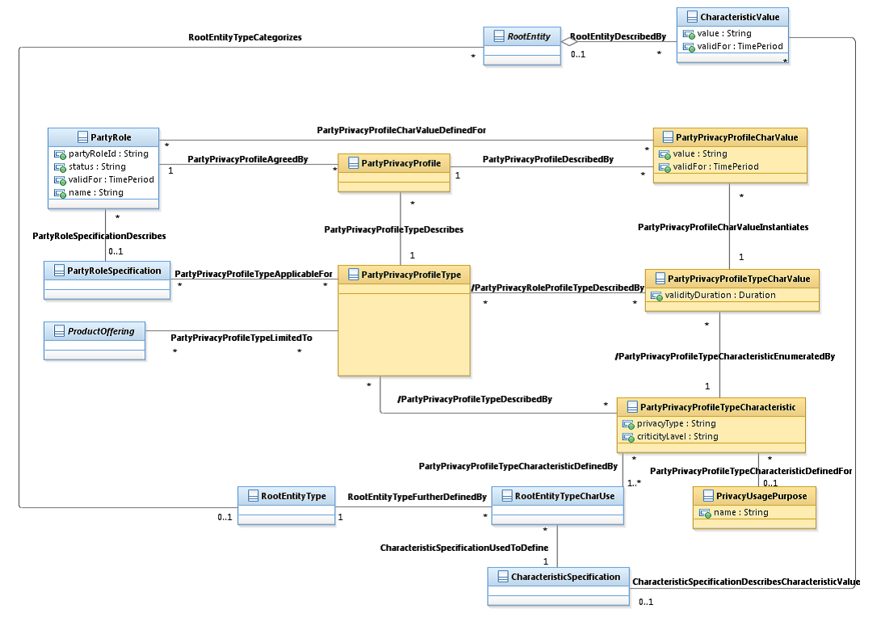

Lifecycle:

The Party Privacy Profile lifecycle is tracked using the status field. The typical lifecycle values that can be taken are: Created, Terminated. The state machine specifying the typical state change transitions is provided below.

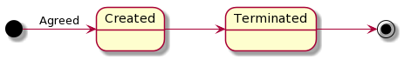

### PARTY PRIVACY Agreement Resource

A Party Privacy Agreement represents the approval made by the Party about a Party Privacy Profile.

JSON representation of a Party Privacy Agreement:

|  |
| --- |
| {  "href": "http://serverlocation:port/privacyManagement/partyPrivacyAgreement/6810",  "id": "6810",  "agreementPeriod": {  "startDateTime": "2016-03-16T15:15:51.209Z",  "endDateTime": "2016-09-16T15:15:51.209Z"  },  "completionDate": "2016-10-16",  "description": "This agreement …",  "documentNumber": 13,  "initialDate": "2016-03-16T15:15:51.210Z",  "name": "Customer mass market privacy agreement",  "statementOfIntent": "Agreement on customer mass market privacy profile",  "status": "validated",  "type": "commercial",  "version": "1",  "agreementSpecification": {  "description": "This agreement specification defines the rules of privacy to be followed by each party",  "href": "http://serverlocation:port/privacyManagement/partyPrivacyAgreementSpecification/8139",  "id": "8139",  "name": "General Agreement Specification"  },  "agreementItem": [  {  "productOffering": [  {  "href": "https://host:port/productOffering/productOffering/9559",   "id": "9559",   "name": "Privacy Service",   "bundledProductOffering": [  {  "href": "https://host:port/productOffering/bundledProductOffering/7120",   "id": "7120",   "name": "Magic Offer",   "bundledProductOffering": []  }  ]  }  ],  "termOrCondition": [  {  "description": "This agreement term or condition …",  "id": "8905",  "validFor": {  "startDateTime": "2016-03-16T15:15:51.211Z",  "endDateTime": "2016-09-16T15:15:51.211Z"  }  }  ]  }  ],  "engagedPartyRole": [  {  "href": "http://serverLocation:port/partyManagement/partyRole/1",  "id": "1",  "name": "Customer",  "partyId": "2345",  "partyName": "John Doe"  }  ],  "agreementAuthorization": [  {  "date": "2016-03-16T15:15:51.211Z",  "signatureRepresentation": "Digital",  "state": "approved"  }  ],  "characteristic": [  {  "name": "country",  "value": "France"  }  ],  "associatedAgreement": [  {  "href": "http://serverlocation:port/privacyManagement/partyPrivacyAgreement/987654",  "id": "987654",  "name": "General Privacy Agreement"  }  ],  "partyPrivacyProfile": [  "href": "http://serverlocation:port/privacyManagement/partyPrivacyProfile/394",  "href": "http://serverlocation:port/privacyManagement/partyPrivacyProfile/1312"  ],  "partyPrivacyProfileCharValue": [  {  "name": "eMailAddress",  "privacyUsagePurpose": "MARKETING",  "value": "Authorized",  "validFor": {  "startDateTime": "2016-03-16T15:15:51.211Z",  "endDateTime": "2016-06-16T15:15:51.211Z"  },  "relatedParty": [  {  "id": "11",  "href": "http ://serverLocation:port/partyManagement/partyRole/11",  "role": "Vendor",  "name": "Alice"  }  ]  }  ]  } |

Field Descriptions:

Agreement: represents the approval made by the Engaged Party about a Party Privacy Profile.

|  |  |
| --- | --- |
| Field | Description |
| agreementPeriod | The time period during which the agreement is in effect |
| completionDate | Date at which the agreement is completed |
| description | Narrative that explains the agreement and details about the it , such as why the agreement is taking place |
| documentNumber | A reference number assigned to an agreement that follows a prescribed numbering system |
| href | Unique URL identifying the agreement as a resource |
| id | Unique identifier for the agreement |
| initialDate | Date at which the agreement was initialized |
| name | A human-readable name for the agreement |
| statementOfIntent | An overview and goals of the agreement |
| status | The current status of the agreement. Typical values are: in process, approved and rejected |
| type | The type of the agreement. For example “commercial” |
| version | A string identifying the version of the agreement |

AgreementAuthorization: represents a business participant that is responsible for approving the Agreement.

|  |  |
| --- | --- |
| Field | Description |
| date | The date associated with the authorization state |
| signatureRepresentation | Indication that represents whether the signature is a physical paper signature or a digital signature |
| state | Current status of the authorization, for example in process, approved, rejected |

AgreementItem: represents a part of the Agreement expressed in terms of a product offering and possibly including specific terms and conditions.

|  |  |
| --- | --- |
| Field | Description |
| productOffering | A list of product offering references |
| termOrCondition | The term or condition of the agreement |

AgreementSpecification: represents a template of an Agreement that can be used when establishing partnerships.

|  |  |
| --- | --- |
| Field | Description |
| description | A narrative that explains in detail what the agreement specification is about |
| href | Reference URL of the agreement specification |
| id | Unique identifier of the agreement specification |
| name | Name of the agreement specification |

AssociatedAgreement: references another related Agreement.

|  |  |
| --- | --- |
| Field | Description |
| href | Reference URL of the agreement |
| id | Identifier of the agreement |
| name | Name of the agreement |

Characteristic: sescribes a given characteristic of an object or entity through a name/value pair.

|  |  |
| --- | --- |
| Field | Description |
| name | Name of the characteristic |
| value | Value of the characteristic |

EngagedPartyRole: defines the Party or Party Role involved in the Agreement.

|  |  |
| --- | --- |
| Field | Description |
| href | Reference URL of the referred party role |
| id | Unique identifier of referred party role |
| name | The name of the referred party role |
| partyId | The identifier of the engaged party that is linked to the PartyRole object |
| partyName | The name of the engaged party that is linked to the PartyRole object |

Party Privacy Profile: represents the set of Privacy settings defined for a Party.

|  |  |
| --- | --- |
| Field | Description |
| href | Reference URL of the agreed party privacy profile |

PartyPrivacyProfileCharValue: represents a high criticality Characteristic whose chosen Privacy rules is included in the Agreement.

|  |  |
| --- | --- |
| Field | Description |
| name | Name of the characteristic |
| privacyUsagePurpose | Defines the “Purpose” authorized or refused for the characteristic (e.g. ADMIN, INFORMATION, MARKETING, RESEARCH, …) |
| relatedParty | Reference to a party or party role for which the privacy rule is defined |
| validFor | The period for which the privacy rule is valid |
| value | Value of the privacy rule |

UML Model:

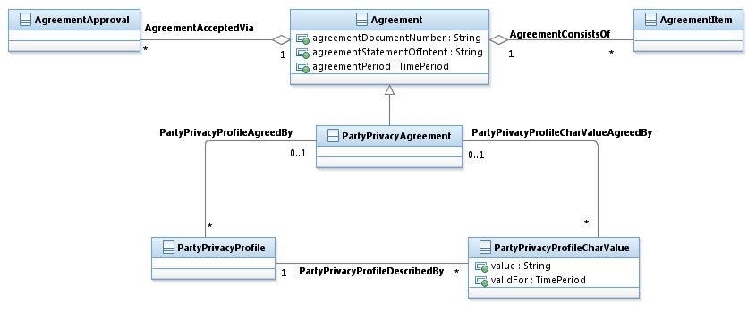

Lifecycle:

The Agreement lifecycle is tracked using the status field. The typical lifecycle values that can be taken are: Initialized, In process, Pending Update, Validated and Rejected. The state machine specifying the typical state change transitions is provided below.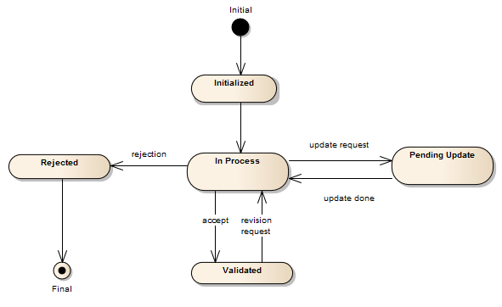

### Export Job Resource

An ExportJob resource represents a TASK used to export resources to a File

The ExportJob resource supports the following properties:

|  |  |
| --- | --- |
| Attribute name | Description |
| query | Used to scope the exported data (identical to GET filter construct using target ID as base)  “query”: ”type=productOffering&version=2.0” |
| path | URL of the root resource acting as the source for streaming content to the file specified by the ExportJob  ../privacyManagement/partyPrivacyProfile |
| content-type | The format of the exported data .By default “application/json” |
| status | notstarted, running, succeeded, failed |
| url | URL of the File containing the data to be exported  a file URL, which is of the form  file://host/path  where host is the fully qualified domain name of the system on which the path is accessible, and path is a hierarchical directory path of the form directory/directory/.../name |
| completionDate | Date at which the Job was completed. |
| creationDate | Date at which the Job was created. |
| errorLog | Reason for Failure |

JSON representation of an ExportJob

|  |
| --- |
| {  "id": "54",  "href": "http:/api/privacManagement/exportJob/54",  "status": "running",  "path": "privacyManagement/",  "content-type": "application/json",  "errorLog": "",  "creationDate": "2013-04-19T16:42:23-04:00",  "completionDate": "2013-04-21T16:42:23-04:00",  "url": "ftp://ftp.myPrivacy.com/privacy/54"  } |

UML Model:



### Import Job Resource

An ImportJob resource represent a TASK used to import resources from a File

The ImportJob resource supports the following properties:

|  |  |
| --- | --- |
| Attribute name | Description |
| content-type | The format of the imported data. By default “application/json” |
| path | URL of the root resource where the content of the file specified by the ImportJob must be applied  ../privacyManagement/partyPrivacyProfile |
| status | notstarted, running, succeeded, failed |
| url | URL of the File containing the data to be imported  a file URL, which is of the form  file://host/path  where host is the fully qualified domain name of the system on which the path is accessible, and path is a hierarchical directory path of the form directory/directory/.../name |
| completionDate | Date at which the Job was completed. |
| creationDate | Date at which the Job was created. |
| errorLog | Reason for Failure if status is failed |

JSON representation of an ImportJob

|  |
| --- |
| {  "id": "54",  "href": "http:/api/ privacyManagement/importJob/54",  "status": "completed",  "path": "privacyManagement/",  "content-type": "application/json",  "errorLog": "",  "creationDate": "2013-04-19T16:42:23-04:00",  "completionDate": "2013-04-21T16:42:23-04:00",  "url": "ftp://ftp.myPrivacy.com/privacy/54"  } |

UML Model:



## Notification Resource Models

11 notification event types are defined :

1. PartyPrivacyProfileTypeCreateNotification
2. PartyPrivacyProfileTypeNotification
3. PartyPrivacyProfileTypeDeleteNotification
4. PartyPrivacyProfileCreateNotification
5. PartyPrivacyProfileUpdateNotification
6. PartyPrivacyProfileDeleteNotification
7. PartyPrivacyAgreementCreateNotification
8. PartyPrivacyAgreementUpdateNotification
9. PartyPrivacyAgreementDeleteNotification
10. ImportJobCompletionNotification
11. ExportJobCompletionNotification

PARTY PRIVACY PROFILE TYPE Notifications

1. Create
2. Update
3. Delete

UML Model:

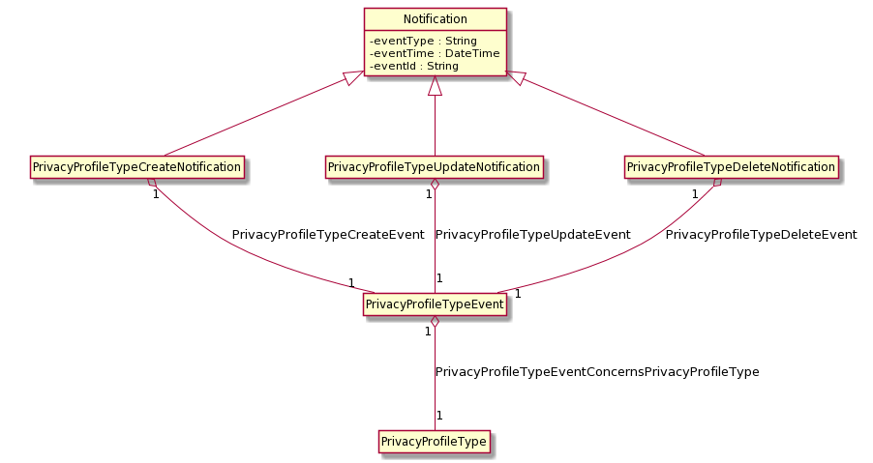

Event: PartyPrivacyProfileTypeCreateNotification

|  |
| --- |
| {  "eventType": "PartyPrivacyProfileTypeCreateNotification",  "eventTime": "2014-09-27T05:46:25.0Z",  "eventId": "1154231",  "event": {  "partyPrivacyProfileType":  {  "id": "12",  Following a whole representation of the Party Privacy Profile Type with all its attributes   See Party Privacy Profile Type Resource.  }  }  } |

Event: PartyPrivacyProfileTypeUpdateNotification

|  |
| --- |
| {  "eventType": "PartyPrivacyProfileTypeUpdateNotification",  "eventTime": "2014-09-27T05:46:25.0Z",  "eventId": "119331",  "event": {  "partyPrivacyProfileType":  {  "id": "12",  Following a whole representation of the Party Privacy Profile Type with all its attributes   See Party Privacy Profile Type Resource.  }  }  } |

Event: PartyPrivacyProfileTypeDeleteNotification

|  |
| --- |
| {  "eventType": "PartyPrivacyProfileTypeDeleteNotification",  "eventTime": "2014-09-27T05:46:25.0Z",  "eventId": "1189231",  "event": {  "partyPrivacyProfileType":  {  "id": "12",  Following a whole representation of the Party Privacy Profile Type with all its attributes   See Party Privacy Profile Type Resource.  }  }  } |

PARTY PRIVACY PROFILE Notifications

1. Create
2. Update
3. Delete

UML Model:

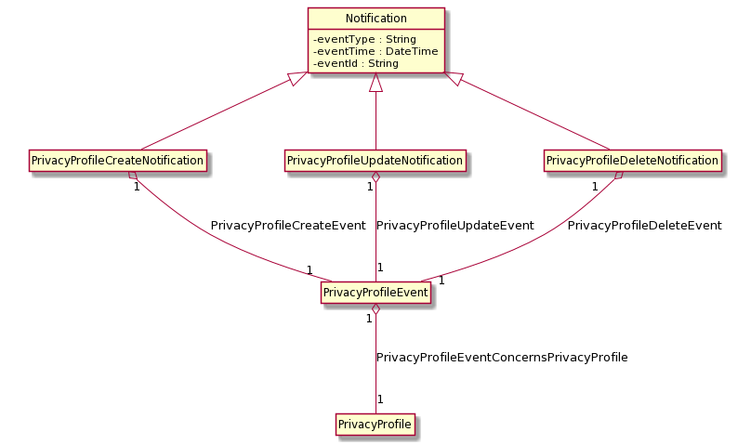

Event: PartyPrivacyProfileCreateNotification

|  |
| --- |
| {  "eventType": "PartyPrivacyProfileCreateNotification",  "eventTime": "2014-09-27T05:46:25.0Z",  "eventId": "1154391",  "event": {  "partyPrivacyProfile":  {  "id": "128",  Following a whole representation of the Party Privacy Profile with all its attributes   See Party Privacy Profile Resource.  }  }  } |

Event: PartyPrivacyProfileUpdateNotification

|  |
| --- |
| {  "eventType": "PartyPrivacyProfileUpdateNotification",  "eventTime": "2014-09-27T05:46:25.0Z",  "eventId": "1156731",  "event": {  "partyPrivacyProfile":  {  "id": "128",  Following a whole representation of the Party Privacy Profile with all its attributes   See Party Privacy Profile Resource.  }  }  } |

Event: PartyPrivacyProfileDeleteNotification

|  |
| --- |
| {  "eventType": "PartyPrivacyProfileDeleteNotification",  "eventTime": "2014-09-27T05:46:25.0Z",  "eventId": "1154278",  "event": {  "partyPrivacyProfile":  {  "id": "128",  Following a whole representation of the Party Privacy Profile with all its attributes   See Party Privacy Profile Resource.  }  }  } |

PARTY PRIVACY AGREEMENT Notifications

1. Create
2. Update
3. Delete

UML Model:

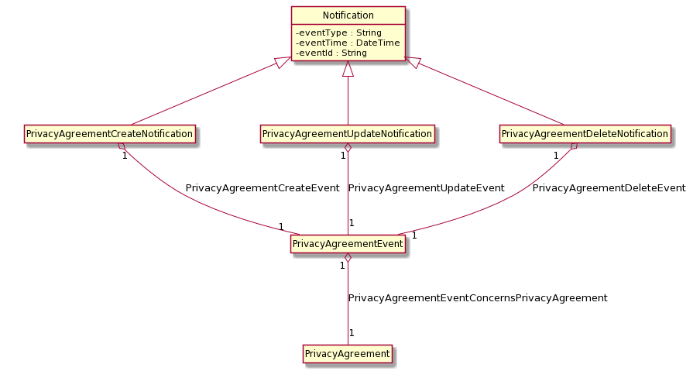

Event: PartyPrivacyAgreementCreateNotification

|  |
| --- |
| {  "eventType": "PartyPrivacyAgreementCreateNotification",  "eventTime": "2014-09-27T05:46:25.0Z",  "eventId": "1154391",  "event": {  "partyPrivacyAgreement":  {  "id": "128",  Following a whole representation of the Party Privacy Agreement with all its attributes   See Party Privacy Agreement Resource.  }  }  } |

Event: PartyPrivacyAgreementUpdateNotification

|  |
| --- |
| {  "eventType": "PartyPrivacyAgreementUpdateNotification",  "eventTime": "2014-09-27T05:46:25.0Z",  "eventId": "1156731",  "event": {  "partyPrivacyAgreement":  {  "id": "128",  Following a whole representation of the Party Privacy Agreement with all its attributes   See Party Privacy Agreement Resource.  }  }  } |

Event: PartyPrivacyAgreementDeleteNotification

|  |
| --- |
| {  "eventType": "PartyPrivacyAgreementDeleteNotification",  "eventTime": "2014-09-27T05:46:25.0Z",  "eventId": "1154278",  "event": {  "partyPrivacyAgreement":  {  "id": "128",  Following a whole representation of the Party Privacy Agreement with all its attributes   See Party Privacy Agreement Resource.  }  }  } |

Export and Import Job Notifications

1. Export Job Completion Notification
2. Import Job Completion Notification

UML Model:



Event: ExportJobCompletionNotification

|  |
| --- |
| {  "eventType": "ExportJobCompletionNotification",  "eventTime": "2014-09-27T05:46:25.0Z",  "eventId": "1154278",  "event": {"exportJob": {  "id": "54",  "href": "http:/api/privacyManagement/exportJob/54",  "status": "succeeded",  "path": "privacyManagement/",  "content-type": "application/json",  "errorLog": "",  "creationDate": "2013-04-19T16:42:23-04:00",  "completionDate": "2013-04-21T16:42:23-04:00",  "url": "ftp://ftp.myPrivacy.com/privacyManagement/54.json"  }} } |

Event: ImportJobCompletionNotification

|  |
| --- |
| {  "eventType": "ImportJobCompletionNotification",  "eventTime": "2014-09-27T05:46:25.0Z",  "eventId": "1154278",  "event": {"importJob": {  "id": "54",  "href": "http:/api/privacyManagement/importJob/54",  "status": "succeeded",  "path": "privacyManagement/",  "content-type": "application/json",  "errorLog": "",  "creationDate": "2013-04-19T16:42:23-04:00",  "completionDate": "2013-04-21T16:42:23-04:00",  "url": "ftp://ftp.myPrivacy.com/privacyManagement/54.json"  }} } |

# API OPERATION TEMPLATES

For every single of operation on the entities use the following templates and provide sample REST requests and responses.

Remember that the following Uniform Contract rules must be used:

|  |  |  |
| --- | --- | --- |
| Operation on Entities | Uniform API Operation | Description |
| Query Entities | GET Resource | GET must be used to retrieve a representation of a resource. |
| Create Entity | POST Resource | POST must be used to create a new resource |
| Partial Update of an Entity | PATCH Resource | PATCH must be used to partially update a resource |
| Remove an Entity | DELETE Resource | DELETE must be used to remove a resource |
| Execute an Action on an Entity | POST on TASK Resource | POST must be used to execute Task Resources |
| Other Request Methods | POST on TASK Resource | GET and POST must not be used to tunnel other request methods. |

Filtering and attribute selection rules are described in the TMF REST Design Guidelines.

Notifications are also described in a subsequent section.

## GET /privacyManagement/partyPrivacyProfileType/{ID}

Note that collections can be retrieved via GET /api/<RESOURCE> with no {ID}

Description:

* Operation to retrieve privacy profile types in a privacy repository
* Filtering is enabled for all attributes
* Attribute selection is enabled for all attributes
* The resource is either a managed entity (query by id) or a collection (query with criteria)
* The resource identifier is a http uri

Behavior:

* Standard behavior and response codes for GET operations

Example: Retrieve privacy profile type with id 103 - with all its attributes.

|  |
| --- |
| **REQUEST** |
| GET /privacyManagement/partyPrivacyProfileType/103  Accept: application/json |
| **RESPONSE** |
| 200  Content-Type: application/json  {  "id": "103",  "href": "http://serverlocation:port/privacyManagement/partyPrivacyProfileType/103",  "version": "1.0",  "lastUpdate": "2013-04-19T16:42:23-04:00",  "name": "Customer Mass Market Privacy",  "description": "This is the customer mass market privacy",  "lifecycleStatus": "active",  "validFor": {  "startDateTime": "2013-04-19T16:42:23-04:00",  "endDateTime": "2013-06-19T00:00:00-04:00"  },  "relatedParty": [  {  "id": "1066",  "href": "http://serverlocation:port/partyManagement/individual/1066",  "role": "Profile Type Admin",  "name": "James Smith"  }  ],  "applicableRole": [  {  "role": "Customer"  }  ],  "partyPrivacyProfileTypeCharacteristic": [  { // ALWAYS example  "id": "42",  "name": "eMailAddress",  "privacyUsagePurpose": "ADMIN",  "description": "this is the email address privacy for internal ADMIN purpose",  "privacyType": "Internal Purpose",  "criticalityLevel": "low",  "validFor": {  "startDateTime": "2013-04-19T16:42:23-04:00",  "endDateTime": ""  },  "partyPrivacyProfileTypeCharValue": [  {  "valueType": "string",  "default": true,  "value": "Authorized",  "validityDuration": "Always"  }  ],  "relatedRole": [  {  "role": "Administrator"  }  ]  },  { // OPT-OUT example  "id": "43",  "name": "eMailAddress",  "privacyUsagePurpose": "INFORMATION",  "description": "this is the email address privacy attributes for internal INFORMATION purpose",  "privacyType": "Internal Purpose",  "criticalityLevel": "low",  "validFor": {  "startDateTime": "2013-04-19T16:42:23-04:00",  "endDateTime": ""  },  "partyPrivacyProfileTypeCharValue": [  {  "valueType": "string",  "default": true,  "value": "Authorized",  "validityDuration": "Always"  },  {  "valueType": "string",  "default": false,  "value": "Unauthorized",  "validityDuration": "Always"  }  ],  "relatedRole": [  {  "role": "Vendor"  },  {  "role": "Employee"  }  ]  },  { // OPT-IN example  "id": "44",  "name": "eMailAddress",  "privacyUsagePurpose": "MARKETING",  "description": "this is the email address privacy attributes for internal MARKETING purpose",  "privacyType": "Internal Purpose",  "criticalityLevel": "high",  "validFor": {  "startDateTime": "2013-04-19T16:42:23-04:00",  "endDateTime": ""  },  "partyPrivacyProfileTypeCharValue": [  {  "valueType": "string",  "default": true,  "value": "Unauthorized",  "validityDuration": "Always"  },  {  "valueType": "string",  "default": false,  "value": "Authorized",  "validityDuration": "3 months"  }  ],  "relatedRole": [  {  "role": "Vendor"  }  ]  },  { // NEVER example  "id": "45",  "name": "eMailAddress",  "privacyUsagePurpose": "RESEARCH",  "description": "this is the email address privacy attributes for internal RESEARCH purpose",  "privacyType": "Internal Purpose",  "criticalityLevel": "low",  "validFor": {  "startDateTime": "2013-04-19T16:42:23-04:00",  "endDateTime": ""  },  "partyPrivacyProfileTypeCharValue": [  {  "valueType": "string",  "default": true,  "value": "Unauthorized",  "validityDuration": "Always"  }  ],  "relatedRole": [  {  "role": "Employee"  }  ]  },  { // External purpose example  "id": "46",  "name": "eMailAddress",  "privacyUsagePurpose": "ADMIN",  "description": "this is the email address privacy attributes for external ADMIN purposes",  "privacyType": "External Purpose",  "criticalityLevel": "low",  "validFor": {  "startDateTime": "2013-04-19T16:42:23-04:00",  "endDateTime": ""  },  "partyPrivacyProfileTypeCharValue": [  {  "valueType": "string",  "default": true,  "value": "UnAuthorized",  "validityDuration": "Always"  }  ],  "relatedRole": [  {  "role": "Administrator"  }  ]  },  { // Internal Retention example  "id": "47",  "name": "eMailAddress",  "description": "this is the internal retention privacy rule for email address",  "privacyType": "Internal Retention",  "criticalityLevel": "low",  "validFor": {  "startDateTime": "2013-04-19T16:42:23-04:00",  "endDateTime": ""  },  "partyPrivacyProfileTypeCharValue": [  {  "valueType": "string",  "default": true,  "value": "Indefinitly",  "validityDuration": "Always"  }  ]  },  { // External Retention example  "id": "48",  "name": "eMailAddress",  "description": "this is the external retention privacy rule for email address",  "privacyType": "External Retention",  "criticalityLevel": "low",  "validFor": {  "startDateTime": "2013-04-19T16:42:23-04:00",  "endDateTime": ""  },  "partyPrivacyProfileTypeCharValue": [  {  "valueType": "string",  "default": true,  "value": "No-retention",  "validityDuration": "Always"  }  ]  },  { // choice of Internal Retention example  "id": "49",  "name": "Invoice Amount",  "description": "this is the retention privacy rule for invoice amount",  "privacyType": "Internal Retention",  "criticalityLevel": "low",  "validFor": {  "startDateTime": "2013-04-19T16:42:23-04:00",  "endDateTime": ""  },  "partyPrivacyProfileTypeCharValue": [  {  "valueType": "numeric",  "default": true,  "unitOfMeasure": "Year",  "value": "15",  "validityDuration": "Always"  },  {  "valueType": "numeric",  "default": false,  "unitOfMeasure": "Year",  "fromValue": "10",  "toValue": "20",  "rangeInterval": "1",  "validityDuration": "Always"  }  ]  }  ]  } |

Example: Retrieve Customer Mass Market Privacy individual entry and we only want to get its name.

|  |
| --- |
| **REQUEST** |
| GET /privacyManagement/partyPrivacyProfileType/103?fields=name  Accept: application/json |
| **RESPONSE** |
| 200  Content-Type: application/json  {  "name": "Customer Mass Market Privacy"  } |

## GET /privacyManagement/partyPrivacyProfile/{ID}

Note that collections can be retrieved via GET /api/<RESOURCE> with no {ID}

Description:

* Operation to retrieve privacy profiles in a privacy repository
* Filtering is enabled for all attributes
* Attribute selection is enabled for all attributes
* The resource is either a managed entity (query by id) or a collection (query with criteria)
* The resource identifier is a http uri

Behavior:

* Standard behavior and response codes for GET operations

Example: Get the name of all privacy profiles instantiating a given privacy profile type (103)

|  |
| --- |
| **REQUEST** |
| GET /privacyManagement/partyPrivacyProfile?fields=name&partyPrivacyProfileType.id=103  Accept: application/json |
| **RESPONSE** |
| 200  Content-Type: application/json  [  {  "id": "394",  "name": "John Doe’s Privacy Profile"  },  {  "id": "1312",  "name": "Jane Doe’s Privacy Profile"  }  ] |

Example: Get a specific privacy profile using its id, returning all attributes

|  |
| --- |
| **REQUEST** |
| GET /privacyManagement/partyPrivacyProfile/394  Accept: application/json |
| **RESPONSE** |
| 200  Content-Type: application/json  {  "id": "394",  "href": "http://serverlocation:port/privacyManagement/partyPrivacyProfile/394",  "name": "John Doe's Privacy Profile",  "description": "This is John Does Privacy profile",  "dateCreated": "2016-03-16T15:15:51.209Z",  "status": "agreed",  "validFor": {  "startDateTime": "2016-03-16T15:15:51.209Z",  "endDateTime": ""  },  "agreedByParty": {  "id": "2345",  "href": "http ://serverLocation:port/partyManagement/individual/2345",  "role": "Customer",  "name": "John Doe"  },  "partyPrivacyProfileType": {  "id": "103",  "href": "http://serverlocation:port/privacyManagement/partyPrivacyProfileType/103"  },  "partyPrivacyProfileCharValue": [  {  "name": "eMailAddress",  "privacyUsagePurpose": "ADMIN",  "value": "Authorized",  "validFor": {  "startDateTime": "2016-03-16T15:15:51.209Z",  "endDateTime": ""  },  "relatedParty": [  {  "id": "10",  "href": "http ://serverLocation:port/partyManagement/organization/10",  "role": "Administrator",  "name": "Orange"  }  ]  },  {  "name": "eMailAddress",  "privacyUsagePurpose": "INFORMATION",  "value": "Authorized",  "validFor": {  "startDateTime": "2016-03-16T15:15:51.209Z",  "endDateTime": ""  },  "relatedParty": [  {  "id": "11",  "href": "http ://serverLocation:port/partyManagement/individual/11",  "role": "Vendor",  "name": "Alice"  },  {  "id": "12",  "href": "http ://serverLocation:port/partyManagement/individual/12",  "role": "Employee",  "name": "Bob"  }  ]  },  {  "name": "eMailAddress",  "privacyUsagePurpose": "MARKETING",  "value": "Authorized",  "validFor": {  "startDateTime": "2016-03-16T15:15:51.209Z",  "endDateTime": "2016-06-16T15:15:51.209Z"  },  "relatedParty": [  {  "id": "11",  "href": "http ://serverLocation:port/partyManagement/individual/11",  "role": "Vendor",  "name": "Alice"  }  ],  "characteristicAgreement": {  "id": "6810",  "href": "http://serverlocation:port/privacyManagement/partyPrivacyAgreement/6810"  }  },  {  "name": "eMailAddress",  "privacyUsagePurpose": "RESEARCH",  "value": "Unauthorized",  "validFor": {  "startDateTime": "2016-03-16T15:15:51.209Z",  "endDateTime": ""  },  "relatedParty": [  {  "id": "12",  "href": "http ://serverLocation:port/partyManagement/individual/12",  "role": "Employee",  "name": "Bob"  }  ]  }  ],  "agreement": {  "id": "6810",  "href": "http://serverlocation:port/privacyManagement/partyPrivacyAgreement/6810",  "type": "commercial"  }  } |

## GET /privacyManagement/partyPrivacyAgreement/{ID}

Note that collections can be retrieved via GET /api/<RESOURCE> with no {ID}

Description:

* Operation to retrieve privacy agreements in a privacy repository
* Filtering is enabled for all attributes
* Attribute selection is enabled for all attributes
* The resource is either a managed entity (query by id) or a collection (query with criteria)
* The resource identifier is a http uri

Behavior:

* Standard behavior and response codes for GET operations

Example: Get a privacy agreement by its id

|  |
| --- |
| **REQUEST** |
| GET /privacyManagement/partyPrivacyAgreement/6810  Accept: application/json |
| **RESPONSE** |
| 200  Content-Type: application/json  {  "href": "http://serverlocation:port/privacyManagement/partyPrivacyAgreement/6810",  "id": "6810",  "agreementPeriod": {  "startDateTime": "2016-03-16T15:15:51.209Z",  "endDateTime": "2016-09-16T15:15:51.209Z"  },  "completionDate": "2016-10-16",  "description": "This agreement …",  "documentNumber": 13,  "initialDate": "2016-03-16T15:15:51.210Z",  "name": "Customer mass market privacy agreement",  "statementOfIntent": "Agreement on customer mass market privacy profile",  "status": "validated",  "type": "commercial",  "version": "1",  "agreementSpecification": {  "description": "This agreement specification defines the rules of privacy to be followed by each party",  "href": "http://serverlocation:port/privacyManagement/partyPrivacyAgreementSpecification/8139",  "id": "8139",  "name": "General Agreement Specification"  },  "agreementItem": [  {  "productOffering": [  {  "href": "https://host:port/productOffering/productOffering/9559",   "id": "9559",   "name": "Privacy Service",   "bundledProductOffering": [  {  "href": "https://host:port/productOffering/bundledProductOffering/7120",   "id": "7120",   "name": "Magic Offer",   "bundledProductOffering": []  }  ]  }  ],  "termOrCondition": [  {  "description": "This agreement term or condition …",  "id": "8905",  "validFor": {  "startDateTime": "2016-03-16T15:15:51.211Z",  "endDateTime": "2016-09-16T15:15:51.211Z"  }  }  ]  }  ],  "engagedPartyRole": [  {  "href": "http://serverLocation:port/partyManagement/partyRole/1",  "id": "1",  "name": "Customer",  "partyId": "2345",  "partyName": "John Doe"  }  ],  "agreementAuthorization": [  {  "date": "2016-03-16T15:15:51.211Z",  "signatureRepresentation": "Digital",  "state": "approved"  }  ],  "characteristic": [  {  "name": "country",  "value": "France"  }  ],  "associatedAgreement": [  {  "href": "http://serverlocation:port/privacyManagement/partyPrivacyAgreement/987654",  "id": "987654",  "name": "General Privacy Agreement"  }  ],  "partyPrivacyProfile": [  "href": "http://serverlocation:port/privacyManagement/partyPrivacyProfile/394",  "href": "http://serverlocation:port/privacyManagement/partyPrivacyProfile/1312"  ],  "partyPrivacyProfileCharValue": [  {  "name": "eMailAddress",  "privacyUsagePurpose": "MARKETING",  "value": "Authorized",  "validFor": {  "startDateTime": "2016-03-16T15:15:51.211Z",  "endDateTime": "2016-06-16T15:15:51.211Z"  },  "relatedParty": [  {  "id": "11",  "href": "http ://serverLocation:port/partyManagement/partyRole/11",  "role": "Vendor",  "name": "Alice"  }  ]  }  ]  } |

## PATCH /privacyManagement/partyPrivacyProfileType/{ID}

This Uniform Contract operation is used to partially update the representation of a privacy profile type.

Description:

* Patch operation can be used partially update one or more privacy profile types
* The resource represents a managed entity or a collection
* The identifier is a string that can consist of numbers, not necessarily alphanumeric

Behavior:

* Return Status Codes:
  + Returns HTTP/1.1 status code 201 if privacy profile type was updated successfully
  + 400 - Bad Request Error
  + 404 - If no record was found for the supplied criteria
  + 500 - The server encountered an unexpected condition which prevented it from fulfilling the request

Patchable attributes for a privacy profile type:

|  |  |  |
| --- | --- | --- |
| Attribute name | Patchable | Rule |
| id | N |  |
| version | Y |  |
| lastUpdate | Y |  |
| name | Y |  |
| description | Y |  |
| lifecycleStatus | Y |  |
| validFor | Y |  |
| relatedParty | Y |  |
| applicableRole | Y |  |
| partyPrivacyProfileTypeCharacteristic | Y |  |

Further document any rules that must be implemented when patching attributes.

|  |  |
| --- | --- |
| Rule name | Rule/Pre Condition/Side Effects/Post Conditions |
| relatedParty | role and party are mandatory |
| applicableRole | role is mandatory |
| partyPrivacyProfileTypeCharacteristic | a default partyPrivacyProfileCharValue is mandatory |

Example: Update the lifecycle status of the Customer Mass Market Privacy (identified with ‘103’).

|  |
| --- |
| **REQUEST** |
| PATCH privacyManagement/partyPrivacyProfileType/103  Content-type: application/json  {  "lifecycleStatus": "Retired"  } |
| **RESPONSE** |
| 201  Content-Type: application/json  {  JSON resource representation with all attributes including the changed one  See Party Privacy Profile Type resource model for details  } |

Example: Update Customer Mass Market Privacy (identified with ‘103’): it is related to a Party or Party Role that is already stored in the party referential.

|  |
| --- |
| **REQUEST** |
| PATCH privacyManagement/partyPrivacyProfileType/103  Content-type: application/json-patch+json  {  "op": "add",  "path": "/relatedParty",  "value": {  "id": "1070",  "href": "http://serverlocation:port/partyManagement/individual/1070",  "role": "Profile Type Admin",  "name": "Edward Miller"  }  } |
| **RESPONSE** |
| 201  Content-Type: application/json  { JSON resource representation with all attributes including the changed one  See Party Privacy Profile Type resource model for details  } |

## PATCH /privacyManagement/partyPrivacyProfile/{ID}

This Uniform Contract operation is used to partially update the representation of a privacy profile.

Description:

* Patch operation can be used partially update one or more privacy profiles
* The resource represents a managed entity or a collection
* The identifier is a string that can consist of numbers, not necessarily alphanumeric

Behavior:

* Return Status Codes:
  + Returns HTTP/1.1 status code 201 if privacy profile was updated successfully
  + 400 - Bad Request Error
  + 404 - If no record was found for the supplied criteria
  + 500 - The server encountered an unexpected condition which prevented it from fulfilling the request

Patchable attributes for a privacy profile:

|  |  |  |
| --- | --- | --- |
| Attribute name | Patchable | Rule |
| id | N |  |
| name | Y |  |
| description | Y |  |
| dateCreated | N |  |
| status | Y |  |
| validFor | Y |  |
| agreedByParty | N |  |
| partyPrivacyProfileType | N |  |
| partyPrivacyProfileCharValue | Y |  |
| agreement | Y |  |

Further document any rules that must be implemented when patching attributes.

|  |  |
| --- | --- |
| Rule name | Rule/Pre Condition/Side Effects/Post Conditions |
| partyPrivacyProfileCharValue | value must be one of the possibilities described in the referenced profile type |
| agreement | Reference must be set |

Example: Update the John Doe’s privacy profile (identified with ‘394’) to tag it as terminated.

|  |
| --- |
| **REQUEST** |
| PATCH privacyManagement/partyPrivacyProfile/394  Content-type: application/json  {  "id": "394",  "href": " http://serverlocation:port/privacyManagement/partyPrivacyProfile/394",  "status": "Terminated",  "validFor": {  "endDateTime": "2016-04-19T16:42:23-04:00"  }  } |
| **RESPONSE** |
| 201  Content-Type: application/json  {  JSON resource representation with all attributes including the changed one  See Party Privacy Profile resource model for details  } |

Example: Update the “eMailAddress for ADMIN purpose” Characteristic Value of the John Doe’s privacy profile (identified with ‘394’).

|  |
| --- |
| **REQUEST** |
| PATCH privacyManagement/ partyPrivacyProfile/394  Content-type: application/json-patch+json  [  {  "op": "replace",  "path": "/partyPrivacyProfileCharValue/0",  "value": {  "name": "eMailAddress",  "privacyUsagePurpose": "ADMIN",  "value": "Authorized",  "validFor": {  "startDateTime": "2016-03-16T15:15:51.209Z",  "endDateTime": "2016-04-19T16:42:23.100Z"  },  "relatedParty": [  {  "id": "10",  "href": "http ://serverLocation:port/partyManagement/organization/10",  "role": "Administrator",  "name": "Orange"  }  ]  }  }, {  "op": "add",  "path": "/partyPrivacyProfileCharValue",  "value": {  "name": "eMailAddress",  "privacyUsagePurpose": "ADMIN",  "value": "Unauthorized",  "validFor": {  "startDateTime": "2016-04-19T16:42:23.100Z",  "endDateTime": ""  }  }  }  ] |
| **RESPONSE** |
| 201  Content-Type: application/json  {  JSON resource representation with all attributes including the changed one  See Party Privacy Profile resource model for details  } |

## PATCH /privacyManagement/partyPrivacyAgreement/{ID}

This Uniform Contract operation is used to partially update the representation of a privacy agreement.

Description:

* Patch operation can be used partially update one or more privacy agreements
* The resource represents a managed entity or a collection
* The identifier is a string that can consist of numbers, not necessarily alphanumeric

Behavior:

* Return Status Codes:
  + Returns HTTP/1.1 status code 201 if privacy profile was updated successfully
  + 400 - Bad Request Error
  + 404 - If no record was found for the supplied criteria
  + 500 - The server encountered an unexpected condition which prevented it from fulfilling the request

Patchable attributes for a privacy profile:

|  |  |  |
| --- | --- | --- |
| Attribute name | Patchable | Rule |
| id | N |  |
| agreementPeriod | Y |  |
| completionDate | N |  |
| description | Y |  |
| documentNumber | Y |  |
| initialDate | Y |  |
| name | Y |  |
| statementOfIntent | Y |  |
| status | Y |  |
| type | Y |  |
| version | Y |  |
| agreementSpecification | Y |  |
| agreementItem | Y |  |
| engagedPartyRole | Y |  |
| agreementAuthorization | Y |  |
| characteristic | Y |  |
| associatedAgreement | Y |  |
| partyPrivacyProfile | Y |  |
| partyPrivacyProfileCharValue | Y |  |

Further document any rules that must be implemented when patching attributes.

|  |  |
| --- | --- |
| Rule name | Rule/Pre Condition/Side Effects/Post Conditions |
| engagedPartyRole | id and name are mandatory |
| associatedAgreement | id and href are mandatory |

Example: Changing the status of the agreement as rejected.

|  |
| --- |
| **REQUEST** |
| PATCH privacyManagement/ partyPrivacyAgreement/6810  Content-type: application/json-patch+json  [  {  "op": "replace",  "path": "/status",  "value": "rejected"  }  ] |
| **RESPONSE** |
| 201  Content-Type: application/json  {  JSON resource representation with all attributes including the changed one  See Party Privacy Agreement resource model for details  } |

## POST /privacyManagement/partyPrivacyProfileType

This operation is used to create a privacy profile type.

* The identifier is a string that can consist of numbers, not necessarily alphanumeric
* The mandatory element(s) is/are
  + partyPrivacyProfileTypeCharacteristic

When using following elements there are some mandatory attributes within each element:

* Within “relatedParty”
  + role
  + href
* Within “applicableRole”
  + role
* Within “partyPrivacyProfileTypeCharacteristic”
  + name
  + privacyUUsagePurpose
  + partyPrivacyProfileTypeCharValue
* The id is generated automatically

Behavior:

* Return Status Codes:
  + 201 - privacy profile type was created successfully
  + 400 - Bad Request Error
  + 500 - The server encountered an unexpected condition which prevented it from fulfilling the request

|  |  |  |  |
| --- | --- | --- | --- |
| Attribute name | Mandatory | Default | Rule |
| id | N | Automatically generated | If not given, the id is generated by the system. It is also possible to add an ID in the POST request, which is then used |
| version | N | 0 |  |
| lastUpdate | N | Current date |  |
| name | N |  |  |
| description | N |  |  |
| lifecycleStatus | N | In Design |  |
| validFor | N |  |  |
| relatedParty | N |  |  |
| applicableRole | N |  |  |
| partyPrivacyProfileTypeCharacteristic | Y |  |  |

Further specify any rules on the creation of the entity

|  |  |
| --- | --- |
| Rule name | Rule/Pre Condition/Side Effects/Post Conditions |
| relatedParty | role and party are mandatory |
| applicableRole | role is mandatory |
| partyPrivacyProfileTypeCharacteristic | a default partyPrivacyProfileCharValue is mandatory |

Example: creation of a privacy profile type named Customer Mass Market Privacy

|  |
| --- |
| **REQUEST** |
| POST privacyManagement/partyPrivacyProfileType  Content-type: application/json  {  "version": "1.0",  "lastUpdate": "2013-04-19T16:42:23-04:00",  "name": "Customer Mass Market Privacy",  "description": "This is the customer mass market privacy",  "lifecycleStatus": "active",  "validFor": {  "startDateTime": "2013-04-19T16:42:23-04:00",  "endDateTime": "2013-06-19T00:00:00-04:00"  },  "relatedParty": [  {  "id": "1066",  "href": "http://serverlocation:port/partyManagement/individual/1066",  "role": "Profile Type Admin",  "name": "James Smith"  }  ],  "applicableRole": [  {  "role": "Customer"  }  ],  "partyPrivacyProfileTypeCharacteristic": [  { // ALWAYS example  "id": "42",  "name": "eMailAddress",  "privacyUsagePurpose": "ADMIN",  "description": "this is the email address privacy for internal ADMIN purpose",  "privacyType": "Internal Purpose",  "criticalityLevel": "low",  "validFor": {  "startDateTime": "2013-04-19T16:42:23-04:00",  "endDateTime": ""  },  "partyPrivacyProfileTypeCharValue": [  {  "valueType": "string",  "default": true,  "value": "Authorized",  "validityDuration": "Always"  }  ],  "relatedRole": [  {  "role": "Administrator"  }  ]  },  { // OPT-OUT example  "id": "43",  "name": "eMailAddress",  "privacyUsagePurpose": "INFORMATION",  "description": "this is the email address privacy attributes for internal INFORMATION purpose",  "privacyType": "Internal Purpose",  "criticalityLevel": "low",  "validFor": {  "startDateTime": "2013-04-19T16:42:23-04:00",  "endDateTime": ""  },  "partyPrivacyProfileTypeCharValue": [  {  "valueType": "string",  "default": true,  "value": "Authorized",  "validityDuration": "Always"  },  {  "valueType": "string",  "default": false,  "value": "Unauthorized",  "validityDuration": "Always"  }  ],  "relatedRole": [  {  "role": "Vendor"  },  {  "role": "Employee"  }  ]  },  { // OPT-IN example  "id": "44",  "name": "eMailAddress",  "privacyUsagePurpose": "MARKETING",  "description": "this is the email address privacy attributes for internal MARKETING purpose",  "privacyType": "Internal Purpose",  "criticalityLevel": "high",  "validFor": {  "startDateTime": "2013-04-19T16:42:23-04:00",  "endDateTime": ""  },  "partyPrivacyProfileTypeCharValue": [  {  "valueType": "string",  "default": true,  "value": "Unauthorized",  "validityDuration": "Always"  },  {  "valueType": "string",  "default": false,  "value": "Authorized",  "validityDuration": "3 months"  }  ],  "relatedRole": [  {  "role": "Vendor"  }  ]  },  { // NEVER example  "id": "45",  "name": "eMailAddress",  "privacyUsagePurpose": "RESEARCH",  "description": "this is the email address privacy attributes for internal RESEARCH purpose",  "privacyType": "Internal Purpose",  "criticalityLevel": "low",  "validFor": {  "startDateTime": "2013-04-19T16:42:23-04:00",  "endDateTime": ""  },  "partyPrivacyProfileTypeCharValue": [  {  "valueType": "string",  "default": true,  "value": "Unauthorized",  "validityDuration": "Always"  }  ],  "relatedRole": [  {  "role": "Employee"  }  ]  },  { // External purpose example  "id": "46",  "name": "eMailAddress",  "privacyUsagePurpose": "ADMIN",  "description": "this is the email address privacy attributes for external ADMIN purposes",  "privacyType": "External Purpose",  "criticalityLevel": "low",  "validFor": {  "startDateTime": "2013-04-19T16:42:23-04:00",  "endDateTime": ""  },  "partyPrivacyProfileTypeCharValue": [  {  "valueType": "string",  "default": true,  "value": "UnAuthorized",  "validityDuration": "Always"  }  ],  "relatedRole": [  {  "role": "Administrator"  }  ]  },  { // Internal Retention example  "id": "47",  "name": "eMailAddress",  "description": "this is the internal retention privacy rule for email address",  "privacyType": "Internal Retention",  "criticalityLevel": "low",  "validFor": {  "startDateTime": "2013-04-19T16:42:23-04:00",  "endDateTime": ""  },  "partyPrivacyProfileTypeCharValue": [  {  "valueType": "string",  "default": true,  "value": "Indefinitly",  "validityDuration": "Always"  }  ]  },  { // External Retention example  "id": "48",  "name": "eMailAddress",  "description": "this is the external retention privacy rule for email address",  "privacyType": "External Retention",  "criticalityLevel": "low",  "validFor": {  "startDateTime": "2013-04-19T16:42:23-04:00",  "endDateTime": ""  },  "partyPrivacyProfileTypeCharValue": [  {  "valueType": "string",  "default": true,  "value": "No-retention",  "validityDuration": "Always"  }  ]  },  { // choice of Internal Retention example  "id": "49",  "name": "Invoice Amount",  "description": "this is the retention privacy rule for invoice amount",  "privacyType": "Internal Retention",  "criticalityLevel": "low",  "validFor": {  "startDateTime": "2013-04-19T16:42:23-04:00",  "endDateTime": ""  },  "partyPrivacyProfileTypeCharValue": [  {  "valueType": "numeric",  "default": true,  "unitOfMeasure": "Year",  "value": "15",  "validityDuration": "Always"  },  {  "valueType": "numeric",  "default": false,  "unitOfMeasure": "Year",  "fromValue": "10",  "toValue": "20",  "rangeInterval": "1",  "validityDuration": "Always"  }  ]  }  ]  } |
| **RESPONSE** |
| 201  Content-Type: application/json  {  "id": "103",  "href": "http://serverlocation:port/privacyManagement/partyPrivacyProfileType/103",  "version": "1.0",  "lastUpdate": "2013-04-19T16:42:23-04:00",  "name": "Customer Mass Market Privacy",  "description": "This is the customer mass market privacy",  "lifecycleStatus": "active",  "validFor": {  "startDateTime": "2013-04-19T16:42:23-04:00",  "endDateTime": "2013-06-19T00:00:00-04:00"  },  "relatedParty": [  {  "id": "1066",  "href": "http://serverlocation:port/partyManagement/individual/1066",  "role": "Profile Type Admin",  "name": "James Smith"  }  ],  "applicableRole": [  {  "role": "Customer"  }  ],  "partyPrivacyProfileTypeCharacteristic": [  { // ALWAYS example  "id": "42",  "name": "eMailAddress",  "privacyUsagePurpose": "ADMIN",  "description": "this is the email address privacy for internal ADMIN purpose",  "privacyType": "Internal Purpose",  "criticalityLevel": "low",  "validFor": {  "startDateTime": "2013-04-19T16:42:23-04:00",  "endDateTime": ""  },  "partyPrivacyProfileTypeCharValue": [  {  "valueType": "string",  "default": true,  "value": "Authorized",  "validityDuration": "Always"  }  ],  "relatedRole": [  {  "role": "Administrator"  }  ]  },  { // OPT-OUT example  "id": "43",  "name": "eMailAddress",  "privacyUsagePurpose": "INFORMATION",  "description": "this is the email address privacy attributes for internal INFORMATION purpose",  "privacyType": "Internal Purpose",  "criticalityLevel": "low",  "validFor": {  "startDateTime": "2013-04-19T16:42:23-04:00",  "endDateTime": ""  },  "partyPrivacyProfileTypeCharValue": [  {  "valueType": "string",  "default": true,  "value": "Authorized",  "validityDuration": "Always"  },  {  "valueType": "string",  "default": false,  "value": "Unauthorized",  "validityDuration": "Always"  }  ],  "relatedRole": [  {  "role": "Vendor"  },  {  "role": "Employee"  }  ]  },  { // OPT-IN example  "id": "44",  "name": "eMailAddress",  "privacyUsagePurpose": "MARKETING",  "description": "this is the email address privacy attributes for internal MARKETING purpose",  "privacyType": "Internal Purpose",  "criticalityLevel": "high",  "validFor": {  "startDateTime": "2013-04-19T16:42:23-04:00",  "endDateTime": ""  },  "partyPrivacyProfileTypeCharValue": [  {  "valueType": "string",  "default": true,  "value": "Unauthorized",  "validityDuration": "Always"  },  {  "valueType": "string",  "default": false,  "value": "Authorized",  "validityDuration": "3 months"  }  ],  "relatedRole": [  {  "role": "Vendor"  }  ]  },  { // NEVER example  "id": "45",  "name": "eMailAddress",  "privacyUsagePurpose": "RESEARCH",  "description": "this is the email address privacy attributes for internal RESEARCH purpose",  "privacyType": "Internal Purpose",  "criticalityLevel": "low",  "validFor": {  "startDateTime": "2013-04-19T16:42:23-04:00",  "endDateTime": ""  },  "partyPrivacyProfileTypeCharValue": [  {  "valueType": "string",  "default": true,  "value": "Unauthorized",  "validityDuration": "Always"  }  ],  "relatedRole": [  {  "role": "Employee"  }  ]  },  { // External purpose example  "id": "46",  "name": "eMailAddress",  "privacyUsagePurpose": "ADMIN",  "description": "this is the email address privacy attributes for external ADMIN purposes",  "privacyType": "External Purpose",  "criticalityLevel": "low",  "validFor": {  "startDateTime": "2013-04-19T16:42:23-04:00",  "endDateTime": ""  },  "partyPrivacyProfileTypeCharValue": [  {  "valueType": "string",  "default": true,  "value": "UnAuthorized",  "validityDuration": "Always"  }  ],  "relatedRole": [  {  "role": "Administrator"  }  ]  },  { // Internal Retention example  "id": "47",  "name": "eMailAddress",  "description": "this is the internal retention privacy rule for email address",  "privacyType": "Internal Retention",  "criticalityLevel": "low",  "validFor": {  "startDateTime": "2013-04-19T16:42:23-04:00",  "endDateTime": ""  },  "partyPrivacyProfileTypeCharValue": [  {  "valueType": "string",  "default": true,  "value": "Indefinitly",  "validityDuration": "Always"  }  ]  },  { // External Retention example  "id": "48",  "name": "eMailAddress",  "description": "this is the external retention privacy rule for email address",  "privacyType": "External Retention",  "criticalityLevel": "low",  "validFor": {  "startDateTime": "2013-04-19T16:42:23-04:00",  "endDateTime": ""  },  "partyPrivacyProfileTypeCharValue": [  {  "valueType": "string",  "default": true,  "value": "No-retention",  "validityDuration": "Always"  }  ]  },  { // choice of Internal Retention example  "id": "49",  "name": "Invoice Amount",  "description": "this is the retention privacy rule for invoice amount",  "privacyType": "Internal Retention",  "criticalityLevel": "low",  "validFor": {  "startDateTime": "2013-04-19T16:42:23-04:00",  "endDateTime": ""  },  "partyPrivacyProfileTypeCharValue": [  {  "valueType": "numeric",  "default": true,  "unitOfMeasure": "Year",  "value": "15",  "validityDuration": "Always"  },  {  "valueType": "numeric",  "default": false,  "unitOfMeasure": "Year",  "fromValue": "10",  "toValue": "20",  "rangeInterval": "1",  "validityDuration": "Always"  }  ]  }  ]  } |

## POST /privacyManagement/partyPrivacyProfile

This operation is used to create a privacy profile.

* The identifier is a string that can consist of numbers, not necessarily alphanumeric
* The mandatory element(s) is/are:
  + agreedByParty
  + partyPrivacyProfileType
  + partyPrivacyProfileCharValue

When using following elements there are some mandatory attributes within each element:

* Within “agreedByParty”
  + role
  + href
* Within “partyPrivacyProfileType”
  + href
* Within “partyPrivacyProfileCharValue”
  + name
  + privacyUsagePurpose
  + value
* Within “agreement”
  + href
* The id is generated automatically

Behavior:

* Return Status Codes:
  + 201 – privacy profile was created successfully
  + 400 - Bad Request Error
  + 500 - The server encountered an unexpected condition which prevented it from fulfilling the request

Specify the attributes required when an entity is created (and their default values if not):

|  |  |  |  |
| --- | --- | --- | --- |
| Attribute name | Mandatory | Default | Rule |
| id | N | Automatically generated | If not given, the id is generated by the system. It is also possible to add an ID in the POST request, which is then used |
| name | N |  |  |
| description | N |  |  |
| dateCreated | N | Current date |  |
| status | N | Created |  |
| validFor | N |  |  |
| agreedByParty | Y |  |  |
| partyPrivacyProfileType | Y |  |  |
| partyPrivacyProfileCharValue | Y |  |  |
| agreement | N |  |  |

Further specify any rules on the creation of the entity

|  |  |
| --- | --- |
| Rule name | Rule/Pre Condition/Side Effects/Post Conditions |
| partyPrivacyProfileCharValue | value must be one of the possibilities described in the referenced profile type |
| agreedByParty | role and party are mandatory |
| partyPrivacyProfileType | reference must be set |
| agreement | reference must be set |

Example: Creation of a new profile type, which is an instantiation of the privacy profile type ‘103’ already created in the privacy referential.

|  |
| --- |
| **REQUEST** |
| POST privacyManagement/partyPrivacyProfile  Content-type: application/json  {  "name": "John Doe's Privacy Profile",  "description": "This is John Does Privacy profile",  "dateCreated": "2016-03-16T15:15:51.209Z",  "status": "agreed",  "validFor": {  "startDateTime": "2016-03-16T15:15:51.209Z",  "endDateTime": ""  },  "agreedByParty": {  "id": "2345",  "href": "http ://serverLocation:port/partyManagement/individual/2345",  "role": "Customer",  "name": "John Doe"  },  "partyPrivacyProfileType": {  "id": "103",  "href": "http://serverlocation:port/privacyManagement/partyPrivacyProfileType/103"  },  "partyPrivacyProfileCharValue": [  {  "name": "eMailAddress",  "privacyUsagePurpose": "ADMIN",  "value": "Authorized",  "validFor": {  "startDateTime": "2016-03-16T15:15:51.209Z",  "endDateTime": ""  },  "relatedParty": [  {  "id": "10",  "href": "http ://serverLocation:port/partyManagement/organization/10",  "role": "Administrator",  "name": "Orange"  }  ]  },  {  "name": "eMailAddress",  "privacyUsagePurpose": "INFORMATION",  "value": "Authorized",  "validFor": {  "startDateTime": "2016-03-16T15:15:51.209Z",  "endDateTime": ""  },  "relatedParty": [  {  "id": "11",  "href": "http ://serverLocation:port/partyManagement/individual/11",  "role": "Vendor",  "name": "Alice"  },  {  "id": "12",  "href": "http ://serverLocation:port/partyManagement/individual/12",  "role": "Employee",  "name": "Bob"  }  ]  },  {  "name": "eMailAddress",  "privacyUsagePurpose": "MARKETING",  "value": "Authorized",  "validFor": {  "startDateTime": "2016-03-16T15:15:51.209Z",  "endDateTime": "2016-06-16T15:15:51.209Z"  },  "relatedParty": [  {  "id": "11",  "href": "http ://serverLocation:port/partyManagement/individual/11",  "role": "Vendor",  "name": "Alice"  }  ],  "characteristicAgreement": {  "id": "6810",  "href": "http://serverlocation:port/privacyManagement/partyPrivacyAgreement/6810"  }  },  {  "name": "eMailAddress",  "privacyUsagePurpose": "RESEARCH",  "value": "Unauthorized",  "validFor": {  "startDateTime": "2016-03-16T15:15:51.209Z",  "endDateTime": ""  },  "relatedParty": [  {  "id": "12",  "href": "http ://serverLocation:port/partyManagement/individual/12",  "role": "Employee",  "name": "Bob"  }  ]  }  ],  "agreement": {  "id": "6810",  "href": "http://serverlocation:port/privacyManagement/partyPrivacyAgreement/6810",  "type": "commercial"  }  } |
| **RESPONSE** |
| 201  Content-Type: application/json  {  "id": "394",  "href": "http://serverlocation:port/privacyManagement/partyPrivacyProfile/394",  "name": "John Doe's Privacy Profile",  "description": "This is John Does Privacy profile",  "dateCreated": "2016-03-16T15:15:51.209Z",  "status": "agreed",  "validFor": {  "startDateTime": "2016-03-16T15:15:51.209Z",  "endDateTime": ""  },  "agreedByParty": {  "id": "2345",  "href": "http ://serverLocation:port/partyManagement/individual/2345",  "role": "Customer",  "name": "John Doe"  },  "partyPrivacyProfileType": {  "id": "103",  "href": "http://serverlocation:port/privacyManagement/partyPrivacyProfileType/103"  },  "partyPrivacyProfileCharValue": [  {  "name": "eMailAddress",  "privacyUsagePurpose": "ADMIN",  "value": "Authorized",  "validFor": {  "startDateTime": "2016-03-16T15:15:51.209Z",  "endDateTime": ""  },  "relatedParty": [  {  "id": "10",  "href": "http ://serverLocation:port/partyManagement/organization/10",  "role": "Administrator",  "name": "Orange"  }  ]  },  {  "name": "eMailAddress",  "privacyUsagePurpose": "INFORMATION",  "value": "Authorized",  "validFor": {  "startDateTime": "2016-03-16T15:15:51.209Z",  "endDateTime": ""  },  "relatedParty": [  {  "id": "11",  "href": "http ://serverLocation:port/partyManagement/individual/11",  "role": "Vendor",  "name": "Alice"  },  {  "id": "12",  "href": "http ://serverLocation:port/partyManagement/individual/12",  "role": "Employee",  "name": "Bob"  }  ]  },  {  "name": "eMailAddress",  "privacyUsagePurpose": "MARKETING",  "value": "Authorized",  "validFor": {  "startDateTime": "2016-03-16T15:15:51.209Z",  "endDateTime": "2016-06-16T15:15:51.209Z"  },  "relatedParty": [  {  "id": "11",  "href": "http ://serverLocation:port/partyManagement/individual/11",  "role": "Vendor",  "name": "Alice"  }  ],  "characteristicAgreement": {  "id": "6810",  "href": "http://serverlocation:port/privacyManagement/partyPrivacyAgreement/6810"  }  },  {  "name": "eMailAddress",  "privacyUsagePurpose": "RESEARCH",  "value": "Unauthorized",  "validFor": {  "startDateTime": "2016-03-16T15:15:51.209Z",  "endDateTime": ""  },  "relatedParty": [  {  "id": "12",  "href": "http ://serverLocation:port/partyManagement/individual/12",  "role": "Employee",  "name": "Bob"  }  ]  }  ],  "agreement": {  "id": "6810",  "href": "http://serverlocation:port/privacyManagement/partyPrivacyAgreement/6810",  "type": "commercial"  }  } |

## POST /privacyManagement/partyPrivacyAgreement

This operation is used to create a privacy agreement.

* The identifier is a string that can consist of numbers, not necessarily alphanumeric
* The mandatory element(s) is/are:
  + name
  + type
  + engagedPartyRole
  + agreementItem

When using following elements there are some mandatory attributes within each element:

* Within “engagedPartyRole”
  + id
  + name
* Within “associatedAgreement”
  + id
  + href
* The id is generated automatically

Behavior:

* Return Status Codes:
  + 201 – privacy profile was created successfully
  + 400 - Bad Request Error
  + 500 - The server encountered an unexpected condition which prevented it from fulfilling the request

Specify the attributes required when an entity is created (and their default values if not):

|  |  |  |  |  |
| --- | --- | --- | --- | --- |
| Attribute name | Mandatory | Default | Rule | |
| id | N | Automatically generated | If not given, the id is generated by the system. It is also possible to add an ID in the POST request, which is then used | |
| agreementPeriod | N |  |  |
| completionDate | N | Current date |  |
| description | N |  |  |
| documentNumber | N |  |  |
| initialDate | N |  |  |
| name | Y |  |  |
| statementOfIntent | N |  |  |
| status | N |  |  |
| type | Y |  |  |
| version | N | 0 |  |
| agreementSpecification | N |  |  |
| agreementItem | Y |  |  |
| engagedPartyRole | Y |  |  |
| agreementAuthorization | N |  |  |
| characteristic | N |  |  |
| associatedAgreement | N |  |  |
| partyPrivacyProfile | N |  |  |
| partyPrivacyProfileCharValue | N |  |  |

Further specify any rules on the creation of the entity

|  |  |
| --- | --- |
| Rule name | Rule/Pre Condition/Side Effects/Post Conditions |
| engagedPartyRole | id and name are mandatory |
| associatedAgreement | id and href are mandatory |

Example: Creation of an Agreement resource, with only the mandatory attributes.

|  |
| --- |
| **REQUEST** |
| POST privacyManagement/partyPrivacyProfile  Content-type: application/json  {  "name": "Customer mass market privacy agreement",  "type": "commercial",  "agreementItem": [  {  "productOffering": [  {  "href": "https://host:port/productOffering/productOffering/9559",   "id": "9559",   "name": "Privacy Service",   "bundledProductOffering": [  {  "href": "https://host:port/productOffering/bundledProductOffering/7120",   "id": "7120",   "name": "Magic Offer",   "bundledProductOffering": []  }  ]  }  ],  "termOrCondition": [  {  "description": "This agreement term or condition …",  "id": "8905",  "validFor": {  "startDateTime": "2016-03-16T15:15:51.211Z",  "endDateTime": "2016-09-16T15:15:51.211Z"  }  }  ]  }  ],  "engagedPartyRole": [  {  "href": "http://serverLocation:port/partyManagement/partyRole/1",  "id": "1",  "name": "Customer",  "partyId": "2345",  "partyName": "John Doe"  }  ]  } |
| **RESPONSE** |
| 201  Content-Type: application/json  {  "href": "http://serverlocation:port/privacyManagement/partyPrivacyAgreement/6810",  "id": "6810",  "completionDate": "2016-10-16",  "name": "Customer mass market privacy agreement",  "type": "commercial",  "version": "0",  "agreementItem": [  {  "productOffering": [  {  "href": "https://host:port/productOffering/productOffering/9559",   "id": "9559",   "name": "Privacy Service",   "bundledProductOffering": [  {  "href": "https://host:port/productOffering/bundledProductOffering/7120",   "id": "7120",   "name": "Magic Offer",   "bundledProductOffering": []  }  ]  }  ],  "termOrCondition": [  {  "description": "This agreement term or condition …",  "id": "8905",  "validFor": {  "startDateTime": "2016-03-16T15:15:51.211Z",  "endDateTime": "2016-09-16T15:15:51.211Z"  }  }  ]  }  ],  "engagedPartyRole": [  {  "href": "http://serverLocation:port/partyManagement/partyRole/1",  "id": "1",  "name": "Customer",  "partyId": "2345",  "partyName": "John Doe"  }  ]  } |

## DELETE /privacyManagement/partyPrivacyProfileType/{ID} or /partyPrivacyProfile/{ID} or /partyPrivacyAgreement/{ID}

Only useful and allowed for administration matters

|  |
| --- |
| **REQUEST** |
| DELETE privacyManagement/partyPrivacyProfileType/103 |
| **RESPONSE** |
| 200 |

## POST /privacyManagement/importJob

ImportJob Tasks are created as resources.

The ImportJob is attached to the URL of the root resource where the content of the file specified by the ImportJob will be applied.

For example to apply the content of the import file located at <ftp://ftp.myPrivacy.com/privacy/54> to the privacyManagement root.

|  |
| --- |
| **REQUEST** |
| POST ../privacyManagement/importJob  Content-type: application/json  {  "url": "ftp://ftp.myPrivacy.com/privacy/54"  } |
| **RESPONSE** |
| 201  Content-Type: application/json  Location: ../privacyManagement/importJob/554  {  "id": "54",  "href": "http:/api/privacyManagement/importJob/54",  "status": "running",  "path": "privacyManagement/",  "content-type": "application/json",  "errorLog": "",  "creationDate": "2013-04-19T16:42:23-04:00",  "url": "ftp://ftp.myPrivacy.com/party/54"   } |

## POST /privacyManagement/exportJob

ExportJob Tasks are created as resources.

The ExportJob is attached to a specific resource acting as the root for the collection of resources to be streamed to a File.

An ExportJob can be attached to a specific Resource in the Privacy Management application or may be attached to the Party Privacy Profile Type, Profile or Agreement collections

* ../privacyManagement/exportJob

Export all the resources within privacyManagement subject to query and path assignments.

* ../privacyManagement/partyPrivacyProfileType/exportJob

Export all the privacy profile type resources within privacyManagement subject to query and path assignments.

For example:

|  |
| --- |
| **REQUEST** |
| POST ../privacyManagement/exportJob  Content-type: application/json  {  } |
| **RESPONSE** |
| 201  Content-Type: application/json  Location: ../privacyManagement/exportJob/54  {  "id": "54",  "href": "http:/api/privacyManagement/exportJob/54",  "status": "running",  "path": "privacyManagement/",  "content-type": "application/json",  "errorLog": "",  "creationDate": "2013-04-19T16:42:23-04:00",  "completionDate": "2013-04-21T16:42:23-04:00",  "url": "ftp://ftp.myPrivacy.com/privacy/54"  } |

## GET privacyManagement/exportJob

ExportJob resources can be found under the API/exportJob collection and may be retrieved using the normal GET constructs.

For example:

|  |
| --- |
| **REQUEST** |
| GET ../privacyManagement/exportJob/54  Content-type: application/json  {  } |
| **RESPONSE** |
| 200  Content-Type: application/json  {  "id": "54",  "href": "http:/api/privacyManagement/exportJob/54",  "status": "running",  "path": "privacyManagement/",  "content-type": "application/json",  "errorLog": "",  "creationDate": "2013-04-19T16:42:23-04:00",  "completionDate": "2013-04-21T16:42:23-04:00",  "url": "ftp://ftp.myPrivacy.com/privacy/54"  } |

## GET privacyManagement/importJob

ImportJob resources can be found under the API/importJob collection and may be retrieved using the normal GET constructs.

For example:

|  |
| --- |
| **REQUEST** |
| GET ../privacyManagement/importJob/54  Content-type: application/json  {  } |
| **RESPONSE** |
| 200  Content-Type: application/json  {  "id": "54",  "href": "http:/api/privacyManagement/importJob/54",  "status": "running",  "path": "privacyManagement/",  "content-type": "application/json",  "errorLog": "",  "creationDate": "2013-04-19T16:42:23-04:00",  "completionDate": "2013-04-21T16:42:23-04:00",  "url": "ftp://ftp.myPrivacy.com/privacy/54"  } |

# API NOTIFICATION TEMPLATES

For every single of operation on the entities use the following templates and provide sample REST notification POST calls.

It is assumed that the Pub/Sub uses the Register and UnRegister mechanisms described in the REST Guidelines reproduced below.

## REGISTER LISTENER POST /hub

Description:

Sets the communication endpoint address the service instance must use to deliver information about its health state, execution state, failures and metrics. Subsequent POST calls will be rejected by the service if it does not support multiple listeners. In this case DELETE /api/hub/{id} must be called before an endpoint can be created again.

Behavior:

* Returns HTTP/1.1 status code 204 if the request was successful.
* Returns HTTP/1.1 status code 409 if request is not successful.

|  |
| --- |
| **REQUEST** |
| POST /api/hub  Accept: application/json  {"callback": "http://in.listener.com"} |
| **RESPONSE** |
| 201  Content-Type: application/json  Location: /api/hub/42  {"id":"42","callback":"http://in.listener.com","query":null} |

## UNREGISTER LISTENER DELETE hub/{id}

Description:

Clears the communication endpoint address that was set by creating the Hub.

Behavior:

* Returns HTTP/1.1 status code 204 if the request was successful.
* Returns HTTP/1.1 status code 404 if the resource is not found.

|  |
| --- |
| **REQUEST** |
| DELETE /api/hub/{id}  Accept: application/json |
| **RESPONSE** |
| 204 |

## publish {EventTYPE} POST /listener

Description:

Provides the Event description

Behavior:

Returns HTTP/1.1 status code 201 if the service is able to set the configuration.

|  |
| --- |
| **REQUEST** |
| POST /client/listener  Accept: application/json  {  "eventType": "EventType",  "eventTime": "2014-09-27T05:46:25.0Z",  "eventId": "1562231",  "event":  {  EVENT BODY   }  } |
| **RESPONSE** |
| 201  Content-Type: application/json |

Example see TMF REST Design Guidelines.

# Notes

## RELEASE HISTORY

|  |  |  |  |
| --- | --- | --- | --- |
| **Release Number** | **Date** | **Release led by:** | **Description** |
| Release 1.0 | mm/dd/2016 | Pierre Gauthier  TM Forum  [pgauthier@tmforum.org](mailto:pgauthier@tmforum.org)  Fabien Venries (Orange)  Julie Bertrand (Orange) | First Release of Draft Version of the Document. |
|  |  |  |  |

## Contributors to Document

|  |  |
| --- | --- |
| Fabien Venries | Orange |
| Julie Bertrand | Orange |
| Pierre Gauthier | TM Forum |
|  |  |
|  |  |