Caso de uso::Atores Package

Stereotype

Definition

Relation (From Source To Target)

Relation (From Target To Source)

Diagram

Caso de uso::Atores::Atores[UseCase Diagram]

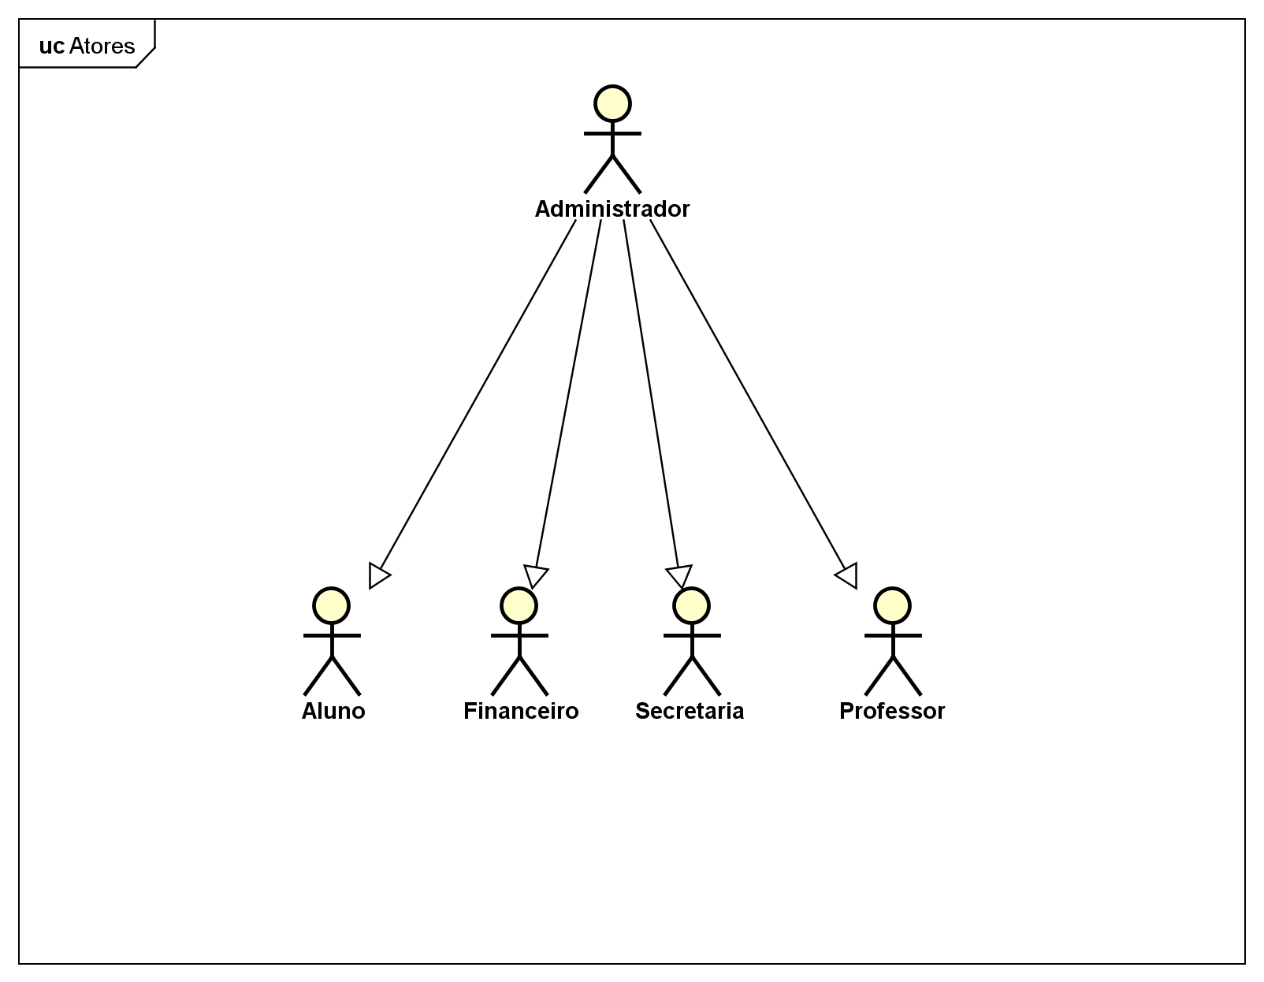

figure 1: Caso de uso::Atores::Atores[UseCase Diagram]

Definition

Custom Property
Name | Value

UseCase

Class

Administrador [Actor]

Declaration
public class Administrador
extends Financeiro, Professor, Secretaria, Aluno

Namespace
Caso de uso::Atores

Stereotype
<<actor>>

Constraint

Definition

Template Parameter

Attribute

Operation

Relation (From Source To Target)

Relation (From Target To Source)

Custom Property
Name | Value

Aluno [Actor]

Declaration
public class Aluno

Namespace
Caso de uso::Atores

Stereotype
<<actor>>
<<stereotype>>

Constraint

Definition

Template Parameter

Attribute

Operation

Relation (From Source To Target)

Relation (From Target To Source)

Custom Property
Name | Value

Financeiro [Actor]

Declaration
public class Financeiro

Namespace
Caso de uso::Atores

Stereotype
<<actor>>

Constraint

Definition

Template Parameter

Attribute

Operation

Relation (From Source To Target)

Relation (From Target To Source)

Custom Property
Name | Value

Professor [Actor]

Declaration
public class Professor

Namespace
Caso de uso::Atores

Stereotype
<<actor>>

Constraint

Definition

Template Parameter

Attribute

Operation

Relation (From Source To Target)

Relation (From Target To Source)

Custom Property
Name | Value

Secretaria [Actor]

Declaration
public class Secretaria

Namespace
Caso de uso::Atores

Stereotype
<<actor>>

Constraint

Definition

Template Parameter

Attribute

Operation

Relation (From Source To Target)

Relation (From Target To Source)

Custom Property
Name | Value

ExternalEntity

DataStore

Requirement

TestCase

Caso de uso::Gerenciar conta a receber Package

Stereotype

Definition

Relation (From Source To Target)

Relation (From Target To Source)

Diagram

Caso de uso::Gerenciar conta a receber::Gerenciar conta a receber[UseCase Diagram]

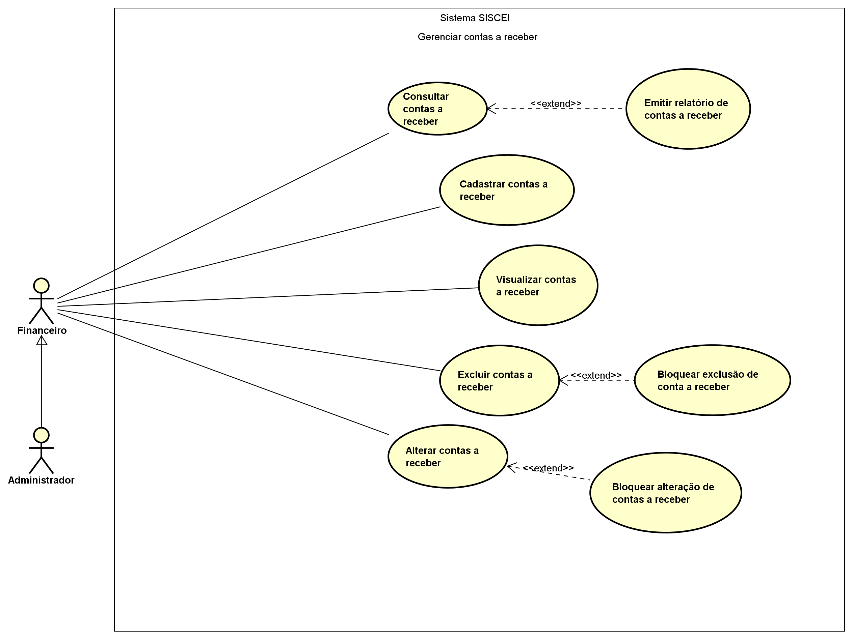

figure 2: Caso de uso::Gerenciar conta a receber::Gerenciar conta a receber[UseCase Diagram]

Definition

Custom Property
Name | Value

UseCase

Alterar contas a receber [UseCase]

Namespace
Caso de uso::Gerenciar conta a receber

Stereotype

Extension Point

Definition

Relation (From Source To Target)

Relation (From Target To Source)
Name | Type | Source | Summary
 | Extend | Bloquear alteração de contas a receber

Custom Property
Name | Value

Bloquear alteração de contas a receber [UseCase]

Namespace
Caso de uso::Gerenciar conta a receber

Stereotype

Extension Point

Definition

Relation (From Source To Target)
Name | Type | Target | Summary
 | Extend | Alterar contas a receber

Relation (From Target To Source)

Custom Property
Name | Value

Bloquear exclusão de conta a receber [UseCase]

Namespace
Caso de uso::Gerenciar conta a receber

Stereotype

Extension Point

Definition

Relation (From Source To Target)
Name | Type | Target | Summary
 | Extend | Excluir contas a receber

Relation (From Target To Source)

Custom Property
Name | Value

Cadastrar contas a receber [UseCase]

Namespace
Caso de uso::Gerenciar conta a receber

Stereotype

Extension Point

Definition

Relation (From Source To Target)

Relation (From Target To Source)

Custom Property
Name | Value

Consultar contas a receber [UseCase]

Namespace
Caso de uso::Gerenciar conta a receber

Stereotype

Extension Point

Definition

Relation (From Source To Target)

Relation (From Target To Source)
Name | Type | Source | Summary
 | Extend | Emitir relatório de contas a receber

Custom Property
Name | Value

Emitir relatório de contas a receber [UseCase]

Namespace
Caso de uso::Gerenciar conta a receber

Stereotype

Extension Point

Definition

Relation (From Source To Target)
Name | Type | Target | Summary
 | Extend | Consultar contas a receber

Relation (From Target To Source)

Custom Property
Name | Value

Excluir contas a receber [UseCase]

Namespace
Caso de uso::Gerenciar conta a receber

Stereotype

Extension Point

Definition

Relation (From Source To Target)

Relation (From Target To Source)
Name | Type | Source | Summary
 | Extend | Bloquear exclusão de conta a receber

Custom Property
Name | Value

Visualizar contas a receber [UseCase]

Namespace
Caso de uso::Gerenciar conta a receber

Stereotype

Extension Point

Definition

Relation (From Source To Target)

Relation (From Target To Source)

Custom Property
Name | Value

Class

ExternalEntity

DataStore

Requirement

TestCase

Caso de uso::Gerenciar conta bancária Package

Stereotype

Definition

Relation (From Source To Target)

Relation (From Target To Source)

Diagram

Caso de uso::Gerenciar conta bancária::Gerenciar conta bancária[UseCase Diagram]

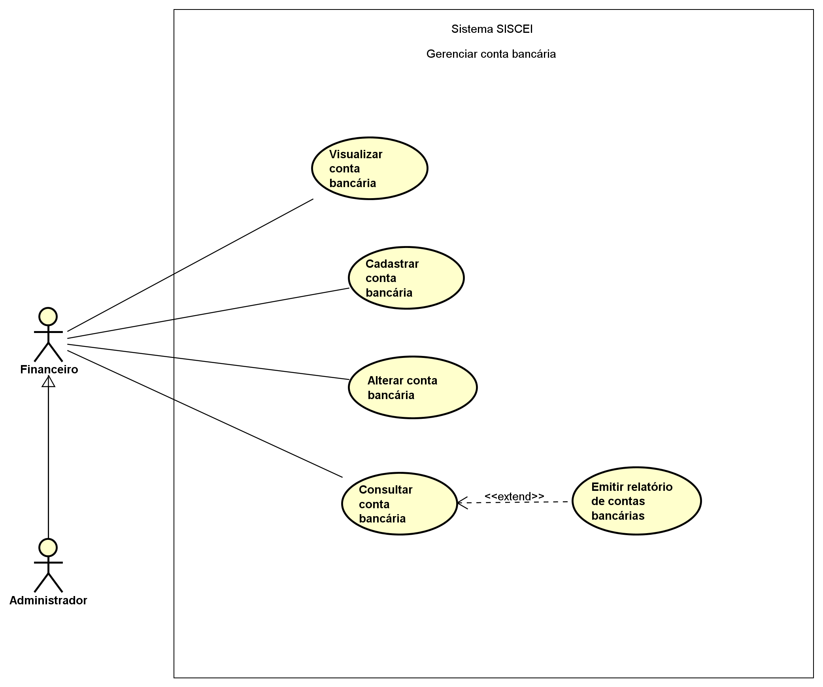

figure 3: Caso de uso::Gerenciar conta bancária::Gerenciar conta bancária[UseCase Diagram]

Definition

Custom Property
Name | Value

UseCase

Alterar conta bancária [UseCase]

Namespace
Caso de uso::Gerenciar conta bancária

Stereotype

Extension Point

Definition

Relation (From Source To Target)

Relation (From Target To Source)
Name | Type | Source | Summary
 | Include | Gerenciar conta bancária

Custom Property
Name | Value

Cadastrar conta bancária [UseCase]

Namespace
Caso de uso::Gerenciar conta bancária

Stereotype

Extension Point

Definition

Relation (From Source To Target)

Relation (From Target To Source)
Name | Type | Source | Summary
 | Include | Gerenciar conta bancária

Custom Property
Name | Value

Consultar conta bancária [UseCase]

Namespace
Caso de uso::Gerenciar conta bancária

Stereotype

Extension Point

Definition

Relation (From Source To Target)

Relation (From Target To Source)
Name | Type | Source | Summary
 | Extend | Emitir relatório de contas bancárias
 | Include | Gerenciar conta bancária

Custom Property
Name | Value

Emitir relatório de contas bancárias [UseCase]

Namespace
Caso de uso::Gerenciar conta bancária

Stereotype

Extension Point

Definition

Relation (From Source To Target)
Name | Type | Target | Summary
 | Extend | Consultar conta bancária

Relation (From Target To Source)

Custom Property
Name | Value

Gerenciar conta bancária [UseCase]

Namespace
Caso de uso::Gerenciar conta bancária

Stereotype

Extension Point

Definition

Relation (From Source To Target)
Name | Type | Target | Summary
 | Include | Visualizar conta bancária
 | Include | Cadastrar conta bancária
 | Include | Alterar conta bancária
 | Include | Consultar conta bancária

Relation (From Target To Source)

Custom Property
Name | Value

Visualizar conta bancária [UseCase]

Namespace
Caso de uso::Gerenciar conta bancária

Stereotype

Extension Point

Definition

Relation (From Source To Target)

Relation (From Target To Source)
Name | Type | Source | Summary
 | Include | Gerenciar conta bancária

Custom Property
Name | Value

Class

ExternalEntity

DataStore

Requirement

TestCase

Caso de uso::Gerenciar contas a pagar Package

Stereotype

Definition

Relation (From Source To Target)

Relation (From Target To Source)

Diagram

Caso de uso::Gerenciar contas a pagar::Gerenciar contas a pagar[UseCase Diagram]

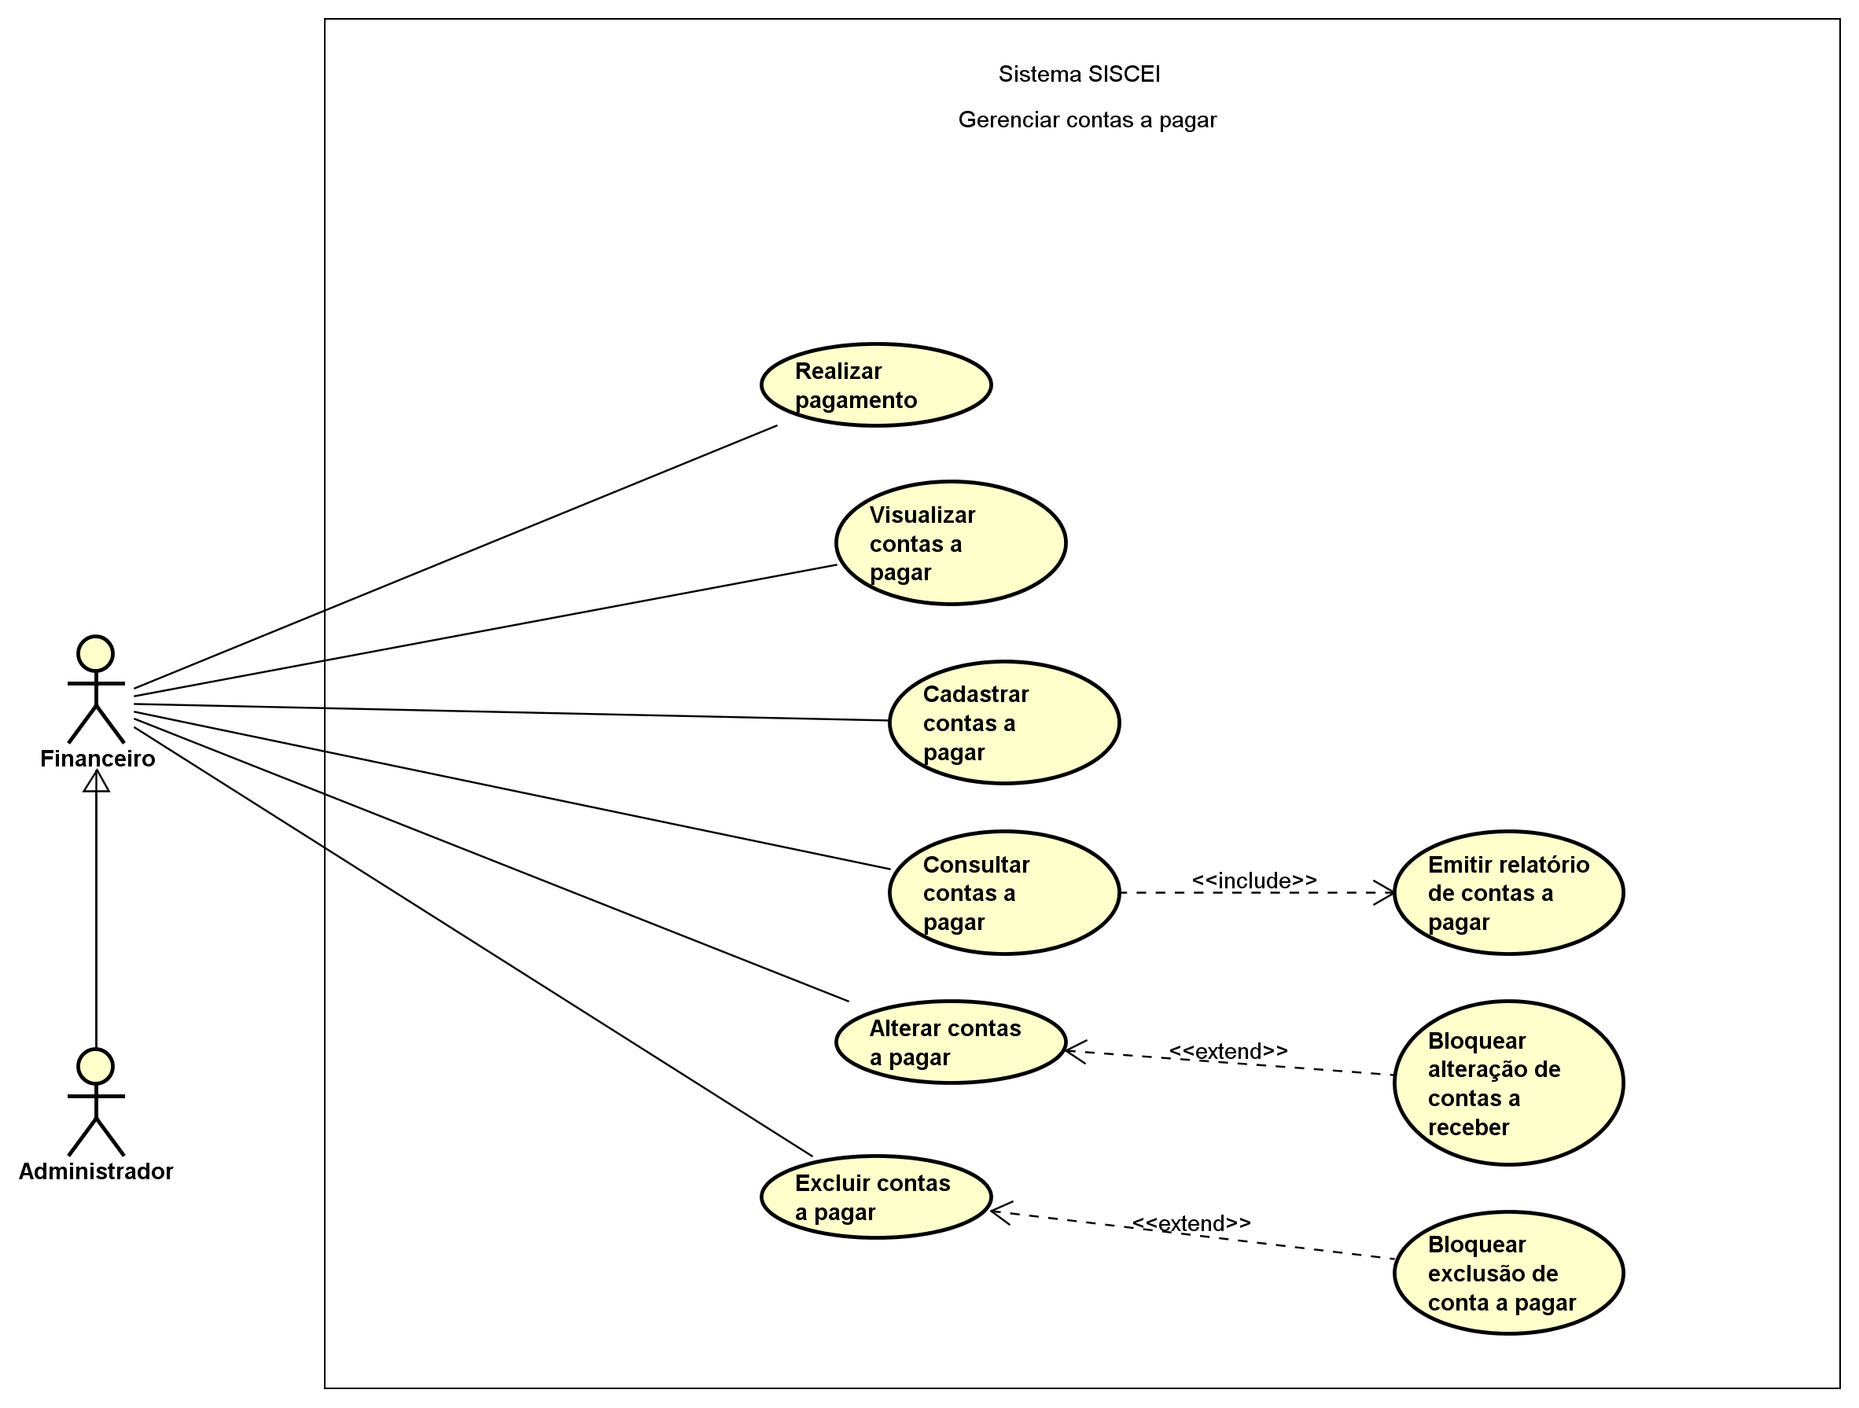

figure 4: Caso de uso::Gerenciar contas a pagar::Gerenciar contas a pagar[UseCase Diagram]

Definition

Custom Property
Name | Value

UseCase

Alterar contas a pagar [UseCase]

Namespace
Caso de uso::Gerenciar contas a pagar

Stereotype

Extension Point

Definition

Relation (From Source To Target)

Relation (From Target To Source)
Name | Type | Source | Summary
 | Extend | Bloquear alteração de contas a receber

Custom Property
Name | Value

Bloquear alteração de contas a receber [UseCase]

Namespace
Caso de uso::Gerenciar contas a pagar

Stereotype

Extension Point

Definition

Relation (From Source To Target)
Name | Type | Target | Summary
 | Extend | Alterar contas a pagar

Relation (From Target To Source)

Custom Property
Name | Value

Bloquear exclusão de conta a pagar [UseCase]

Namespace
Caso de uso::Gerenciar contas a pagar

Stereotype

Extension Point

Definition

Relation (From Source To Target)
Name | Type | Target | Summary
 | Extend | Excluir contas a pagar

Relation (From Target To Source)

Custom Property
Name | Value

Cadastrar contas a pagar [UseCase]

Namespace
Caso de uso::Gerenciar contas a pagar

Stereotype

Extension Point

Definition

Relation (From Source To Target)

Relation (From Target To Source)

Custom Property
Name | Value

Consultar contas a pagar [UseCase]

Namespace
Caso de uso::Gerenciar contas a pagar

Stereotype

Extension Point

Definition

Relation (From Source To Target)
Name | Type | Target | Summary
 | Include | Emitir relatório de contas a pagar

Relation (From Target To Source)
Name | Type | Source | Summary
 | Extend | Emitir relatório de contas a pagar

Custom Property
Name | Value

Emitir relatório de contas a pagar [UseCase]

Namespace
Caso de uso::Gerenciar contas a pagar

Stereotype

Extension Point

Definition

Relation (From Source To Target)
Name | Type | Target | Summary
 | Extend | Consultar contas a pagar

Relation (From Target To Source)
Name | Type | Source | Summary
 | Include | Consultar contas a pagar

Custom Property
Name | Value

Excluir contas a pagar [UseCase]

Namespace
Caso de uso::Gerenciar contas a pagar

Stereotype

Extension Point

Definition

Relation (From Source To Target)

Relation (From Target To Source)
Name | Type | Source | Summary
 | Extend | Bloquear exclusão de conta a pagar

Custom Property
Name | Value

Realizar pagamento [UseCase]

Namespace
Caso de uso::Gerenciar contas a pagar

Stereotype

Extension Point

Definition

Relation (From Source To Target)

Relation (From Target To Source)

Custom Property
Name | Value

Visualizar contas a pagar [UseCase]

Namespace
Caso de uso::Gerenciar contas a pagar

Stereotype

Extension Point

Definition

Relation (From Source To Target)

Relation (From Target To Source)

Custom Property
Name | Value

Class

ExternalEntity

DataStore

Requirement

TestCase

Caso de uso::Gerenciar fornecedor Package

Stereotype

Definition

Relation (From Source To Target)

Relation (From Target To Source)

Diagram

Caso de uso::Gerenciar fornecedor::Gerenciar fornecedor[UseCase Diagram]

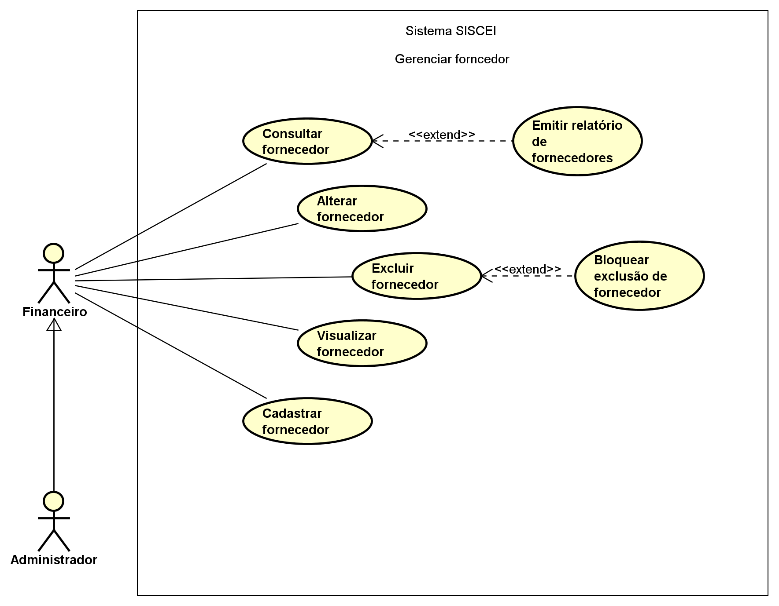

figure 5: Caso de uso::Gerenciar fornecedor::Gerenciar fornecedor[UseCase Diagram]

Definition

Custom Property
Name | Value

UseCase

Alterar fornecedor [UseCase]

Namespace
Caso de uso::Gerenciar fornecedor

Stereotype

Extension Point

Definition

Relation (From Source To Target)

Relation (From Target To Source)

Custom Property
Name | Value

Bloquear exclusão de fornecedor [UseCase]

Namespace
Caso de uso::Gerenciar fornecedor

Stereotype

Extension Point

Definition

Relation (From Source To Target)
Name | Type | Target | Summary
 | Extend | Excluir fornecedor

Relation (From Target To Source)

Custom Property
Name | Value

Cadastrar fornecedor [UseCase]

Namespace
Caso de uso::Gerenciar fornecedor

Stereotype

Extension Point

Definition

Relation (From Source To Target)

Relation (From Target To Source)

Custom Property
Name | Value

Consultar fornecedor [UseCase]

Namespace
Caso de uso::Gerenciar fornecedor

Stereotype

Extension Point

Definition

Relation (From Source To Target)

Relation (From Target To Source)
Name | Type | Source | Summary
 | Extend | Emitir relatório de fornecedores

Custom Property
Name | Value

Emitir relatório de fornecedores [UseCase]

Namespace
Caso de uso::Gerenciar fornecedor

Stereotype

Extension Point

Definition

Relation (From Source To Target)
Name | Type | Target | Summary
 | Extend | Consultar fornecedor

Relation (From Target To Source)

Custom Property
Name | Value

Excluir fornecedor [UseCase]

Namespace
Caso de uso::Gerenciar fornecedor

Stereotype

Extension Point

Definition

Relation (From Source To Target)

Relation (From Target To Source)
Name | Type | Source | Summary
 | Extend | Bloquear exclusão de fornecedor

Custom Property
Name | Value

Visualizar fornecedor [UseCase]

Namespace
Caso de uso::Gerenciar fornecedor

Stereotype

Extension Point

Definition

Relation (From Source To Target)

Relation (From Target To Source)

Custom Property
Name | Value

Class

ExternalEntity

DataStore

Requirement

TestCase

