### INFORME EXAMEN SEGUNDO PROGRESO FELIPE OCAÑA

### Script Base de datos: PERSONA

Creamos la tabla donde se van a almacenar los datos:

Creación del proyecto en Visual estudio, ASP.NET Core WEB API

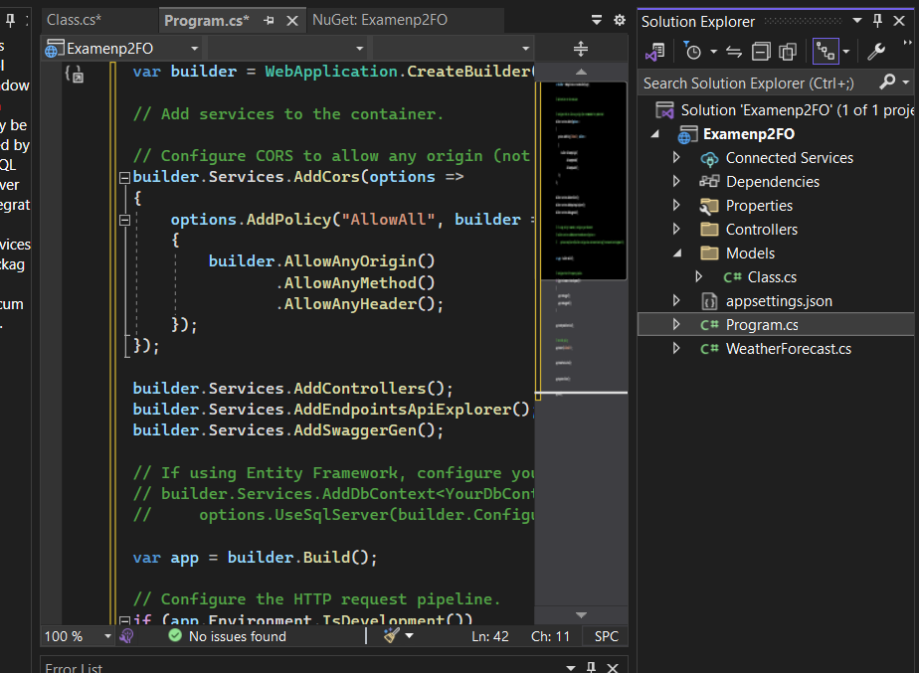

<https://github.com/felipeocana1/P2FO>