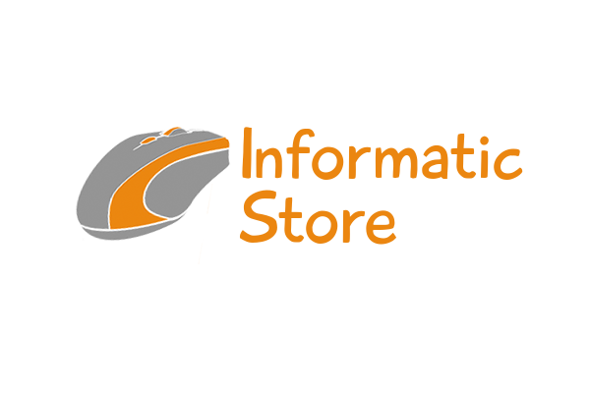
Informatic Store


My project is about a computer store. It will be a CRUD application that manages a standard computer store. It'll let us use it as a client or a administrator.

Tables Customer
Order
Product
Contain
ShoppingCart
Provider

Functions

In the customers main menu, we have 3 options: products, shopping cart and orders. If we access as admin, the menus will be clients, products and suppliers.

A customer will be able to see the list of products, save it in the shopping cart, make purchases and carry the order history. The administrator will manage the entire system: the list of customers, products, suppliers, and so on.

In addition, the admin being the root of the application will be able to create, read, update and delete any record referring to its menus.

Inner app

The first screen will be login which will display a different menu according to the type of user.

Products We select the ones we want to buy and their quantity.

Shopping Cart Each product appears with its price and quantity, in addition to the total price.

Order Shows all purchases made, list of products, price and total expenses.

Possible improvements

- Manage money Enter accounting table. Customers can pay and so take profits from the store.
The expenses of the suppliers.

- Change the language According to the user. Save attribute in Customers table. Add button in the main menu.

The accounting we can know the balance of the store, that is, the profits or losses that may have. From there, the main function that we can perform is to register a new account, so for that account we have the attributes purchase expenses, sales earnings, balance and concept.
In order to know if there are profits obtained in the store, the application calculates the sum of all purchases made in a given period of time, and this total is subtracted from the expenses invested in purchase, thus we obtain the result either positive or negative Indicating whether there is a deficit or the opposite, there are economic benefits.

