Ethereum Dapp for Tracking Items through Supply Chain

The contract address
0x197cA75aBD1F851efF9D47fa4fC1c53F2a1E2Fa5

If libraries were used, include why these libraries were adopted.
To develop the roles in a standard and secure way of the AcessControl contracts the library Roles was used. It allows for the inclusion and removal of roles for the FarmerRole.sol, DistributorRole.sol, RetailerRole.sol, and ConsumerRole.sol contracts.

If IPFS is used, include how IPFS is used in this project.
IPFS was not used.

node version number
V10.19.0

Truffle version number
Truffle v4.1.14 (core: 4.1.14)

web3 version number
1.6.0

UML documents:

Activity
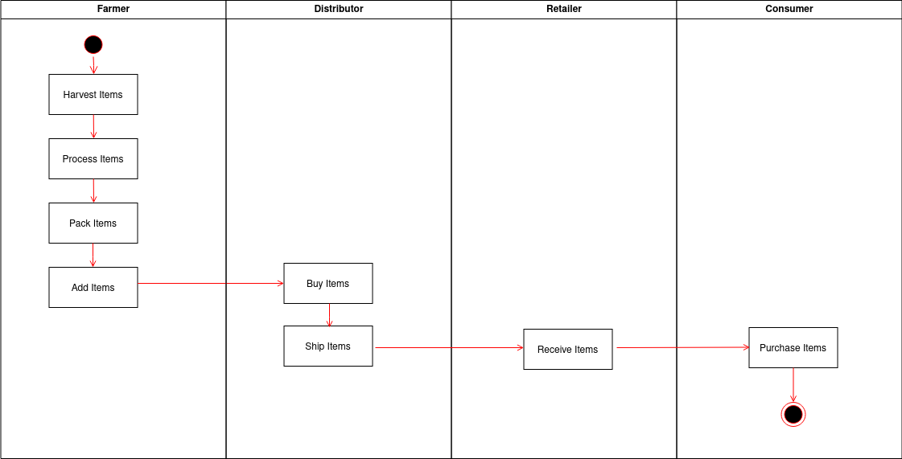

Sequence
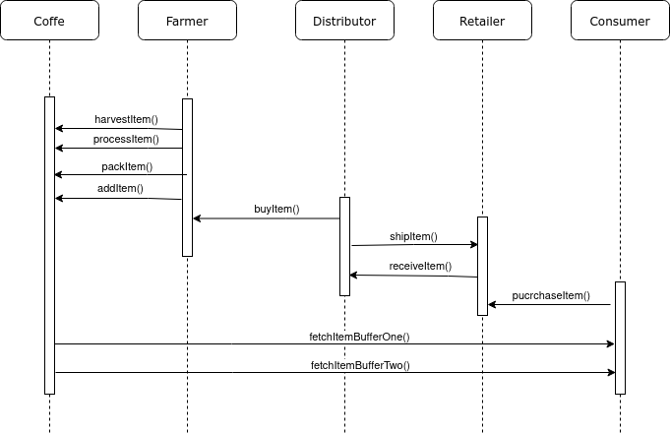

State
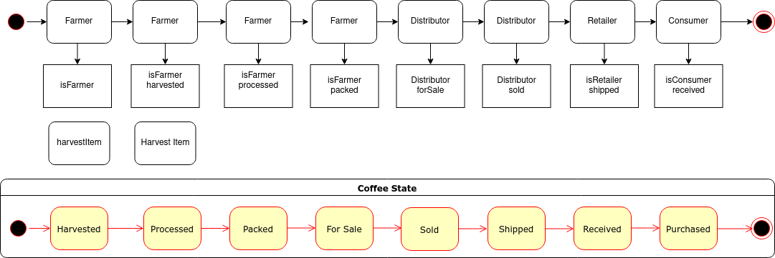

Class (Data Model)
