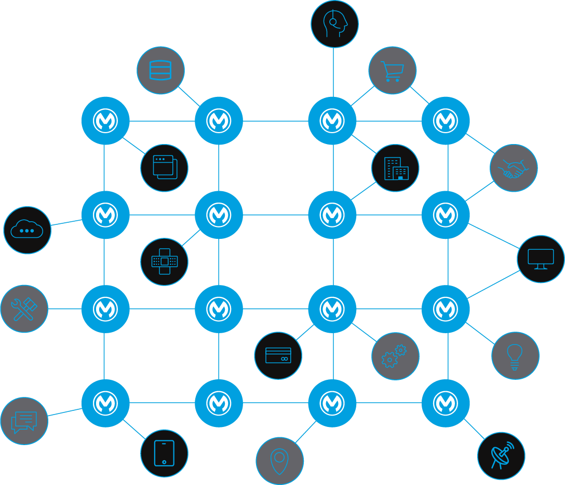Solution Design

|  |  |  |  |
| --- | --- | --- | --- |
| **Version** | **Date** | **Author** | **Description** |
| 0.1 | 16/10/2022 | William F. Cardenas | Initial version |
| 1.0 | 18/10/2022 | William F. Cardenas | Delivered version |

Table of contents

Introduction 7

Audience 7

References 7

Anypoint Platform Architecture 7

Others 7

Use-case overview 9

Business Process Overview 10

Acme Products - Process View 10

Assumptions 11

Prerequisites 11

Business Requirements 12

Technical Design 13

Overview 13

Dependency View 14

Logical View 15

Acme Products - Process View 15

Acme and Big company - Process View 16

Acme MDM sync - Process View 17

Search products - Sequence Diagram 18

Manage products 19

Product creation – Marketing - Sequence Diagram 19

Product creation – CQRS with notification - Sequence Diagram 20

Product creation – Legal - Sequence Diagram 21

Product creation – CQRS- Sequence Diagram 22

Search products – Acme Inc. + Big Company - Sequence Diagram 23

Components/Mule Applications 23

Non-Functional Requirements 25

Security 25

SLA/Performance 26

Response Times 27

Throughput 27

Policies related to performance 28

Logging 29

Monitoring 29

Reliability 30

Reuse Considerations 30

Installation Requirements 31

Mule Components 31

Non-Mule Components 31

# Introduction

This document is designed as a practical exercise within the process for the opportunity as Solution Architect, in this document will be used to define the technical components required to implement the proposed solution.

## Audience

This document’s audience primarily includes architects, consultants, and recruiters engaged in this exercise.

## References

*<Provide references to all relevant documents such as Anypoint platform architecture, overall reference architecture, best practices, etc.>*

### Anypoint Platform Architecture

o [*Anypoint Platform Architecture*](https://catalyst.mulesoft.com/display/OBD/Platform+Architecture+Template)

### Others

o [*Naming Strategy*](https://catalyst.mulesoft.com/display/OBD/API+Discovery+and+Naming+Strategy)

o [*Mule Versioning*](https://catalyst.mulesoft.com/display/OBD/API+Versioning+Recommendations) *Recommendations*

o [*API Design Considerations*](https://catalyst.mulesoft.com/display/OBD/API+Design+Recommendations)

o [*Coding Standards*](https://catalyst.mulesoft.com/display/OBD/Mule+Code+Style+Guide)

# Use-case overview

The company Acme inc. has the need to expose to its customers its product catalog, this catalog must have different kinds of filters, sorting and pagination, additionally it must be able to add, modify and replace products by the marketing area with a subsequent approval of the legal area. We are also considering the inclusion of a third-party product catalog, and these must be displayed within the Acme Inc. catalog, based on that we consider the possible inclusion of other product catalogs. It is also necessary to have high availability at the catalog consultation level.

## Business Process Overview

### Acme Products - Process View

## Assumptions

This section covers any assumptions that have been made in the process of designing the solution.

* The experience layer is ignored because it is assumed that the web applications involved are compliant with the process API scheme, any non-compliant customer should have its own experience API.
* Compliant web applications do not need to be limited or placed under any service level agreements.
* The use of external data repositories is in disuse due to the need to avoid having data folded in multiple repositories and prioritizes the use of a single source of truth.
* The approval process when creating a product is since a user from the marketing area creates or modifies a product, then a user from the legal area is notified via email, then this user accesses the back office to approve the operation.
* The use of roles or profiles is not required at API level.
* As this is a purely didactic scenario, we do not have real data, therefore we estimate that one thousand requests will be made per minute.

## Prerequisites

This section covers any prerequisites that are required as part of the solution.

* Application that visualizes the products.
* application that manages the product management.
* There is an email notification system.
* Web applications have their own authentication and authorization systems.

## Business Requirements

This section captures high-level requirements as part of the solution.

* Acme Inc. needs to be able to display its product catalog through its website.
* It must be possible to create, modify and delete products through the back office.
* The creation, modification and deletion of products happens in two steps, first an action is executed by the marketing users in the back office, a notification is sent to the legal users, the legal user will give the approval through the back office so that the product is ready to be offered.
* In the future, other product repositories could be included to be displayed in the web application.
* Products that cannot be processed for any reason will be sent to an Outbox repository for future analysis and/or processing.

# 

# Technical Design

This section captures technical design details of the solution.

## Overview

through a network of microservices based on API led connectivity the processes directly related to products will be exposed, since the queries will be exponentially greater than the actions, it has been proposed to add two databases with different purposes, a master data management or MDM that will be placed as in a documentary database, mongo DB has been chosen as the only source of truth. On the other hand, there will be a database for searches, Elastic Search has been selected for this task. For the sake of simplicity, the experience layer has been omitted and compliant applications within Acme Inc. will be able to directly access our API at the process layer, however any other applications that require access to product related processes will have to access them through experience API's that make them comply with the process API. the process API will oversee both the process input interface and managing the command and query resource segregation. it will also oversee managing the dead letter queues. at the system layer level, an API will be created to link communication with the notification system, an API for actions with MongoDB and an API for actions on elastic search. additionally, an API will be created to link with the database where Big Company's products are stored. With the aim of synchronizing Big Company and any other product source, a product synchronization API is added for the purpose of feeding the single source of truth or MDM. Finally, an API will be added as an option to link to an Outbox repository where we will store all the unprocessed information for analysis and future retries, also any other external repository from which we need to extract products can be reached through a specific system API for that repository that can be linked to the MDM synchronization API.

## Dependency View

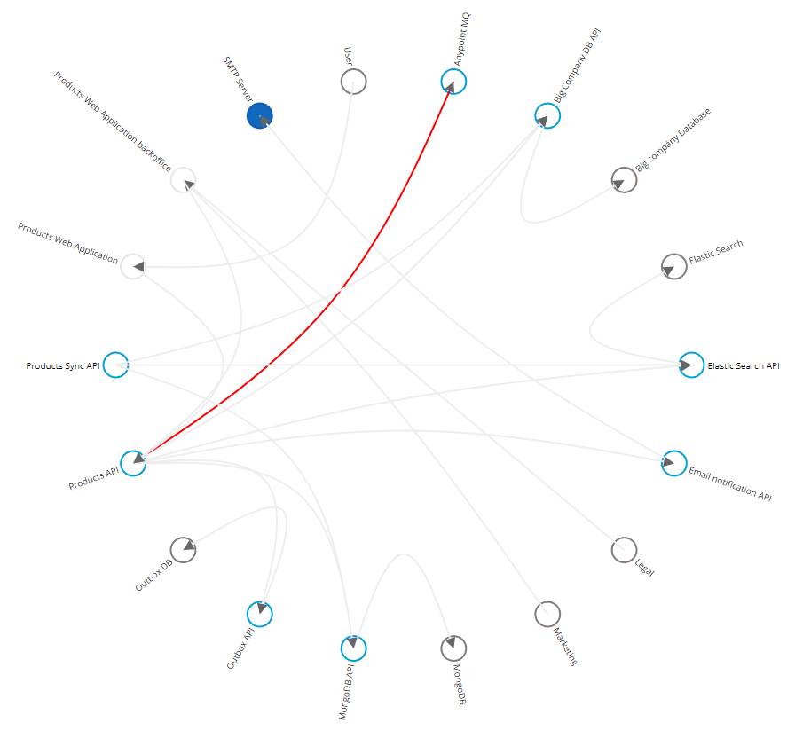

## Logical View

### Diagram Description automatically generatedAcme Products - Process View

### Diagram Description automatically generatedAcme and Big company - Process View

### Acme MDM sync - Process View

### Search products - Sequence Diagram

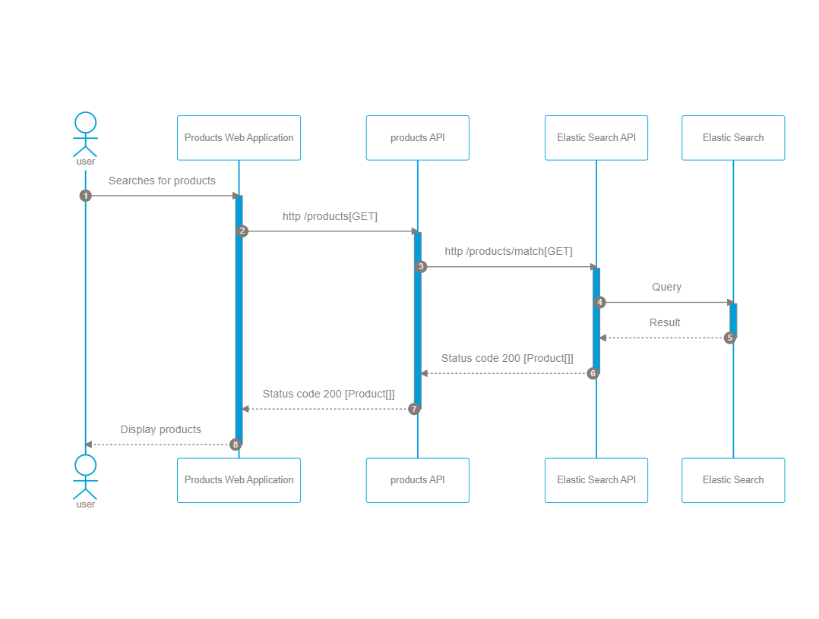

### Manage products

### Product creation – Marketing - Sequence Diagram

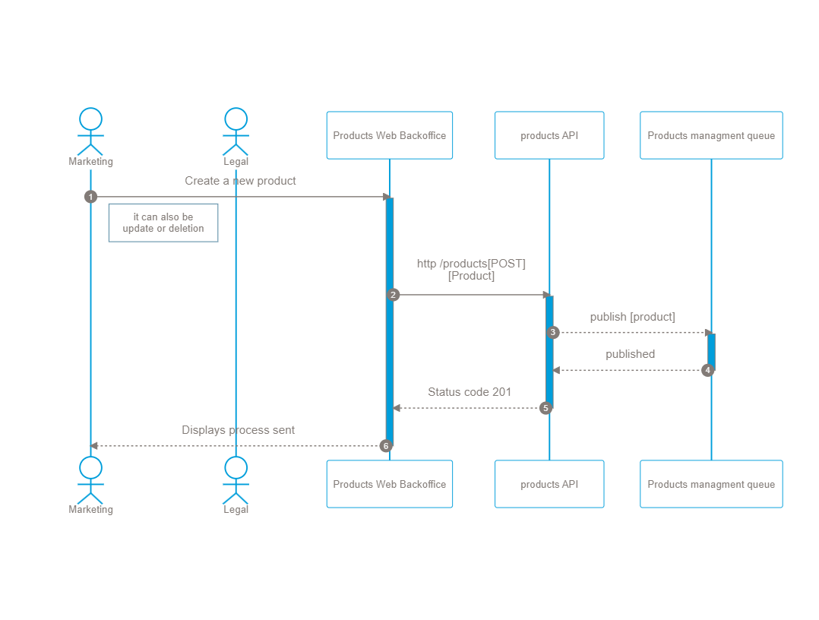

### Product creation – CQRS with notification - Sequence Diagram

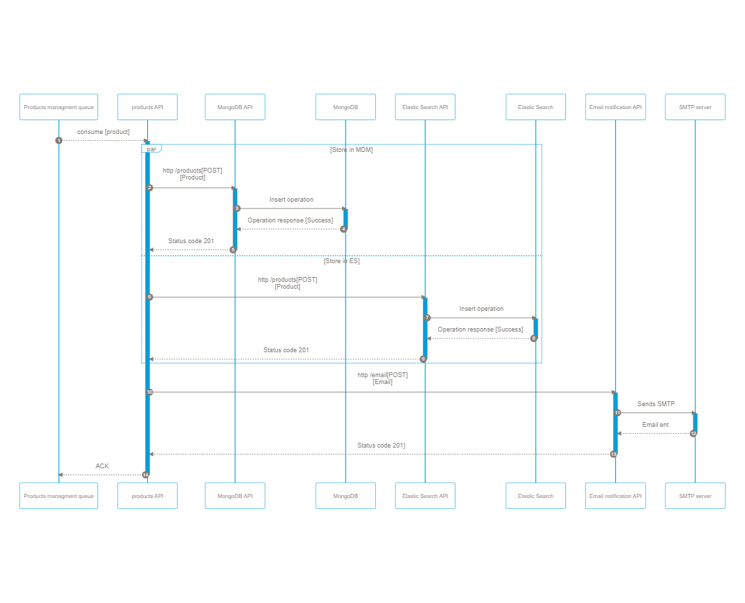

### Product creation – Legal - Sequence Diagram

### Product creation – CQRS- Sequence Diagram

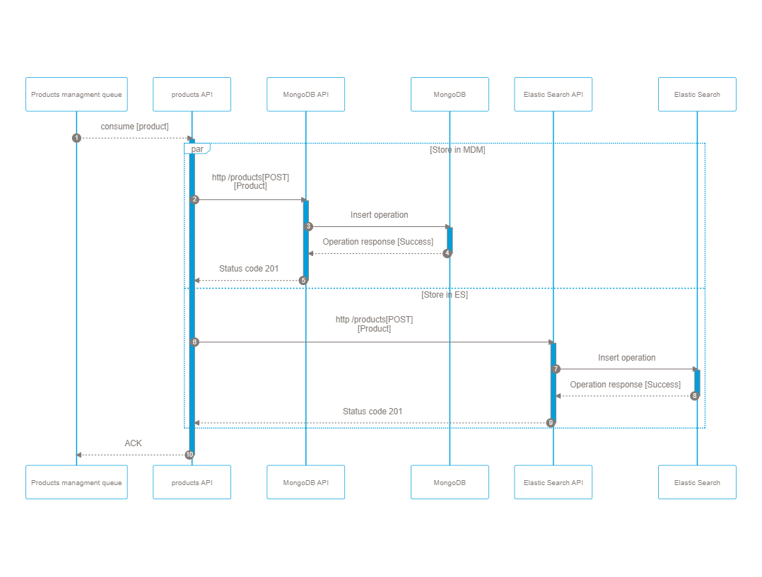

### Search products – Acme Inc. + Big Company - Sequence Diagram

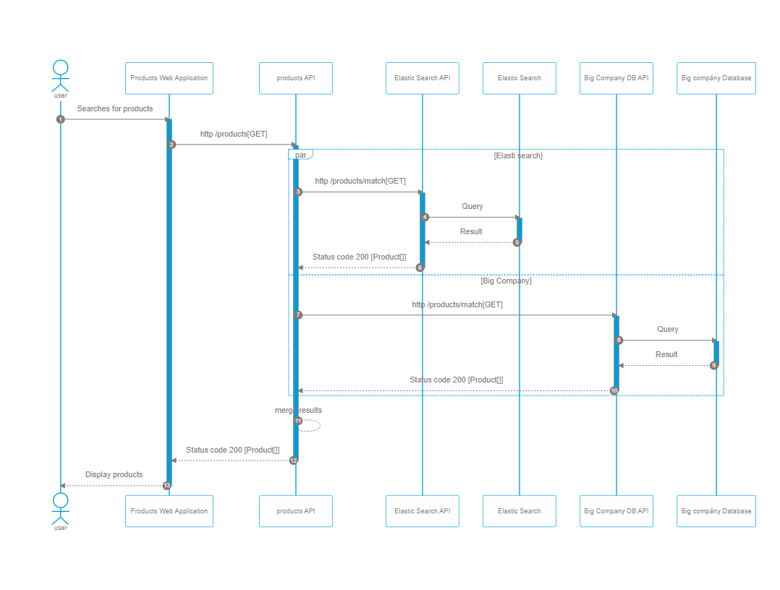

## Components/Mule Applications

*<Capture the list of Mule Applications part of this solution>*

|  |  |  |  |
| --- | --- | --- | --- |
| **Mule Applications** | | | |
| S.No | Application Name | Type | Description |
| 1 | acme-marketing-prod-p-products-v1 | *API, Integration* |  |
| 2 | acme-marketing-prod-p-products-sync-v1 | *Integration, Batch Application* |  |
| 3 | acme-marketing-prod-s-mongodb-v1 | *API, Integration* |  |
| 4 | acme-marketing-prod-s-elasticsearch-v1 | *API, Integration* |  |
| 5 | acme-marketing-prod-s-email-v1 | *API, Integration* |  |
| 6 | acme-marketing-prod-s-bigcompanydb-v1 | *API, Integration* |  |
| 7 | acme-marketing-prod-s-outboxdb-v1 | *API, Integration* |  |

# 

# Non-Functional Requirements

This section captures the non-functional requirements of all APIs related to the use-case(s)/solution.

## Security

*<Describe the security related details such as policies, etc. for All Components/Applications>*

|  |  |  |
| --- | --- | --- |
| **Authentication** | | |
| S.No | Application Name | Authentication Type/Policy |
| 1 | acme-marketing-prod-p-products-v1 | *Client ID Enforcement* |
| 2 | acme-marketing-prod-s-mongodb-v1 | *Client ID Enforcement* |
| 3 | acme-marketing-prod-s-elasticsearch-v1 | *Client ID Enforcement* |
| 4 | acme-marketing-prod-s-email-v1 | *Client ID Enforcement* |
| 5 | acme-marketing-prod-s-bigcompanydb-v1 | *Client ID Enforcement* |
| 6 | acme-marketing-prod-s-outboxdb-v1 | *Client ID Enforcement* |

|  |  |  |
| --- | --- | --- |
| **Authorization** | | |
| S.No | Application Name | Authorization Scopes |
| 1 | N/A |  |

|  |  |  |
| --- | --- | --- |
| **Other Security Policies** | | |
| S.No | Application Name | Policy |
| 1 | N/A |  |

|  |  |  |
| --- | --- | --- |
| **Encryption** | | |
| S.No | Application Name | Encryption Requirements |
| 1 | N/A |  |

## SLA/Performance

The acme products web site will make an estimated 1000 requests every minute, on the other hand the back office will make the same amount in a day. Taking this into account there will be an SLA for each of the web applications sharing a tier of 1000 requests per minute.

### Response Times

The expected response times for each of the elements are as follows

|  |  |  |
| --- | --- | --- |
| **Response Times** | | |
| S.No | Application Name | Response Time (95%) |
| 1 | acme-marketing-prod-p-products-v1 | *95% within 2.5 seconds* |
| 2 | acme-marketing-prod-p-products-sync-v1 | *95% within 5 seconds* |
| 3 | acme-marketing-prod-s-mongodb-v1 | *95% within 1 seconds* |
| 4 | acme-marketing-prod-s-elasticsearch-v1 | *95% within 1 seconds* |
| 5 | acme-marketing-prod-s-email-v1 | *95% within 1 seconds* |
| 6 | acme-marketing-prod-s-bigcompanydb-v1 | *95% within 1 seconds* |
| 7 | acme-marketing-prod-s-outboxdb-v1 | *95% within 1 seconds* |

### Throughput

* *Up to two thousand requests will be expected per minute.*

|  |  |  |
| --- | --- | --- |
| **Throughput** | | |
| S.No | Application Name | TPS |
| 1 | acme-marketing-prod-p-products-v1 | 33 |
| 2 | acme-marketing-prod-p-products-sync-v1 | 0.5 |
| 3 | acme-marketing-prod-s-mongodb-v1 | 0.1 |
| 4 | acme-marketing-prod-s-elasticsearch-v1 | 32 |
| 5 | acme-marketing-prod-s-email-v1 | 0.1 |
| 6 | acme-marketing-prod-s-bigcompanydb-v1 | 32 |
| 7 | acme-marketing-prod-s-outboxdb-v1 | 0.1 |

### Policies related to performance

*<Provide list of all policies related to performance such as Spike Control, Rate limiting etc.>*

|  |  |  |  |
| --- | --- | --- | --- |
| **Policies** | | | |
| S.No | Application Name | Policy | Details |
| 1 | acme-marketing-prod-p-products-v1 | Rate-Limiting SLA Based | *1000 x minute x each client* |
| 2 | acme-marketing-prod-p-products-sync-v1 | N/A |  |
| 3 | acme-marketing-prod-s-mongodb-v1 | Rate-Limiting SLA Based | *1000 x minute to acme-marketing-prod-p-products-v1* |
| 4 | acme-marketing-prod-s-elasticsearch-v1 | Rate-Limiting SLA Based | *2000 x minute to acme-marketing-prod-p-products-v1, 1000 x minute to acme-marketing-prod-p-products-sync-v1* |
| 5 | acme-marketing-prod-s-email-v1 | Rate-Limiting SLA Based | *100 x minute to acme-marketing-prod-p-products-v1* |
| 6 | acme-marketing-prod-s-bigcompanydb-v1 | Rate-Limiting SLA Based | *2000 x minute to acme-marketing-prod-p-products-v1, 1000 x minute to acme-marketing-prod-p-products-sync-v1* |
| 7 | acme-marketing-prod-s-outboxdb-v1 | Rate-Limiting SLA Based | *1000 x minute to acme-marketing-prod-p-products-v1* |

## Logging

The internal log system provided by MuleSoft will be used as a log strategy.

## Monitoring

All API's will reside in Anypoint platform and monitoring will be performed within this platform.

## Reliability

To guarantee operations and reduce the possibility of failure, CQRS, Queues and Outbox patterns are implemented. In addition, each http call will have a retry strategy based on the type of response of the called service.

## Reuse Considerations

Each API considered within this design was considered with a reuse purpose either as part of this requirement or future requirements. Additionally, each component and/or flow within the API's was considered as a functional or non-functional use case as individual blocks with unique responsibility which can be reused by other components.

# 

# Installation Requirements

This section covers the Mule Application Installation Requirements.

## Mule Components

* *SSL Certificates*
* *MQ Topics/Exchanges setup*
* *Anypoint Security*
* *Generation of clients*

## Non-Mule Components

*Capture details related to external system dependencies such as, but not limited to: -*

* *MongoDB*
* *Elastic Search*
* *Web Application*
* *Back-office web application*