Practical Assessment 3
Host Web Application: AgriMarket
Name | fill in
Admission number | fill in
Unit / class | fill in
Date | fill in
Application | AgriMarket: farmers sell produce directly to buyers (Node.js, Express, MySQL, HTML/CSS/JavaScript)
GitHub repository | https://github.com/felistusmwangi03-bit/agrimarket
Live website | paste your https://....onrender.com address

Yellow highlighted text marks what you must fill in or insert from your own deployment. Everything else is complete.

Task 1: Hosting platform comparison
AgriMarket is one Express server that serves both the API and the website, and stores data in MySQL. It therefore needs a host that runs Node.js and a MySQL database. Three free options were compared.
Criteria | Render (free web service) | Railway (trial, then free plan) | Aiven (free MySQL, database only)
Runs Node.js / Express | Yes | Yes | No (database only)
Free resources | 750 instance hours a month; sleeps after 15 minutes without traffic, about 1 minute to wake | One-time $5 credit for up to 30 days (1 GB RAM), then $1 credit a month | 1 GB RAM, 1 CPU, 1 GB disk, 76 connections
Automatic SSL/TLS | Yes, managed certificates | Yes, HTTPS on generated domains | Yes, encrypted connections
Git deployment | Yes, from GitHub on every push | Yes, from GitHub | Not applicable
Database support | Free Postgres only, expires after 30 days; no MySQL | Databases available during the trial; free plan has very little credit | MySQL; may power off when idle and can be switched back on
Main drawback | Sleeps when idle; files lost on restart | Trial ends after 30 days, not reliably free | Database only

Final choice: Render (application) with Aiven (MySQL database)
- Backend compatibility: Render runs the existing Node.js server with npm start and no code rewrite; Aiven provides real MySQL, so the schema and queries work unchanged (the app only needs DB_SSL=true).
- Ease of deployment: connect the GitHub repository (a render.yaml file in the project sets everything up), type the database details in the dashboard, and each git push redeploys.
- Reliability: Render’s free web service has no expiry date, and Aiven’s free MySQL plan has no stated time limit. The trade-off is that the free web service sleeps after 15 minutes idle, so the first visit after a quiet period takes about a minute; an uptime monitor reduces this.
Sources (free-tier terms checked on 29 October 2026): render.com/docs/free; docs.railway.com/reference/pricing/free-trial; aiven.io/docs/products/mysql/concepts/mysql-free-tier. Free-tier terms change, so recheck before submitting.

Task 2: Domain lookup
The domain written in the assessment, www.cdacc.go.ke, returned “Non-existent domain” on both the local network DNS and Google DNS (8.8.8.8). The council’s actual domain is tvetcdacc.go.ke, which was looked up on 29 October 2026 using whois.com and nslookup.
Item | Result
Domain | tvetcdacc.go.ke
Registry | KENIC (Registry Domain ID 320195-KENIC)
Registrar | ICT Authority, Teleposta Towers, 12th Floor, Kenyatta Ave, Nairobi
Creation date | 22 February 2016
Expiry date | 22 February 2027
Last updated | 18 February 2026
Status / DNSSEC | active / unsigned
Name servers (NS) | ns1.kenet.or.ke, ns2.kenet.or.ke, ns3.kenet.or.ke
A record (IP address) | 197.136.12.4 (www.tvetcdacc.go.ke is an alias of tvetcdacc.go.ke)
Mail servers (MX) | Preference 0: tvetcdacc-go-ke.mail.protection.outlook.com
TXT records | v=spf1 include:spf.protection.outlook.com -all  MS=ms42129984

Observations: the name servers belong to KENET; email runs on Microsoft 365 (the SPF record allows only Microsoft servers to send mail for the domain); the domain expires in about four months and needs renewing; DNSSEC is unsigned, which is a possible security improvement.
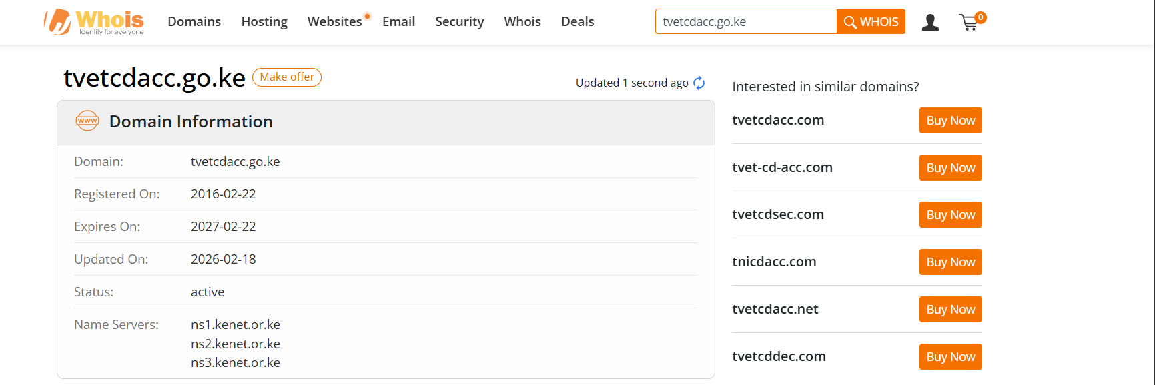
Figure 1: WHOIS domain information for tvetcdacc.go.ke
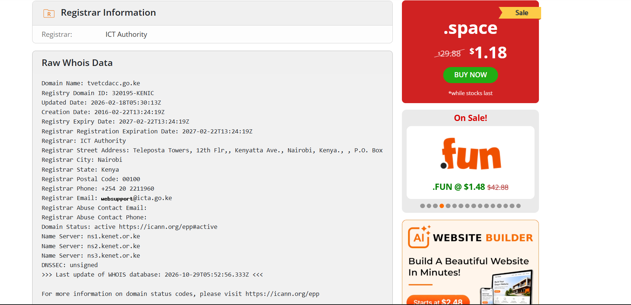
Figure 2: Raw WHOIS data (registrar, dates, status, name servers)
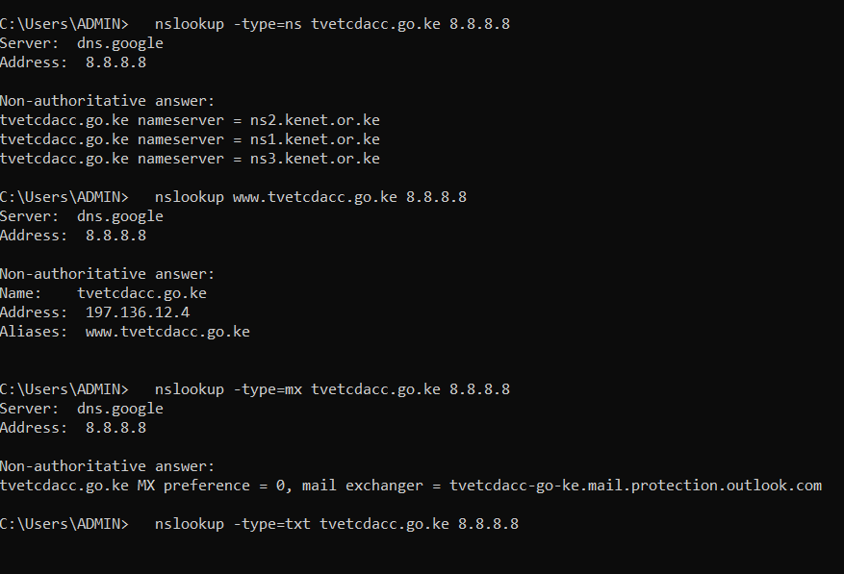
Figure 3: nslookup for NS, A and MX records
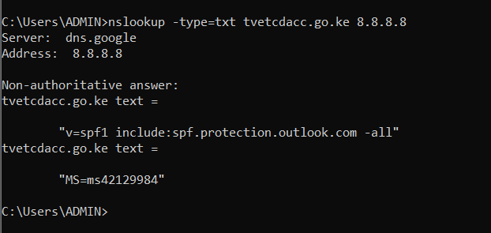
Figure 4: nslookup for TXT records
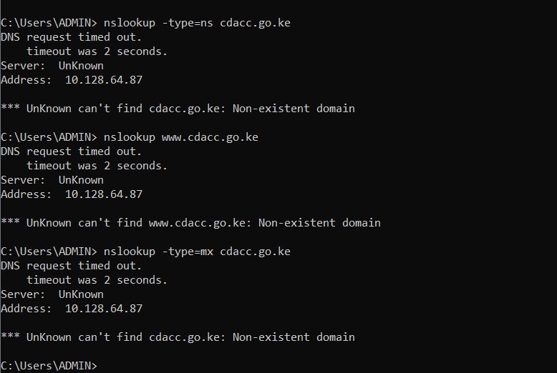
Figure 5: cdacc.go.ke on the local DNS server (non-existent domain)
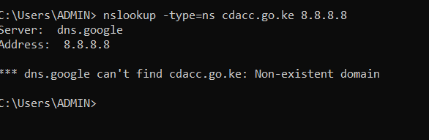
Figure 6: cdacc.go.ke on Google DNS 8.8.8.8 (non-existent domain)

Task 3: GitHub repository
The project was initialised as a Git repository in the project folder, with a .gitignore for sensitive files, a README, and seven meaningful commits, then pushed to GitHub.
Item | Detail
Repository | https://github.com/felistusmwangi03-bit/agrimarket
Branch | main
.gitignore | Excludes node_modules/, .env, .env.* (except .env.example), log files and .pem files, so passwords and secrets are never committed
README.md | Covers the framework (Node.js 18+, Express 4, MySQL via mysql2, plain HTML/CSS/JS front end), the environment variables table (PORT, DB_HOST, DB_PORT, DB_USER, DB_PASSWORD, DB_NAME, JWT_SECRET, DB_SSL, DB_SKIP_CREATE), local setup with XAMPP, and the deployment steps
Documentation in the repo | docs/ holds the ERD, wireframes, API.md, DATABASE.md, GIT.md, MAINTENANCE.md and test evidence

Commit history
No. | Commit message
1 | Add documentation, ERD, wireframes and MySQL schema
2 | Add Express API: auth, products, orders, contact, admin
3 | Add front end pages, styles and shared JavaScript
4 | Add automated tests and test evidence
5 | Add hosting configuration: root scripts and Render blueprint
6 | Add README and maintenance schedule
7 | Add Assessment 3 report and GitHub upload script

Commands used
git init
git add <files> (one group of files per commit)
git commit -m "<message>"
git branch -M main
git remote add origin https://github.com/felistusmwangi03-bit/agrimarket.git
git push -u origin main

Verification that all files are accessible on GitHub
Check | Expected | Result
Folders backend, frontend, docs and tests are visible | Yes | Pass / Fail
README.md displays on the repository home page | Yes | Pass / Fail
.gitignore is present | Yes | Pass / Fail
No .env file is in the repository (only .env.example) | None | Pass / Fail
Files open when clicked (for example backend/server.js) | Yes | Pass / Fail
Screenshot to insert: the GitHub repository page showing the folders and README; the .gitignore file; the output of git log --oneline.

Task 4: Deployment account and configuration

Part A: Database on Aiven (free MySQL)
- Create an account at aiven.io and a project; create a MySQL service on the Free plan and wait until it shows Running.
- Copy the Host, Port, User, Password and Database name from the service page (connections use SSL).
- From the computer, create backend/.env (ignored by Git) with those values plus DB_SSL=true, DB_SKIP_CREATE=true and a JWT_SECRET, then run npm install and npm run setup inside the backend folder. This creates the 7 tables and the sample data.

Part B: Web service on Render
- Create an account at render.com using Sign in with GitHub and allow access to the agrimarket repository.
- Choose New, then Blueprint, select the repository (Render reads render.yaml) and type the five database values when asked. Alternatively choose New, then Web Service, and enter the settings below.
Setting | Value
Runtime | Node
Branch | main
Root directory | (empty)
Build command | npm run build (installs the backend packages)
Start command | npm start (runs node server.js in backend)
Instance type | Free
Health check path | /api/health

Environment variable | Value
DB_HOST, DB_PORT, DB_USER, DB_PASSWORD, DB_NAME | From the Aiven service page (typed in the Render dashboard only)
DB_SSL | true
JWT_SECRET | Generated by Render (long random text, different from the local one)
NODE_VERSION | 20
PORT | Set automatically by Render

No sensitive values in Git
Secrets are held only in the Render and Aiven dashboards. The .gitignore excludes .env, and the repository contains only backend/.env.example with placeholders. Checked with:
git ls-files | findstr /i ".env" (only .env.example appears)
git grep -n "DB_PASSWORD" (only placeholders and documentation)
Screenshot to insert: the Render settings page; the environment variables list (values hidden); the git ls-files result.

Task 5: Deploy and verify the live application
The application was deployed from GitHub using Render’s Git integration. The build and startup logs were reviewed: a successful deploy shows npm install completing, the line “AgriMarket is running”, and the service status Live.
Build and startup log result: describe what the log showed, for example: build succeeded, no errors, service Live

Live application tests
Test | How | Expected | Result
Health check | Open /api/health | {"server":"ok","database":"ok"} | Pass / Fail
Home page | Open the live address | Page loads with styling and images | Pass / Fail
Static assets | F12, Network tab, reload | style.css and app.js return 200 | Pass / Fail
Database read | Open Produce Catalogue | 8 products shown | Pass / Fail
Registration (write) | Create a new buyer account | Account created, logged in | Pass / Fail
Login | buyer@agrimarket.co.ke / Password123 | Redirected to the catalogue | Pass / Fail
Order (write) | Add to cart and place an order | Order number shown | Pass / Fail
Mobile width | F12 device toolbar at 375 px | No sideways scroll, menu button works | Pass / Fail

If the deployment fails
Log message | Cause | Fix
Cannot find module 'express' | Packages not installed | Build command must be npm run build
JWT_SECRET is missing | Variable not set | Add JWT_SECRET in Render
ECONNREFUSED / ENOTFOUND | Wrong database host or port | Re-copy from Aiven
ER_ACCESS_DENIED_ERROR | Wrong user or password | Re-copy from Aiven
SSL / HANDSHAKE error | Encryption not enabled | Set DB_SSL to true
ER_NO_SUCH_TABLE | Setup not run on the cloud database | Run npm run setup (Task 4, Part A)
Note: the free service sleeps after 15 minutes idle, so the first request afterwards takes about a minute.
Screenshot to insert: the deploy log, each live test above, and the mobile view.

Task 6: SSL/TLS
Render issues and renews the HTTPS certificate automatically for the onrender.com address, so no manual setup is needed. It was verified with the browser padlock.
Check | Expected | Result
Padlock shown on the https:// address | Shown, no warning | Pass / Fail
Certificate issuer (padlock, Connection is secure, Certificate is valid) | Valid today | issuer and dates
http:// address redirects to https:// | Yes | Pass / Fail
Database connection encrypted (DB_SSL=true, no SSL errors in logs) | Yes | Pass / Fail
Screenshot to insert: the padlock, the certificate details window, and the http:// address redirecting to https://.

Task 7: Monitoring
Monitoring uses Render’s native logging tools, a health check and an external uptime check.
- Open the Logs tab and confirm the startup lines and no red error lines.
- Generate traffic (home page, login, catalogue, an order), then search the log for “error” and “500”. No matches means the application runs without errors.
- Check the Metrics tab (CPU, memory, response status) and the Events tab (latest deploy is Live).
- Set the Health Check Path to /api/health and enable email notifications for failed deploys.
- Optionally create a free uptime monitor (for example UptimeRobot) on /api/health every 5 minutes with an email alert.
Item | Tool | Frequency | Healthy result
Application logs | Render Logs tab | Daily in week 1, then weekly | No error or 500 lines
Health endpoint | /api/health | Every 5 minutes | "database":"ok"
Resource usage | Render Metrics tab | Weekly | Well below the free limit
Deploy status | Render Events tab | After every push | Latest deploy is Live
Log check result: for example: searched logs for "error" and "500", no matches, date and time
Screenshot to insert: the Logs tab with the startup lines, the log search with no matches, and the Metrics tab.

Task 8: Maintenance schedule
Area | Task | How often
Backup | Export the database with mysqldump -h HOST -P PORT -u USER -p --ssl-mode=REQUIRED DBNAME > backup-YYYY-MM-DD.sql and store it off the server | Weekly, and before every update
Backup | Keep the last 4 weekly backups and 1 monthly backup; delete older ones | Monthly
Recovery | Test-restore the latest backup into a fresh database and log in with a demo account | Quarterly
Recovery | After a bad deploy, roll back in Render (Events, last working deploy); target under 30 minutes | When needed
Dependencies | Run npm outdated then npm update; test locally before pushing | Monthly
Dependencies | Run npm audit and fix high or critical issues | Monthly, and on Dependabot alerts
Dependencies | Move Node.js to the current LTS version | Every 6 to 12 months
Security | Review user and admin accounts; remove unused ones | Monthly
Security | Rotate JWT_SECRET and the database password (users log in again) | Every 6 months or after a leak
Security | Check the HTTPS padlock and certificate; confirm no secrets in Git | Monthly
Security | Run node tests/run-tests.js after every change | Every change
Health monitoring | Read the Render logs and open /api/health | Daily in week 1, then weekly
Health monitoring | External uptime check on /api/health with an email alert | Every 5 minutes (automatic)
Health monitoring | Review database size and connection errors | Monthly

