Domain Lookup Report
Practical Assessment 3, Task 2: tvetcdacc.go.ke (TVET CDACC)
Name
Admission number
Date of lookup | 29 October 2026
Tools used | whois.com (WHOIS) and nslookup (Windows Command Prompt, DNS server dns.google 8.8.8.8)

1. Purpose
To perform a domain lookup on the institutional domain and record the registrar, DNS records and expiry details. The domain named in the assessment, www.cdacc.go.ke, did not resolve (see section 5), so the council’s actual domain, tvetcdacc.go.ke, was looked up.

2. Summary of results
Item | Result
Domain | tvetcdacc.go.ke
Registry | KENIC (Registry Domain ID: 320195-KENIC)
Registrar | ICT Authority, Teleposta Towers, 12th Floor, Kenyatta Ave, Nairobi, Kenya (websupport@icta.go.ke, +254 20 2211960)
Creation date | 22 February 2016
Expiry date | 22 February 2027 (about 4 months from the lookup date)
Last updated | 18 February 2026
Status | active
DNSSEC | unsigned
Name servers (NS) | ns1.kenet.or.ke  ns2.kenet.or.ke  ns3.kenet.or.ke
A record (IP address) | 197.136.12.4 (www.tvetcdacc.go.ke is an alias of tvetcdacc.go.ke)
Mail servers (MX) | Preference 0: tvetcdacc-go-ke.mail.protection.outlook.com
TXT records | v=spf1 include:spf.protection.outlook.com -all  MS=ms42129984

3. WHOIS record
The WHOIS record shows the domain is registered through the Kenya Network Information Centre (KENIC) registry with ICT Authority as registrar. It was created on 22 February 2016, is active, and expires on 22 February 2027.
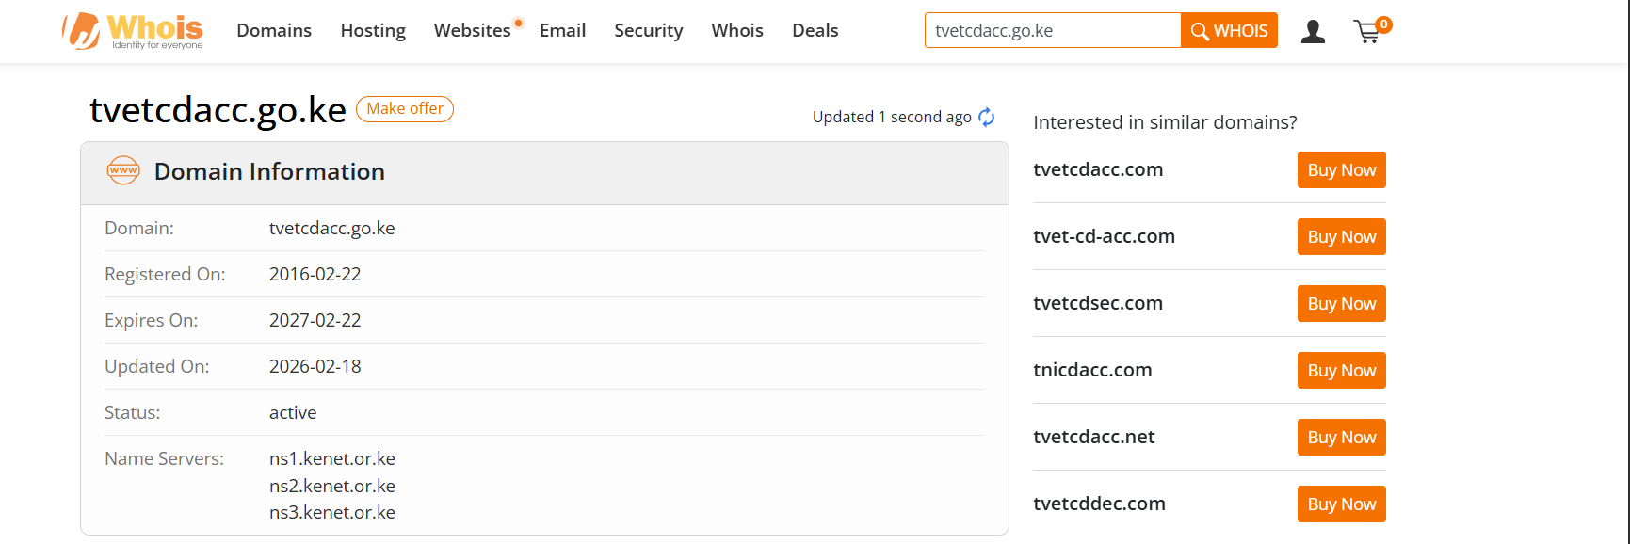
Figure 1: WHOIS domain information for tvetcdacc.go.ke (whois.com)
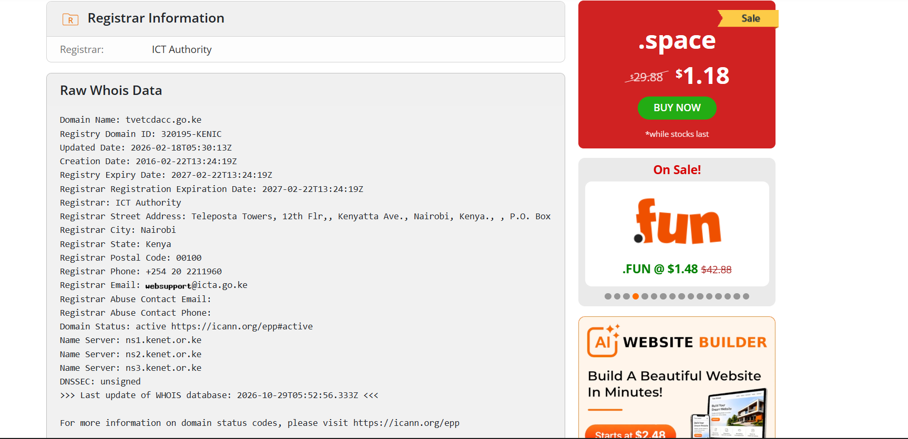
Figure 2: Raw WHOIS data showing registrar, dates, status and name servers

4. DNS records
The following commands were run in Command Prompt using Google public DNS (8.8.8.8). Answers were non-authoritative.
Command | Purpose
nslookup -type=ns tvetcdacc.go.ke 8.8.8.8 | Name servers
nslookup www.tvetcdacc.go.ke 8.8.8.8 | IP address of the website (A record)
nslookup -type=mx tvetcdacc.go.ke 8.8.8.8 | Mail servers
nslookup -type=txt tvetcdacc.go.ke 8.8.8.8 | Text records
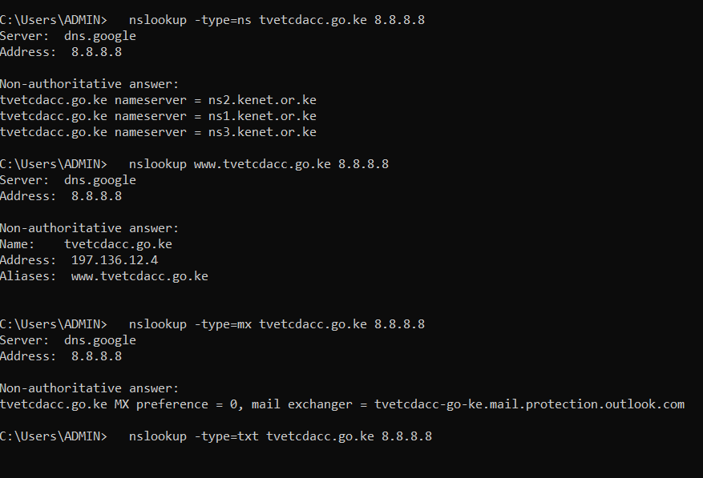
Figure 3: NS, A and MX lookups for tvetcdacc.go.ke
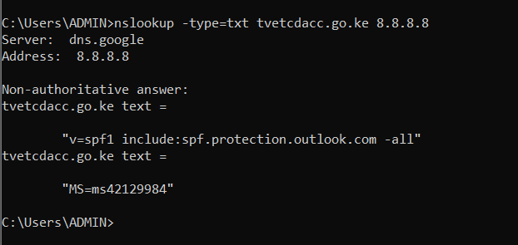
Figure 4: TXT lookup for tvetcdacc.go.ke

What the records show
- The name servers belong to KENET (the Kenya Education Network), which hosts the domain’s DNS.
- The website address resolves to 197.136.12.4; www is an alias of the main domain.
- Email is handled by Microsoft 365 (Outlook mail protection).
- The SPF record allows only Microsoft 365 servers to send mail for the domain, and -all tells receivers to reject mail from any other source, which helps prevent email spoofing.
- MS=ms42129984 is a Microsoft domain verification code showing the domain was added to Microsoft 365.

5. Lookup of cdacc.go.ke
The domain written in the assessment, www.cdacc.go.ke, was looked up first. Both the local network DNS server and Google DNS (8.8.8.8) returned “Non-existent domain”, so the name does not exist. The council’s domain was then found to be tvetcdacc.go.ke and looked up as shown above.
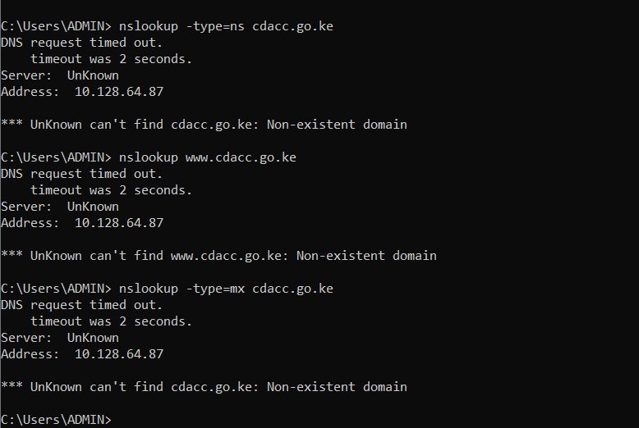
Figure 5: Lookups of cdacc.go.ke on the local network DNS server (non-existent domain)
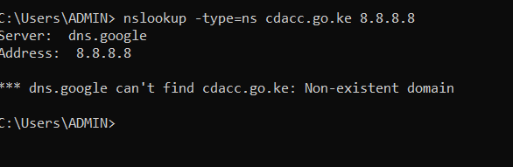
Figure 6: Lookup of cdacc.go.ke on Google DNS 8.8.8.8 (non-existent domain)

6. Observations
- Expiry: the domain expires on 22 February 2027, so it needs renewing soon to avoid losing the website and email.
- DNSSEC is unsigned, so DNS answers for this domain are not cryptographically signed. Enabling DNSSEC would be a security improvement.
- The domain is active and the name servers, website address and mail records all resolve correctly.

