Exhibit Document — “Founders as the Next Offset”
Deliverable 1. Three exhibits supporting the argument that America’s founder class is its decisive asset in the techno-economic competition with China. Each entry contains the exhibit, a plain-English annotation, and a full source citation. Figures are reproducible from the scripts in code/; see the repository README.
Author: Felix Aidala · Prepared for: Cardinal40 (Economist role) · Date: June 2026
The three exhibits trace one logical chain:
- Where frontier talent now works — innovation has moved from the academy into industry and company-building.
- Why the founder specifically matters — founders are not interchangeable managers; remove them and innovation measurably falls.
- Why America’s system wins — the U.S. has a vastly deeper exit machine to finance, reward, and recycle those founders than China does.

Exhibit 1 — Since the 1970s, industry has caught up with academia for new U.S. PhDs
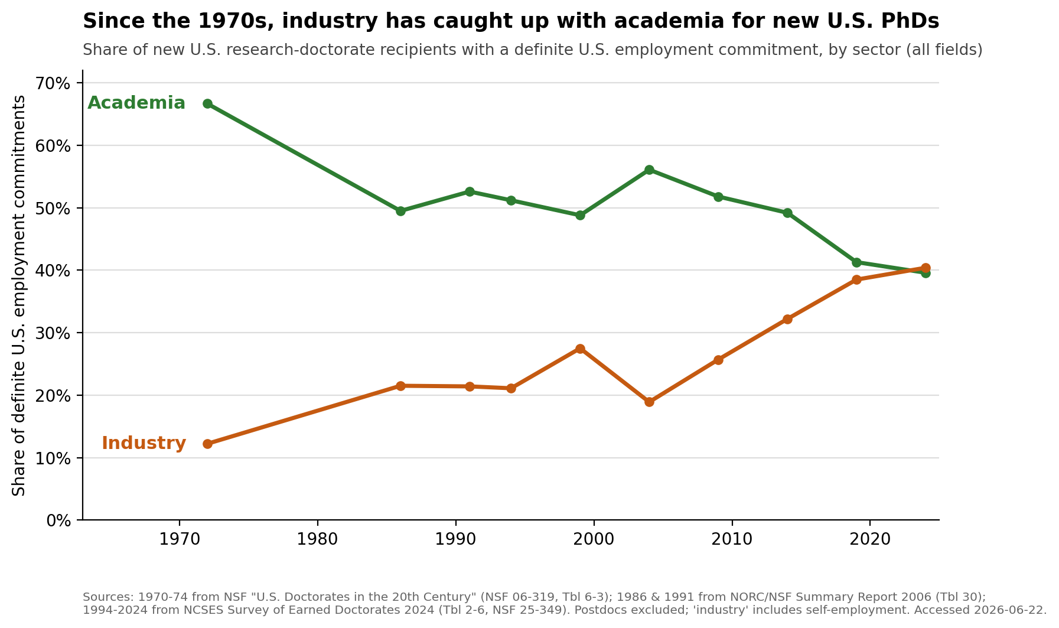
Exhibit 1
Annotation. This figure anchors the essay’s opening claim: that the locus of American technological advantage has shifted since the Second World War and the Cold War that followed. The scientists who built the first nuclear weapons were academics on leave from their universities. Today the country’s most capable new PhDs increasingly leave the academy for industry, where they builds and lead America’s frontier companies (Anthropic among them). That steady migration of scientific talent into the private sector is what the figure is meant to show, and it is what motivates the investment thesis that follows. Two cautions are worth stating plainly. First, to recover a picture reaching this far back I had to use all fields rather than science and engineering alone, so these are not exclusively technical PhDs. Second, the chart shows talent moving into industry, not talent becoming founders — I am careful not to imply the latter, because the great majority of these scientists never start a company. The claim is the narrower and more defensible one: the frontier of scientific work now sits inside industry.
Sources. Three vintages of the same NSF/NCSES measure (sector of new research doctorate recipients with a definite U.S. employment commitment; postdocs excluded; “industry” includes self-employment): (1) 1970–74 — NSF/SRS (2006), U.S. Doctorates in the 20th Century, NSF 06-319, Table 6-3 (five-year average). (2) 1986, 1991 — NORC/NSF, Doctorate Recipients from U.S. Universities: Summary Report 2006, Table 30 (selected years 1986–2006). URL: https://www.norc.org/content/dam/norc-org/pdfs/SED_Sum_Rpt_2006.pdf (3) 1994–2024 — NCSES, Survey of Earned Doctorates 2024, Table 2-6, NSF 25-349. URL: https://ncses.nsf.gov/pubs/nsf25349/assets/data-tables/tables/nsf25349-tab002-006.pdf All accessed 2026-06-22. The 1994–2024 segment uses the single current NCSES trend table (no vintage-mixing within it). Per-point sourcing in data/raw/sed_table2-6_employment_sector.csv and data/raw/sed_historical_employment_sector_allfields.csv.

Exhibit 2 — Founders are not interchangeable managers
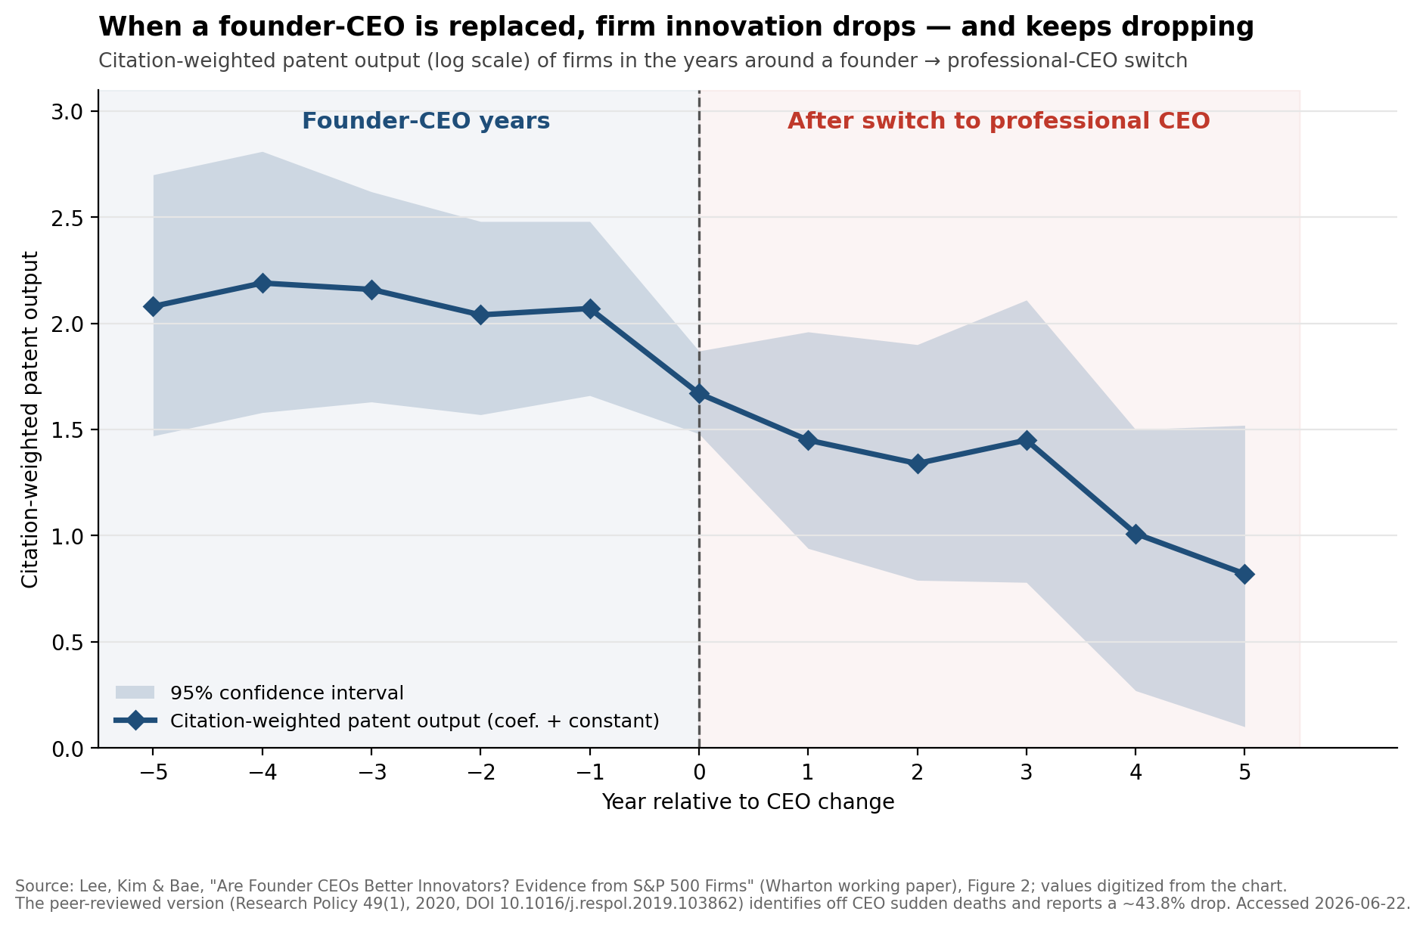
Exhibit 2
Annotation. This figure speaks to the distinctive skillset a founder brings and to whether the person who builds a company can be swapped for a professional manager once it is built. It is an event study drawn directly from Lee, Kim, and Bae (2020): when a founder-CEO exits unexpectedly, citation-weighted patents, a standard proxy for innovation, fall. Event studies can be confusing on a first read, because what they plot is a difference-in-differences rather than a simple time trend; given more time, I would replicate the authors’ analysis myself so the figure could show the treated and comparison groups as separate lines. Nuance not to overclaim: the shaded 95% confidence band widens after the switch, so the later post-switch points are imprecisely estimated; read the result as the clear break at year 0 plus the published magnitude, not as a precise year-by-year path. I present the authors’ figures; I did not re-run the analysis, whose hand-collected data are not redistributable.
Sources. Event-study figure: Lee, Joon Mahn; Kim, Jongsoo; Bae, Joonhyung, “Are Founder CEOs Better Innovators? Evidence from S&P 500 Firms” (Wharton Mack Institute working paper; S&P 500, 1993–2003), Figure 2, “Switching from Founder CEO to Professional CEO.” Values digitized from the published chart (±~0.03 reading error) into data/raw/lee_kim_bae_fig2_event_study.csv. URL: https://mackinstitute.wharton.upenn.edu/wp-content/uploads/2016/03/Mahn-Lee-Joon-Kim-Jongsoo-and-Bae-Joonhyung_Are-Founder-CEOs-Better-Innovators.-Evidence-from-SP-500-Firms.pdf Headline magnitude (corroboration): Lee, J.M., Kim, J., & Bae, J. (2020), “Founder CEOs and innovation: Evidence from CEO sudden deaths in public firms,” Research Policy 49(1), 103862, DOI 10.1016/j.respol.2019.103862; key estimates in data/raw/lee_kim_bae_2020_estimates.csv. Method: the figure plots the coefficient-plus-constant from a firm fixed-effects panel OLS of ln(1 + citation-weighted patent count) on year-relative-to-switch dummies. All accessed 2026-06-22.

Exhibit 3 — America’s exit machine: far deeper capital markets than China’s
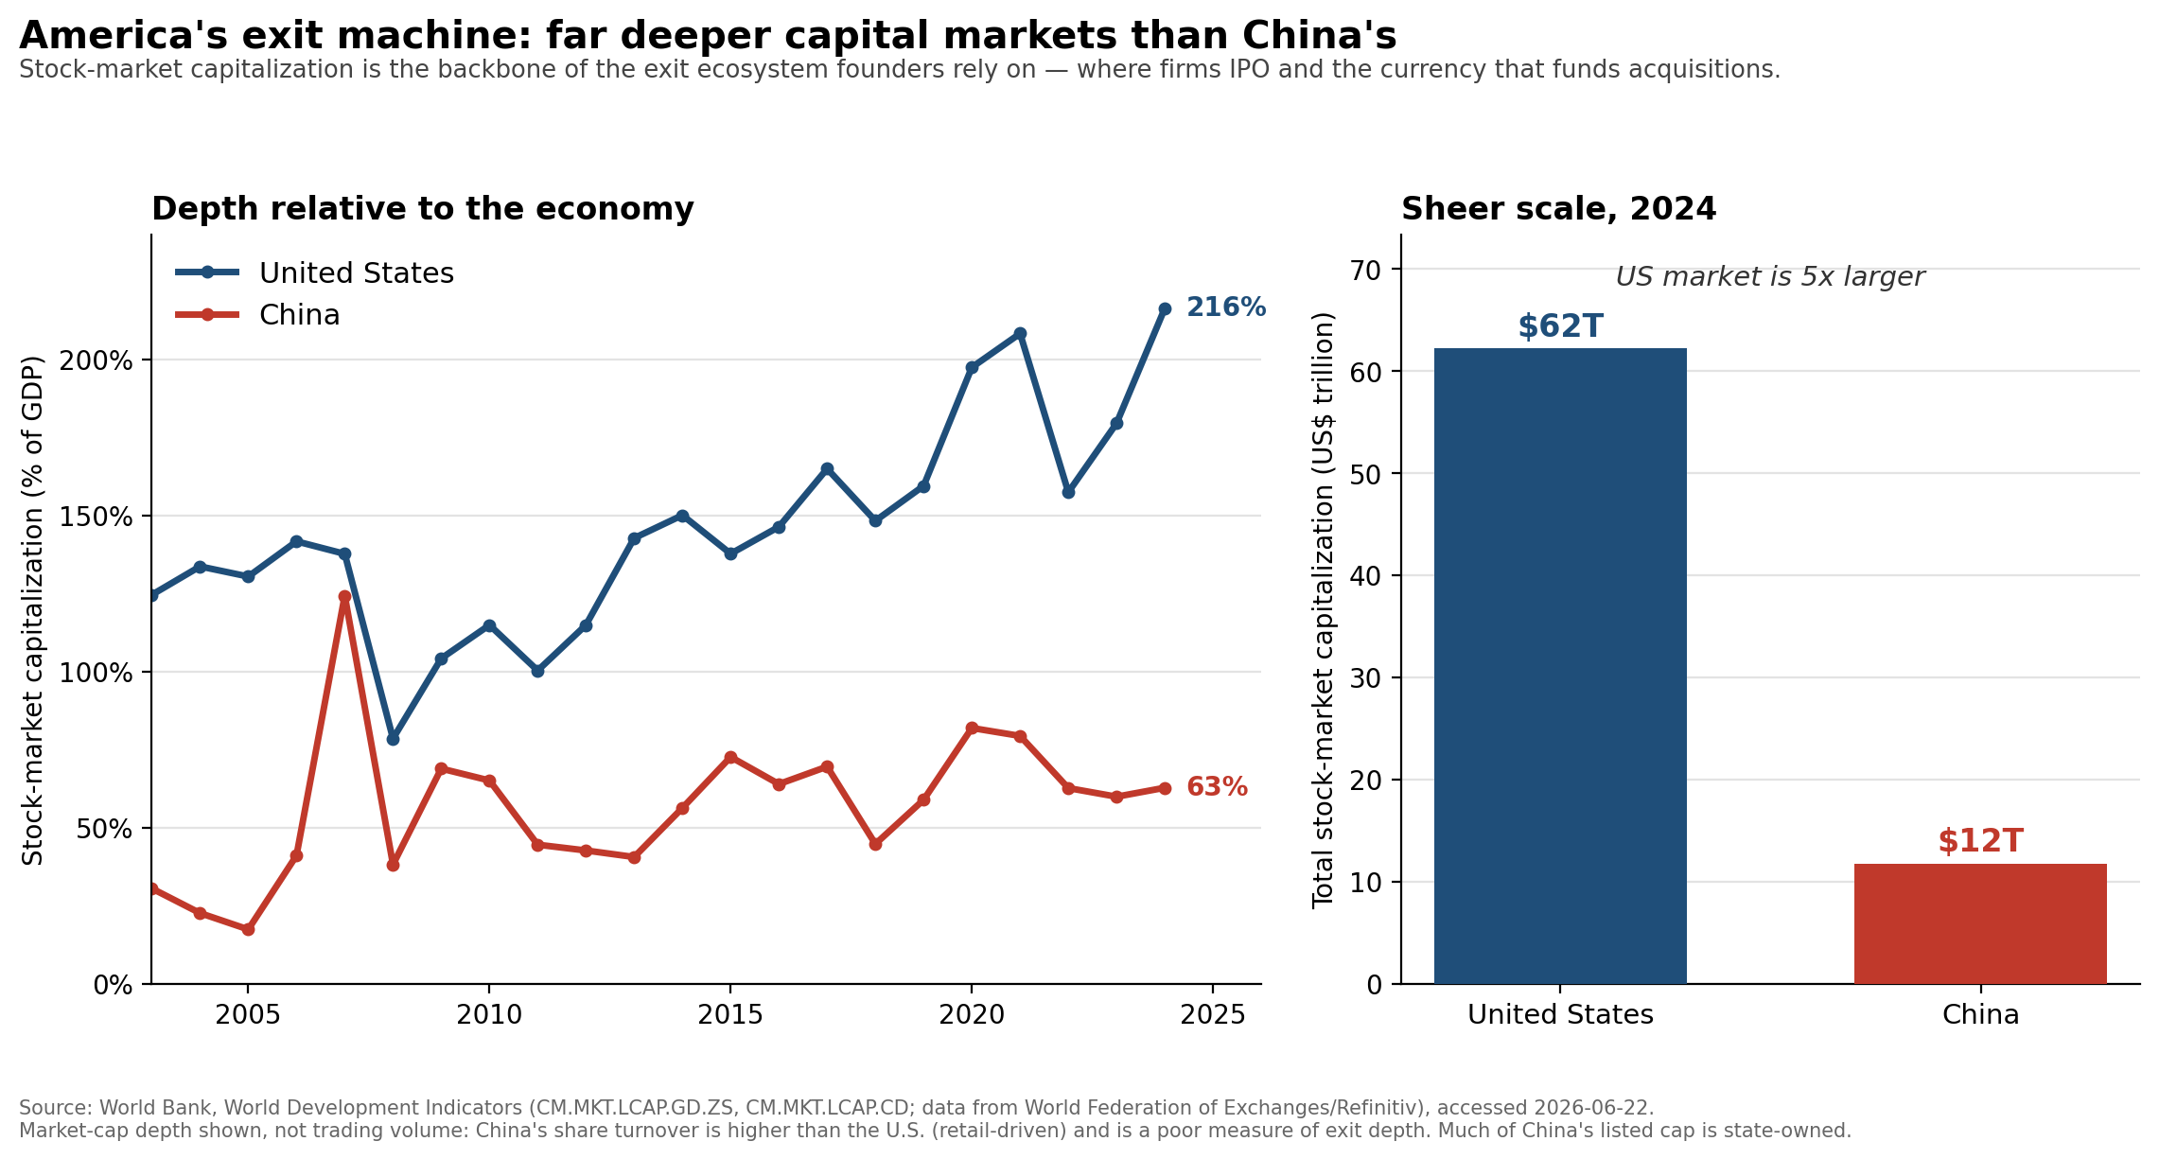
Exhibit 3
Annotation. This figure is the most basic, but is intended for a section that discusses the advantages and disadvantages the U.S. holds over China.

Deep, liquid public-equity mark

Deep, liquid public-equity markets are the backbone of the exit ecosystem founders depend on — the place companies IPO and the currency that funds acquisitions — and on this measure the U.S. dwarfs China: U.S. stock-market capitalization is ~216% of GDP vs. China’s ~63% (3.4× deeper relative to the economy) and ~$62 trillion vs. ~$12 trillion in absolute size (~5× larger) in 2024. The headline for the writer: America’s structural advantage isn’t only that it produces founders — it’s that it can finance the swing, reward the win, and recycle the capital, which is exactly the flywheel a thinner exit market starves. The nuance a reader (and a careful critic) might miss: we deliberately use market-cap depth, not trading volume — China’s share turnover is actually higher than the U.S. (≈186% vs. 148% of GDP in 2024), but that reflects retail speculation, not exit capacity, so it would mislead. Two further caveats: public markets are a proxy for the whole exit ecosystem (M&A and secondaries also matter), and a large share of China’s listed value is state-owned with capital controls limiting exit and repatriation — so China’s usable exit depth for a private investor is arguably thinner still.

Source. World Bank, World Development Indicators (underlying data: World Federation of Exchanges / Refinitiv). Indicators CM.MKT.LCAP.GD.ZS (market capitalization, % of GDP), CM.MKT.LCAP.CD (market capitalization, current US$), and CM.MKT.TRAD.GD.ZS (stocks traded, % of GDP — context only). Pulled via the World Bank API, accessed 2026-06-22; snapshot cached in data/raw/worldbank_market_depth.csv. Coverage: United States and China, 2003–2024 (absolute market cap available through 2025). API docs: https://datahelpdesk.worldbank.org/.

How to reproduce
pip install -r requirements.txt
python code/exhibit1_stem_phd_pathways.py
python code/exhibit2_founder_ceo_innovation.py
python code/exhibit3_exit_market_depth.py
Each script prints the key figures it computes and writes its figure to this folder. Methodological choices are documented at the top of each script and in the annotations above.

