# Does agent behaviour stabilise over time?

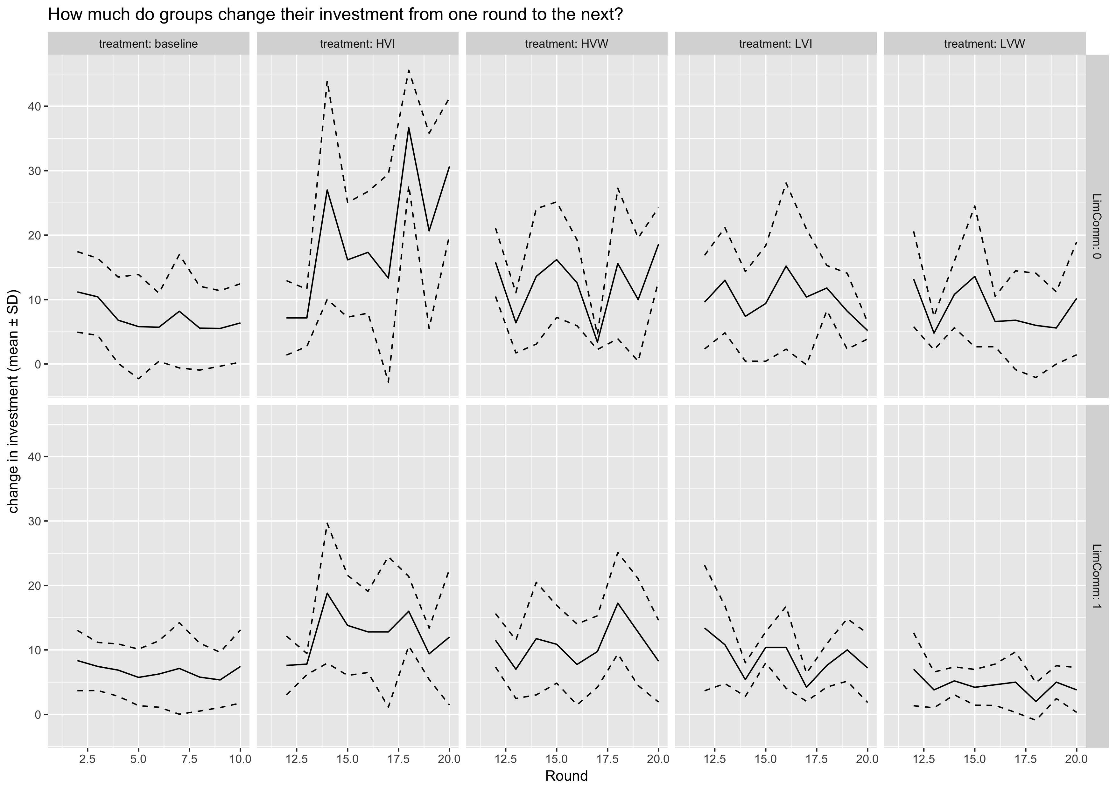

* Graph shows the change in investment from one round to the next (means across groups of the same treatment)
  + Change is measured at the individual level -> so even if the total investment at the group level remains the same, but the individual contributions change, this would be captured.
  + 0 means no change (= stable behaviour), 50 means that all agents change their investment from 0 to 10 (or vice versa)
* unfortunately, there is no trend of stabilisation in phase 1 – when there is no variability in environmental conditions
* in phase 2, investment has to adapt to the variable environmental conditions

# Infrastructure as an indicator of success

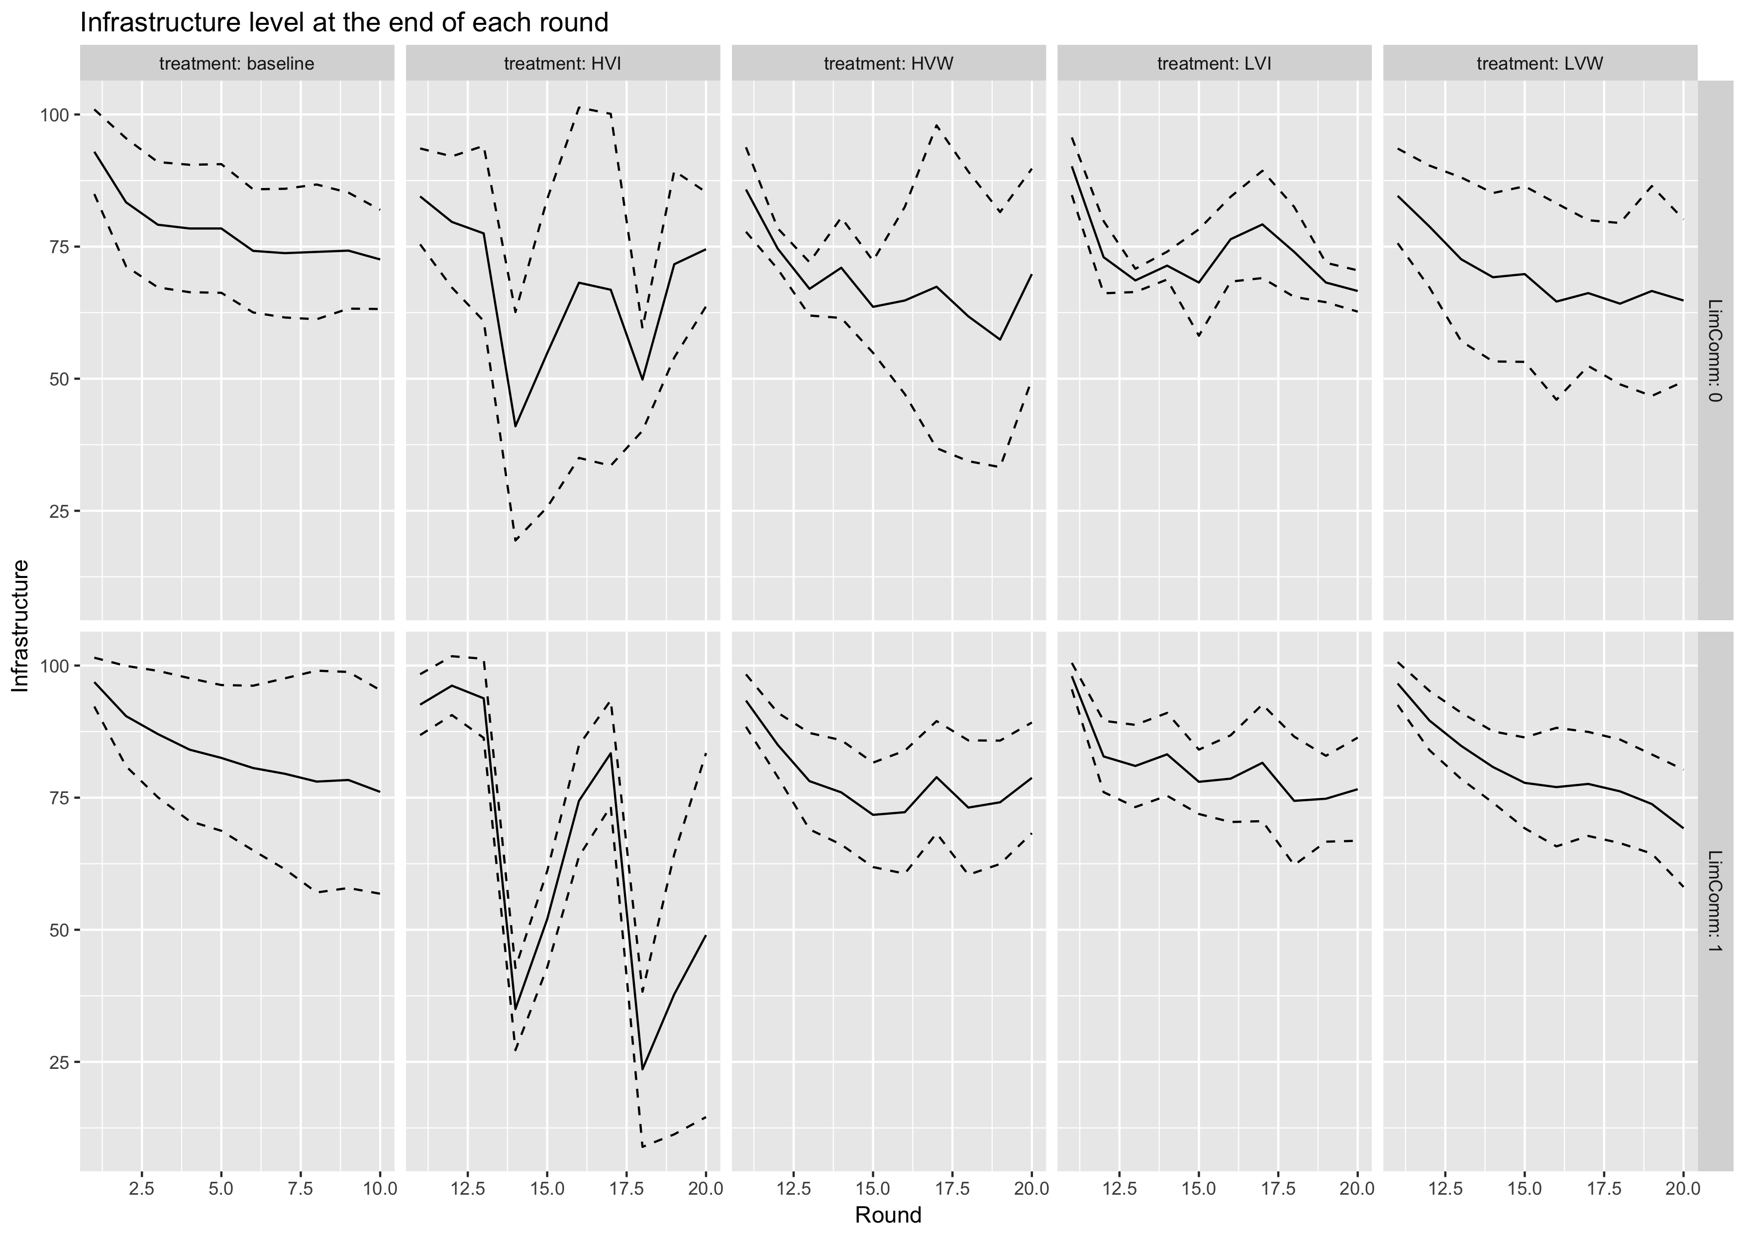

* As an indicator of success, infrastructure should optimally be maintained at 66, except for the water variability treatments where water flow can be higher than 30 cfps
* On average, groups manage rather well – however in some treatments, groups show a high variance

# Utilization of potential water flow – is infrastructure level sufficient?

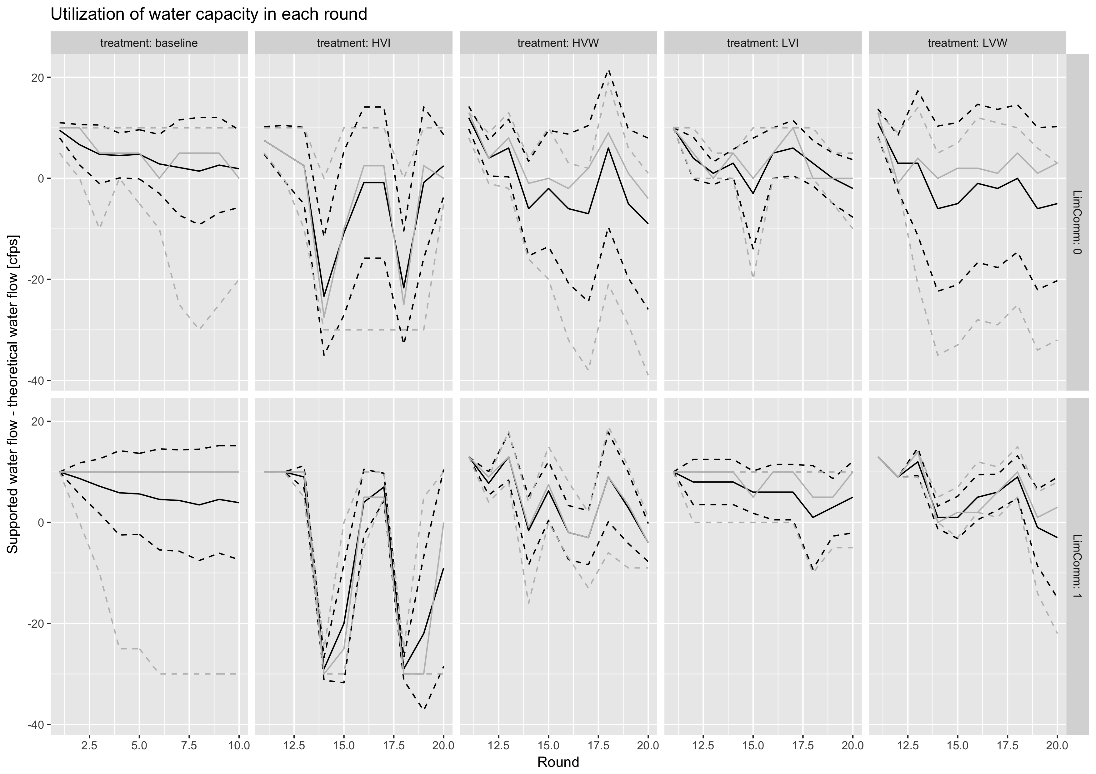

* The graph shows the difference between the supported water flow and the theoretically achievable water flow (in other words: if > 0, capacity is larger than the actual water flow; if < 0, water flow is reduced due to insufficient infrastructure)
  + Black solid line: mean; grey solid line: median
  + Black dashed lines: mean ± SD, grey dashed lines: min/max
* With full communication, groups manage rather well on average (except for HVI)
* There is always at least one group that can provide the necessary infrastructure to obtain the entire theoretical water flow