We would like you to complete a small project using Node.js, Express, MongoDB, React and Redux.

Here are the requirements:

1. The goal of the application is to track expenses.

2. An "expense" is made of the following information: an amount, a date, and a description.

3. The application should be a **single-page application** that displays a list of expenses (see example below)

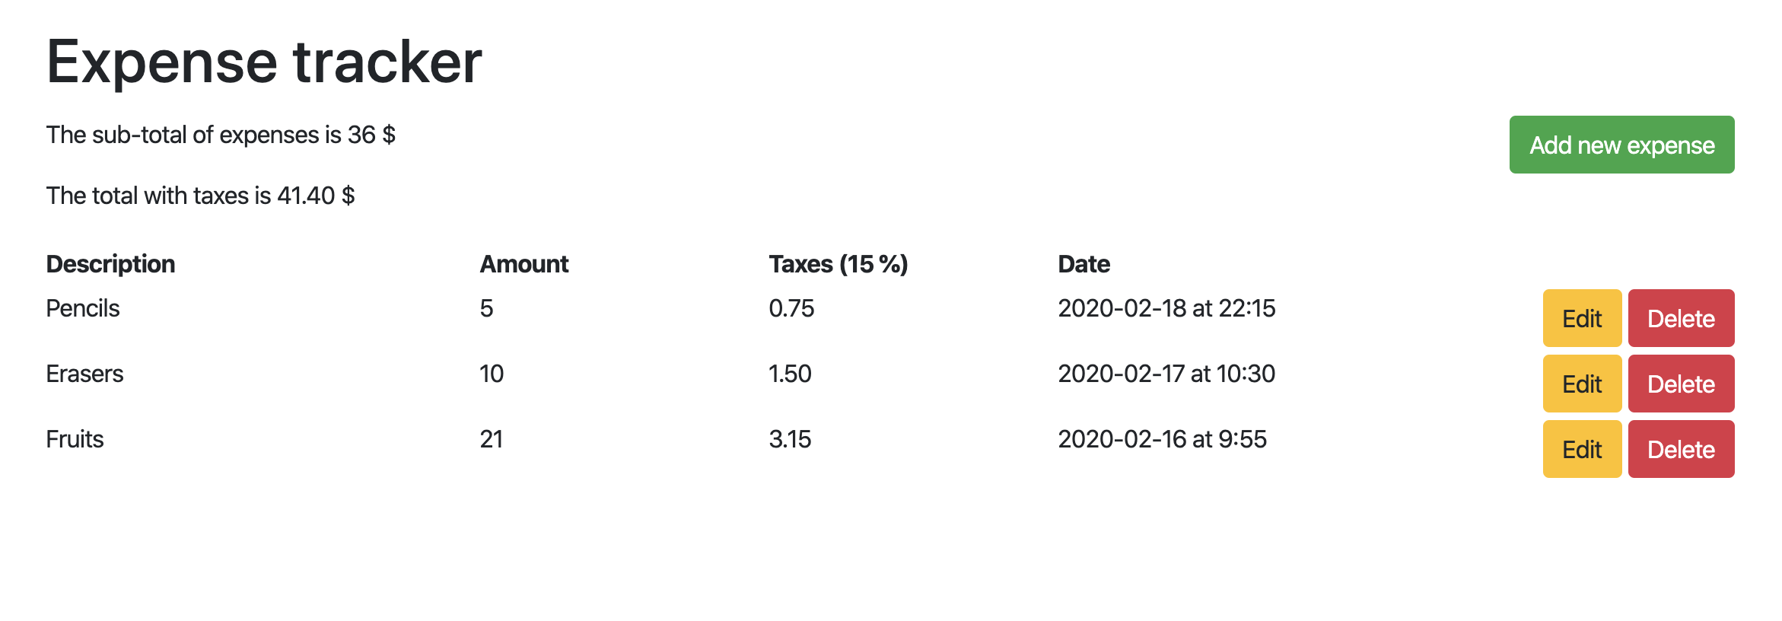

4. When you load the page, previously-created expenses should be loaded from the database and displayed as a list.

5. Each expense should display the amount of taxes (15%) that should be collected on them.

6. The application should always have a counter that displays  
- the sub-total (before taxes) of the amount of all expenses at the top of the page;  
- the total of all expenses, including taxes;

7. There should be a button that displays a form to create a new expense.

8. When the form to create a new expense is filled, there should be a button to save it to the database. Once an expense is saved, the list should be updated with the new item.

9. Each expense should have a button that allows editing it. Clicking that button should make the values of the expense editable through input fields, and a button to update the entry. Once saved, the expense should update to its new data.

10. Each expense should have a button that allows editing it. Clicking that button should remove that expense from the database. Once an expense is deleted, the list should be updated without that item.

Please upload your code to your GitHub repository and send us the link.

Finally, a few tips:

- Please make good use of React's bindings and functional capabilities.

- Please avoid copying data from props to state when not necessary.

- If anything is unclear, write your assumptions in your README.  
- Focus on quality first, then completion.

- The more documentation you write, the easier it is for us to follow your thought process and evaluate your code.