4.7 Gaussian Quadrature

+**************************************************************************************+

1. a

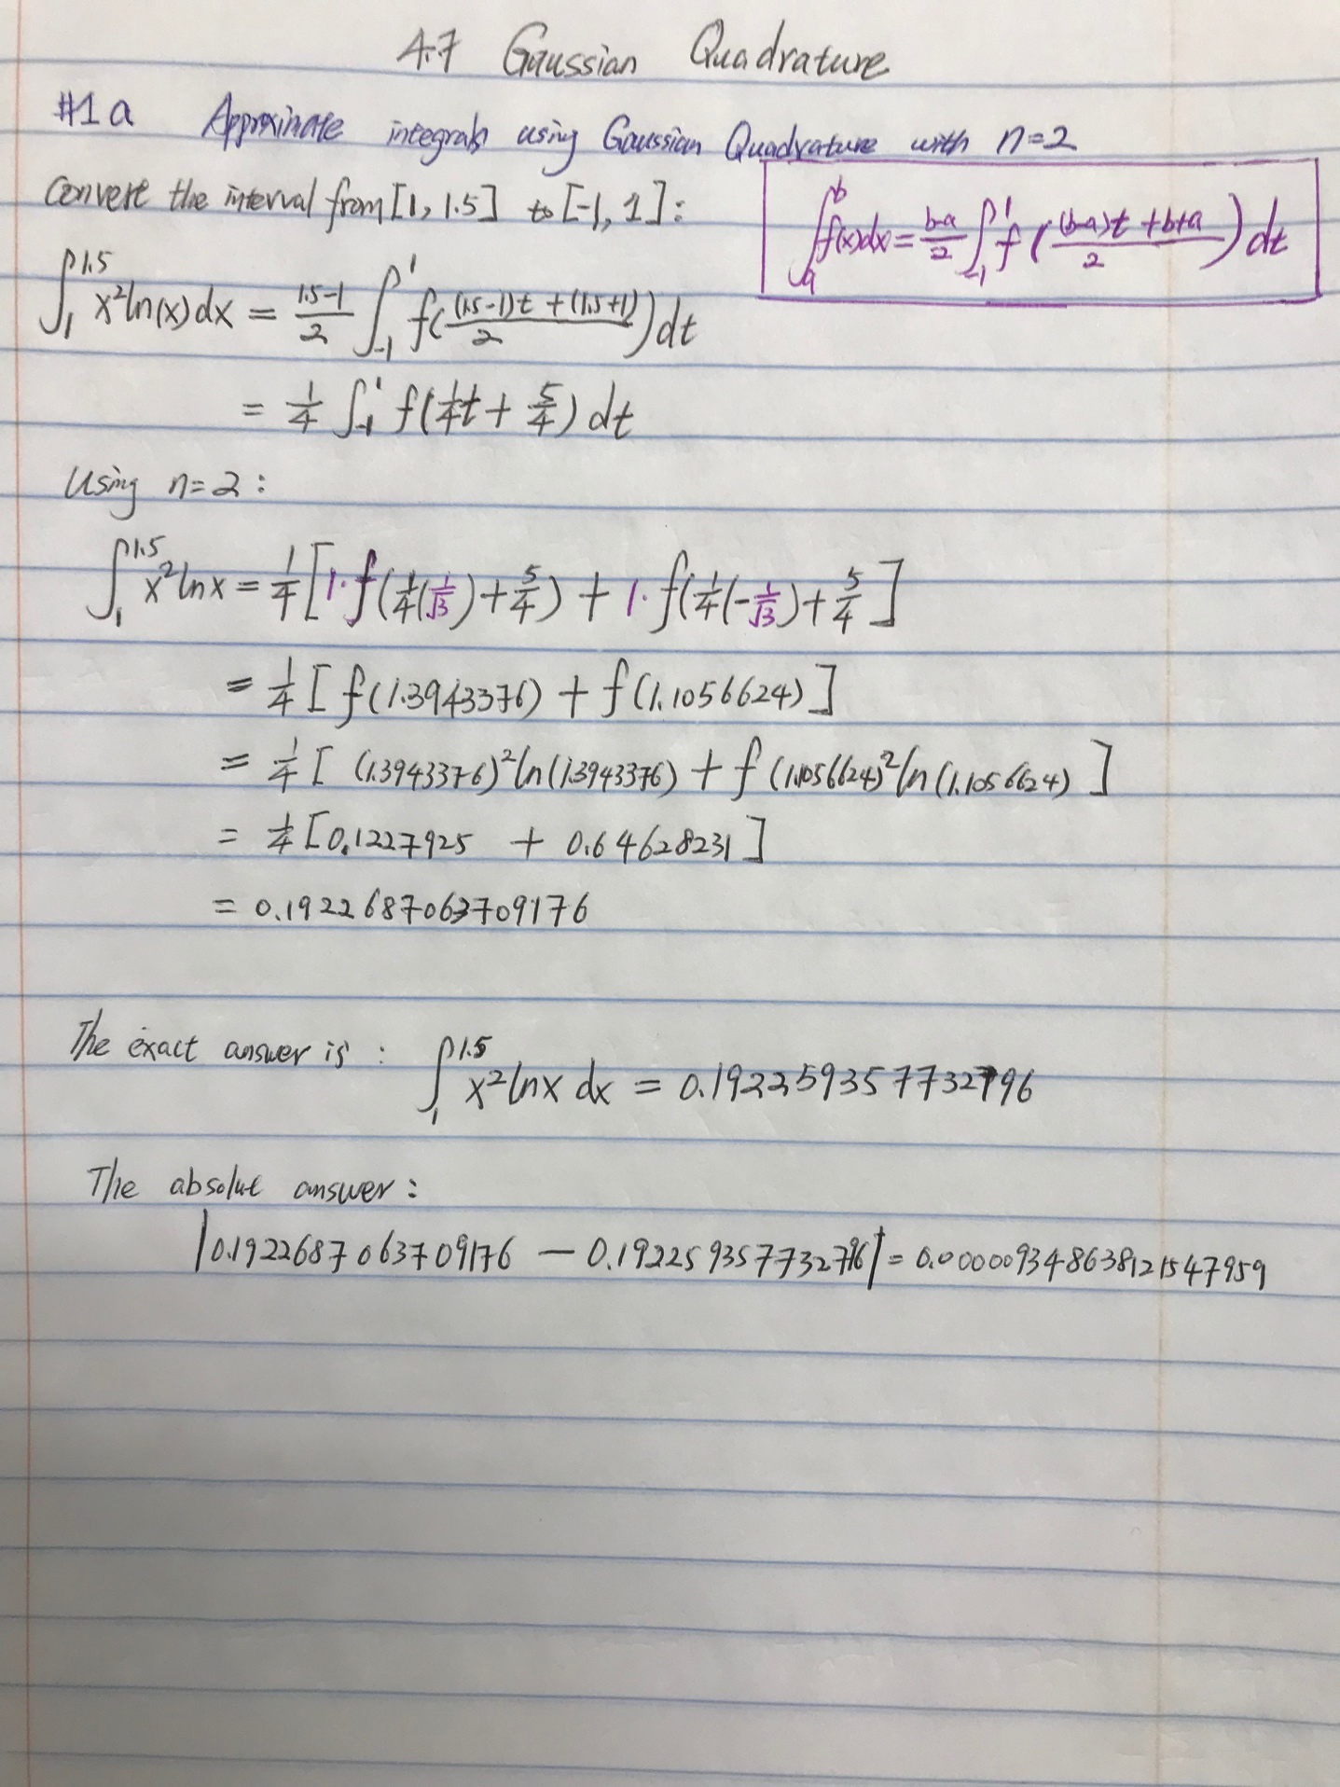

+**************************************************************************************+

1. a

$$\int_{1}^{1.5}{x^{2}lnx dx=\frac{1.5-1}{2}}\int_{-1}^{1}{f(\frac{\left(1.5-1\right)t+\left(1.5+1\right)}{2})dt}$$

$$=\frac{1}{4}\int_{-1}^{1}{f\left(\frac{t}{4}+\frac{5}{4}\right)dt}$$

Using n=3:

$$=\frac{1}{4}[ \frac{5}{9}f(\left( 0.25\left(-0.7745966692414834\right)+ 1.25\right))+ \frac{8}{9}f(\left( 0.25\left(0\right)+ 1.25\right))+ \frac{5}{9}f\left(\left( 0.25\left(0.7745966692414834\right)+ 1.25\right)\right)]$$

$=\frac{1}{4}[ \frac{5}{9}f($ 1.056350832689629 $)+ \frac{8}{9}f\left(1.25\right)+ \frac{5}{9}f\left(0.42513103156751902\right) ]$

=0. 192259377256879

The absolute error is

|0.192259377256879−0.192259357732796|= 0.00000001952408298921959

+**************************************************************************************+

1. a

$$\int_{1}^{1.5}{x^{2}lnx dx=\frac{1}{4}\int_{-1}^{1}{f\left(\frac{t}{4}+\frac{5}{4}\right)dt}}$$

Using n = 4, we have

$\int_{1}^{1.5}{x^{2}lnx dx }$ = 0.25{0.3478548451374538 ***f*** (0.25(−0.8611363115940526) + 1.25)

+ 0.6521451548625461 ***f***(0.25(−0.3399810435848563) +1.25)

+0.6521451548625461 ***f***(0.25( 0.3399810435848563) + 1.25)

+0.3478548451374538 ***f***(0.25( 0.8611363115940526) + 1.25)}

= 0.25 {0.01270976103900079 + 0.13517931157193655 + 0.33580948870208782

+ 0.28533886990642765}

=0.1922593578048632

The absolute error is

|0.1922593578048632−0.192259357732796|= 0.00000000007206715779695116

+**************************************************************************************+

1. a

using R code, with n= 5:

f=function(x){x^2*log(x)}

gaussianquad (1, 1.5, f, 5)

[1] 0.192259357733

> actual = 1/9*(1.5^3*(3*log(1.5)-1)+1);actual

[1] 0.192259357732796

> abs (gaussianquad (1,1.5, f,5)- actual)

[1] 3.460287612000457e-13

+**************************************************************************************+

1. a

Let’s start with the n = 2 case.

The Legendre polynomial is $x^{2}-\frac{1}{3}$, which has the roots of $x_{1}=-\frac{1}{\sqrt{3}}$ and $x_{2}=\frac{1}{\sqrt{3}}$ = ${-x}_{1}$

The formula for the c constants is found in the preamble of Theorem 4.7 of our book.

$$c_{i}=\int_{-1}^{1}{\prod_{\begin{aligned}j=1 \\ j≠i\end{aligned}}^{n}{\frac{x-x_{j}}{x_{i}-x_{j}}}}dx$$

Thus

$$c_{1}=\int_{-1}^{1}{\prod_{\begin{aligned}j=1 \\ j≠i\end{aligned}}^{2}{\frac{x-x_{j}}{x_{1}-x_{j}}}}dx=\int_{-1}^{1}{\frac{x-x_{2}}{x_{1}-x_{2}}}dx$$

Since $x_{2}$ = ${-x}_{1}$

$$c_{1}=\int_{-1}^{1}{\frac{x-x_{2}}{x_{1}-(-x_{1})}}dx=\frac{1}{2x_{1}}\int_{-1}^{1}{x-x_{2} dx}=\frac{1}{2x_{1}}\left(\frac{x^{2}}{2}-x_{2}x\right)|_{-1}^{1}=\frac{-4x_{2}}{4x_{1}}=1$$

The answer is exactly the same for c2 as all you have to do is switch indices of the xi’s in the problem.

The answer will finish with

$$c_{2}=\frac{-4x_{1}}{4x_{2}}=\frac{-4x_{1}}{-4x_{1}}=1$$

Thus, the nodes and coefficients for the Gaussian Quadrature rule with n = 2 is

$x_{1}=-\frac{1}{\sqrt{3}}{ and c}_{1}=1$ and, $x_{2}=\frac{1}{\sqrt{3}} {and c}_{2}=1$

Next, for the case of n = 3.

The Legendre polynomial is x(x2−3/5) =0*,* which has the roots of $x_{1}=-\sqrt{\frac{3}{5}},x_{2}=0,$ and $x_{3}=\sqrt{\frac{3}{5}}=-x_{1}$

Using the formula in the preamble of Theorem 4.7 again (with n = 3) yields:

$$c_{1}=\int_{-1}^{1}{\prod_{\begin{aligned}j=1 \\ j≠i\end{aligned}}^{2}{\frac{x-x_{j}}{x_{1}-x_{j}}}}dx=\int_{-1}^{1}{\frac{(x-x_{2})(x-x_{3})}{{(x}_{1}-x_{2})(x_{1}-x_{3})}}dx$$

